INTERACTION DESIGN CASE STUDY
Creative Operations Platform
From a personal portfolio to a unified, enterprise-pattern product prototype.
PRODUCT PROMISE
One workspace to publish, distribute, understand, and evolve creative work.
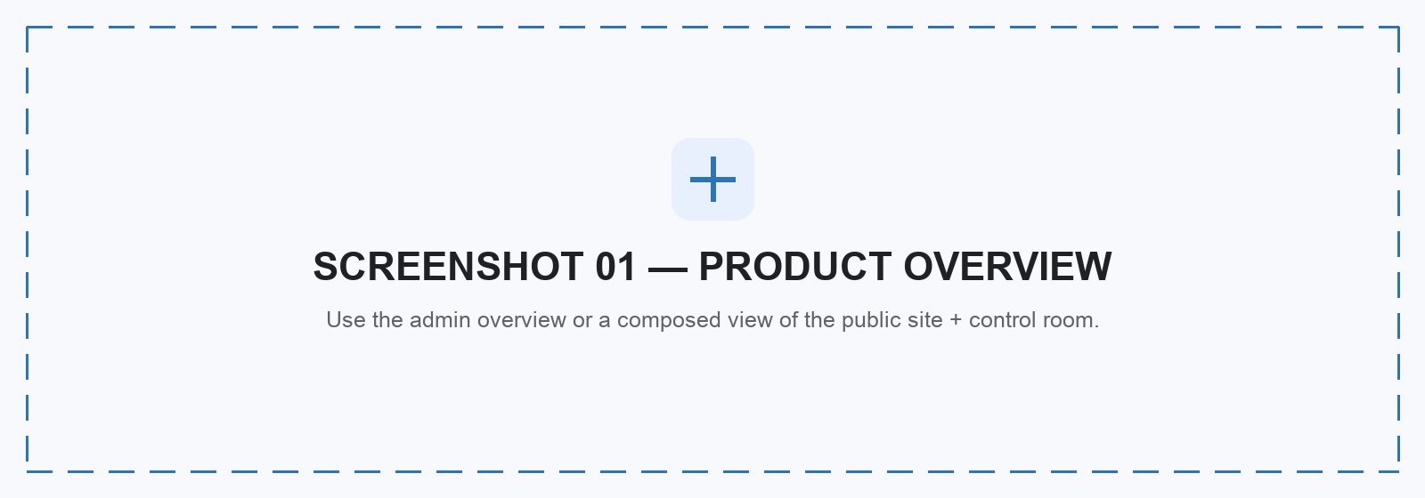
Hero image placeholder · Recommended crop: 16:7
ROLE Product strategy · Interaction design · Visual design · Full-stack prototyping
STAGE Working single-operator platform · Enterprise validation roadmap defined
CORE STACK Astro · React · TypeScript · Supabase · Cloudflare R2 · Vercel · Resend
SCOPE Public site · Admin workspace · AI tools · Media pipeline · Analytics
The project began with a personal need: manage a growing body of work and repeated enquiries without switching between disconnected tools. The same workflow problem appears across independent creators, studios, and small teams.

01 · OPPORTUNITY

One creative practice. Too many disconnected tools.
Publishing, files, newsletters, analytics, research notes, and enquiries lived in separate systems. Every hand-off lost context. Repeated inbound questions suggested that this was not only a personal workflow issue.
USER SIGNAL Repeated enquiries about projects, services, workshops, resources, and collaboration.
CORE NEED A single place to create, manage, publish, communicate, and learn.
PRODUCT HYPOTHESIS A modular operations platform can reduce context switching while preserving creative flexibility.
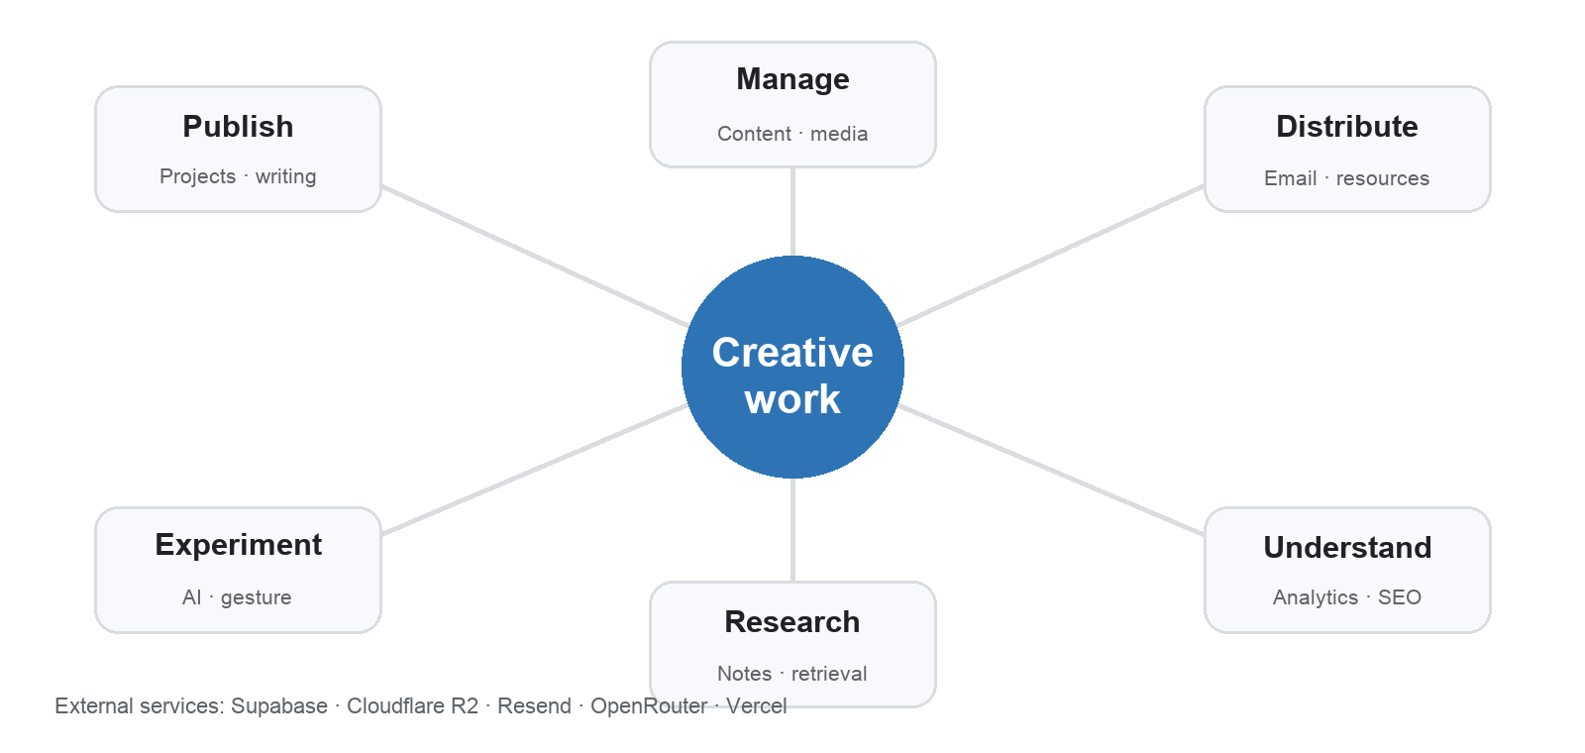
The product grew outward from one central object: the work itself.
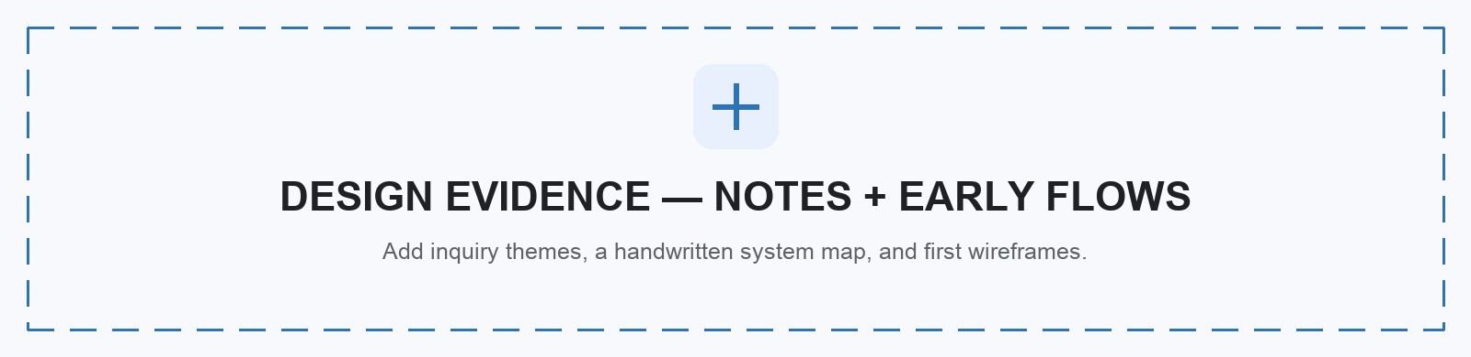
Replace this placeholder with evidence, not decoration.
Research boundary: current evidence combines direct workflow observation and recurring enquiry patterns. The next phase requires structured interviews, competitor analysis, and task-based usability testing.

02 · CORE PRODUCT FLOW

Design the entire content lifecycle.
The key design decision was to treat publishing as a stateful workflow—not a save button. Every project moves through creation, preview, validation, publication, delivery, and learning.
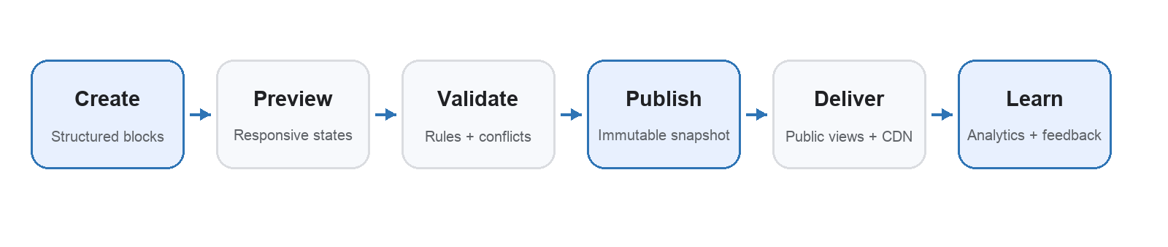
Primary workflow · Each step exposes clear status, feedback, and recovery.
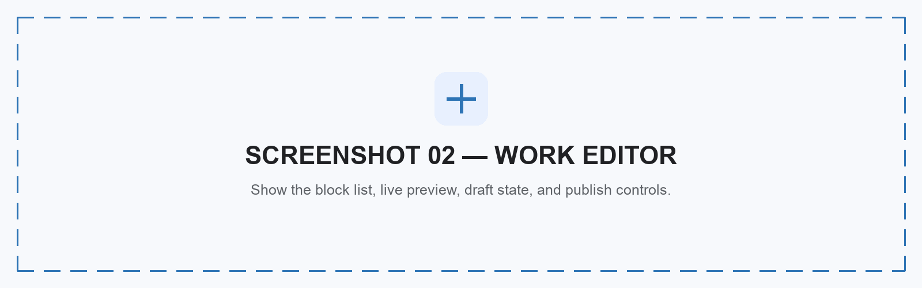
Show one task, one decision, and one visible system state.
await requirePortfolioAdmin();
const { data, error } = await supabase.rpc("portfolio_save_draft", {
p_project_id: projectId,
p_expected_lock_version: draft.lockVersion,
p_payload: toSavePayload(draft),
});
The editor delegates authorization and conflict protection to a database function. A stale tab cannot overwrite newer work.
- Recovery by design. Published versions are immutable backups; restoring one never changes the live project until it is published again.
- Safe public surface. Sanitized views expose only published fields; draft and admin data remain private.

03 · PLATFORM ARCHITECTURE

Show tasks. Hide infrastructure complexity.
Users interact with clear workflows. The platform coordinates data, identity, object storage, background processing, email, AI models, and delivery behind those workflows.
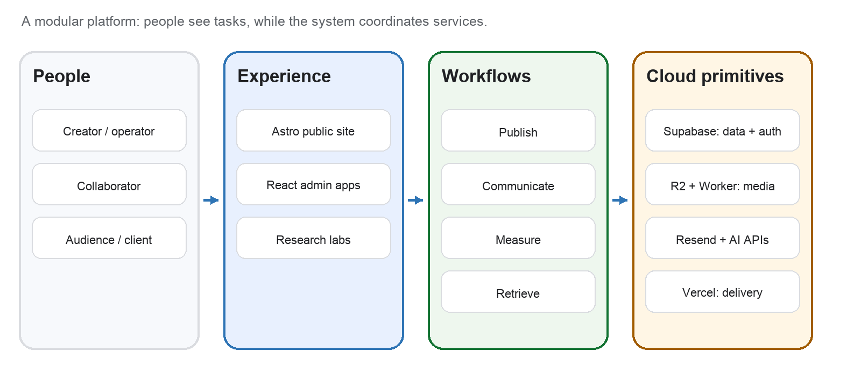
System model · Experience, workflow, and cloud layers remain modular.
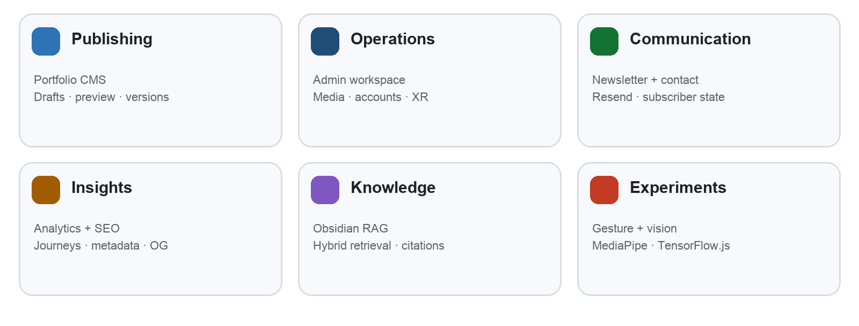
Six product modules share identity, media, content, and system feedback.
const questionEmbedding = await createEmbedding(searchQuery);
const { data } = await supabase.rpc("match_obsidian_chunks", {
query_embedding: questionEmbedding,
match_count: 12,
match_threshold: 0.16,
public_only: publicOnly,
});
The knowledge assistant retrieves only permitted note chunks before it generates a cited answer.

04 · INTERACTION DESIGN

Make complex systems feel calm.
The interface is organized around tasks and system states. Each screen should answer three questions: What can I do? What is happening? How can I recover?
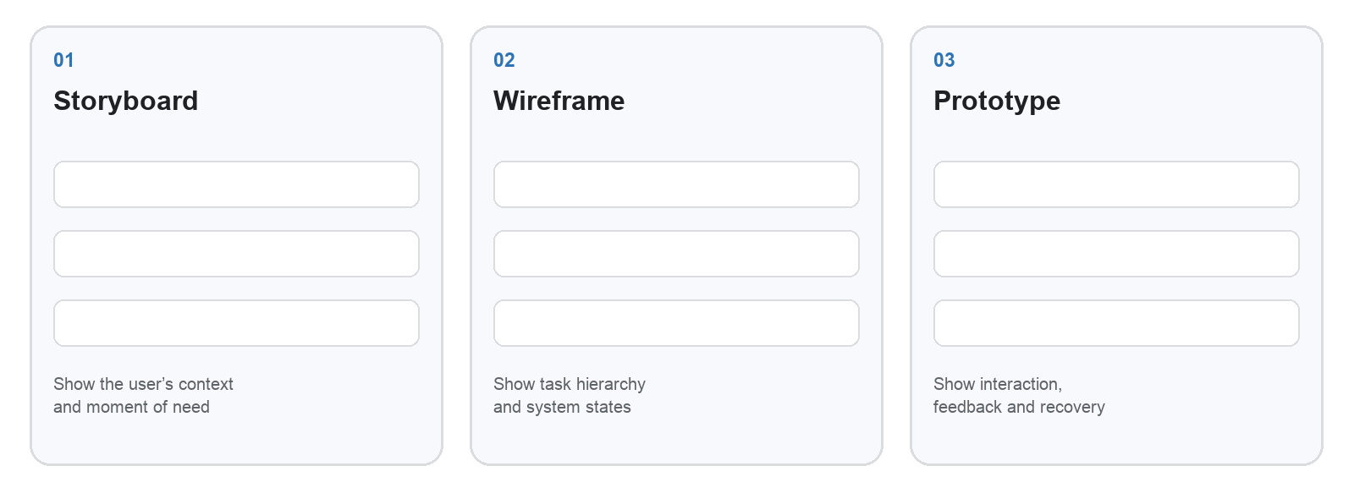
Portfolio artifact placeholders · Replace with real storyboard, wireframe, and prototype frames.
- Progressive disclosure. Show essential controls first; reveal advanced settings when needed.
- Consistent status language. Draft, processing, published, failed, and recovered mean the same across tools.
- Reversible actions. Version history, protected media, and explicit publishing reduce destructive mistakes.
- Accessible by default. Semantic controls, keyboard access, alt text, reduced motion, and responsive layouts.
- Shared patterns. Layouts, blocks, tokens, validation, feedback, and empty states form the product language.

Enterprise patterns, clearly bounded
Capability | Working prototype | Enterprise validation
Access | Supabase Auth, RLS and server-only privileged keys | Organization tenancy, SSO and audit logs
Reliability | Immutable publish backups, queue retries and recovery | SLOs, incident runbooks and disaster recovery
Data | Public/private views and signed media uploads | Retention, governance and regional policy
Quality | Focused unit and end-to-end tests | CI gates, load tests and formal accessibility audit
Positioning: enterprise-pattern product prototype—not a claim of enterprise deployment or scale.

05 · REFLECTION

A working product—and a clearer design practice.
The prototype proves that publishing, communication, media, analytics, knowledge, and experimentation can share one coherent system. It also exposed where exploration must become product discipline.
MISTAKE I over-normalized the first portfolio schema.
LESSON I learned that a portable document snapshot can be safer and easier to author than maximum relational purity.
MISTAKE I let experiments grow into large components.
LESSON I learned to extract state machines, hooks, primitives, and design tokens once an idea proves useful.
MISTAKE Quality gates arrived too late.
LESSON I learned that tests, type checks, linting, builds, security checks, and documentation must run as one system.
MISTAKE Publishing exposed operational gaps.
LESSON I learned that cache freshness, staging access, observability, and recovery are part of the user experience.
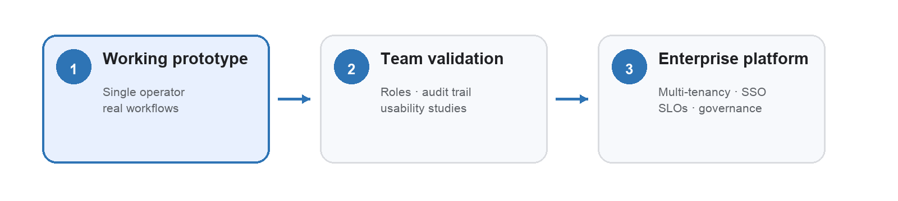
Scale is a validation path, not a visual claim.

Why this aligns with Google ACI UX
- Translates complex technical systems into understandable user flows.
- Connects storyboards, wireframes, prototypes, specifications, and implementation.
- Balances user needs with security, reliability, storage, compute, and operational constraints.
- Demonstrates end-to-end ownership: concept, system design, build, measurement, and iteration.
ROLE FIT
The domain is creative operations. The transferable skill is designing clarity, control, and trust across a complex cloud-backed system.
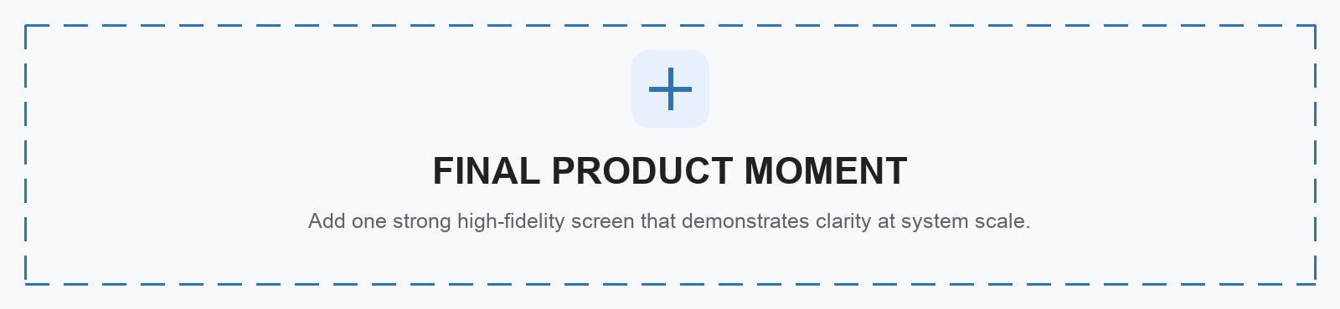
Closing visual placeholder · Add product link or QR code when the case study is published.

