**TinySWF Bitmap Usage**

1. How to assign a bitmap filename by export tag

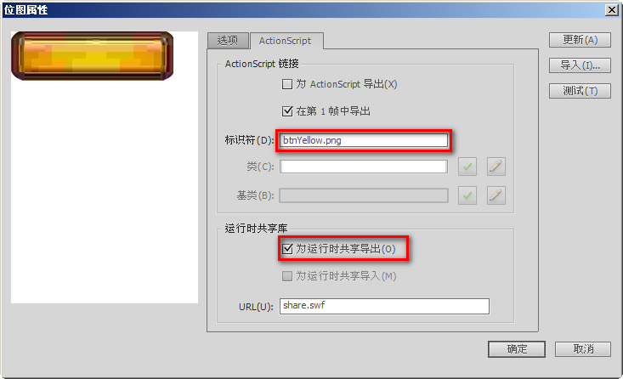

Note: bitmap files should be in the same folder with swf files

1. How to assign a placeholder symbol by import tag

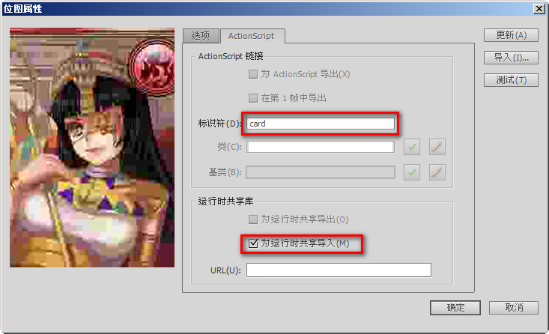

Note: you can register placeholder symbol to replace bitmap in program.