OS Lab 2 Report

1) Code organization

- File Processing : Methods to handle file creating , opening , writing and reading . There are helper method to read and write a line to specific file . All methods made generic so it can be reused again in another programs .

- Matrix Operations : Methods to allocate , free and multiply (by the two ways) matrices . Matrices and their dimensions are global to avoid passing pointers to functions . There are two helper methods to multiply a row and an element to be used in the two main methods .

- Main : Where the combining of all main methods happens . First get files paths from user or use the default paths , second open the corresponding files to read input matrices , then multiply them by the two ways and finally saves the output matrices in the corresponding output files .

2) Main functions

- void read_matrix(int row_num, int col_num, int** matrix, FILE* file) : Reads the given matrix with the given dimensions from the given file .

- void write_matrix(int row_num, int col_num, int** matrix, FILE* file) : Writes the given matrix with the given dimensions into the given file .

- void multiply_element_thread() : Multiplies the two input matrices by the (thread per element) method , where every element multiplication is done by a thread . The result is saved into the output matrix .

- void multiply_row_thread() : Multiplies the two input matrices by the (thread per row) method , where every row multiplication is done by a thread . The result is saved into the output matrix .

3) Code compilation and running

- Compiling the code is simply by going to the project directory and type the command “make” , which will eventually compile the code .

- Running the code is by typing (./mat_mult.out) to run it in by its default files paths names ( a.txt b.txt c1.out c2.out ) or (./ mat_mult.out Mat1 Mat2 MatOut) to provide it with the files paths names .

4) Sample runs

- Small size matrices :

input file 1
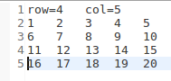

input file 2
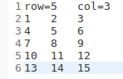

output file 1
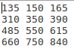

output file 2

standard output

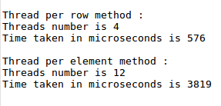

- large size matrices :

input file 1
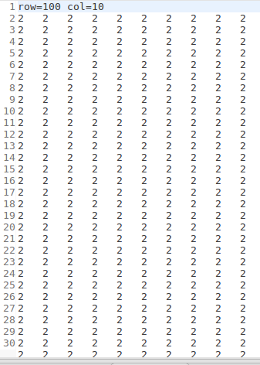

input file 2

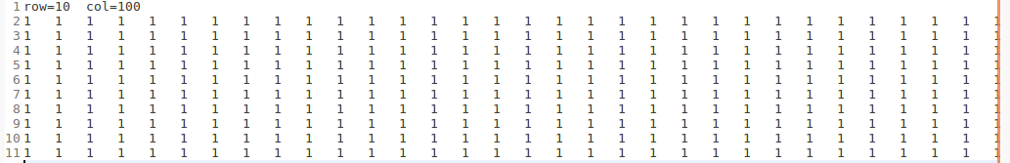

output file 1

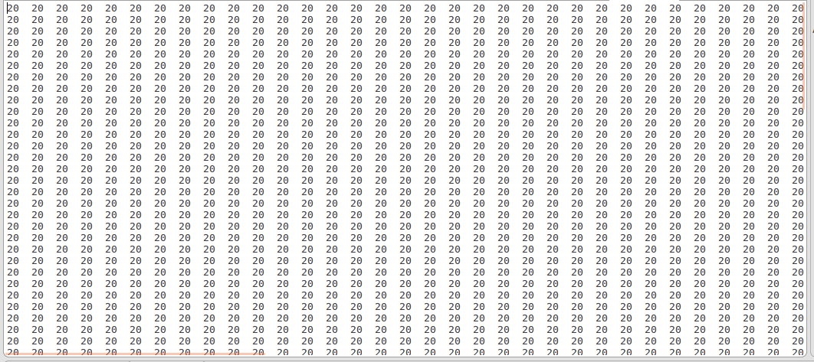

output file 2

standard output

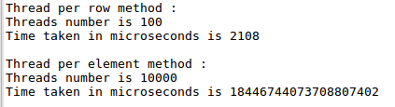

- In consistent dimensions :

Input matrix 1

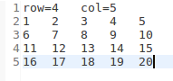
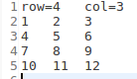
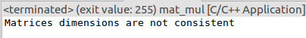

Input matrix 2

standard output

- Large threads :

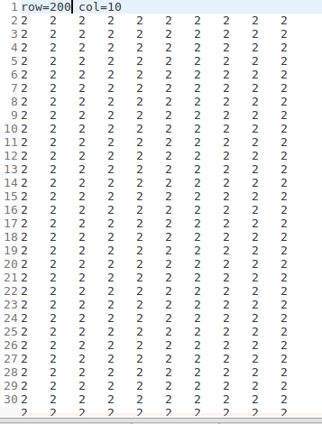
Input matrix 1

Input matrix 2

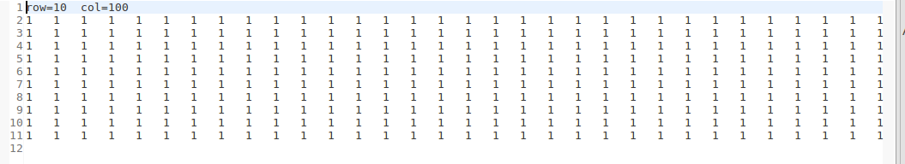

standard output

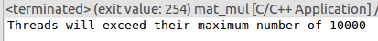

5) Comparison :

Thread per row method is faster than Thread per element method . As the matrices go larger , the gap between the two methods increases vastly .

This is because the time taken to create a thread is much bigger than the operation done by it

