Comparison between my Game of Life parallel implementations.

Antonio Boffa
520931

The code I used for this comparison is available on github here:
https://github.com/aboffa/Parallel_Game_of_Life
and attached to this report.

I compile using the right version of g++ in the Xeon PHI server and these flags: -fopenmp -O3 -DNDEBUG -ptrhead -I ./lib/sdsl-lite/include

I use the library sdsl-lite [1] in order to use their bit-vector, just because I am used to use it.
To install it:
git submodule update --init --recursive
cd ./lib/sdsl-lite
./install .

I implemented a single class Game_of_Life with 3 main method:

1 - step_sequential( number_of_iteration )
2 - step_parallel_open_mp( number_of_iteration, number_of_workers )
3 - step_parallel_pthread( number_of_iteration, number_of_workers )

The first one is just a simple implementation of a game of life step, that is: compute the number of neighbors, change the “aliveness” of the corresponding cell in a temporary grid. In the end I swap the two grid.

The second one is trivial, I just copy and paste step_sequential( ) and add
#pragma omp parallel for num_threads(nw) schedule(auto)
in front of the right for loop.
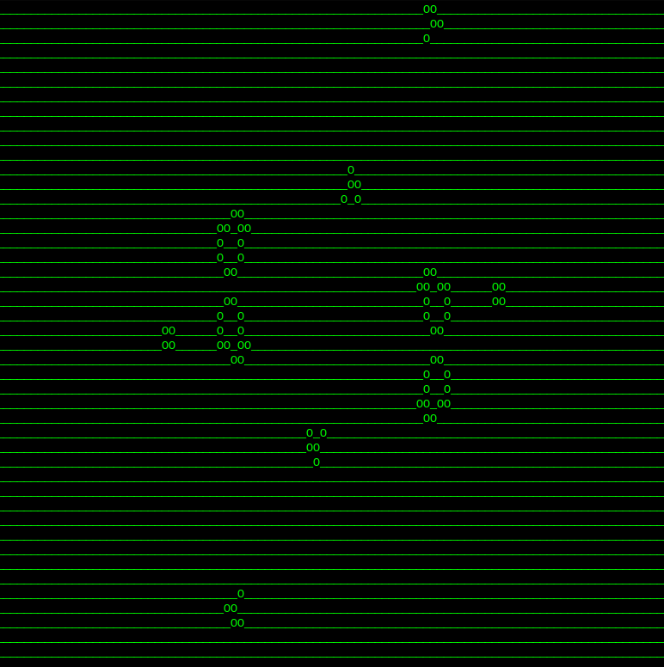
The third one is more involving. I use two condition variable and a mutex to make the thread wait the completion of all the others at the end of each step. Then the main does the swap. Done the swap all the threads are awakened ( notify_all( ) ) and they can continue the new iteration.

I tested the sequential implementation and then the two parallel implementation for each number of worker between 1 and 64. The plots of the speed-up are available below. The plot of the scalability are quite similar since: Time_open_mp_1worker = 0.9897 Time_sequential e Time_pthread_1worker = Time_sequential.
In both the parallel implementations the speed-up is linear until 18/20 workers. Then it start to decrease, as we have seen during the course. With a lot of workers (>25) there is “noise”. I think because the server is quite busy during these days.

I also attach an image of a working “bigun”. I imported the pattern from file in the format Life 1.06.

Reference:
[1] https://github.com/simongog/sdsl-lite

