Bohaichuk Andrii Architect, Team Lead, Senior Java / Full Stack Developer
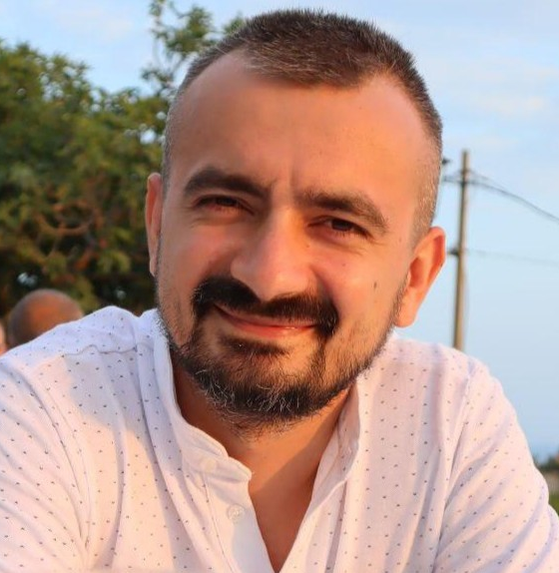
bogaychuk.a@gmail.com
+380 96 808 5507
Kyiv, Ukraine

linkedin.com/in/abohaichuk
github.com/abogaichuk/

SUMMARY
- Overall 10+ years Java / Full Stack development experience
- Design and implement projects, processes and operations from scratch in startups
- In-depth knowledge of network technologies and Unix-like operating systems
- Experience with wide range of programming languages, platforms and tools

SKILLS
Java(Spring Boot, Spring[Security, Cloud, Web, Data], Hibernate, Quarkus, Junit, Mockito); JavaScript(Vue.js, Webpack); Lua; PostgreSQL; MongoDb; Gradle; Docker; Linux; BurpSuite;

EXPERIENCE
Sep 2021 – present time Senior Java Developer, Team Lead @ UdelphiCommerce
Create, test and package new java library for internal usage and to be sold as a part of product
Lead the strategic optimization of the library. Mentoring team members, code review. Java(Multithreading, Junit), Gradle, gRPC.

Jul 2018 – Aug 2021 Integration Engineer @ AstoundCommerce
Design new APIs and modification of existing. API security check(OWASP). Integration of different third party APIs using different protocols(http, ftp, smpt, web socets). Collaboration with other teams and departments, ensuring seamless integration of software components, aligning with the overall project timeline, and contributing to the success of the entire development lifecycle. Java, mulesoft, BurpSuite, ZAP

Dec 2017 – Jul 2018 JS Developer @ INSTA.tools
SAAS for scraping and filtering users from Instagram, doing interactions on these users using private API(reverse engineering of web and android client), JavaScript(Vue.js, Webpack)

Jun 2017 – Apr 2018 Full Stack Developer Java/JS @ GlobalLogic
Adaptation of existing modules for current customer needs using: Java, JS, Gradle, Junit, Mockito, PostgreSQL

Nov 2015 – Mar 2017 Software Engineer, Backend Developer, Team Lead @ Skywell
Design and developing server side application for mobile/web. Active communication with stakeholders, product owners, and the development team. Java(Spring Boot, Hibernate, WebSocket, Junit, Mockito), PostgreSQL, Redis, RabbitMQ, Maven, Cisco, Asterisk, Linux.

Jul 2014 – Oct 2015 Java Developer @ DATAS Technology
Developing new enterprise web application for big ukrainian bank using Java, zkoss, OracleDB

EDUCATION
2002 – 2009 Physics Engineering @ National Technical University of Ukraine “Kyiv Polytechnic Institute"

