**Ce este o aplicatie distribuita?**

Distributed applications (distributed apps) are applications or software that runs on multiple computers within a network at the same time and can be stored on servers or with cloud computing. Unlike traditional applications that run on a single system, distributed applications run on multiple systems simultaneously for a single task or job.

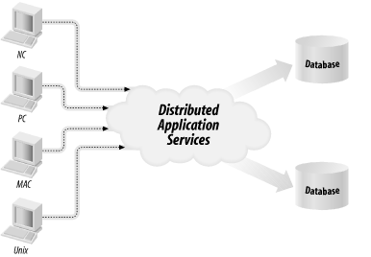

Distributed apps can communicate with multiple servers or devices on the same network from any geographical location. The distributed nature of the applications refers to data being spread out over more than one computer in a network.

Distributed applications are broken up into two separate programs: the client software and the server software. The client software or computer accesses the data from the server or [cloud](http://searchnetworking.techtarget.com/definition/cloud) environment, while the server or cloud processes the data. Cloud computing can be used instead of servers or hardware to process a distributed application's data or programs. If a distributed application component goes down, it can[failover](http://searchstorage.techtarget.com/definition/failover) to another component to continue running.

Distributed applications allow multiple users to access the apps at once. Many developers, IT professionals or enterprises choose to store distributed apps in the cloud because ofcloud's [elasticity](http://searchcio.techtarget.com/definition/IT-elasticity) and scalability, as well as its ability to handle large applications or workloads.

**Suportul Haskell pentru dezvoltarea aplicatiilor distribuite. Platforma Cloud Haskell.**

Cloud Haskell is a set of libraries that bring Erlang-style concurrency and distribution to Haskell programs. This project is an implementation of that distributed computing interface, where processes communicate with one another through explicit message passing rather than shared memory.

Originally described by the joint [Towards Haskell in the Cloud](http://research.microsoft.com/en-us/um/people/simonpj/papers/parallel/remote.pdf) paper, Cloud Haskell has be re-written from the ground up and supports a rich and growing number of features for

* building concurrent applications using asynchronous message passing
* building distributed computing applications
* building fault tolerant systems
* running Cloud Haskell nodes on various network transports
* working with several network transport implementations (and more in the pipeline)
* supporting *static* values (required for remote communication)

Cloud Haskell comprises the following components, some of which are complete, others experimental.

* [distributed-process](https://github.com/haskell-distributed/distributed-process): Base concurrency and distribution support
* [distributed-process-platform](https://github.com/haskell-distributed/distributed-process-platform): The Cloud Haskell Platform - APIs
* [distributed-static](http://hackage.haskell.org/package/distributed-static): Support for static values
* [rank1dynamic](http://hackage.haskell.org/package/rank1dynamic): Like Data.Dynamic and Data.Typeable but supporting polymorphic values
* [network-transport](http://hackage.haskell.org/package/network-transport): Generic Network.Transport API
* [network-transport-tcp](http://hackage.haskell.org/package/network-transport-tcp): TCP realisation of Network.Transport
* [network-transport-inmemory](https://github.com/haskell-distributed/network-transport-inmemory): In-memory realisation of Network.Transport (incomplete)
* [network-transport-composed](https://github.com/haskell-distributed/network-transport-composed): Compose two transports (very preliminary)
* [distributed-process-simplelocalnet](http://hackage.haskell.org/package/distributed-process-simplelocalnet): Simple backend for local networks
* [distributed-process-azure](http://hackage.haskell.org/package/distributed-process-azure): Azure backend for Cloud Haskell (proof of concept)
* One of Cloud Haskell’s goals is to separate the transport layer from the process layer, so that the transport backend is entirely independent. In fact other projects can and do reuse the transport layer, even if they don’t use or have their own process layer (see e.g.[HdpH](http://hackage.haskell.org/package/hdph)).
* Abstracting over the transport layer allows different protocols for message passing, including TCP/IP, UDP, [MPI](http://en.wikipedia.org/wiki/Message_Passing_Interface), [CCI](http://www.olcf.ornl.gov/center-projects/common-communication-interface/), [ZeroMQ](http://zeromq.org/), [SSH](http://openssh.com/), MVars, Unix pipes, and more. Each of these transports provides its own implementation of the Network.Transport API and provide a means of creating new connections for use within Control.Distributed.Process.
* The following diagram shows dependencies between the various subsystems, in an application using Cloud Haskell, where arrows represent explicit directional dependencies.

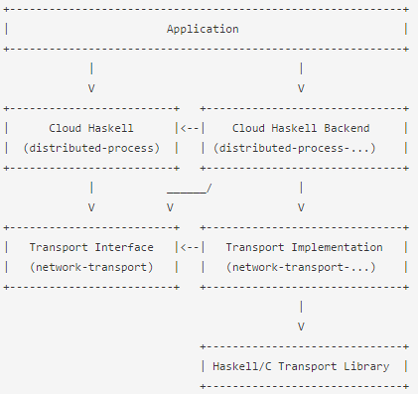

In this diagram, the various nodes roughly correspond to specific modules:

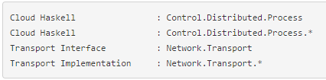

An application is built using the primitives provided by the Cloud Haskell layer, provided by the Control.Distributed.Process module, which defines abstractions such as nodes and processes.

The application also depends on a Cloud Haskell Backend, which provides functions to allow the initialisation of the transport layer using whatever topology might be appropriate to the application.

It is, of course, possible to create new Cloud Haskell nodes by using a Network Transport Backend such as Network.Transport.TCPdirectly.

The Cloud Haskell interface and backend make use of the Transport interface provided by the Network.Transport module. This also serves as an interface for the Network.Transport.* module, which provides a specific implementation for this transport, and may, for example, be based on some external library written in Haskell or C.

**Concurenta si Aplicatii Distribuite**

The *Process Layer* is where Cloud Haskell’s support for concurrency and distributed programming are exposed to application developers. This layer deals explicitly with

The core of Cloud Haskell’s concurrency and distribution support resides in the [distributed-process](https://github.com/haskell-distributed/distributed-process) library. As well as the APIs necessary for starting nodes and forking processes on them, we find all the basic primitives required to

* spawn processes locally and remotely
* send and receive messages, optionally using typed channels
* monitor and/or link to processes, channels and other nodes

Most of this is easy enough to follow in the haddock documentation and the various tutorials. Here we focus on the essential *concepts*behind the process layer.

A concurrent process is somewhat like a Haskell thread - in fact it is a forkIO thread - but one that can send and receive messages through its *process mailbox*. Each process can send messages asynchronously to other processes, and can receive messages synchronously from its own mailbox. The conceptual difference between threads and processes is that the latter do not share state, but communicate only via message passing.

Code that is executed in this manner must run in the Process monad. Our process will look like any other monad code, plus we provide and instance of MonadIO for Process, so you can liftIO to make IO actions available.

Processes reside on nodes, which in our implementation map directly to the Control.Distributed.Processes.Node module. Given a configured Network.Transport backend, starting a new node is fairly simple:

D:\Facultate\Projects\Gits\CloudHaskell\Cloud-Haskell-Example\doc\res\4.png

Once this function returns, the node will be up and running and able to interact with other nodes and host processes. It is possible to start more than one node in the same running program, though if you do this they will continue to send messages to one another using the supplied Network.Transport backend.

Given a new node, there are two primitives for starting a new process.

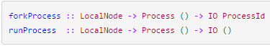

Once we’ve spawned some processes, they can communicate with one another using the messaging primitives provided by [distributed-processes][distributed-processes], which are well documented in the haddocks.

TECH SHIT:

Exemple:

Prerequisites :

In order to go through this tutorial, you will need a working Haskell environment. If you don’t already have one follow the instructions [here](https://www.haskell.org/downloads) to install the compiler and then [go here](https://github.com/commercialhaskell/stack/wiki/Downloads) to install stack, a popular build tool for Haskell projects.

Once you’re up and running, you’ll want to get hold of the distributed-process library and a choice of network transport backend. This guide will use the network-transport-tcp backend, but other backends are available on [Hackage](https://hackage.haskell.org/) and [GitHub](https://github.com/).