**What I’ve Learned**:

Structura:

Solutie

* DataLayer
  + DataMapper
* DomainLayer
  + DomainModel
  + ServiceLayer

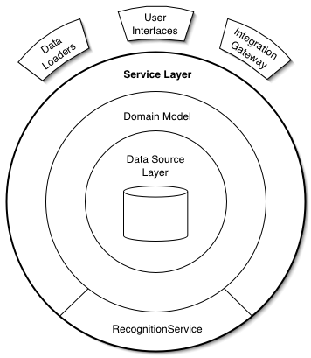

DataMapper: servicii de acces la surse de date

* Entity Framework
* Enterprise Library. Common
* Enterprise Library. Validation

DomainModel: clasele de model al logicii; valideaza datele pentru service layer

* Enterprise Library. Common
* Enterprise Library. Validation

ServiceLayer: validare de date; sa nu ajunga incorecte dpdv al logicii in BD, orchestrare de apeluri catre domain model, manipulare de apeluri

* Enterprise Library. Common
* Enterprise Library. Validation
* Enterprise Library. Logging