Cairo University

Faculty of engineering

Dept. of Electronics and Electrical Communications

Second Year

**ELECTRONICS**

**ELC 2020**

**RF amplifier**

**Answer Sheet**

|  |  |  |
| --- | --- | --- |
| ID | Section | Name |
| 9220473 | 2 | عبدالرحمن محمد صلاح الدين أبو هندي |
| 9220640 | 3 | محمد إبراهيم يوسف الدميري |

|  |  |  |  |
| --- | --- | --- | --- |
|  | **Expression** | **Calculated Values** | **Simulated Values** |
| **BE Junction Voltage** | **VBE** | **0.7 V** | **0.792 V** |
| **Base Current** |  | **22.096 A** | **20.519 $μ$ A** |
| **Collector Current** | $$βI_{B}$$ | **2.2096 mA** | **2.0519 mA** |
| **Collector Voltage** |  | **11.9779 V** | **11.9794 v** |
| **Load Impedance At**  **Resonance** |  | **0.15625 MΩ** | **0.155 MΩ** |
| **Quality Factor** |  | **125** | **121.541** |
| **Center Frequency** |  | **1.59154 MHZ** | **1.5922 MHZ** |
| **BW** |  | **12732.32 HZ** | **13000 HZ** |

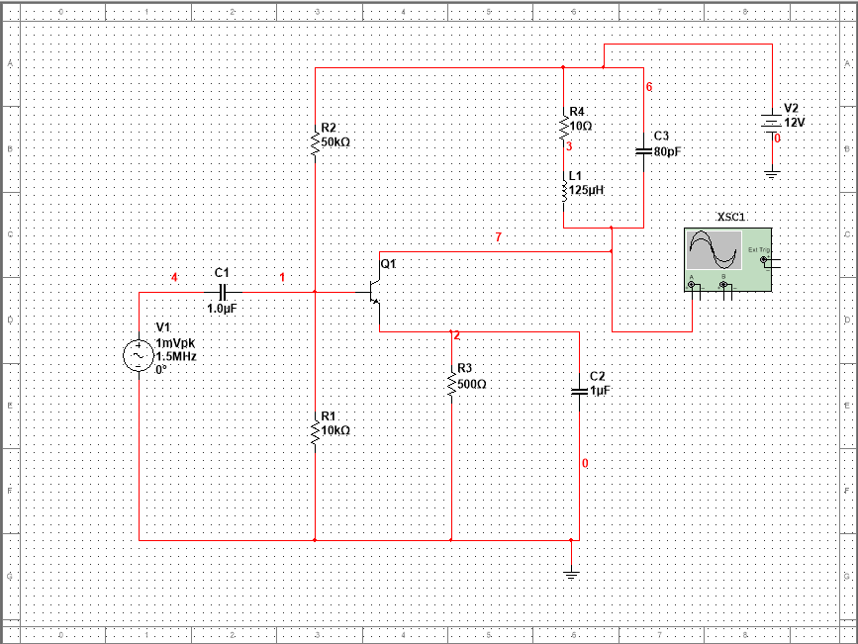

The simulated Circuit

|  |  |
| --- | --- |
|  | **Simualtion** |
| **1.BE Junction Voltage**  **2.Collector Voltage**  **3.Base Current**  **4.Collector Current** |  |
| **Load Impedance At**  **Resonance** | **We calculated the load impedance at resonance by dividing the voltage at center frequency by the current at the center frequency.**    **Load Impedance = $\frac{12.3279 kV }{79.3309mA}$ = 155400 $Ω$ =0.1554k $Ω$** |
| **Quality Factor** | **Quality Factor is calculated by dividing the simulated center frequency by the bandwidth.** |
| **Center Frequency** |  |
| **BW** | Band width from linear scale    Band width from decibel scale |

**Q2) The gain at 1.5MHz = 58.43 DB= 835.05 V/V**

**Gain**

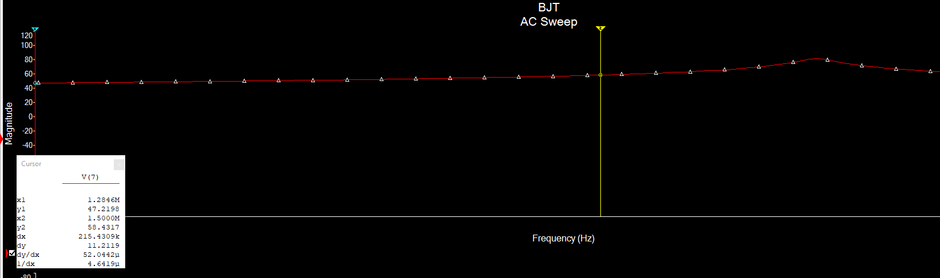

**Decibel gain**

**Q3)**

Collector node voltage

* **The Amplitude at 1.5MHz = 882 mV.**
* **The Expected Value from AC Simulation = 835.05 mV.**