Project
NEO Analytics

The problem
The NEO network is quite new but already support a huge number of transactions per day and as been the target for some spammers due the fact transaction with a fee less then 10GAS are consider free.
The question is:
- How is the average occupation of the blocks?
- How much fees are been gather each block?
- How many smart contracts are deployed in the main net?
- How many wallet exist?
- When the “big” wallets move their assets?
- Can the system inform when spam starts?
- Etc.
Tho obtain this information several tools have been developers by individual developers and it’s time to develop a tool that scan the NEO blockchain and compile analytics information.

The implementation
The implementation is split in two main phases:
- Build the blockchain synchronizer
- Build the analytic tool

The synchronizer
To sync the blockchain the project NeoSharp was forked and there will be a re-implementation of part of the code in order to focus only in the synchronization of the blockchain in a relational database.
This fork will be called NeoSharp-Light and it’s a light version because this node will not generate blocks and will not execute transactions, will be a lighter version of the node code.
The NeoSharp-Light when started will connect to the configured peers and will not provide command prompt for the user. The User Interface to command the node will be done through a web dashboard.
The major feature of the NeoSharp-Light is that any provider can be plugged in order to persist the blockchain in any type of database. The first implementation of this provider will be MySQL or MariaDb (OpenSource version of MySQL).
Having queryable data will provide the analytic tool a platform to create several KPI that will provide good analytic information about the NEO blockchain.

The analytic tool
There will be ETL running over the stored data that will gather relevant information about the NEO blockchain.
The data will been show in a Web Portal or in a cross-platform application.
The tool will is extensible where any client can develop any new KPI.

The Road map
The development of the NEO Analytics will have two main interactions
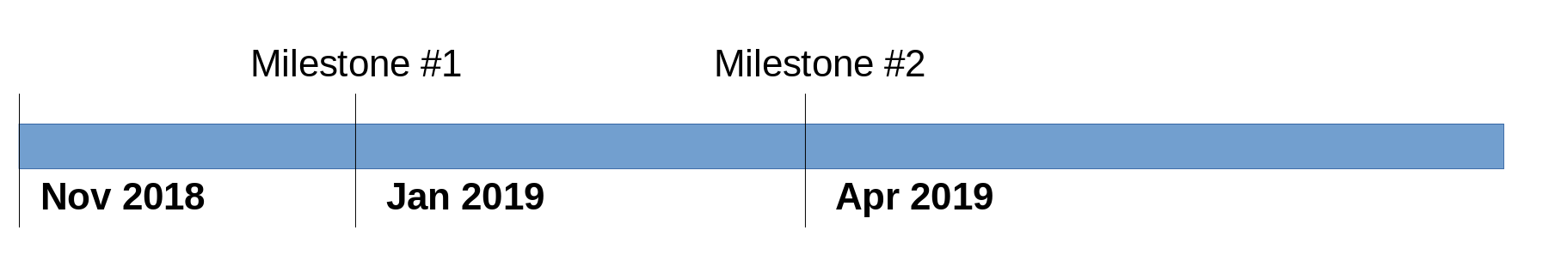
At Milestone #1:
- NeoSharp-Light is implemented

At Milestone #2:
- NEO Anlytics tool implemented

The team

Future implementation

