Lab 13: Neural Network

P1. Visually, what are the differences between the different rhythms?
Atrial fibrillation is characterized by the absence of clearly identifiable P waves, a low-amplitude fibrillatory baseline, and highly irregular R–R intervals, often associated with an increased heart rate. Atrial flutter presents a typical sawtooth pattern of atrial activity with relatively regular QRS and usually a faster rate than normal sinus rhythm. Normal sinus rhythm shows a regular heart rate with consistent P–QRS–T morphology and stable R–R intervals. Sinus bradycardia and sinus tachycardia preserve normal sinus morphology but differ by a slower or faster heart rate, leading to longer or shorter R–R intervals.
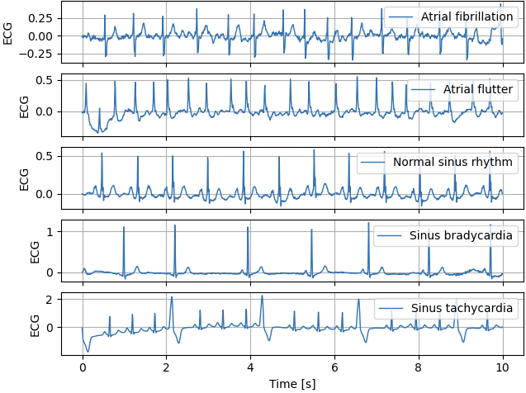
  - P2. Comment the metrics shown in TensorBoard and the confusion matrices. Does the model overfit? Are there some rhythms that are difficult to classify?
The metrics displayed in TensorBoard show that the training and validation accuracies evolve closely together, with only a small difference between them. This indicates that there is limited overfitting. The losses do not reach a complete plateau, suggesting that the model could benefit from further training epochs without overfitting immediately.

The confusion matrices show that normal sinus rhythm, sinus bradycardia and sinus tachycardia are classified correctly most of the time. By contrast, atrial fibrillation and atrial flutter are more difficult to distinguish and are often misclassified, probably because of their similar heart rates and waveform characteristics.

P3. Define two custom models to classify cardiac rhythms from ECG signals.
Two CNN models were implemented. CustomModel1 is a lightweight CNN comprising only two convolutional layers, followed by pooling and global average pooling. With just 2,900 trainable parameters, this model is designed to extract basic temporal and morphological ECG features while maintaining a low level of complexity and computational cost.
CustomModel2 is a deeper convolutional neural network comprising four convolutional blocks, each with an increasing number of filters. These blocks are combined with batch normalisation and pooling operations. The model uses global average pooling to aggregate temporal information, as well as a small fully connected classifier with dropout for regularisation. With roughly 47,900 trainable parameters, CustomModel2 is designed to capture more intricate hierarchical ECG features while keeping model complexity under control.
P4. How do the two custom models perform? Do they overfit? Do they outperform the first model?
The two custom models show different performance levels.
CustomModel1 shows low accuracy of around 40–45% on the training, validation and test sets, indicating clear underfitting. The confusion matrices reveal significant misclassification between atrial fibrillation, atrial flutter and normal sinus rhythm, whereas sinus bradycardia and sinus tachycardia are recognised more accurately. This suggests that the model primarily captures coarse heart rate information.

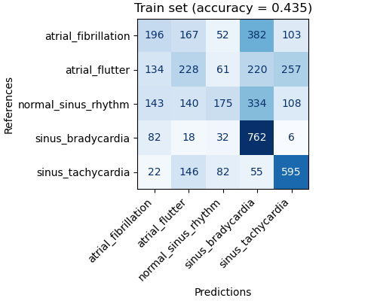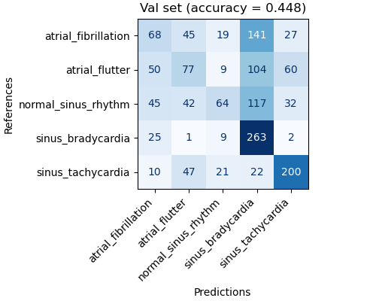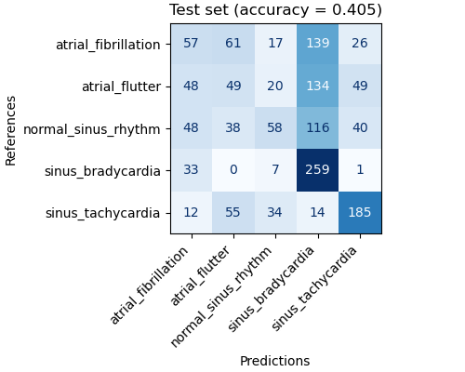
By contrast, CustomModel2 achieves substantially higher performance, with accuracies of around 80% on the training set, and approximately 74% on the validation and test sets. The relatively small difference between the training and validation accuracies suggests limited overfitting and good generalisation. The confusion matrices demonstrate improved discrimination across all rhythms, although atrial fibrillation and atrial flutter remain partially confused. Overall, CustomModel2 outperforms CustomModel1, but does not surpass the original CNN, which still achieves the best classification performance overall.

