EE512 – Applied Biomedical Signal Processing
Practical session – Instantaneous Frequency

Instructions
- Please submit your report as a single PDF file.
- We recommend working in a group of 3–4 students; you can prepare one single report for the group (name1_name2_name3_lab_InstantaneousFrequency.pdf), but every member needs to upload the same file individually.
- There are 3 experiments consisting of questions testing your understanding and correct interpretation of the signals and the results.
- The Matlab functions for each experiment are already provided. Inlude in the report ONLY the code/lines used to call the Matlab functions and to visualize the signals/results, BUT not the code of the provided functions.

Useful in-house Matlab functions
AR_psd power spectral density, parametric estimation
IFhilbert IF estimation using Hilbert transform
Teager IF estimation using Teager-Kaiser
STFT IF estimation using STFT
AdaptBP IF estimation using adaptive bandpass filter
AdaptBP_weight IF estimation using adaptive bandpass filter on multiple signals

Additional build-in Matlab commands
buttord determination of filter order
butter IIR filter synthesis
filtfilt output of a filter with forward and backward filtering
freqz filter frequency response
resample signal resampling

Experiment 1: the importance of pre-filtering for instantaneous frequency estimation

The file “AA_AFib” contains 500 samples from the 12 surface ECG electrodes (sampling frequency Fs = 50 Hz) during an episode of atrial fibrillation, after ventricular activity cancellation.

1.1 Bandpass filter (frequency range from 4 to 7 Hz) the signals from the electrodes V3 and V4 (columns 9 and 10) using an IIR filter synthetized with:

>> [Nb,wn] = buttord([0.16 0.28], [0.12 0.32],0.5,20);

>> [b,a] = butter(Nb,wn);

>> signal_filt = filtfilt(b,a,signal);

Due to physiological constraints, the atrial fibrillation frequency lies into the interval [3-12]Hz, but the frequency range usually met in clinical practice is [4-7]Hz.
Q1.1. Is the frequency response of the filter adequate?

The filter’s amplitude response shows a flat passband between 4–7 Hz, matching the expected atrial fibrillation (AF) frequency range.
Low (< 3.5 Hz) and high (> 7.5 Hz) frequencies are strongly attenuated, minimizing baseline drift and noise. The transition bands are steep and the gain in the passband is 1, so the filter is well-suited for isolating the atrial activity.
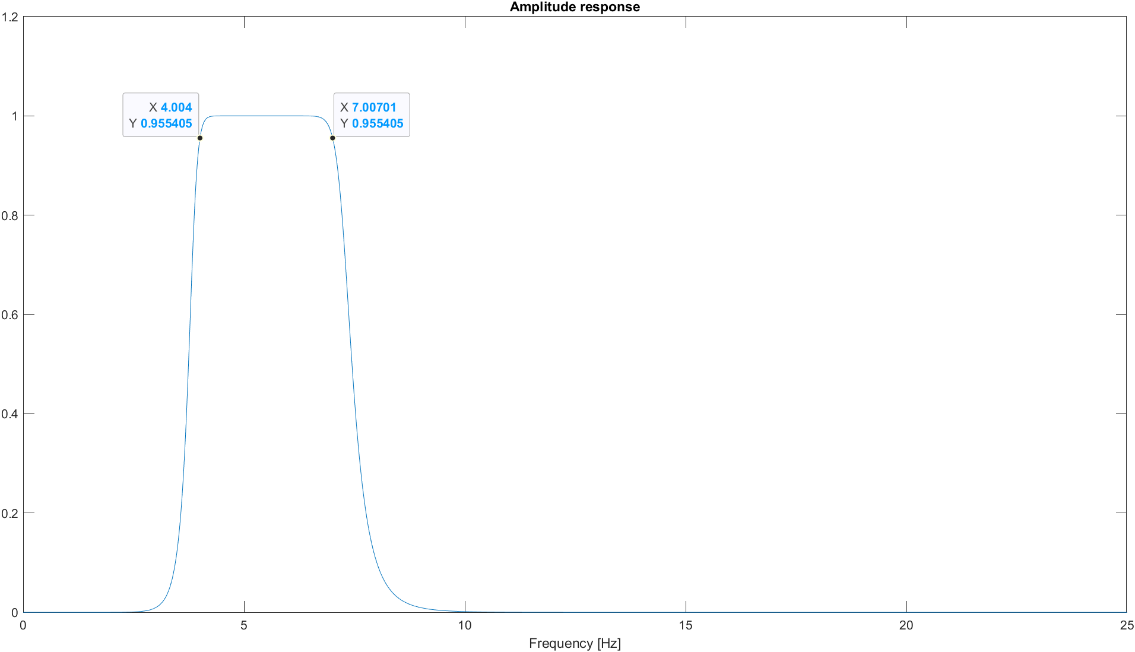

Note. To visualize the amplitude response, the simplest way is to use:

>> [h,w]=freqz(b,a,1000);

>> plot(Fs.*linspace(0,0.5,1000),abs(h))

Visualize the signals and the corresponding power spectral densities (parametric spectral estimation using an order of 20) before and after bandpass filtering.

>> [Px, freq] = AR_psd(signal, 20, 50, 25, 0, 1);
Q1.2. The maximum frequency for the plot is set at 25Hz. Why wouldn't it make sense to visualize a spectrum of higher frequencies?

Because the signal is sampled at Fs = 50 Hz, the highest frequency that can be represented without distortion is the Nyquist frequency, which is Fs/2=25 Hz.
Any higher frequency would give no new information since the useful atrial activity is between 4–7 Hz or at a maximum 12Hz if not filtered, showing more than 25 Hz makes no sense.

1.2 Use the Matlab function IFhilbert, teager, STFT(Hamming window of length M = 31) and AdaptBP (f0 = 5, beta = 0.85 or 0.98, delta = 0.9) to estimate the IF, first on the two raw signals of the previous experiment, then on the outputs of the bandpass filter.

Q1.3. Conclusion? Which method is the most effective? Was the bandpass pre-filtering worth it? How does the beta coefficient affect the IF estimation? Why?

On the raw V3 signal, the Hilbert and Teager methods show very unstable instantaneous frequency with many spikes caused by noise and amplitude variations. The STFT produces step-like changes because it switches between dominant frequencies in each short window. The AdaptBP method gives a smoother and better estimation: beta = 0.85 adapts faster but is noisier, while beta = 0.98 provides a more stable curve that can be exploited easier.

After bandpass filtering (4–7 Hz), all methods improve. Hilbert and Teager still show small peaks, while STFT and especially AdaptBP become much smoother. AdaptBP gives the most consistent result, which matches the expected atrial activity.
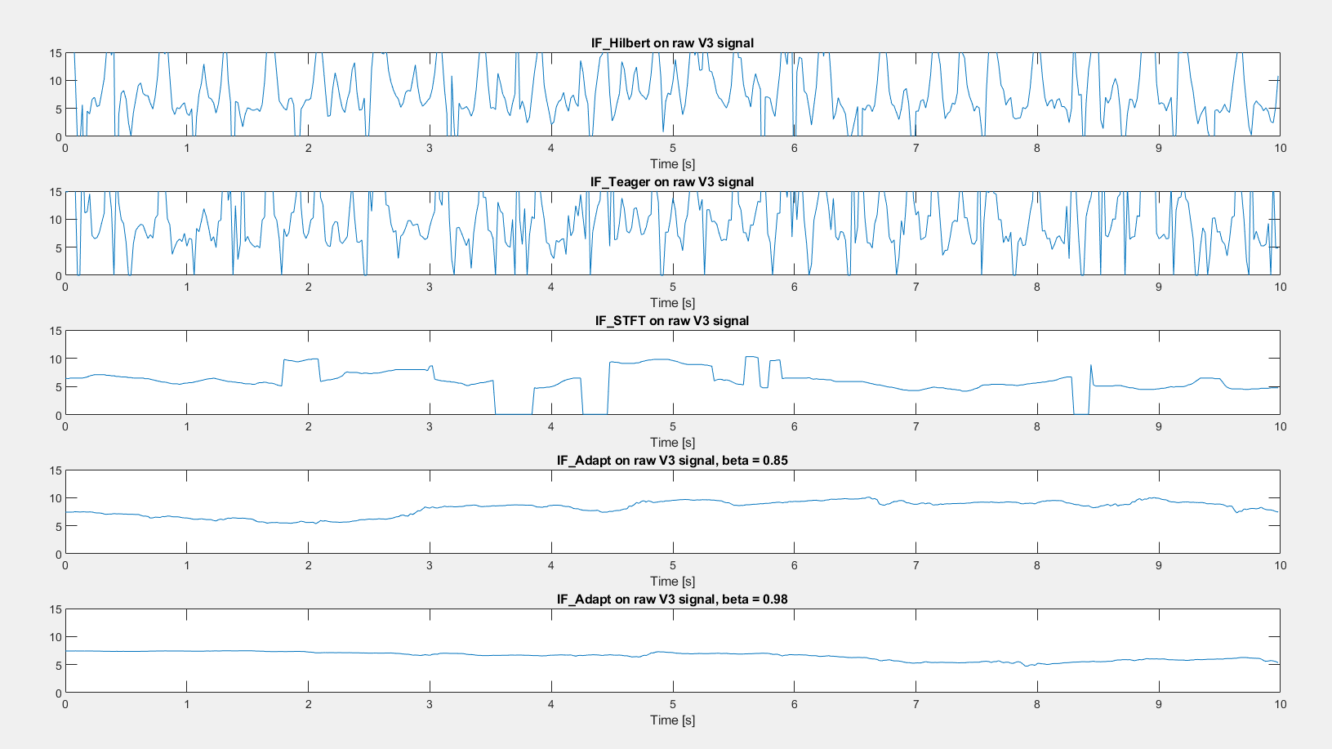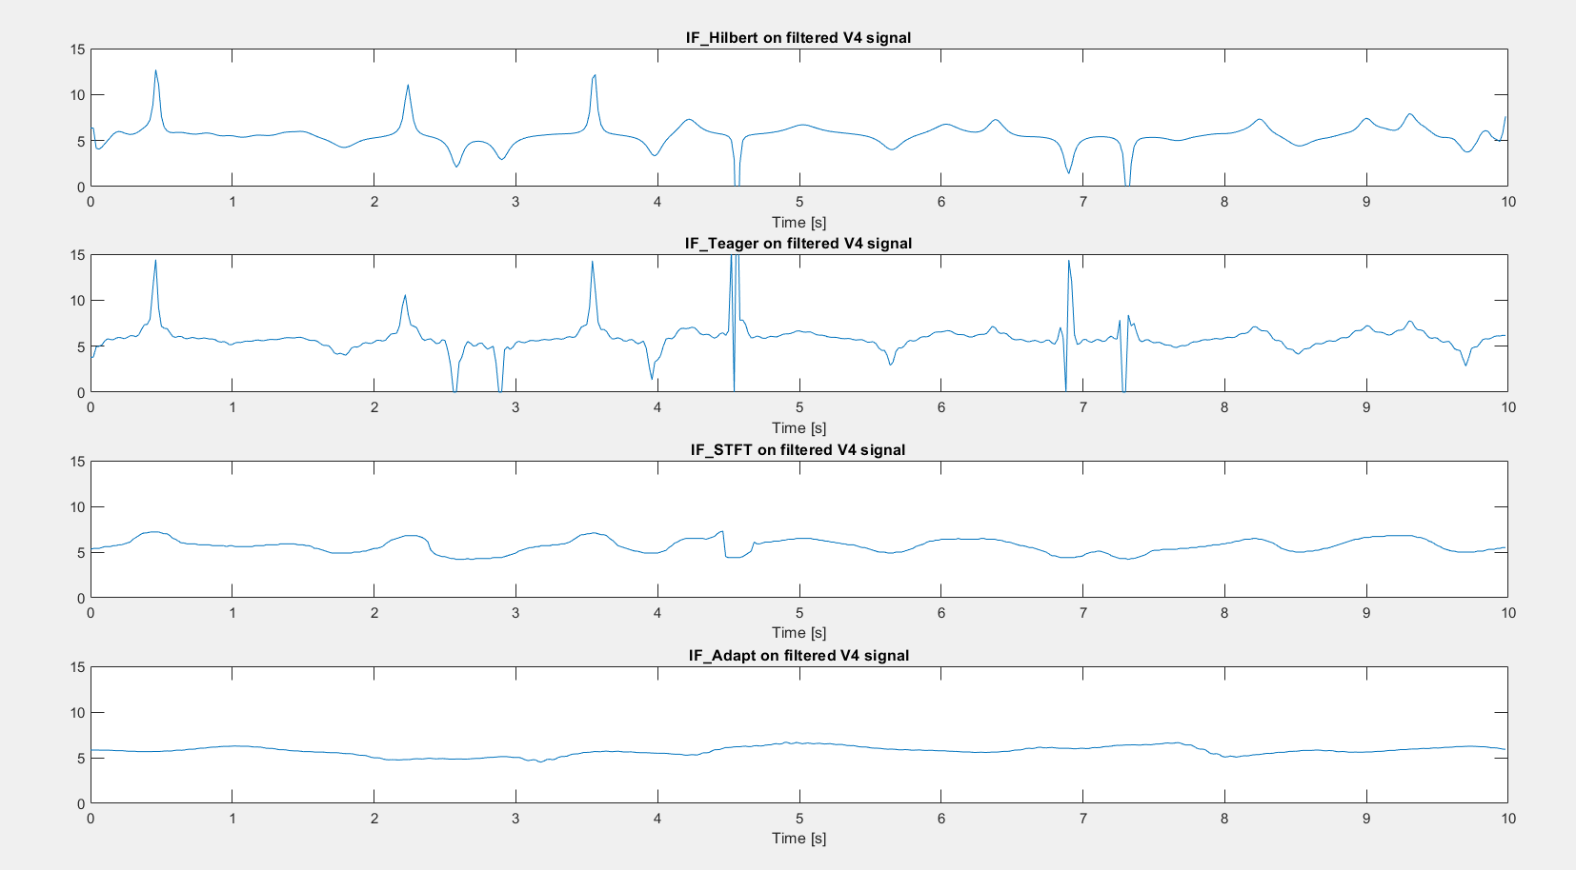

Experiment 2: indirect estimation of respiration frequency from respiration sinus arrhythmia (RSA) during a VO2-max test

RSA is the modulation of RR intervals induced by respiration. VO2 max is the maximum rate of oxygen consumption during an incremental effort. It is an important indicator of physical fitness, especially with regard to endurance capacity. Other variables of interest are the ventilatory thresholds that correspond to the exercise intensity at two specific instants of the effort. These instants correspond to significant changes in the time evolution of the respiration frequency (RF). The latter can be monitored using a mask, but this is uncomfortable for the subject. Indirect estimation of RF using RSA is clearly a promising solution.
In this experiment, we are using a recording of the RR-intervals during a VO2 max test (3 minutes of rest, 3 minutes cycling at 85 rpm without a load, then load increasing by 1 W every 2 seconds). A mask was used to obtain the reference RF. The idea is to develop an RSA-based scheme for RF estimation from the RR-intervals.

The file “VO2max” contains several variables:
t sampling times of the regularly resampled RR intervals
RR RR-intervals sampled at 4 Hz
tr sampling times of the respiration frequency (mask)
RF respiration frequency

2.1. Plot the RR and RF signals.
2.1 Design an high-pass IIR filter to remove the low-frequency components in the RR signal and keep only the components with frequency > 0.15 Hz.

>> [Nb,Wn] = buttord(0.4/4,0.2/4,0.5,20) ;

>> [b,a] = butter(Nb,Wn, 'high') ;

>> Resp = filtfilt(b,a,RR-RR(1));
Q2.1. Check that the output signal represent the respiration component only.
The RR signal is composed of a very low frequency component that represents the slow adaptation of the heart rate to the increase of load of the cycling. Superimposed to that component there is a faster oscillation at frequency that increases with time that is due exactly to the RSA. High pass filtering enables to visualize this component only.

2.2 Use the Matlab function IFhilbert, Teager, STFT (window length M = 31), and AdaptBP (f0 = 0.25, beta = delta = 0.925) on the resulting fitered signal. You needs to lowpass filter the IF estimates using for instance:

>> IFf = filtfilt(a,[1 a-1],IF); for a suitable value of a (e.g. a = 0.05).

Q2.2. Assess the performances by visually comparing the IF estimate wiht the reference respiration frequency.

- All methods maintain high accuracy during the steady, gradual frequency increase between 200s and 800s.
- In the initial phase, Teager and Hilbert show more variance and larger deviations from the reference RF while Adaptive BP and STFT appear to be smoother and track the reference RF more closely.
- In the latest phase (900s-1100s) in which frequency changes faser, the Adaptive BP and STFT methods provide the tightest fit to the reference RF during the sharp increase and the peak region around 1000s}. The red lines are almost superimposed on the blue line.
Teager and Hilbert show minor lags or undershoots during the sharp peak compared to Adaptive BP and STFT, meaning they react slightly less accurately to the rapid frequency changes.
- The Adaptive BP and STFT methods seem slightly more robust to the sharp transient artifact observed around 550s, which appears to be a significant spike in the reference signal.
- Based on visual inspection, the Adaptive Bandpass (BP) and STFT methods exhibit superior performance as they provide a smoother, more accurate, and less attenuated estimate of the instantaneous respiration frequency across all phases, especially during periods of rapid change.

Experiment 3: extraction of a common oscillation and estimation of its instantaneous frequency using bandpass adaptive filtering

The file “heart_3” contains (columns, sampling frequency 4 Hz) the RR-intervals, blood pressure, and respiration of one subject breathing spontaneously.
Two phenomena are of particular interest in signals of this type. First, respiration modulates the RR-intervals (the so-called sinus arrhythmia) and, to a lesser estend the blood preasure. Second, the baroreflex, i.e. the dynamic regulation of blood preassure by heart rate variability, mediated by the autonomous nerve system, leads in rest conditions to a modulation at a frequency between 0.05 and 0.1Hz of the RR-intervals.

3.1. Remove the mean values and resample the signals at 1 Hz. Visualize the signals and the corresponding power spectral densities (parametric spectral estimation using an order of 20) before and after downsampling.

>> [Px, freq] = AR_psd(signal, 30, 1, 0.5, 0, 1);
Q3.1. Why were the signals downsampled from 4Hz to 1Hz?

The signals were downsampled from 4 Hz to 1 Hz because all relevant physiological oscillations occur at very low frequencies, well below 0.5 Hz. The respiration signal shows a dominant peak around 0.25–0.30 Hz, while the RR intervals and blood pressure have most of their energy below 0.10 Hz, as visible in the AR spectra computed with the corrected AR model of order 20. A sampling frequency of 1 Hz therefore satisfies the Nyquist criterion and preserves all meaningful information.
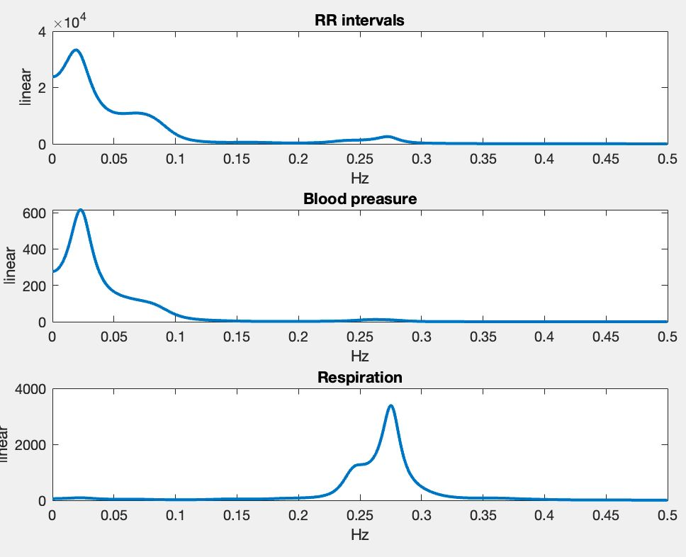
Downsampling also reduces high-frequency noise and unnecessary data redundancy, making the analysis more stable and computationally efficient. In addition, using a lower sampling rate improves the robustness of the AR spectral estimation because the model no longer attempts to fit irrelevant high-frequency components.

3.2 Use AdaptBP_weight to extract the common oscillation between the RR-intervals and the respiration (f0 = 0.2, beta = 0.9, delta = mu = 0.95).
Q3.2. What do the two filter outputs represent? Check visually that the amplitude of the two filter outputs are well correlated. What does the estimated IF represent? Compare the variation of the IF estimate with a non-parametric spectrum estimate of the respiration signal.

The two filter outputs represent the same underlying respiratory oscillation extracted from the RR-intervals and from the respiration signal. The RR component reflects respiratory sinus arrhythmia, while the respiration component is the filtered version of the breathing signal itself. Visually, the amplitudes of the two outputs are clearly correlated, showing the same envelope and similar variations over time.
The estimated instantaneous frequency (IF) corresponds to the time-varying respiratory frequency shared by both signals. It remains approximately within the 0.23–0.28 Hz range.
When compared with the non-parametric spectrum of the respiration signal, the IF oscillates around the dominant spectral peak at ~0.25–0.28 Hz. The PSD provides an average frequency estimate, whereas the IF reveals the slow temporal fluctuations of the respiratory rate that are not visible in the static spectrum.

3.3 Use AdaptBP_weight to extract the common oscillation between the RR intervals and the pressure (f0 = 0.06, beta = 0.9, delta = mu = 0.95).
Q3.3. What do the two filter outputs represent? Are the amplitudes of the two filter outputs correlated?

The two filter outputs represent the common low-frequency oscillation shared by the RR-intervals and blood pressure, which corresponds to the baroreflex modulation. The RR component shows the slow variations in heart period caused by autonomic regulation, while the BP component reflects the corresponding low-frequency oscillation in arterial pressure.
Visually, the two outputs do not show a strong amplitude correlation. Although they oscillate at the same frequency, their amplitudes vary differently over time. This is expected, because the strength of baroreflex coupling is weaker and more variable than the direct respiratory influence seen in Experiment 3.2. As a result, the baroreflex component extracted from RR is not as tightly aligned in amplitude with the component extracted from blood pressure.
The estimated instantaneous frequency remains within the expected low-frequency band (approximately 0.05–0.10 Hz), consistent with the non-parametric spectral peak observed in both signals.

