EE512 – Applied Biomedical Signal Processing
Practical session – SVD
Instructions
- Please submit your report as a single PDF file.
- We recommend working in groups of 3 students; the last group can be a group of 2 or 4. You can prepare one single report for the group (name1_name2_name3_lab_SVD.pdf), but every member needs to upload the same file individually.
- There are 3 experiments in this practical session. The python scripts for each experiment are already coded and will only require minimal inputs from you. A major part of this practical session is therefore focused on questions testing your understanding and correct interpretation of the signals and the analysis results that you see.

Useful commands: Type help function_name for more information on inputs and outputs, and doc function_name for a more detailed description of the function.
numpy.linalg.svd singular value decomposition.
Scipy.stats.zscore center data to have mean 0 and scaled to have standard deviation 1.
numpy.cumsum returns the cumulative sum of a vector A.

Additional command:
SSA_decomposition singular spectrum analysis decomposition.

Experiment 1: 12-leads ECG

File ECG.csv contains 500 samples from the 12-leads ECG (sampling frequency 50 Hz) during an episode of atrial fibrillation, after ventricular activity cancellation.
A 12-leads ECG contains 12 signals computed from 10 electrodes (Figure 1) :
- 6 precordial leads (V1-V6)
- 3 limb leads (I, II, III)
- 3 augmented limb leads (VR, VL, VF)
The 3 augmented limb leads are a combination of the limb leads, which are themselves dependent with respect to the potential reference.
Extract the singular values on the first six columns only (leads I, II, III, VR, VL, VF), and the last six columns (leads V1 – V6).

QUESTION #1.1: Limb leads and augmented limb leads
- Explain the difference between singular values of the six first columns, and of the last 6 columns.
- Singular values of the first six leads are smaller with respect to the ones of the precordial ones V1-V6. This may be due to the fact that the precordial leads have a lower total energy of the signal.
- Furthermore, in the case of the limb leads and augmented leads, the total information of the signal is almost completely retained by the 1st component, suggesting a very regular and predictive behaviour of the signal.
Instead, for the precordial leads information is spreaded across the first 3 components.

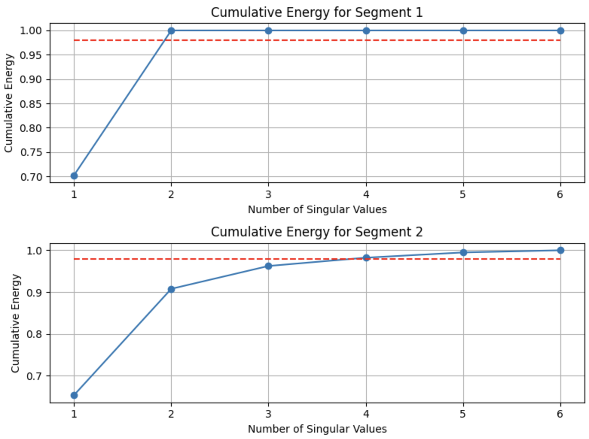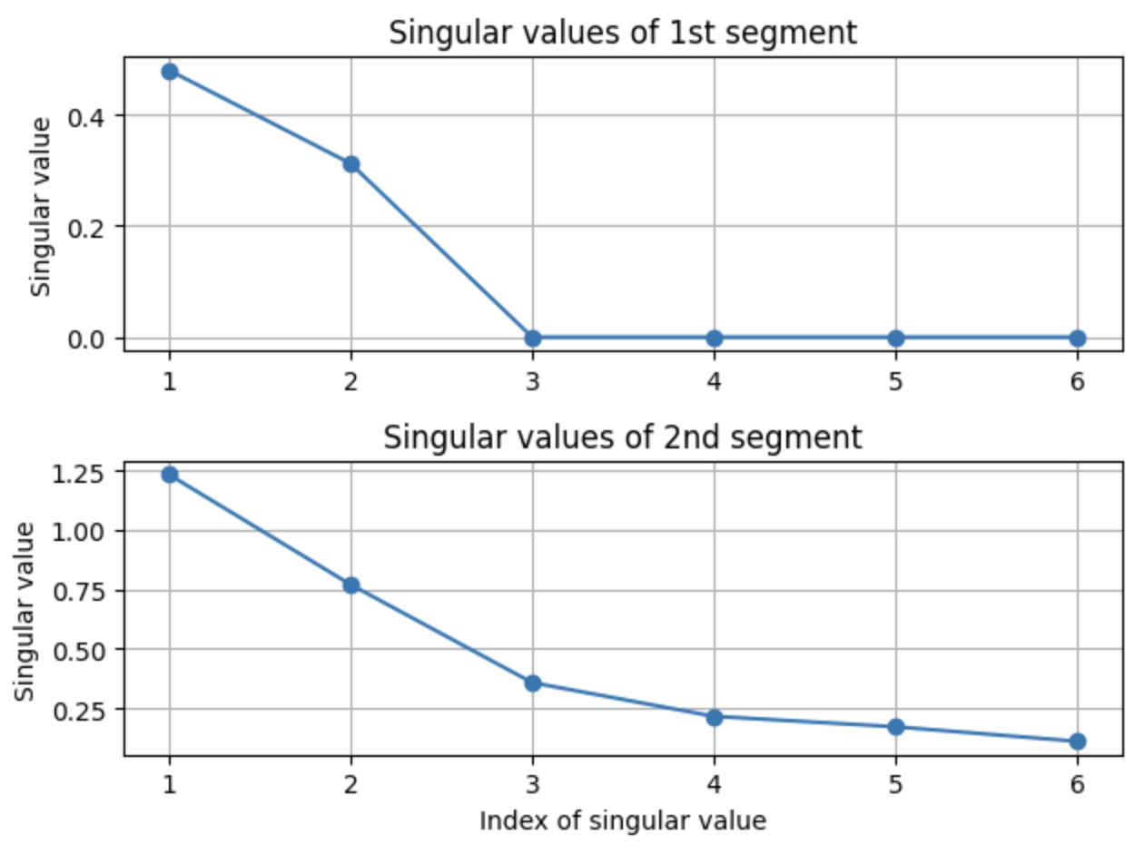
- Computate of the effective rank with a threshold of 0.98.
As shown in the above plots the effective rank with a threshold of 98% of the total energy of singular values is 1 in che case of limb and augemnted leads, 3 in the case of precordial V1-V6 leads. The correlation between the first 6 leads (agumented leads are just a combination of the limb leads I,II,III) means that less components are needed to retain the 98% of the energy of the singular values.
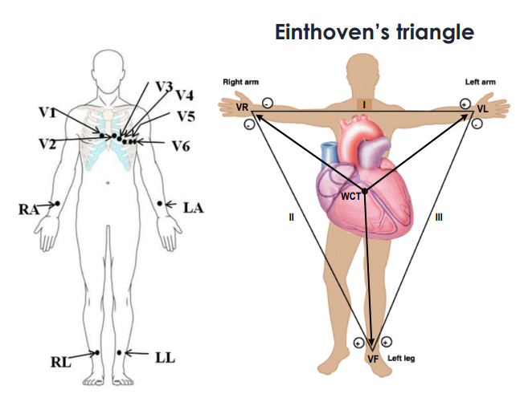
Figure 1. Placement of the 10 electrodes from which 12-leads ECG signals are computed.

Experiment 2: Singular values and process complexity
In this experiment we analyze EEG signals from a patient with Parkinson’s disease implanted with an electrical stimulation device (sampling frequency 512 Hz). EEG signals were recorded before, during and afer brain stimulation.
Files EEG_av.dat, EEG_pe.dat, and EEG_ap.dat contain each four EEG signals (4 leads) respectively recorded prior to stimulation, during stimulation and after stimulation. We compute in all three situations the singular value decomposition of the data matrix, and divide the singular values by the largest one.
The goal of this experiment is to understand the relationship between the EEG leads in each case (before, during and after stimulation) through their singular values.

QUESTION #2.1: Data pre-processing
- Explain from the singular values of the SVD of the raw EEG signal, the relationship between EEG leads before stimulation.
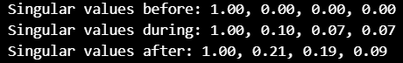
Before the stimulation, the singular value decomposition shows that one singular value dominates while the others are much smaller. This means that the tree small leads share almost the same temporal structure, indicating strong correlation.
- Implement pre-processing of the EEG signals before stimulation to normalize the data. Then re-compute the singular value decomposition of the pre-processed signals.
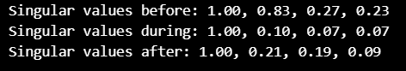
After normalizing each lead by removing its mean and scaling it to unit variance, the SVD spreads the energy more across singular values. The SVD reflects only true structural differences between leads

- Explain the relationship between EEG leads based on these new singular values, and the difference observed with the ones computed in a).
Once normalized, the smaller singular values become relatively larger than in the raw case, revealing that the leads are less strictly aligned than what the raw data suggested. The correlation between leads appears less extreme because the normalization removes scale effects that previously inflated the first singular value.
Figure 2. 4 leads ECG signals before stimulation
QUESTION #2.2: Correlation interpretation
Apply the same pre-processing to the EEG during and after the stimulation, compute their singular values and normalize them by the largest one.
- Based on the resulting singular values are the signals more correlated before, during or after stimulation.
Comparing the normalized singular values across the three conditions shows that the leads are most correlated during stimulation, less correlated after stimulation, and least correlated before stimulation, as indicated by the dominance of the first singular value.
- Explain in terms of correlation the difference between each case ( ‘before’, ‘during’, ‘after’).
Before stimulation, the singular values are more spread out and all remain clearly non-zero, which means the four leads are not linearly dependent and their correlation is relatively weak. During stimulation, the three smallest singular values become much smaller, so almost all the energy is concentrated in one dominant singular value; this shows that the signals become very. After stimulation, the singular value pattern lies between the two previous cases: the leads are still more correlated than before stimulation, but less tightly coupled than during stimulation, indicating that the influence of the stimulation is only partly fading.

Experiment 3: Drift cancellation and frequency component extraction
In this experiment we analyze the ppg and accelerometer signal from wrist device on a subject during a running session.
The goal in this experiment is to separate the respiration signal from the heart rate and running cadence, using SSA.
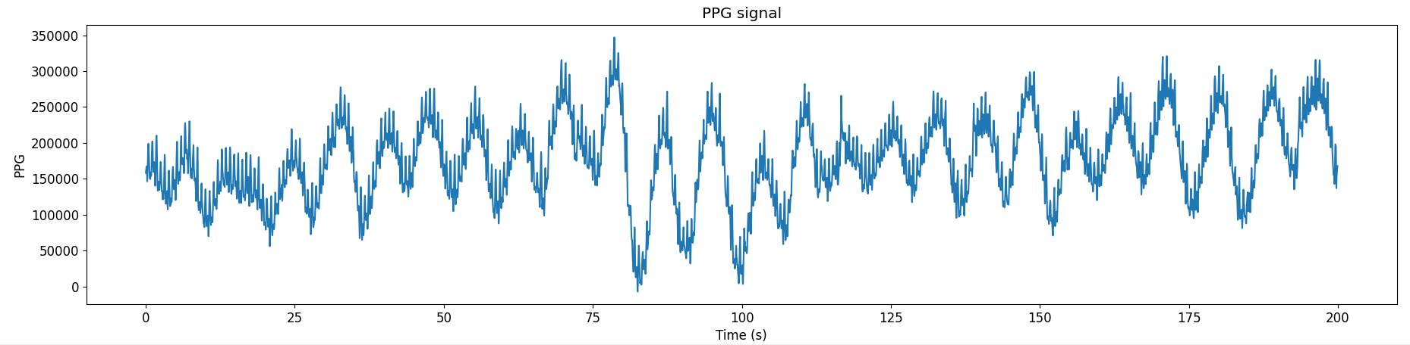

QUESTION #3.1: Drift cancellation
Find a window length L, so that the first component obtained using the function SSA_decomposition corresponds to the long-term drift (baseline) on both ppg and accelerometer signals.

QUESTION #3.2: Respiration and cadence components extraction
The baseline is subtracted from the signals and decomposed using SSA_decomposition.
- Find the component(s) related to the respiration in the PPG signal. Plot their sums.
- Find the component(s) related to the cadence in the accelerometer signal and give the corresponding frequency in steps per minute (Hint: in general cadence is about 180 steps per minute).
- Explain where the components of the SSA deocomposition of the accelerometer signal at 1.5Hz and 6Hz come from. (Hint: c.f. Module 04 Time-Frequency Lab)

QUESTION #3.3: Heart rate estimation
The respiration components are subtracted from the PPG signal without baseline and decomposed using SSA_decomposition. The resulting signal is now mainly driven by the running cadence and the heart rate.
- Based on the components observed from the accelerometer signal analysis, find the component related to the heart rate in the ppg signal, and give the corresponding heart rate in bpm (beats per minute)?
Have a good session, and don’t hesitate to ask questions!

