1.0 | Distributed Cache and Persistence Architecture

This document provides a technical specification for the distributed caching layer and data synchronization pipelines deployed across high-throughput production clusters.
1.1 | Cache-Aside Pattern and Invalidation

The caching architecture implements the standard Cache-Aside pattern combined with time-to-live (TTL) expiration and proactive write-through invalidation for sensitive database records.
◆ Replication Lag Considerations
Read replicas can experience brief replication lag during heavy write spikes. For strictly consistent read operations, route queries to the primary database node.

Eviction Policy Notice
Ensure that maxmemory-policy is configured to volatile-lru in production so that persistent auth tokens are never evicted prematurely.

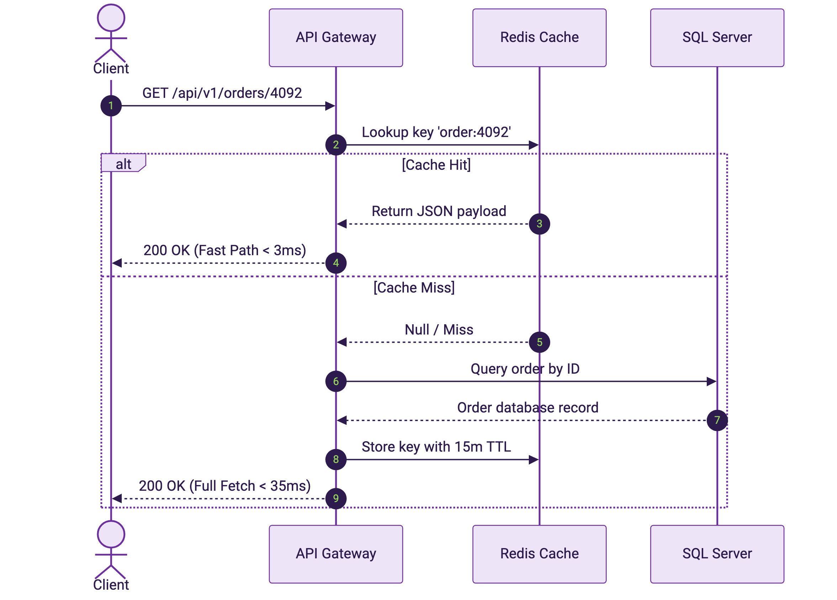
Figure 1. End-to-end sequence diagram demonstrating Cache-Aside lookup, miss handling, and asynchronous replenishment.
The distributed cache interface and typed fallback mechanism are implemented in TypeScript as follows:
export interface CacheConfig {
endpoint: string;
port: number;
ttlSeconds: number;
maxRetries: number;
}

export class OrderCacheClient {
constructor(private readonly config: CacheConfig) {}

public async getOrder(orderId: string): Promise<Record<string, unknown> | null> {
const key = `order:${orderId}`;
const raw = await this.readRemote(key);
if (!raw) return null;
return JSON.parse(raw) as Record<string, unknown>;
}
}

1.2 | Data Access Implementation

The following Python snippet demonstrates the repository pattern with connection pooling and resilient timeout retry loops:
import json
from datetime import timedelta

def fetch_order_details(order_id: int, redis_client, db_pool) -> dict:
cache_key = f"order:{order_id}"
cached_val = redis_client.get(cache_key)
if cached_val:
return json.loads(cached_val)

with db_pool.acquire() as conn:
record = conn.query_one("SELECT id, amount, status FROM orders WHERE id = %s", order_id)
if record:
redis_client.setex(cache_key, timedelta(minutes=15), json.dumps(record))
return record
return {}

The relational database persistence schema utilizes partitioned indexing to optimize range scan throughput:
-- Partitioned Orders schema with clustered index and foreign constraints
CREATE TABLE dbo.Orders (
OrderID BIGINT IDENTITY(1,1) NOT NULL,
CustomerID INT NOT NULL,
OrderDate DATETIMEOFFSET NOT NULL DEFAULT SYSDATETIMEOFFSET(),
TotalAmount DECIMAL(18, 2) NOT NULL,
OrderStatus NVARCHAR(50) NOT NULL,
CONSTRAINT PK_Orders PRIMARY KEY CLUSTERED (OrderID, OrderDate)
);
GO

-- Filtered nonclustered index for high-velocity pending transactions
CREATE NONCLUSTERED INDEX IX_Orders_Pending
ON dbo.Orders (CustomerID, TotalAmount)
WHERE OrderStatus = N'Pending';
GO

1.3 | Cluster Node Telemetry

Production telemetry verifies memory consumption, query throughput, and p99 latency across all cluster nodes.
Cluster health monitoring daemons emit node state payloads in the following JSON schema:
{
"clusterId": "redis-cluster-eu-west-1",
"nodeId": "redis-master-01",
"status": "HEALTHY",
"metrics": {
"totalOpsPerSec": 145000,
"hitRatio": 0.984,
"memoryUsedBytes": 34359738368,
"replicationLagMs": 0.35
},
"timestamp": "2026-09-05T14:30:00Z"
}

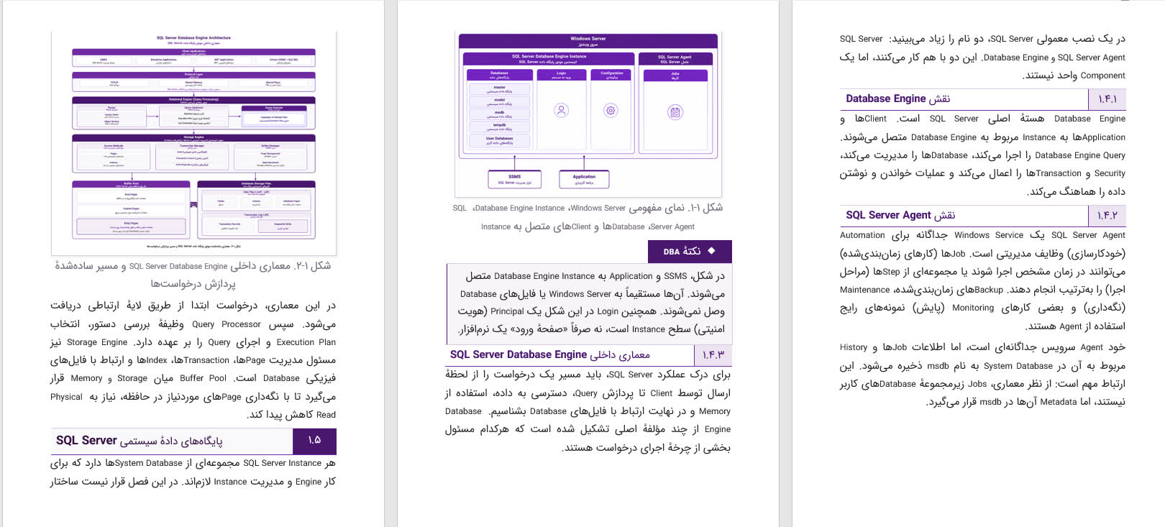
1.3.1 | Cluster Node Status Matrix

The following table summarizes node roles, resource allocations, and operational status:
Node Identifier | Role | Memory Allocated | Latency (p99) | Replication Status | Health
redis-master-01 | Primary | 32 GB | 0.8 ms | Primary Master | Healthy
redis-replica-01a | Replica | 32 GB | 1.1 ms | In-Sync (Lag 0ms) | Healthy
redis-replica-01b | Replica | 32 GB | 1.2 ms | In-Sync (Lag 1ms) | Healthy
redis-sentinel-01 | Monitor | 512 MB | 0.2 ms | Quorum Active | Healthy

1.4 | Maintenance and Backup Procedures

All replica snapshots are streamed to cold storage buckets nightly. Automated verification ensures RPO (Recovery Point Objective) under 15 minutes and RTO (Recovery Time Objective) under 5 minutes.

