# 1. Data preprocessing

# 2. Build ML models

# 3. Evaluate overfitting / underfitting for the eight ML methods

Generating learning curves...

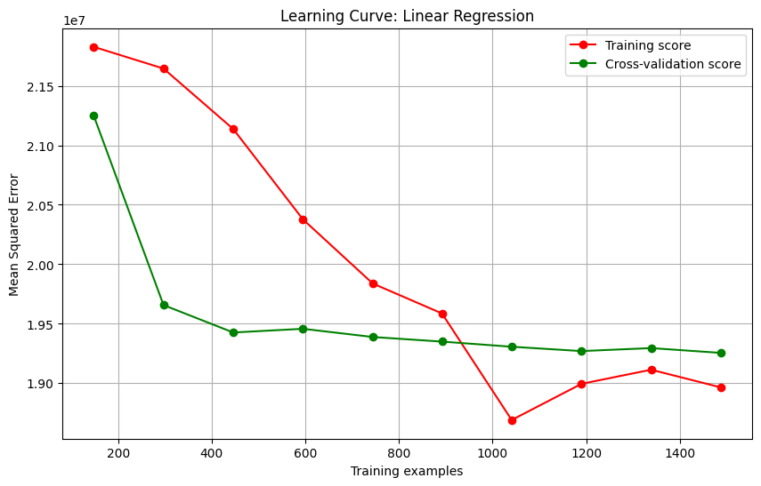

✓ Successfully saved: plots/Linear_Regression.png

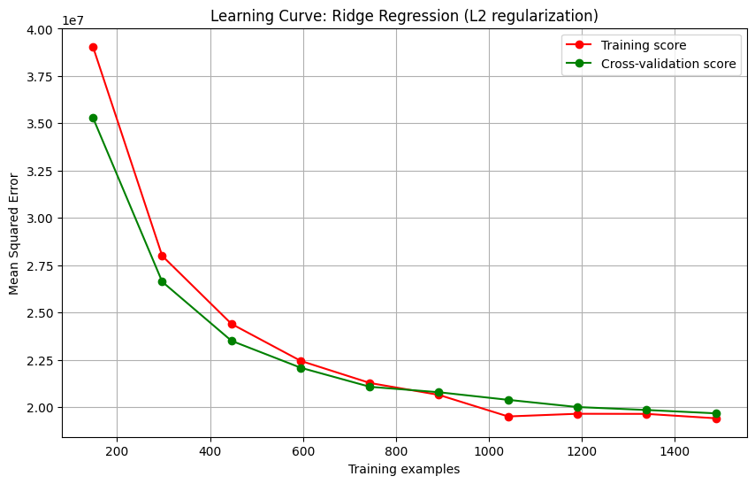

✓ Successfully saved: plots/Ridge_Regression_L2.png

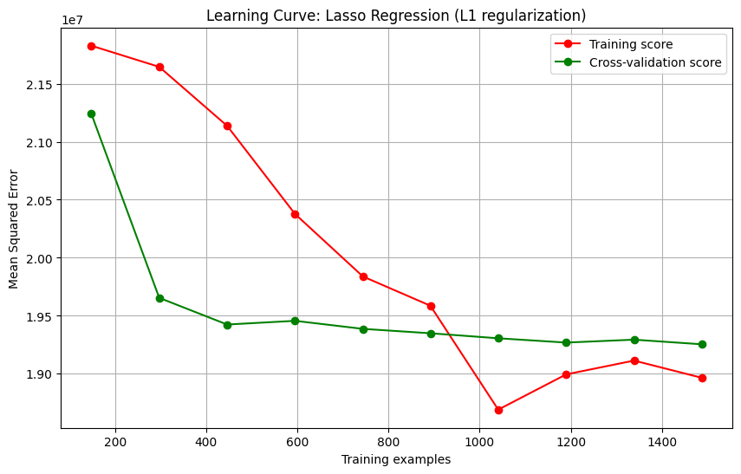

✓ Successfully saved: plots/Lasso_Regression_L1.png

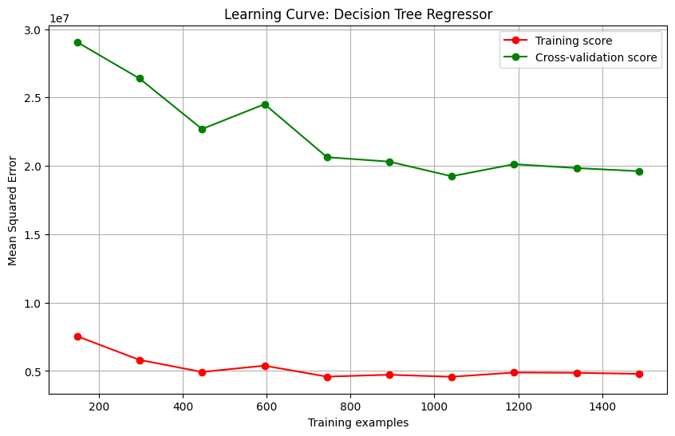

✓ Successfully saved: plots/Decision_Tree_Regressor.png

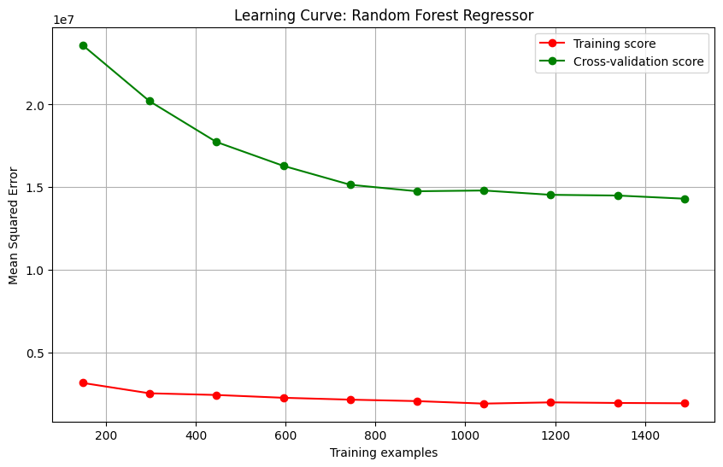

✓ Successfully saved: plots/Random_Forest_Regressor.png

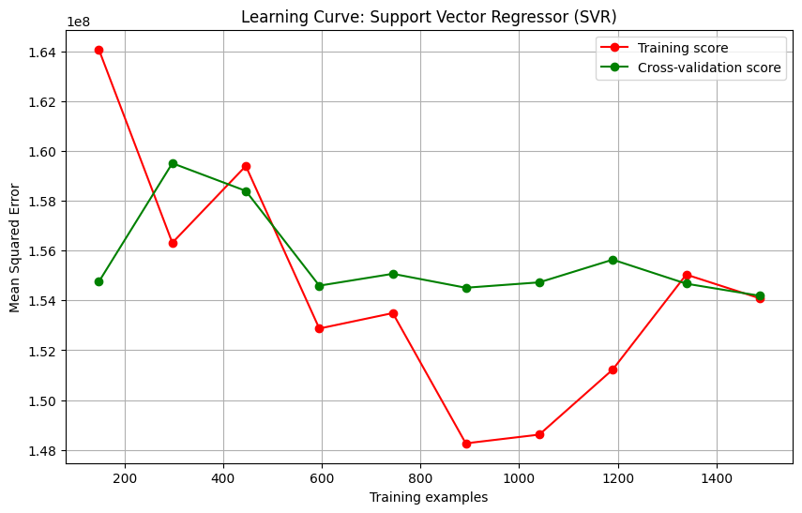

✓ Successfully saved: plots/Support_Vector_Regressor_SVR.png

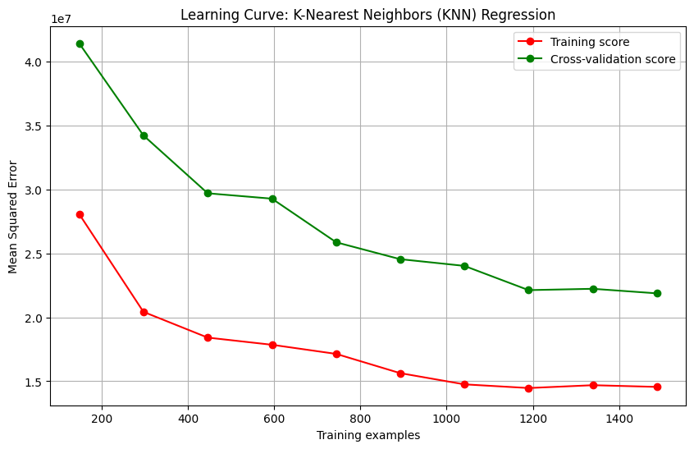

✓ Successfully saved: plots/KNN_Regression.png

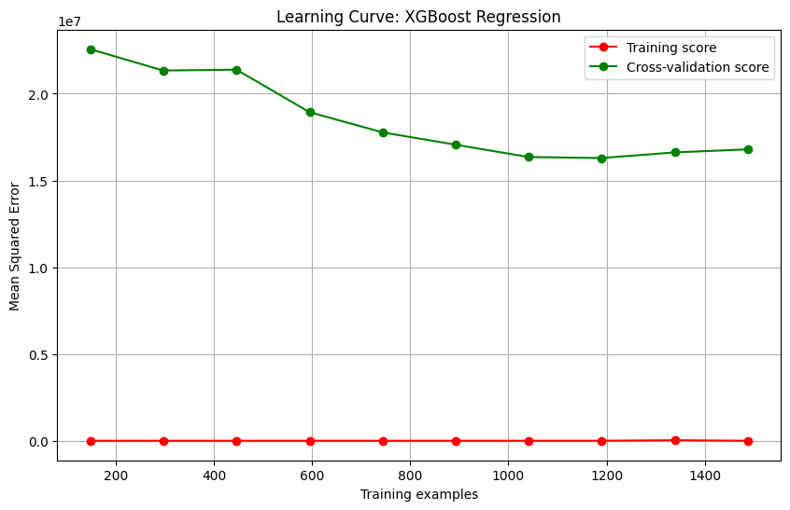

✓ Successfully saved: plots/XGBoost_Regression.png

All plots generated!

# 4. Hyperparameters tunning

*********************************************************

Tuning Lasso Regression...

Fitting 5 folds for each of 10 candidates, totalling 50 fits

Lasso - Best parameters: {'alpha': np.float64(46.41588833612773)}

Lasso - Best CV score: -19231998.9332

Lasso - Test set R² score: 0.8357

Lasso - Test set MSE: 23429492.2760

*********************************************************

Tuning Ridge Regression...

Fitting 5 folds for each of 10 candidates, totalling 50 fits

Ridge - Best parameters: {'alpha': np.float64(2.154434690031882)}

Ridge - Best CV score: -19254493.9437

Ridge - Test set R² score: 0.8359

Ridge - Test set MSE: 23403632.4924

*********************************************************

# 5. Performance comparison between ML models

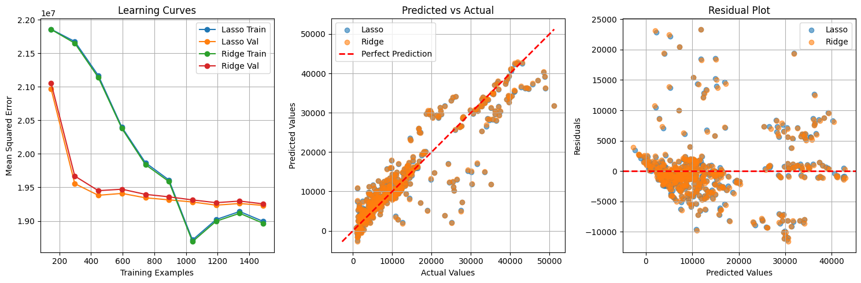

Model Performance Metrics:

==================================================

Lasso | MSE: 23429492.2760 | R²: 0.8357

Ridge | MSE: 23403632.4924 | R²: 0.8359

# 6. Save the best model

Model saved successfully!