****-* (Don’t edit this line.)
Critical buckling load of a three-layer sandwich Timoshenko beam resting on a Kerr elastic foundation
¹ Abolfazl Akramibostanabad, ^{2,*}Mehdi Mohammadimehr
¹MSc Student, ²Professor
^{1,2} Department of Solid Mechanics, Faculty of Mechanical Engineering, University of Kashan, Kashan, 87317-53153, Iran.
*Corresponding Author: mmohammadimehr@kashanu.ac.ir

This study presents analytically the buckling behavior of a thin three-layered carbon/epoxy–nomex honeycomb–carbon/epoxy sandwich Timoshenko beam resting on Kerr elastic foundation. The beam is modeled using Timoshenko beam theory to account for transverse shear deformation, which may be significant due to the relatively low shear stiffness of the Nomex honeycomb core. The displacement field is defined in terms of the transverse displacement of the mid-plane and the rotation of the cross-section, from which the axial and transverse shear strains are obtained. The total potential energy is formulated by considering the strain energy of the sandwich beam, the elastic potential energy of the Kerr foundation, and the potential associated with the applied axial compressive load. The equilibrium equations are obtained by applying the principle of minimum potential energy. The constitutive relations are then used to determine the stress resultants and the extensional, bending–extension coupling, bending, and transverse shear stiffness coefficients. Since the three layers configuration of the beam structure is symmetric. The three parameters of the Kerr foundation are retained in the governing equations to examine their effects on the buckling load. For simply supported boundary conditions, the Navier method is used to obtain the modal equations for the transverse displacement and cross-sectional rotation. The resulting equations form a coupled algebraic system, and the critical axial load for each mode is obtained from the corresponding characteristic equation. The lowest critical value among the admissible modes is taken as the buckling load of the sandwich beam.
            - Buckling behavior; Sandwich Timoshenko beam; Kerr elastic foundation; Principle of minimum potential energy.

- Introduction
Sandwich structures, with thin stiff face sheets and a light compliant core, combine a high bending stiffness with a low weight. They are used in aircraft floors, fairings, control surfaces and rotor blades, in launch-vehicle and UAV structures, and also used in naval and armored defense platforms. Glass-fiber skins also keep radomes transparent to radar, whereas carbon-fiber skins give the highest stiffness.
The main limit of these thin-walled members under compression is buckling. Because honeycomb cores like Nomex [1] have a low shear modulus, transverse shear deformation lowers the buckling load, an effect ignored by Euler–Bernoulli theory but included in Timoshenko theory [2]. In service, panels are also bonded to frames, foam or compliant substructures, which behave as an elastic foundation. The Kerr model [3] describes it with two springs and a shear layer.
A closed-form critical load allows fast screening of materials and dimensions in early design, before costly finite-element or test campaigns. This paper derives it for a symmetric sandwich Timoshenko beam on a Kerr foundation and studies the effect of slenderness, resin and fiber type.
- Theoretical Formulation
  - Kinematics and constitutive relations
Consider a beam of length L, width b and thickness h, with two identical face sheets of thickness 0.2h and a core of thickness h_{c} = 0.6h. Timoshenko theory assumes u(x,z) = u₀(x) + zψ(x) and w(x,z) = w₀(x), where u₀ and w₀ are the mid-plane displacements and ψ is the cross-section rotation. The strains are
$ε_{x}={u_{0}}^{'}+zψ^{'}, γ_{xz}=ψ+{w_{0}}^{'}$ (1)
Each layer obeys σ_{x} = Q₁₁ε_{x} and τ_{xz} = Q₅₅γ_{xz}. Integrating through the thickness gives the extensional, coupling, bending and shear stiffnesses A₁₁, B₁₁, D₁₁ and S = κ_{s}A₅₅, where κ_{s} is the shear correction factor. The layup is symmetric, hence B₁₁ = 0.
  - Equilibrium and Navier solution
The total potential energy sums the strain energy, the foundation potential and the potential of the axial load N₀. The lower spring k_{l}, upper spring k_{u} and shear layer k_{g} of the Kerr foundation reduce to K_{w} = k_{l}k_{u}/(k_{l} + k_{u}) and K_{s} = k_{g}k_{u}/(k_{g} + k_{u}). Minimum potential energy gives the equilibrium equations
$\begin{aligned}N^{'}= 0 \\ M^{'}-Q= 0 \\ Q^{'}-\left(N_{0}-K_{s}\right){w_{0}}^{″}-K_{w}w_{0}= 0\end{aligned}$ (2)
- Materials and Numerical Procedure
The face sheets are unidirectional glass and carbon fiber/epoxy laminates with fiber volume fraction V_{f} = 0.6 and four epoxy resins (Table 1). Glass fibers have E_{f1} = 72.4 GPa, G_{f12} = 38.03 GPa, ν_{f} = 0.229; carbon fibers 225 GPa, 30.20 GPa, 0.20; E_{f2} = 15.64 GPa for both. E₁ and ν₁₂ follow the rule of mixtures, E₁ = V_{f}E_{f1} + V_{m}E_{m}, and E₂ and G₁₂ the Halpin–Tsai relation [4], P = P_{m}(1 + ξηV_{f})/(1 − ηV_{f}),
with η = (P_{f}/P_{m} − 1)/(P_{f}/P_{m} + ξ), where P is E₂ (ξ = 2) or G₁₂ (ξ = 1), and G₁₃ = G₁₂. The Nomex core has E₁ = 44.5 MPa, E₂ = 4.4 MPa, G₁₃ = 14.6 MPa and ν₁₂ = 0.2606. The beam has h = 5 mm, b = h/4 and κ_{s} = 0.5. The foundation is defined by k_{l} = k_{u} = 10⁻⁵A₁₁/L and k_{g} = 10⁻⁶A₁₁L. The slenderness study uses isotropic face sheets (E = 1.44 GPa, ν = 0.3) and modes n = 1–20.
- Results and Discussion
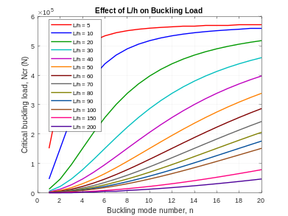
    - Critical load versus mode number for different slenderness ratios L/h.
Fig. 1 plots N_{cr}^{(n)} against the mode number for slenderness ratios from 5 to 200. Every curve rises with n, so the first mode is critical in all cases. The buckling load falls from 1.52×10⁵ at L/h = 5 to 1.33×10² at L/h = 200. Short beams flatten near S = 5.76×10⁵, the shear-stiffness bound in Eq. (3), so for stubby members core shear limits the load. The Kerr terms change the load by under 0.5% up to L/h = 100.
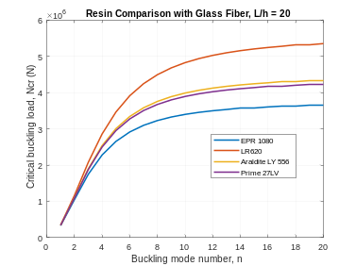
    - Effect of the resin on the critical load of glass-fiber face sheets, L/h = 20.
Fig. 2 compares the four resins for glass-fiber skins at L/h = 20. All curves nearly coincide at the first mode, which is governed by D₁₁ and therefore by the fiber, and they separate at higher modes, where the load approaches the shear-controlled value and the resin matters. LR620 gives the highest load, since its larger modulus raises G₁₂ and hence S, whereas EPR 1080 is the lowest (Table 1). The first-mode spread is only about 4%, so the resin can be chosen for processing or environmental resistance.
      - Matrix, effective face-sheet moduli (GPa) and critical load
Face sheet | E_{m} | E₁ | G₁₂ | N_{cr} (10⁵)
Glass / EPR 1080 | 2.73 | 44.53 | 3.73 | 3.314
Glass / LR620 | 4.16 | 45.10 | 5.54 | 3.457
Glass / Araldite LY 556 | 3.40 | 44.80 | 4.46 | 3.389
Glass / Prime 27LV | 3.30 | 44.76 | 4.34 | 3.378
Carbon / LR620 | 4.16 | 136.66 | 5.35 | 9.172

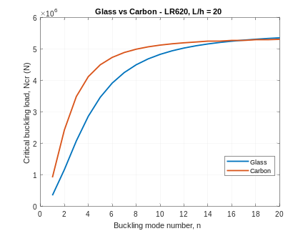
    - Glass versus carbon fibers with LR620 resin, L/h = 20.
Fig. 3 shows that carbon skins triple D₁₁ and raise the buckling load from 3.46×10⁵ to 9.17×10⁵, a factor of 2.65 that is below 3 because of shear flexibility. At high modes the curves converge and cross near n = 17, since carbon/LR620 has a slightly lower G₁₂ and thus lower S. Higher modes are thus controlled by shear stiffness and the critical first mode by the fiber modulus.
- Conclusion
A closed-form buckling load was derived for a symmetric sandwich Timoshenko beam on a Kerr foundation. The first mode was critical in all cases, the load followed Euler scaling for slender beams and was bounded by the shear stiffness for short ones, and carbon/LR620 face sheets gave the highest load. The formula suits fast preliminary sizing of aerospace and defense sandwich panels.
References
- Ardebili, A. et al., Enhancing Strength of Nomex Sandwich Structures through the Utilization of Nano Clay Dispersed Epoxy Resin: A Study in Aerospace Applications
- Mohammadjavad Jafari, Mehdi Mohammadimehr,. Forced vibration control of Timoshenko’s micro sandwich beam with CNT/GPL/CNR reinforced composites integrated by piezoelectric on Kerr’s elastic foundation using MCST
- Sajadian, S.A., Mohammadimehr, M. and Irani Rahaghi, M., Vibration Response of a Sandwich Higher-Order Micro Beam Based on Shear and Normal Deformation Theory on Kerr Elastic Foundation with Thickness Stretching Effect
- Halpin, J.C. and Tsai, S.W., AFML-TR-67-423, 1969.

