* **Amazon SageMaker**

Amazon SageMaker is a comprehensive platform that simplifies the process of building, training, and deploying machine learning (ML) models. It provides managed infrastructure, tools, and workflows to support ML development for various use cases. Here are some key features and components of Amazon SageMaker:

1. **Amazon SageMaker Autopilot**: Automates the process of building, training, and tuning ML models based on tabular datasets. It explores different solutions and provides recommendations for model deployment.
2. **Amazon SageMaker Canvas**: Offers a visual, point-and-click interface for business analysts to generate ML predictions without requiring ML expertise or coding skills.
3. **Amazon SageMaker Clarify**: Provides visibility into training data and models to identify and mitigate bias. It helps detect bias during data preparation and model training, and explains model predictions.
4. **Amazon SageMaker Data Labeling**: Offers data labeling services to create high-quality training datasets for ML models by adding informative labels to raw data.
5. **Amazon SageMaker Data Wrangler**: Simplifies the process of data preparation and feature engineering by providing a visual interface for tasks such as data selection, cleansing, exploration, and visualization.
6. **Amazon SageMaker Edge**: Enables ML on edge devices such as smart cameras and robots. It optimizes, secures, and deploys models to edge devices and provides monitoring capabilities.
7. **Amazon SageMaker Feature Store**: A purpose-built repository to store and access ML features, facilitating easy naming, organization, and reuse of features across teams.
8. **Amazon SageMaker JumpStart**: Offers pre-built ML solutions for common use cases, allowing quick deployment and customization of models using AWS CloudFormation templates and reference architectures.
9. **Amazon SageMaker Model Building**: Provides tools and libraries for building ML models, including over 15 built-in algorithms and access to over 150 pre-built models from popular model zoos.
10. **Amazon SageMaker Model Training**: Reduces the time and cost of training and tuning ML models at scale by leveraging high-performing ML compute infrastructure and automatic scaling capabilities.
11. **Amazon SageMaker Model Deployment**: Simplifies the deployment of ML models for making predictions (inference) by offering a range of ML infrastructure and deployment options. Integrates with MLOps tools.
12. **Amazon SageMaker Pipelines**: A purpose-built CI/CD service for ML that enables the creation, automation, and management of end-to-end ML workflows at scale.
13. **Amazon SageMaker Studio Lab**: A free ML development environment that provides compute, storage, and security for learning and experimenting with ML, without the need for infrastructure configuration or AWS account.

In addition to the core SageMaker features, the AWS ecosystem offers support for popular frameworks such as Apache MXNet, TensorFlow, PyTorch, and Hugging Face. The AWS Deep Learning AMIs and Deep Learning Containers provide pre-configured environments for deep learning development, and specific capabilities exist for geospatial ML, NLP with Hugging Face, and PyTorch and TensorFlow on AWS.

* **Amazon Comprehend/medical**

Amazon Comprehend and Amazon Comprehend Medical are services that utilize machine learning and natural language processing to extract valuable insights and relationships from unstructured data. They can identify key information such as language, phrases, entities, sentiment, and medical details from various sources, making it easier to analyze and understand the data for a wide range of applications.

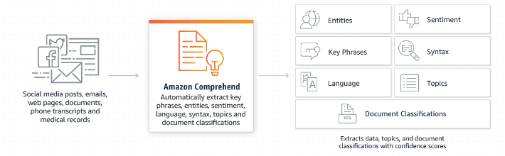

Class : NLP

Beneficial : Moderate (3/5)

Difficulty : Easy (1/5)

* **Amazon DevOps Guru**

Amazon DevOps Guru is a machine learning-powered service that monitors and improves the operational performance and availability of applications. By analyzing operational data, it can detect abnormal behavior (such as increased latency, error rates, resource constraints, etc.) and alert you to potential issues, providing insights into the root cause and recommendations for remediation, all through a centralized dashboard without requiring manual setup or specialized ML knowledge

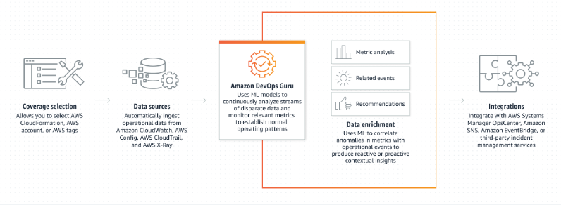

Class : Monitoring🤔

Beneficial : Moderate (3/5)

Difficulty : Moderate (2/5)

* **Amazon Forecast**

Amazon Forecast is a managed service that utilizes machine learning to generate highly accurate forecasts. By combining time series data with additional variables, it can provide predictions that are up to 50% more accurate than traditional methods. The service requires no machine learning expertise and handles all aspects of model building, training, and deployment, with a pay-as-you-go pricing model.

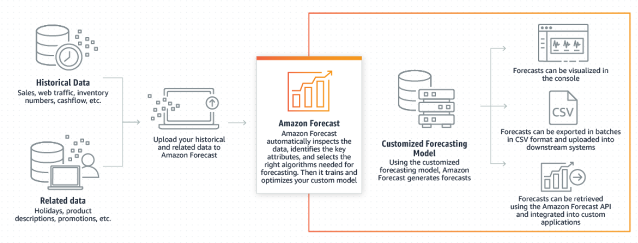

Class : AutoML

Beneficial : Useful (5/5)

Difficulty : Moderate (2/5)

* **Amazon Kendra**

Amazon Kendra is a managed search service that utilizes machine learning to enhance enterprise search capabilities. It enables efficient retrieval of information from various sources within an organization, simplifying the process of finding relevant content for employees and customers. With Amazon Kendra, there's no need to manually manage servers or develop ML models, as it is a fully managed service.

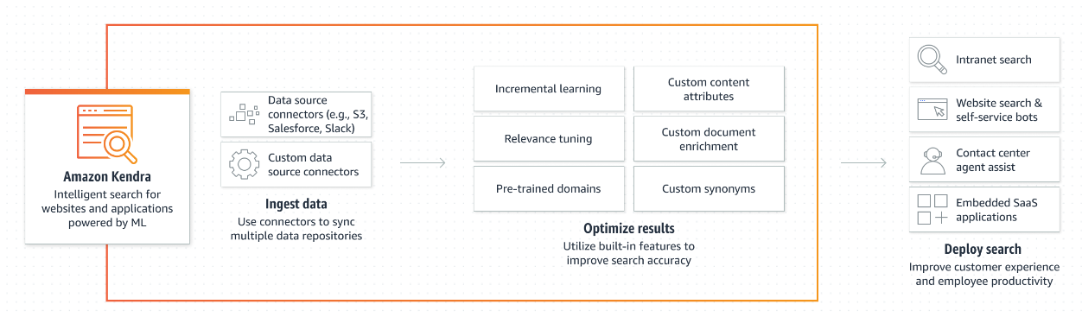

Class : Searching(NLP)

Beneficial : Moderate (3/5)

Difficulty : Hard (4/5)

* **Amazon Lex**

Amazon Lex is a fully managed AI service that allows developers to design, build, test, and deploy conversational interfaces with voice and text capabilities. It utilizes deep learning technology for automatic speech recognition and natural language understanding, enabling the creation of engaging chatbots and interactive voice response systems. With an intuitive console and pay-as-you-go pricing, developers can quickly build sophisticated conversational interfaces without requiring deep learning expertise or upfront costs.

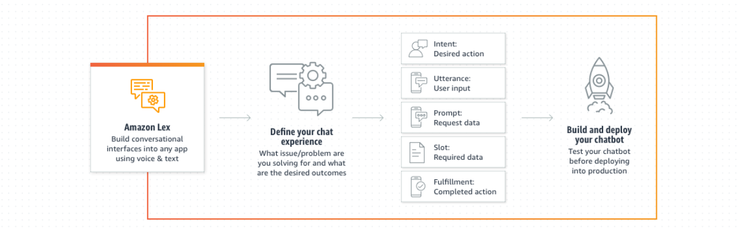

Class : Speech

Beneficial : Useful (5/5)

Difficulty : Hard (5/5)

* **Amazon Lookout for Equipment**

Amazon Lookout for Equipment is a service that leverages sensor data from equipment (such as pressure in a generator, flow rate of a compressor, revolutions per minute of fans) to automatically train a customized machine learning model without requiring ML expertise. By analyzing real-time sensor data, it can identify potential equipment issues, enabling early detection, diagnosis, and action to minimize costly downtime and false alerts.

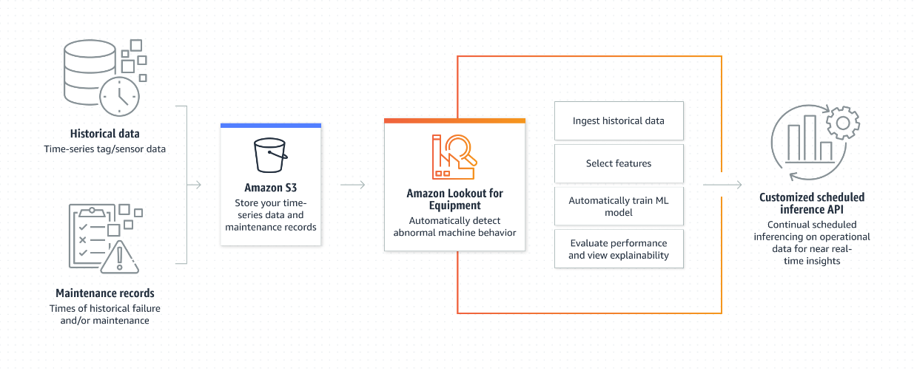

Class : Monitoring

Beneficial : Useless (1/5)

Difficulty : Easy (1/5)

* **Amazon Polly**

Amazon Polly is an AI service that converts text into natural-sounding speech. It offers a wide selection of lifelike voices in various languages and provides fast response times for real-time interactions. You can cache and save the speech audio, and the service is easy to integrate into applications. In addition, Amazon Polly offers Neural Text-to-Speech (NTTS) voices for improved speech quality, including a Newscaster style, and it provides the option to create custom voices for organizations. The pricing is based on the number of characters converted to speech, and there are no restrictions on storage or reuse of the generated voice output.

Class : text-to-speech

Beneficial : Useful (4/5)

Difficulty : Moderate (3/5)

* **Amazon Rekognition**

Amazon Rekognition is a user-friendly service that enables developers to incorporate image and video analysis into their applications without requiring ML expertise. It offers various functionalities, including object, text, and scene recognition, as well as detection of inappropriate content. The service also provides accurate facial analysis and search capabilities for tasks like user verification and people counting. With Amazon Rekognition Custom Labels, developers can create models tailored to their specific business needs, such as classifying machine parts or identifying unhealthy plants. The service handles the complex aspects of model development, requiring only the provision of relevant images.

Class : Computer vision

Beneficial : Useful (5/5)

Difficulty : Moderate (3/5)