you'll create the resources you need to start working with Azure Machine Learning.

* workspace
* compute instance

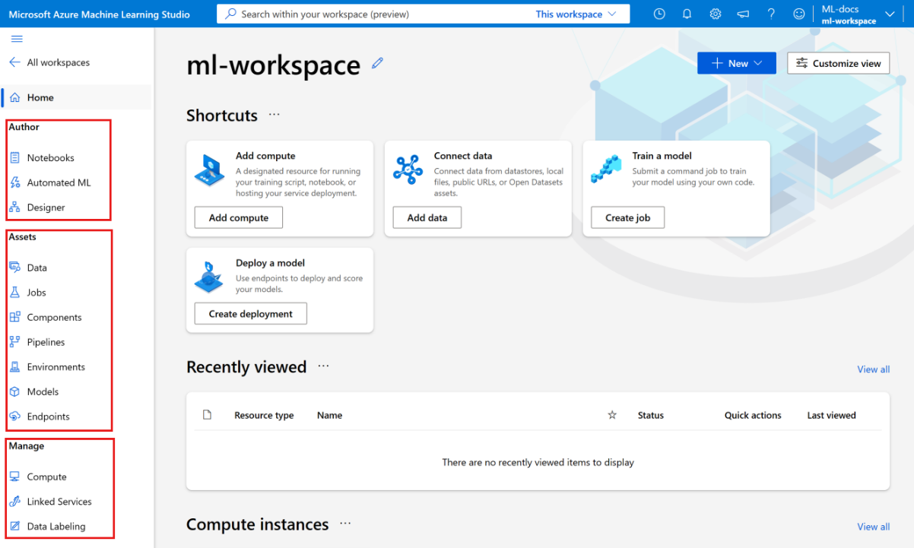

Review the parts of the studio on the left-hand navigation bar:

* The **Authoring** section of the studio contains multiple ways to get started in creating machine learning models. You can:
  + **Notebooks** section allows you to create Jupyter Notebooks, copy sample notebooks, and run notebooks and Python scripts.

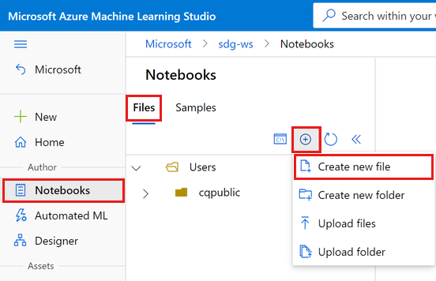

* + **Automated ML** steps you through creating a machine learning model without writing code.
  + **Designer** gives you a drag-and-drop way to build models using prebuilt components.
* The **Assets** section of the studio helps you keep track of the assets you create as you run your jobs. If you have a new workspace, there's nothing in any of these sections yet.
  + **Data** Azure Machine Learning uses Uniform Resource Identifiers (URIs), which point to storage locations in the cloud. A URI makes it easy to access data in notebooks and jobs. Data URI formats look similar to the web URLs that you use in your web browser to access web pages.

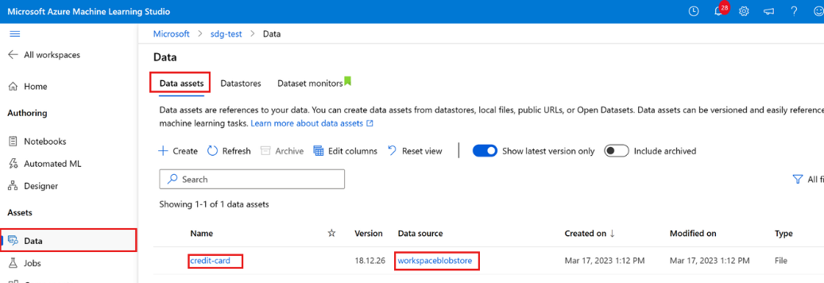

* + **Jobs** use the results tracked by **MLFlow** to decide which model is better. You can reference metrics like accuracy, or other indicators that matter most for your scenarios. You can dive into these results in more detail by looking at the jobs created by **MLflow**. (mlflow.sklearn.autolog(), mlflow.set_experiment("Develop on cloud tutorial"), mlflow.start_run(), mlflow.end_run())

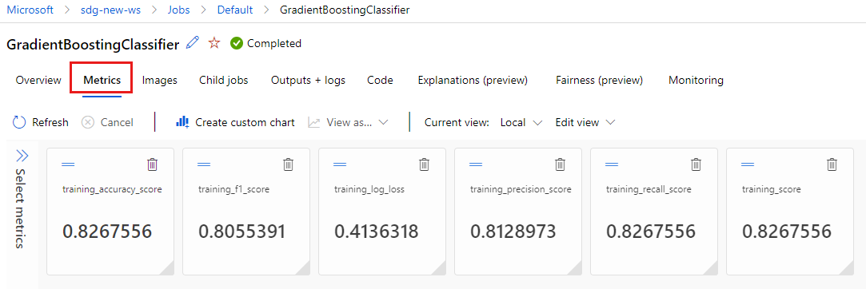

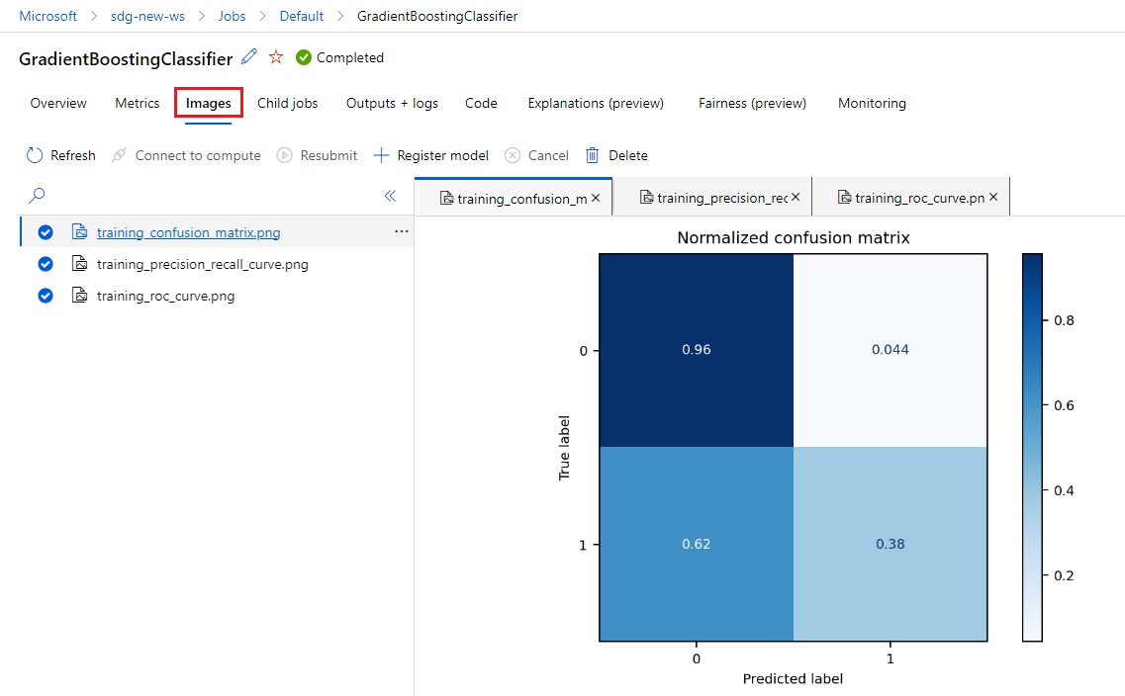

* The **Manage** section of the studio lets you create and manage compute and external services you link to your workspace. It's also where you can create and manage a **Data labeling** project.