**1. Testing Report:**

**1.1. Unit testing Report:**

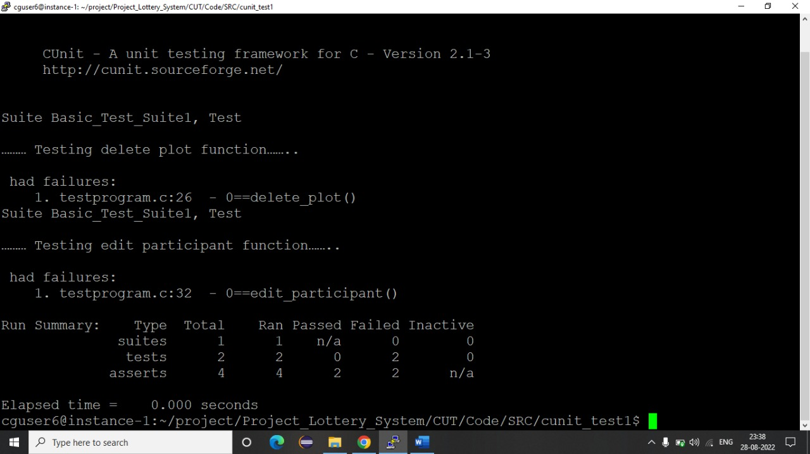

**1.2. Integration Testing Report:**

**Participant corner module**

Case 1: Grab a token

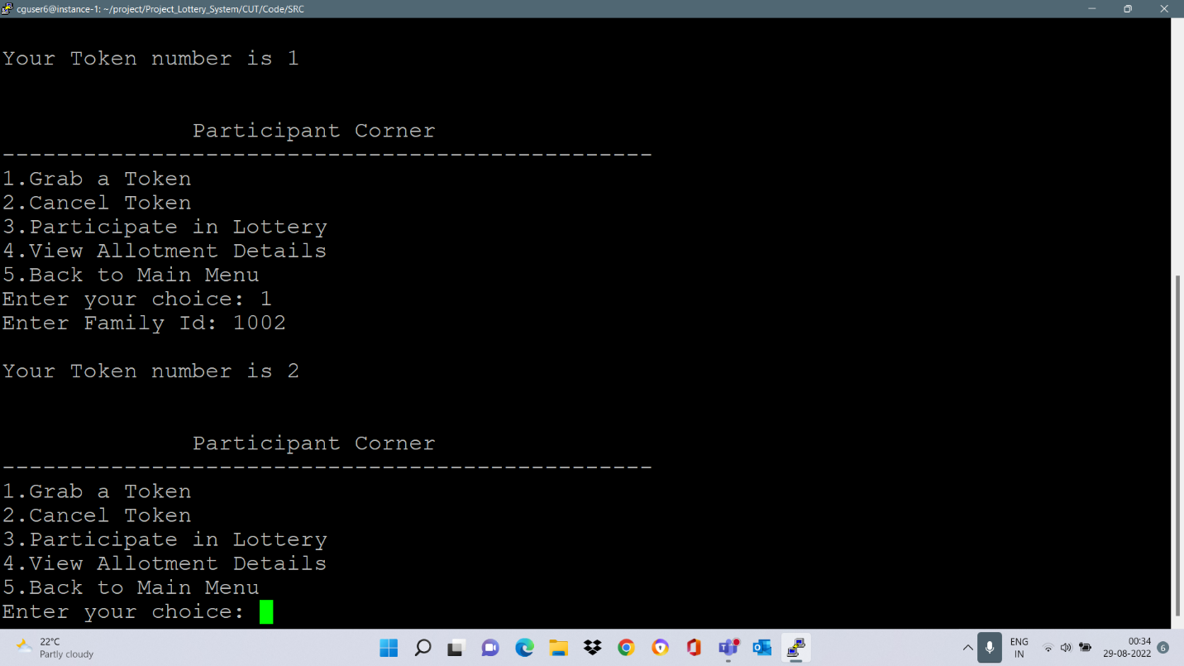

Case 2: Participate in lottery

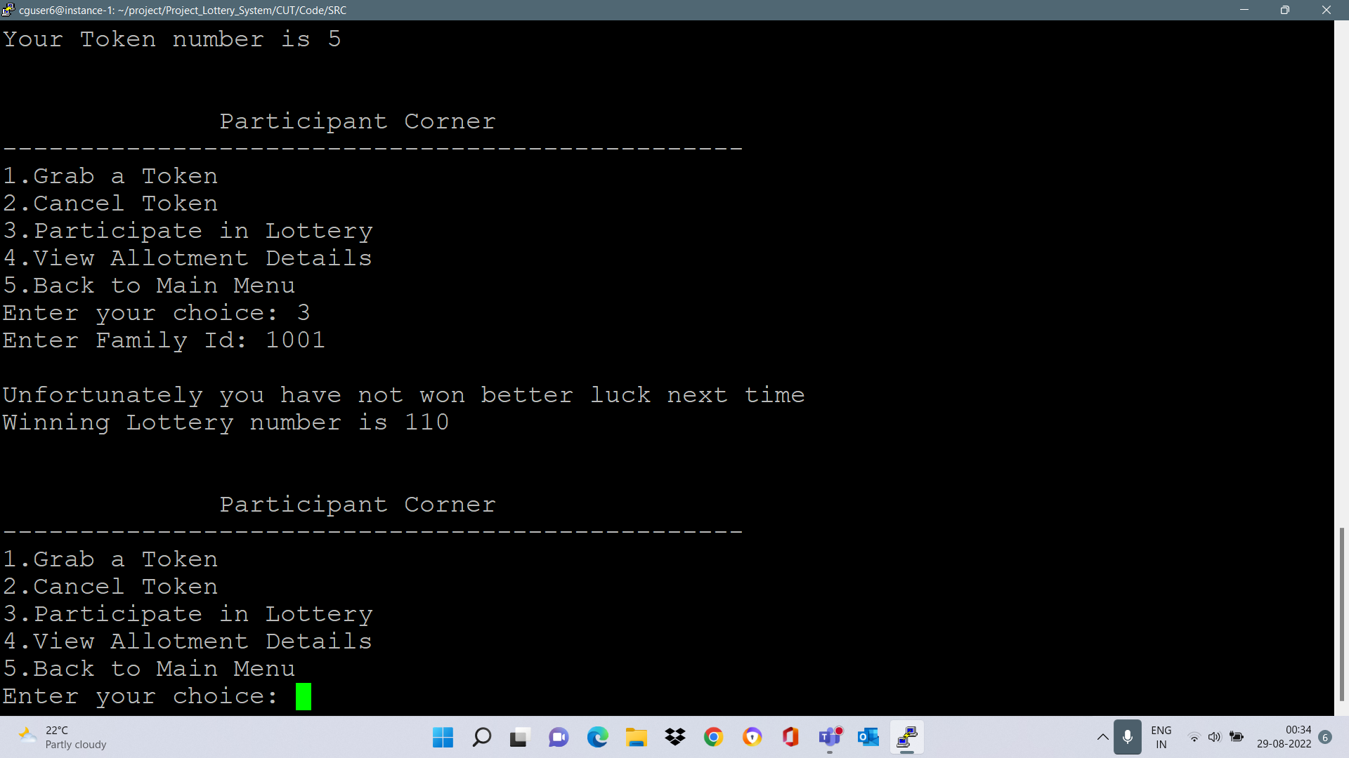

Case 3: Participated in lottery and won

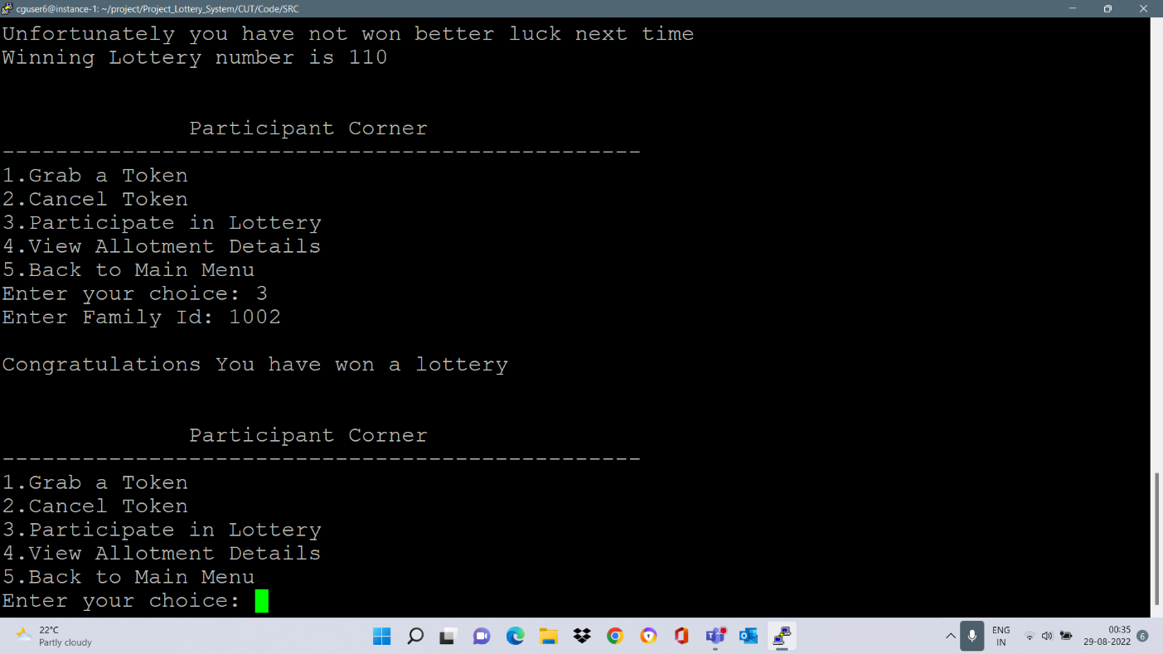

Case 4: Viewing allotment details

