**1.Design Overview:**

**1.1. Data Flow Diagram:**

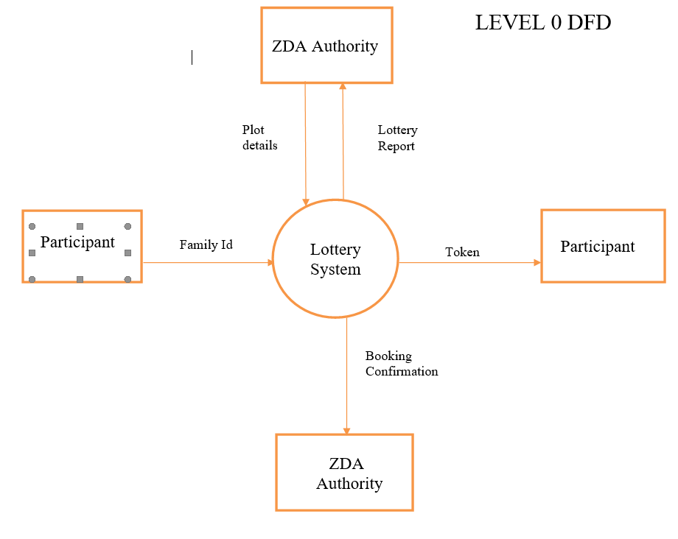

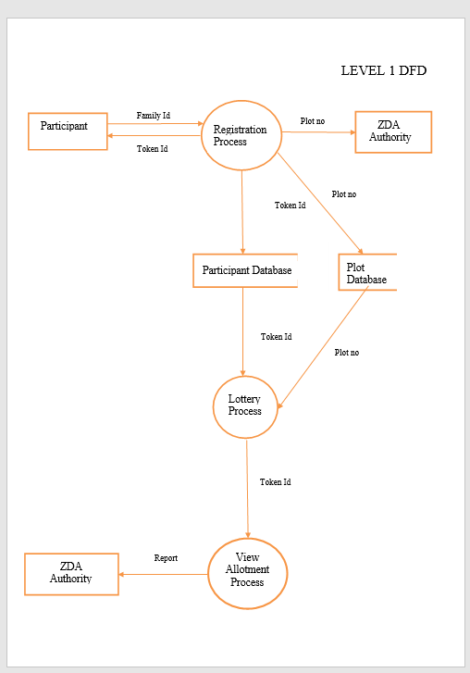

**1.2. Flowcharts:**

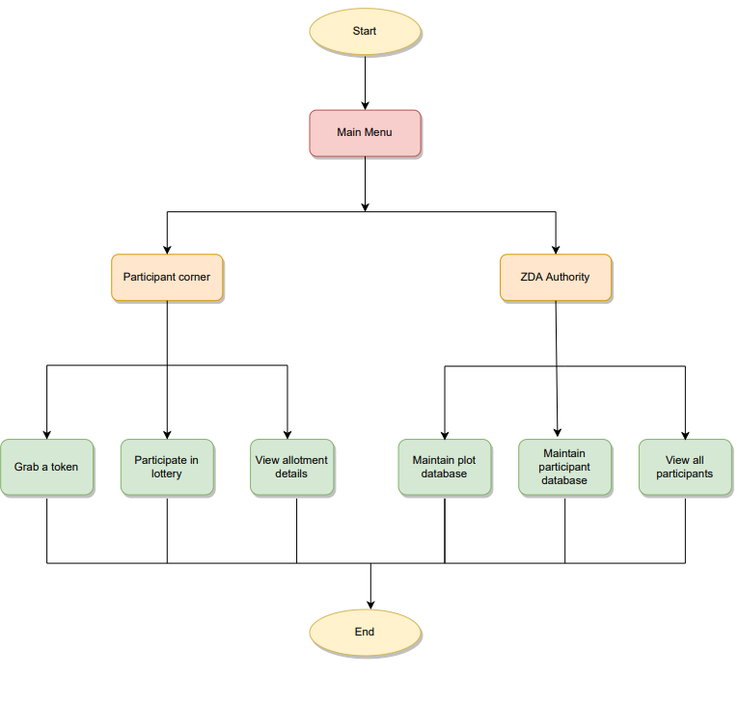

**Fig.1.2.1: Flowchart of Main Menu**

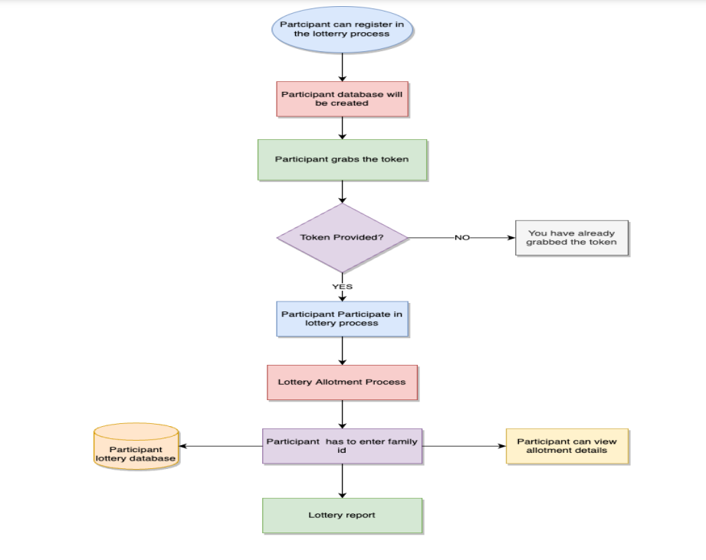

**Fig.1.2.2: Flowchart of Participant Corner**

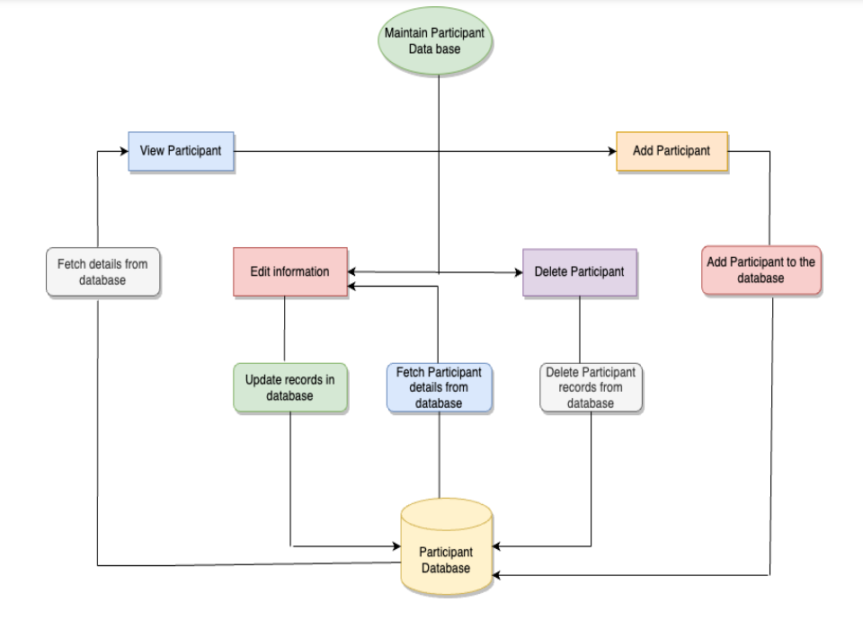

**Fig.1.2.3: Flowchart of Maintain Participant Database**

**2. System Architecture:**

**2.1.Functions:**

**2.1.1.Participant Corner**: Out of 500 households from the city only 300 participants are allowed to grab a token which is available on the website.2 tokens cannot be issued to a single family. So now the participant can register by entering their unique family id and can view the allotment details through the auto generated confirmation message.

**2.1.2.ZDA Authority**: ZDA Authority maintains plot database by adding, editing, deleting and viewing plot details. It also maintains participant database by adding, editing, removing and viewing all participants database. They can also view the Lottery report. ZDA authorities have to supply a password to access the admin features online

**2.1.2.1.Add Plot Details:** ZDA Authority adds plot details into database like plot no, Size (in sq. ft.), price of plot, etc.

**2.1.2.2.Edit Plot Details:** ZDA Authority can edit the plot details and modify the database as and when required.

**2.1.2.3.Delete Plot Details**: ZDA Authority can delete the plot details from the existing database.

**2.1.2.4.View Plot Details:** ZDA Authority can view the plot details.

**2.1.2.5.Add Participant Details:** ZDA Authority adds participant details into database like participant name, slno. (Auto-generated), family id, token no. Plot no., Amount to be paid. The last two fields are automatically updated after allotment.

**2.1.2.6.Edit Participant Details:** ZDA Authority can edit the participant details and modify the participant database as and when required.

**2.1.2.7.Remove Participant Details:** ZDA Authority can remove the participant details from the existing database.

**2.1.2.8.View Participant Details:** ZDA Authority can view all the participant details.

**2.1.3.View Lottery Report:** ZDA Authority can view the lottery report.

**2.2. Structures :**

**2.2.1.Participant:**

This structure is used to group participant type structure members like

-Family_id

-name

-participated in lottery

-plot_no

-token_no

-size

-remaining_amount

**2.2.2.Plot**

This structure is used to group plot type structure members like

-plot_no

-size of plot

-allot

-price of plot

**2.2.3.Queue**

This structure is used to group queue type structure members like

-token

-self referencing pointer next