**App name - Gofresha User App**

**App package name- com.gofresha.app**

**Technology - Flutter (Cross - Platform)**

**Installation Guide**

* To install and setup Flutter follow the steps [here](https://flutter.dev/docs/get-started/install/windows)
* To setup Flutter with VSCode follow the steps [here](https://flutter.dev/docs/get-started/editor?tab=vscode)
* Run following command in the Visual Studio Code Terminal

1. flutter create -i swift -a java Gofresha User App
2. cd Gofresha User App
3. flutter clean
4. flutter run

* To generate apk

1. flutter clean
2. flutter build apk --release

| **Images** | **Path** | **Screen Path** |
| --- | --- | --- |
| Splash Screen | assets/splash.jpg | lib/screens/splashScreen.dart |
| Intro screen | assets/intro_1.png | lib/screens/introScreen.dart |
| assets/intro_2.png | lib/screens/introScreen.dart |
| assets/intro_3.png | lib/screens/introScreen.dart |
| Sign Up Screen | assets/signup.png | lib/screens/signUpScreen.dart |
| Explore Screen | assets/exploreImg.png | lib/screens/exploreScreen.dart |
| bookingConfirmation Screen | assets/bookingConfirmation.png | lib/screens/bookingConfirmationScreen.dart |

**FONTS - pubspec.yaml**

| PoppinsRegular | assets/fonts/Poppins-Regular.otf |
| --- | --- |

**Colors - lib/Theme/nativeTheme.dart**

| **#** | **Color code** |
| --- | --- |
| Primary color | #FA692C |
| primaryColorLight | #898A8D |
| primaryColorDark | #FA692C |
| primaryIconTheme - color | #FA692C |
| Text button - background color | #FA692C |
| Text button - shadow color | white |
| Text button - foreground color | white |
| Divider theme - color | transparent |
| Card - color | white |
| Card - shadowColor | #EEEEEE |
| TextFormfield - filled color | white |
| bottomNavigationTheme- background color | #171D2C |
| Appbar icon theme- color | #171D2C |
| Appbar theme-color | transparent |
| scaffoldBackgroundColor | white |
| bottomSheet -background color | white |
| elevatedButton -background color | #FA692C |
| snackBar -background color | #171D2C |
| Dialog -background color | #EEEEEE |
| floatingActionButton - background color | #FA692C |

**Package - pubspec.yaml**

| **Package Name - version** | **Description** |
| --- | --- |
| introduction_screen: ^2.1.0 | For creating introductionScreen |
| Font_awesome_flutter - 9.1.0 | To access icon of font awesome |
| carousel_slider: 4.0.0 | To show slider with auto play |
| dots_indicator: 2.0.0 | To indicate dots with reference to slider |
| date_picker_timeline: ^1.2.3 | To pick a date from user |
| material_design_icons_flutter: 4.0.5955 | To access icons of material design |
| slide_button: ^0.2.9 | To create sliding effect |
| shared_preferences: ^2.0.6 | To store something locally |
| device_info_plus: ^2.1.0 | To get device info |
| connectivity_plus: ^1.0.6 | To check connectivity of device |
| image_picker: ^0.8.3+2 | For picking an image |
| url_launcher: ^6.0.9 | For launching a url |
| http: ^0.13.3 | For consuming HTTP resources |
| permission_handler: ^8.1.4+2 | This plugin provide a cross-platform api to request and check permission |
| email_validator: ^2.0.1 | For validating email |
| image_cropper: ^1.4.1 | To crop an image |
| flutter_image_compress: ^1.1.0 | To compress an image |
| path_provider: ^2.0.2 | For finding commonly used locations on filesystem |
| dio: 4.0.0 | A powerful Http client for Dart, which supports Interceptors, Global configuration, FormData, Request Cancellation, File downloading, Timeout etc. |
| flutter_rating_bar: ^4.0.0 | Used for giving rating |
| jiffy: ^4.1.0 | Used for parsing, manipulating, querying and formatting dates |
| firebase_analytics: ^8.3.0 | A Flutter plugin to use the Google Analytics for Firebase API. |
| firebase_auth: ^3.0.2 | To use the Firebase Authentication API. |
| firebase_core: ^1.5.0 | To use the Firebase Core API, which enables connecting to multiple Firebase apps. |
| mobile_number: ^1.0.4 | To get the device mobile number |
| sms_autofill: ^2.0.1 | To provide SMS code autofill support. |
| otp_autofill: ^1.1.0 | To provide OTP autofill |
| flutter_facebook_auth: ^3.5.0 | For login with facebook |
| google_sign_in: ^5.0.7 | For login with google |
| intl: ^0.17.0 | To Provide internationalization and localization facilities, including message translation, plurals and genders, date/number formatting and parsing, and bidirectional text. |
| cached_network_image: ^3.1.0 | To show image from internet |
| geolocator: ^7.4.0 | To provides easy access to platform specific location services |
| shimmer: ^2.0.0 | To create shimmer effect |
| scratcher: ^2.1.0 | To temporarily hide content from users. |
| razorpay_flutter: ^1.2.3 | For connecting with razorpay SDK |
| geocoding: ^2.0.1 | To provide easy geocoding and reverse-geocoding features. |
| firebase_messaging: ^10.0.6 | To use firebase cloud messaging api |
| flutter_local_notifications: ^8.1.1+2 | A cross platform plugin for displaying local notifications. |
| latlng: ^0.1.0 | For geodesy and geographical calculations. |
| mapbox_search: ^2.1.0+1 | For providing easy api calls to MapBox Search API. |
| google_maps_flutter: ^2.0.8 | To provide a Google Maps widget. |
| flutter_mapbox_autocomplete: ^2.0.0 | For MapBox Places autocomplete. |
| flutter_paystack: ^1.0.5+1 | For making payments via Paystack Payment Gateway |
| flutter_html: ^2.1.2 | For rendering HTML and CSS as Flutter widgets. |
| share_plus: 2.1.4 | For sharing contents |
| flutter_polyline_points: ^1.0.0 | To decodes encoded google polyline string into list  of geo-coordinates suitable for showing route/polyline on maps |
| fdottedline: 1.0.1 | To get dotted line widget |
| provider | Used for the localization |

**To add new language**

**Follow the below steps**

1. Create new file on given path (lib \ l10n) with file extension **.arb**

For eg : for english language, create file as **app_en.arb**

1. Mention the language code in l10n.dart (lib \ l10n \ l10n.dart)

For eg : for english language, **const**  **Local(‘en’)**

1. Add key, value and description for the text.

For eg :

* 1. "lbl_login" : "Login",
     1. "@lbl_login":{
  2. "description": "Login"
     1. },

1. To access the text from the .arb file, do the following practice as shown below : AppLocalizations.of(context).lbl_login

**To change base url**

**lib/models/businessLayer/global.dart**

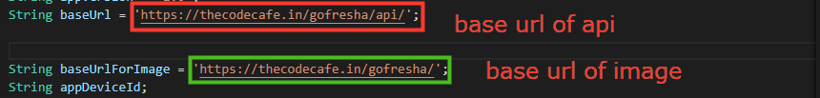

**To change Package name**

**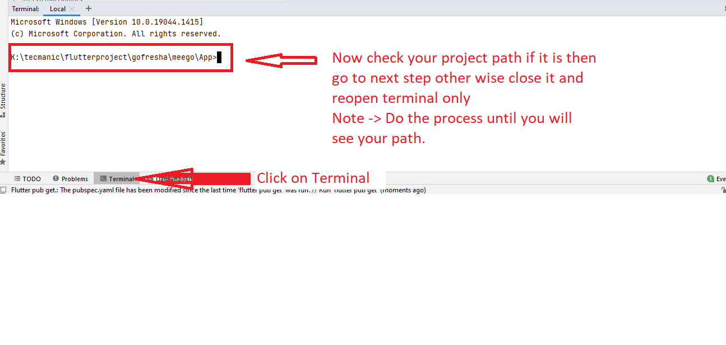  
  
After that in terminal type following command.  
  
flutter pub run change_app_package_name:main com.demo.user  
  
Note -> com.demo.user change with your package name.**

**To change app icon  
For Android Only**1. Rename your logo -> logo  
2. File format must be .png.

3. Demission would be only 512 x 512 px.

4 logo Path followed by your project path App\assets



**After that in terminal type following command.  
  
flutter pub run flutter_launcher_icons:main  
  
For IOS   
you will generate icons according ios and paste/Replace all those file in given path.**1.generate icon for android and ios from website app icon generator.,click <https://appicon.co/> **followed by your project path \App\ios\Runner**

**To setup firebase**

To setup firebase and integrate with the app click [here](https://firebase.google.com/docs/android/setup)

**To setup facebook**

To setup firebase and integrate with the app click [here](https://facebook.meedu.app/#/android)

**Google Map Api Key**

**If new api key is generated from the google map console then do the following changes**

**android/app/src/main/AndroidManifest.xml**

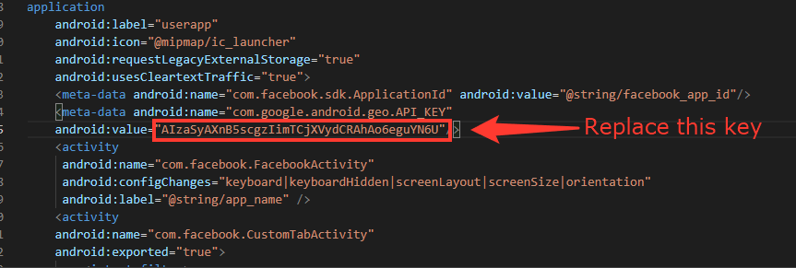

**lib/models/businessLayer/global.dart**

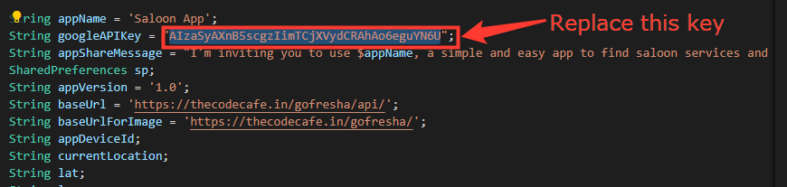

**Also, download latest google-services.json and replace this file with android/app/goolge-services.json**