

AMERICAN INTERNATIONAL UNIVERSITY–BANGLADESH (AIUB)
Dept. of Computer Science
Faculty of Science and Technology
CSC2210: OBJECT ORIENTED PROGRAMMING 2
Summer 2026-2027
Section: [O]

Project Report On
Project Name [ Type Master ]
Supervised By
AL Jubair Hossain

Submitted By:
Name | ID
1. Abonti Jannati | 24-60114-3
2. Reaz Rahman Email | 24-60148-3
3. Atanu Khashkel Ajit | 24-60115-3
- Talhaz Jubair Taurat | 24-59719-3
Obtained Marks for CO2 and CO4 (Description given in the following page)
Assessment  Criteria | Not Attended/ Incorrect (0) |  | Inadequate  (1-2) |  | Average  (3) | Good  (4) | Excellent  (5)
Evaluation Criteria (CO2) |  | Total = |  | Evaluation Criteria (CO4) |  |  | Total =
Requirement fulfillment |  |  |  | Design & Innovation
Validation |  |  |  | Teamwork & Ethics
Verification |  |  |  | Communication

CO2: Display and verify the mean of a real-life Project using the concepts of C# Graphical User Interface based environment with database integration to depict a desktop-based application.
Assessment  Criteria | Not Attended/ Incorrect (0) | Inadequate  (1-2) |  | Average  (3) |  | Good  (4) |  | Excellent  (5)
Evaluation Criteria | Evaluation Definition
Requirement fulfillment | Fails to demonstrate any understanding of real-life scenario-based project development or functional requirement identification. There is no attempt to depict a project or identify functional requirements accurately. |  | Demonstrates limited understanding of real-life scenario-based project development and functional requirement identification. The project depicted lacks coherence or relevance to real-life scenarios, and functional requirements are inaccurately identified or insufficiently described. |  | Presents a basic depiction of a real-life scenario-based project and identifies some functional requirements. However, the project lacks depth or complexity, and some functional requirements may be vaguely defined or missing key details. |  | Effectively demonstrates a realistic scenario-based project and accurately identifies most functional requirements. The project is well-developed with appropriate complexity, and functional requirements are clearly articulated with relevant details. |  | Exhibits an exceptional understanding of real-life scenario-based project development and accurately identifies all functional requirements. The project is meticulously developed with thorough attention to detail, reflecting a comprehensive understanding of Object-Oriented Programming project development activities.
Validation | Fails to demonstrate any understanding or implementation of validation forms in their system. There is no attempt to deal with data validation, and validation requirements are completely ignored or incorrectly applied. |  | Demonstrates limited understanding of validation forms and data validation techniques. While some attempt may be made to implement validation, it is incomplete or poorly executed, leading to inadequate handling of data validation. |  | Shows a basic understanding of validation forms and data validation techniques. They attempt to implement validation, but some aspects may be missing or incorrectly implemented, resulting in partial or inconsistent handling of data validation. |  | Effectively demonstrates the use of validation forms and implements data validation techniques. Validation is mostly accurate and comprehensive, ensuring the proper handling of data input and verification in the system. |  | Exhibits an exceptional understanding and implementation of validation forms and data validation techniques. Validation is meticulously implemented with thorough attention to detail, ensuring robust data validation procedures and contributing to the overall reliability and integrity of the system.
Verification | Fails to demonstrate any attempt to verify the system data or functional requirements. There is no evidence of understanding or implementation of verification processes, and data flow is not considered. |  | Demonstrates limited understanding of verification processes and data flow in the system. Verification attempts are incomplete or inaccurate, and there is insufficient consideration given to ensuring data integrity and functionality. |  | Shows a basic understanding of verification processes and attempts to verify system data. However, verification efforts may be inconsistent or lack thoroughness, and there may be gaps in ensuring proper functional requirements and data flow. |  | Identifies and verifies system data, ensuring proper functional requirements are met. Verification efforts are mostly accurate and thorough, with attention to ensuring data integrity and appropriate data flow within the system. |  | Exhibits an exceptional understanding of verification processes and meticulously verifies system data. Verification efforts are comprehensive and precise, with a keen focus on ensuring all functional requirements are met and maintaining proper data flow throughout the system.

CO4: Display and verify the mean of a real-life Project using the concepts of C# Graphical User Interface based environment with database integration to depict a desktop-based application.
Assessment  Criteria | Not Attended/ Incorrect (0) | Inadequate  (1-2) |  | Average  (3) |  | Good  (4) |  | Excellent  (5)
Evaluation Criteria | Evaluation Definition
Requirement fulfillment | Fails to demonstrate any attempt to perform or solve system functional requirements. There is no evidence of addressing real-life scenario-based projects or identifying functional requirements for Object-Oriented Programming project development activities. |  | Demonstrates limited understanding of system functional requirements and real-life scenario-based projects. Attempts to perform or solve functional requirements may be incomplete or inaccurately applied, and there is insufficient consideration given to proper identification of requirements. |  | Shows a basic understanding of system functional requirements and attempts to perform or solve them. However, the execution may lack depth or thoroughness, and there may be gaps in addressing all aspects of real-life scenario-based projects or properly identifying functional requirements. |  | Effectively demonstrates the performance and solution of system functional requirements for real-life scenario-based projects. Requirements are identified with clarity and relevance, and the execution is mostly accurate and comprehensive, reflecting a solid understanding of Object-Oriented Programming project development activities. |  | Exhibits an exceptional understanding of system functional requirements and adeptly performs and solves them for real-life scenario-based projects. Requirements are meticulously identified and executed with thorough attention to detail, showcasing a comprehensive mastery of Object-Oriented Programming project development activities.
Validation | Fails to demonstrate any understanding or implementation of validation forms or data validation techniques. There is no evidence of addressing validation requirements or dealing with data validation in their system. |  | Demonstrates limited understanding of validation forms and data validation techniques. While some attempt may be made to implement validation, it is incomplete or poorly executed, leading to inadequate handling of data validation. |  | Shows a basic understanding of validation forms and data validation techniques. They attempt to implement validation, but some aspects may be missing or incorrectly implemented, resulting in partial or inconsistent handling of data validation. |  | Demonstrates the use of validation forms and implements data validation techniques. Validation is mostly accurate and comprehensive, ensuring the proper handling of data input and verification in the system, although there may be minor issues. |  | Exhibits an exceptional understanding and implementation of validation forms and data validation techniques. Validation is meticulously implemented with thorough attention to detail, ensuring robust data validation procedures and contributing to the overall reliability and integrity of the system.
Verification | Fails to demonstrate any understanding or attempt to verify system data or functional requirements. There is no evidence of addressing verification requirements or considering data flow in their system solution. |  | Demonstrates limited understanding of verification processes and data flow in the system. Verification attempts may be incomplete or inaccurately applied, and there is insufficient consideration given to ensuring proper functional requirements and data flow. |  | Shows a basic understanding of verification processes and attempts to verify system data. However, verification efforts may lack thoroughness or precision, and there may be gaps in ensuring proper functional requirements and data flow within the system. |  | Effectively identifies and verifies system data, ensuring proper functional requirements are met. Verification efforts are mostly accurate and comprehensive, with attention to ensuring data integrity and appropriate data flow within the system. |  | Exhibits an exceptional understanding of verification processes and meticulously verifies system data. Verification efforts are comprehensive and precise, with a keen focus on ensuring all functional requirements are met and maintaining proper data flow throughout the system.

Table of Contents: Page no.

1. Introduction 6
2. Feature list : 6
3. Database Design : 7
3.1 ER Diagram : 7
3.2 Normalization : 8
3.3 Finalization : 9
4. UML Diagram : 10
4.1 Use Case Diagram: 10
4.2 Activity Diagram: 12
5. SQL Code : 14
6. Conclusion : 15
7. Screenshots 15

- Introduction :
The Type Master is a 2D arcade-style game built in Unity game engine using C# and integrated with Supabase for back-end system. This game is designed to merge the educational skill building with engaging gameplay mechanics. The game challenges the player to improve typing speed and accuracy with limited life constraints and different modes of difficulty with respect to word length. Players navigate their way through interactive mechanics such as falling words attached to parachutes that detonates upon touching the ground unless players types the words correctly. Subsequently, a combo mechanism encourages the player to strive for an even higher score.
The primary objective of this project is to design a 2D game architecture by implementing key programming concepts learned throughout this course and basics game development principles. The underlying game structure of this project is documented in details by listing all the game features, Entity-Relationship(ER) diagrams, Unified Modelling Language(UML) diagrams- Use Case diagram and Activity diagram. The diagrams features all the important entities such as USER, AUTH_USER, GAME_SESSION, WORD, BOMB and much more to showcase how each of them interact with each other.

Feature list :

- Database connection:
- Registration with appropriate details such as email address and age limit (18+); which stores online .
- Only using low detected password with updating feature from the sign in and user page.
- Store profile photo and update whenever the user like.
- Date of registration and update of the any details stores within the database .

- Game features:
- 3 level choice [ easy, medium, hard ]
- Typing mechanism.
- Settings feature [ allows themes ( dark / light ), with or without music ]
- 3 different high score saver; which shows after game over [ when hearts become zero ]
- Pause feature [ has
- 2x and 3x score bonus for consecutive correct answer [ each level has different amount ]
- Animated hero who fights when a word is entered, overjoyed when the word is correct and gets electric shock when a word hits the ground and blast .
- Different level has different word length and word falling depends on the word length.
- Word is selected through API; so user gets completely different word each time they play.
- Retro pixel aesthetic as UI for the user.

Database Design :

ER Diagram :
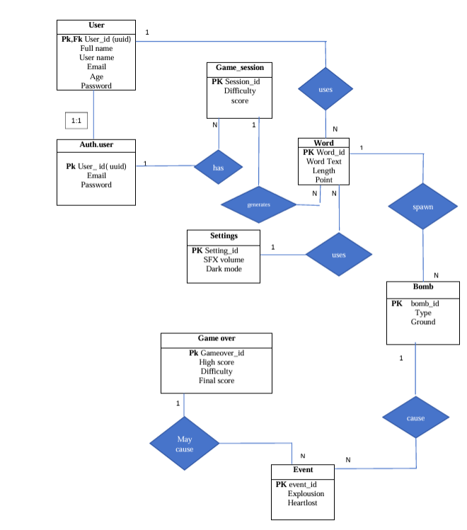

The ER diagram represents the structure of the 2D Unity game and shows how the main components of the system are connected with
Each other . The diagram has many entity includes the user and authentication , game session, words , game over , bomb and events
Which contains different information . such as the user section contains information of user id , full name , email , age and passwords while the authentication manages all of the user information to connect correctly .
Also there are gameplay entities like Game Session and Word entities. The game session maintain the session information like session id , difficulty and score . on the other hand word entities contains the word ID, word text, length, and associated points. These entities represent the players activities and scoring in individual levels or difficulty .
The diagram also shows the game's configuration and outcome related components which is setting section that represent the games configurable option like sound on or off , dark mode to maintain the players preferable settings . The most important entity has also present which is Game over which shows the player performance including high- score , difficulty level and final score. In addition, the Bomb and Ground Event entities represent significant gameplay events.
Overall the ER diagram provides and clear the overview of relationship between user user information, authentication, game sessions, words, settings, scores, and events. This structure help logical organization to understand the game system and provides major components interact with each other.

Normalization :

UNF (Unnormalized Form):
USER_GAME_SYSTEM (User_id, Full_name, User_name, Email, Age, Password, Auth_Email, Auth_Password, Session_id, Difficulty, Score, Setting_id, SFX_volume, Dark_mode, Gameover_id, High_score, Final_score, {Word_id, Word_Text, Length, Point}, {Bomb_id, Type, Ground}, {Event_id, Explosion, Heartlost})

1NF (First Normal Form)
• USER (User_id, Full_name, User_name, Email, Age, Password)
• AUTH_USER (User_id, Email, Password)
• SETTINGS (Setting_id, SFX_volume, Dark_mode, User_id)
• GAME_SESSION (Session_id, Difficulty, Score, User_id)
• GAME_OVER (Gameover_id, High_score, Difficulty, Final_score, Session_id)
• WORD (Word_id, Word_Text, Length, Point, Session_id)
• BOMB (Bomb_id, Type, Ground, Session_id)
• EVENT (Event_id, Explosion, Heartlost, Session_id)
• WORD_BOMB (Word_id, Bomb_id)
• BOMB_EVENT (Bomb_id, Event_id)

2NF (Second Normal Form)
• USER (User_id, Full_name, User_name, Email, Age, Password)
• AUTH_USER (User_id, Email, Password)
• SETTINGS (Setting_id, SFX_volume, Dark_mode, User_id)
• GAME_SESSION (Session_id, Difficulty, Score, User_id)
• GAME_OVER (Gameover_id, High_score, Difficulty, Final_score, Session_id)
• WORD (Word_id, Word_Text, Length, Point, Session_id)
• BOMB (Bomb_id, Type, Ground, Session_id)
• EVENT (Event_id, Explosion, Heartlost, Session_id)
• WORD_BOMB (Word_id, Bomb_id)
• BOMB_EVENT (Bomb_id, Event_id)

Finalization :

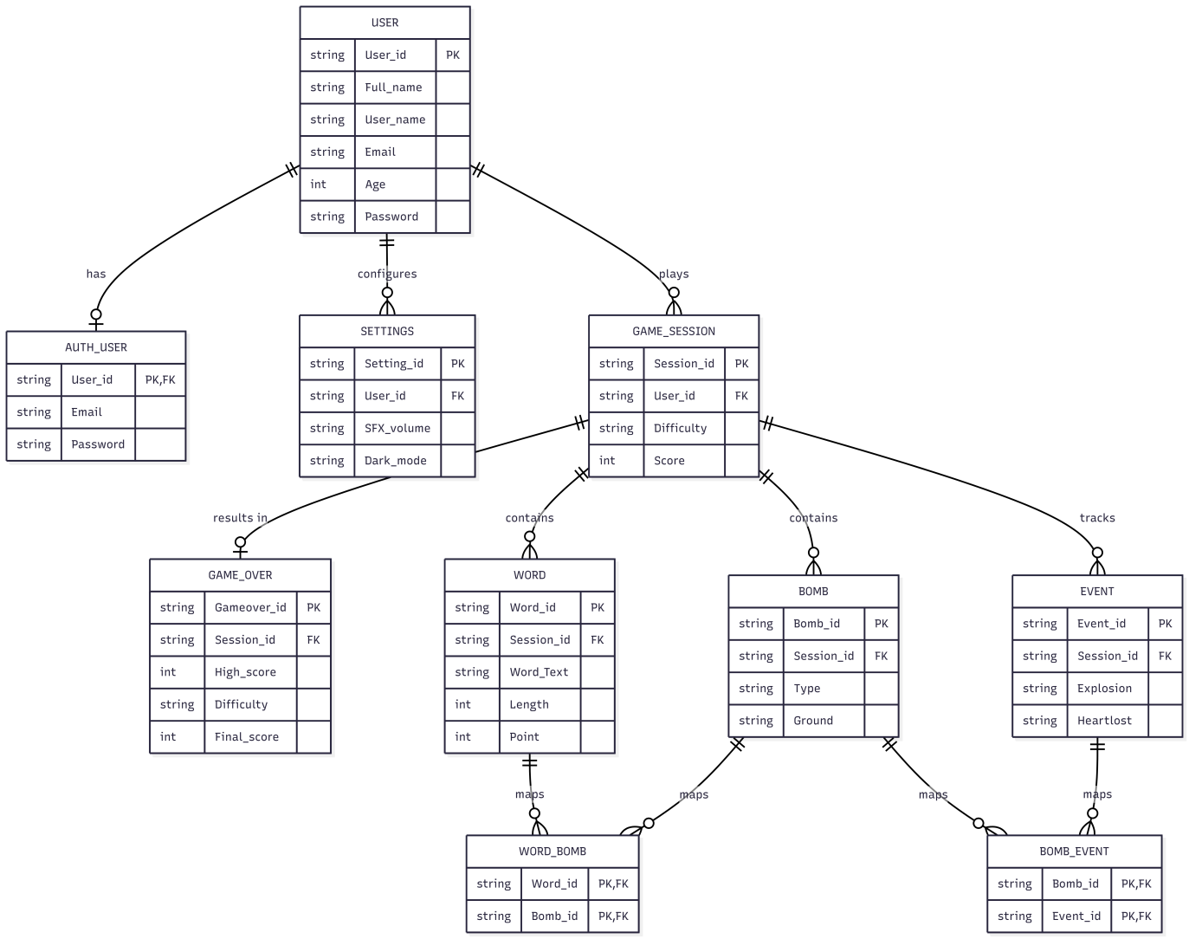

UML Diagram :

Use Case Diagram:

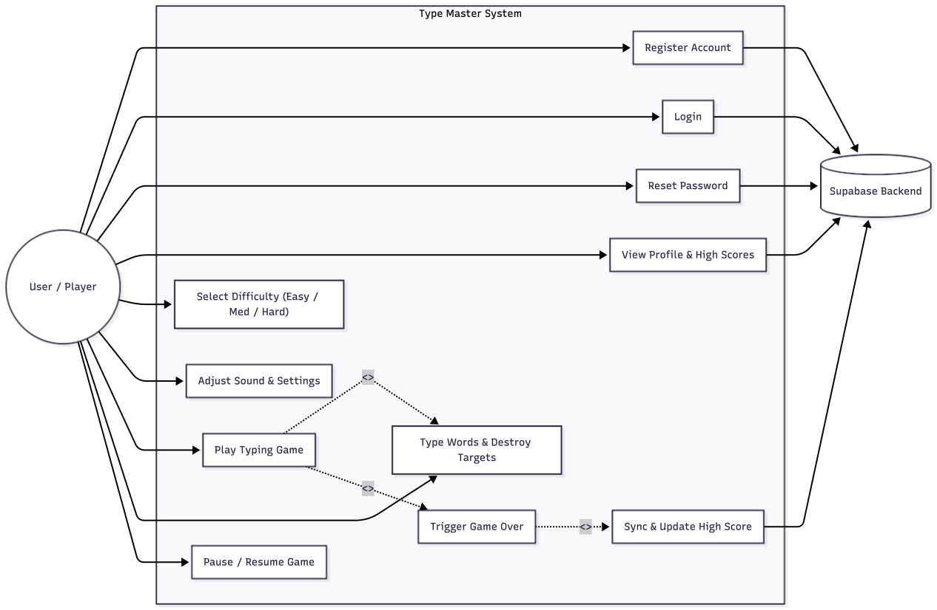

The Use Case diagram shows the functions interactions between the primary actor(User/Player) and the external Supabase Back end. The use cases are bound within the Type Master system boundary.
- Actors
- User/Player: can interact directly with the Graphical User Interface(GUI) to Register account, Login, Reset password, View profile and high scores, Select difficulty, adjust settings, play the game with real time keyboard input, pause and resume game.
- Supabase Back-end: manages the database with read and write operations, verification system and storing high score as per user.
- Use Cases
- Register Account: New Users can set up an account by providing required credentials that are checked and stored by Supabase.
- Login: checks user credentials in the Supabase database and starts an authenticated session.
- Reset Password: offers account recovery for existing user by cross checking username and email.
- See Profile and High Scores: fetches and displays personal informational, and highest score from Supabase.
- Select Difficulty: lets the player choose between three difficulties-Easy, Medium,Hard.
- Adjust sound and settings: offer toggling sound off or on and switch game background between light or dark mode.
- Play typing game: contains the game mechanisms with falling words on parachutes and a typing field for the player to type.
- Type input and destroy targets: captures the keystrokes from the player in the typing field and compares the string input with the word object. If both of them matches, the player score a point.
- Trigger game over: stops the game mechanisms when players losses all their hearts due to bombs exploding and displays the final score along with high score.
- Sync and update high score: compares the current session score with the existing high score from Supabase and update the existing high score if a new score is achieved.
- Pause/Resume game: temporarily stops the game, game physics without resetting scene state.
- Behavioral Relationships:
- <<include>> Relationships:
- Play typing game → Type input and destroy targets: the players real time keystrokes are must to execute the main game loop.
- Trigger Game Over → Sync and update high score: Score evaluation and storing the score is automatically done whenever a game session is over.
- <<extend>> Relationships:
- Play typing game ← Type input and destroy targets: when game over is triggered due to loss of all hearts for a giver difficulty, the sequence extends to normal gameplay loop.

Activity Diagram:

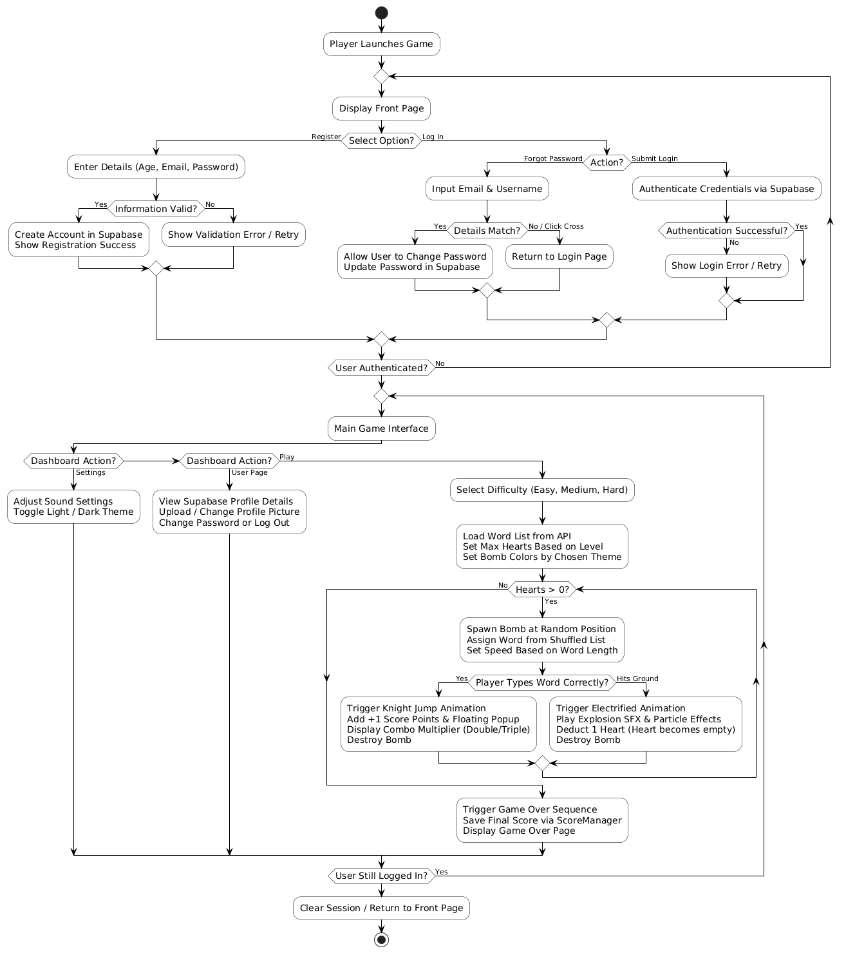

This diagram shows how the “Type master” game works step by step. When the player starts the game, they see the front page where they can log in or create a new account. For registration, the system checks if the given information is valid (whether age limit, email, password etc are okay ) before creating the account in Supabase (online database used for this project). In the login section,user can log in normally by giving correct information ( if it matches then they goes the game interface, if not then error is given ) there is also a forgot password option. In the for got password page, if the user enters a matching email and username, they can change their password, or they can click the cross button to return to the previous page it came from. In the main game page there are three main buttons: Play, User, and Settings. In the User page, players can view their details [which was saved in the Supabase], upload a profile picture[ or change the previous profile picture ] , change their password, or log out to clear the session. The Settings button allows them to adjust sound and toggle between Light and Dark themes.When the player clicks the Play button, the actual game begins. First, they select a difficulty level (Easy, Medium, or Hard), which loads the word list from an API and sets the total hearts based on that level which was selected by the user. The game also adjusts the bomb text colors according to the chosen light or dark theme. During gameplay, bombs spawn at random positions, and their falling speed changes according to word length. If the player types the word correctly before it drops, the Knight plays the jumping animation, score points [ +1 ] are added with floating popups, combo multipliers (Double or Triple) appear for consecutive correct answers [consecutive number depends on the level], and the bomb is destroyed. However, if a bomb hits the ground, the character plays the electrified animation, explosion audio and particle effects trigger, one heart becomes empty, and the bomb disappears. This game loop repeats as long as remaining hearts are greater than zero. Once hearts reach zero, the game over sequence triggers and saves the final score using Score Manager and goes to the game over page . If the user is not logged in then it goes to the front page.

SQL Code :
1. create table if not exists public.users (
id uuid primary key references auth.users(id) on delete cascade,
full_name text not null,
username text not null unique,
email text not null unique,
age integer not null check (age >= 13 and age <= 120),
photo_url text,
high_score integer not null default 0,
created_at timestamptz not null default now(),
updated_at timestamptz not null default now()
);
create index if not exists idx_users_username on public.users (username);
create index if not exists idx_users_email on public.users (email);
create or replace function public.set_updated_at()
returns trigger as $$
begin
new.updated_at = now();
return new;
end;
$$ language plpgsql;
drop trigger if exists trg_users_updated_at on public.users;
create trigger trg_users_updated_at
before update on public.users
for each row
execute function public.set_updated_at();
alter table public.users enable row level security;
create policy "Public can check username/email availability"
on public.users
for select
using (true);
create policy "Users can insert their own profile"
on public.users
for insert
with check (auth.uid() = id);
create policy "Users can update their own profile"
on public.users
for update
using (auth.uid() = id)
with check (auth.uid() = id);
2. DROP POLICY IF EXISTS "Enable insert for authenticated users only" ON users;
DROP POLICY IF EXISTS "Enable insert for all users" ON users;
CREATE POLICY "Enable insert for authenticated users only" ON users
FOR INSERT
TO public
WITH CHECK (true);
3. CREATE POLICY "Allow public read access to users"
ON public.users
FOR SELECT
TO anon, authenticated
USING (true);

Conclusion :
Type Master game project successfully delivers a user friendly type based gaming environment using unity Application . The project combines with game development , user authentication , Difficulty selection , settings system , scoring points, audio and visual effects and game-over mechanism into an interactive unity application .The main concept of this game is to improve the player's typing skills by developing typing speed and accuracy through engaging gameplay. The ER diagram describe the key entities, their attributes, and the relationships among them, providing a clear view of the application overall structure and data management.
For the future enhancements may include online leader boards , rewards , achievements for reaching specific scores , multiple players, mobile supports would make more competitive and rich feature .
All modules of the project were tested on the Windows platform using Unity 6.5. The entire game was developed using C# with gameplay mechanics, user interface, scene management, and supporting functionalities.

Screenshots
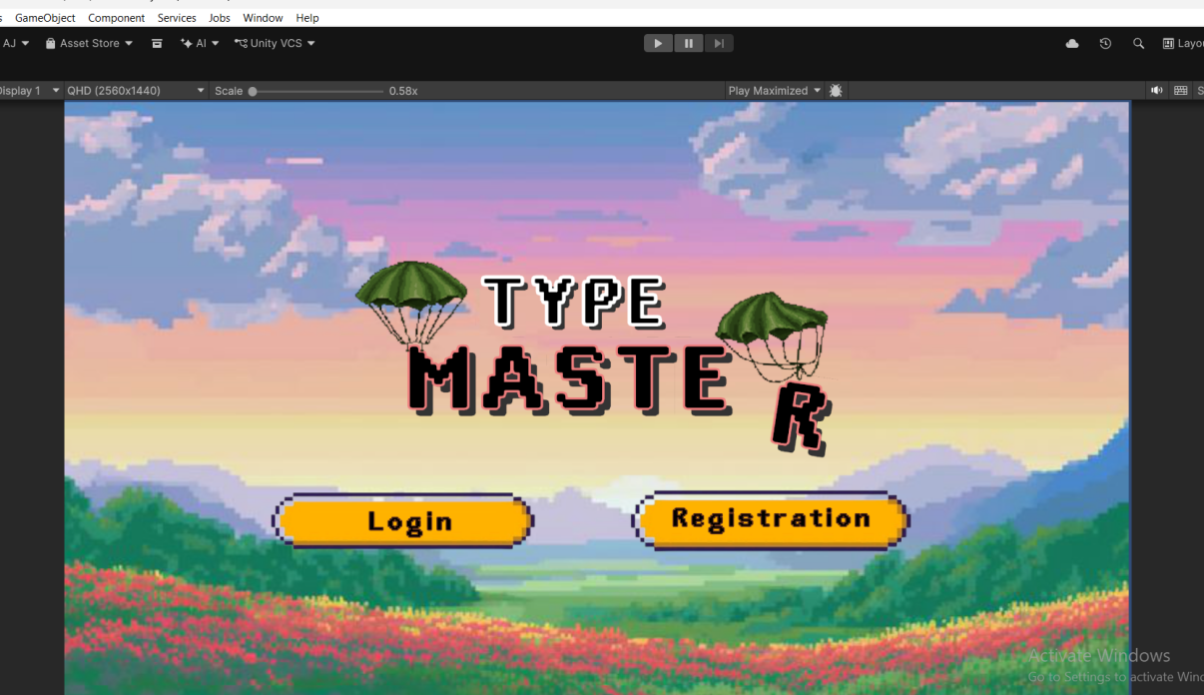
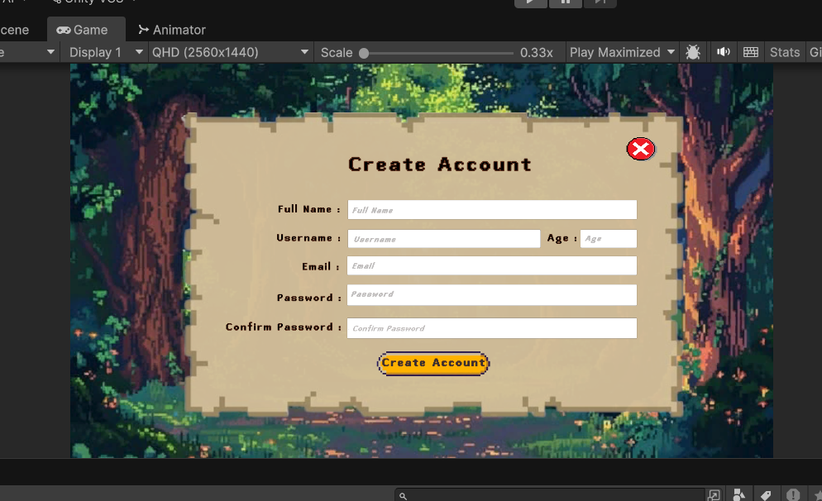
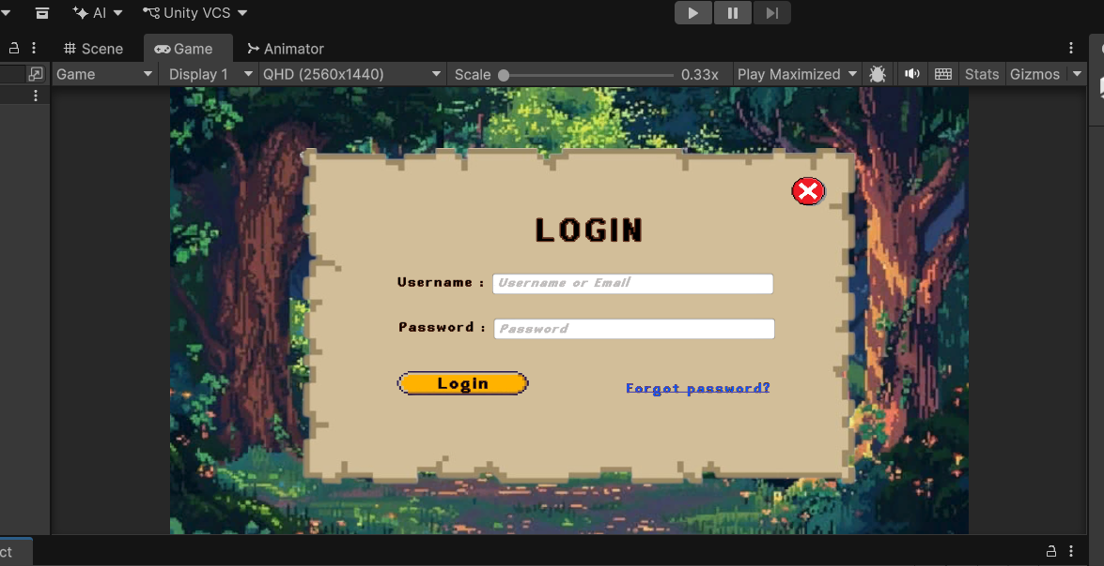
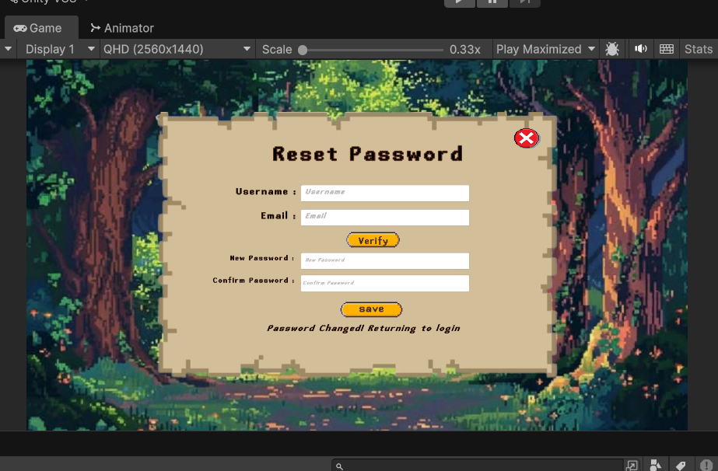
Fig: The front pages [ login, registration & Forgot password ]
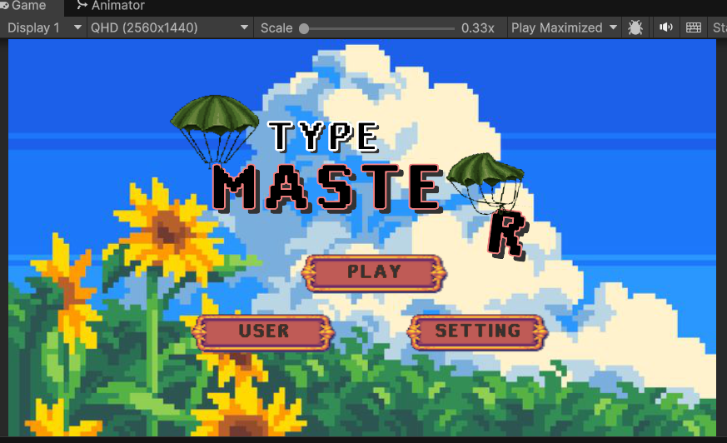
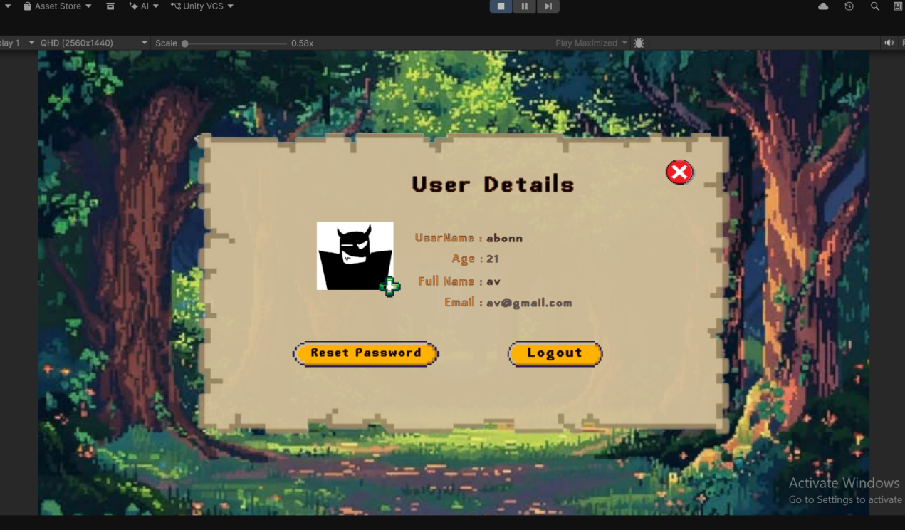
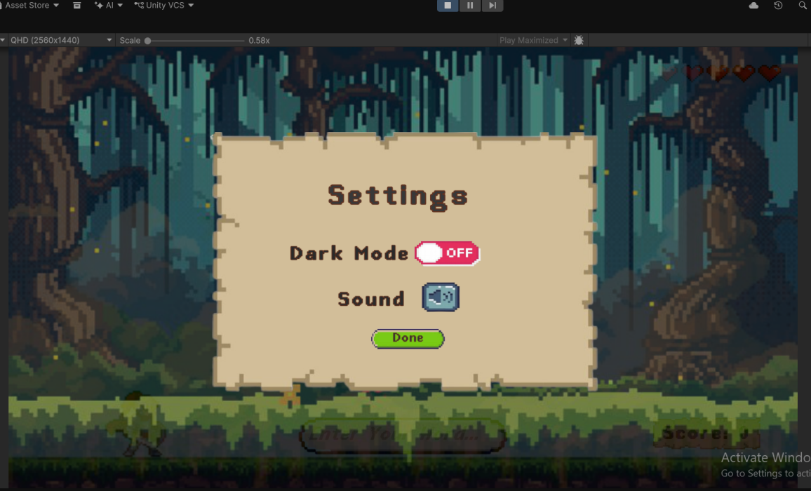
Fig: The main Game Page

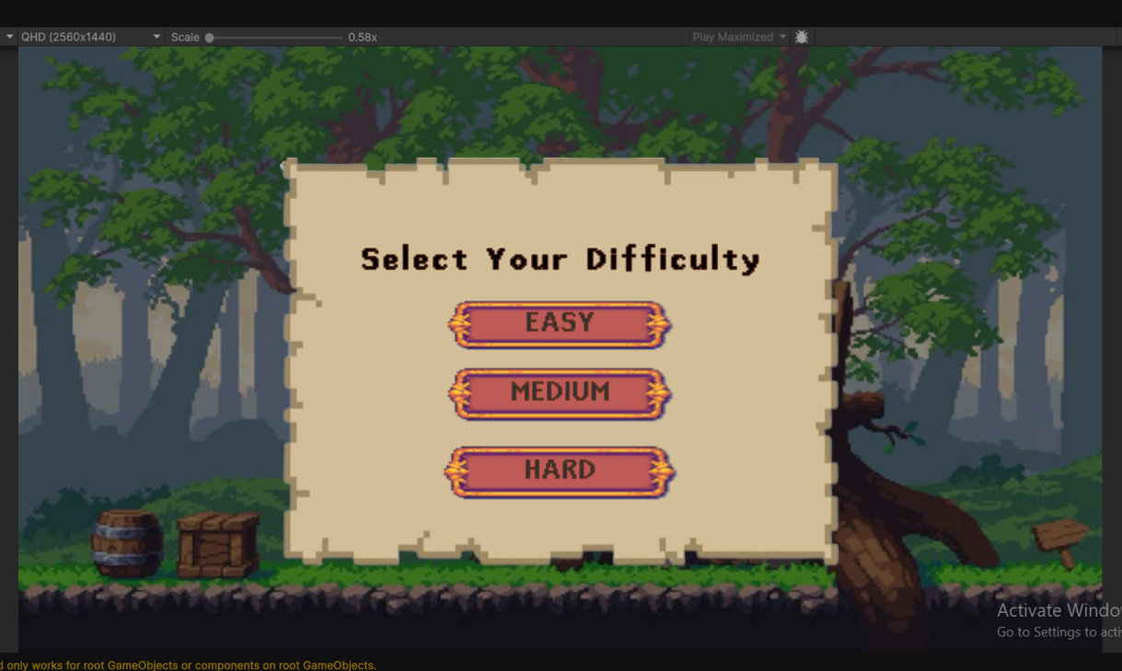
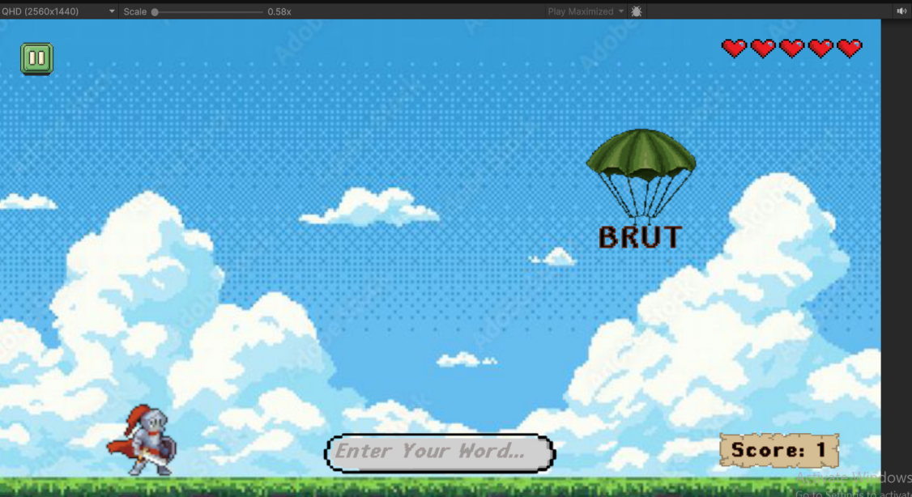
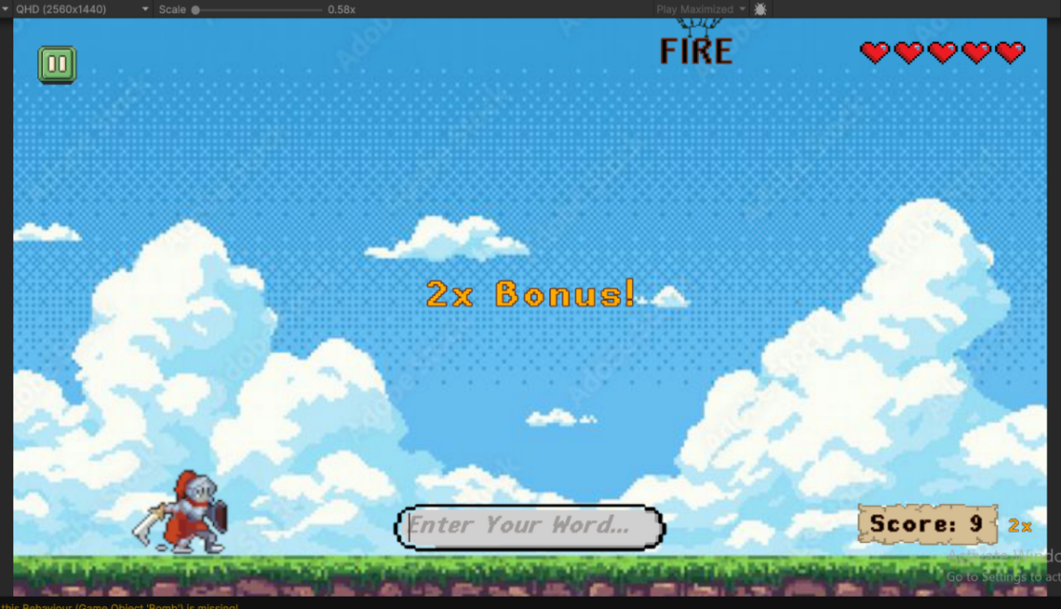
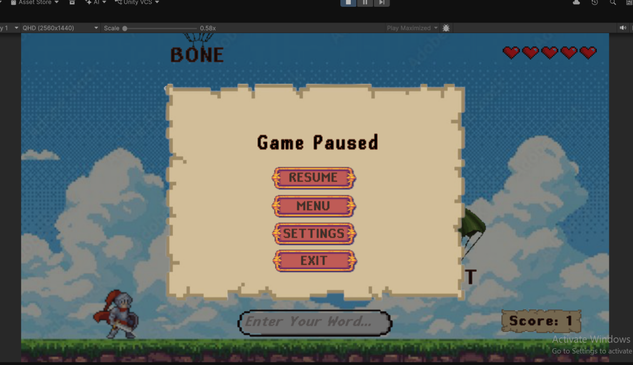
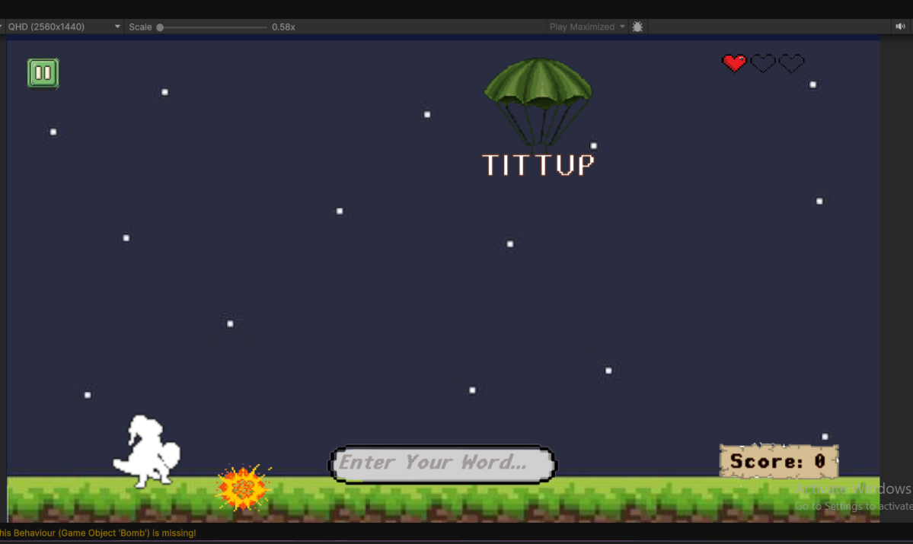
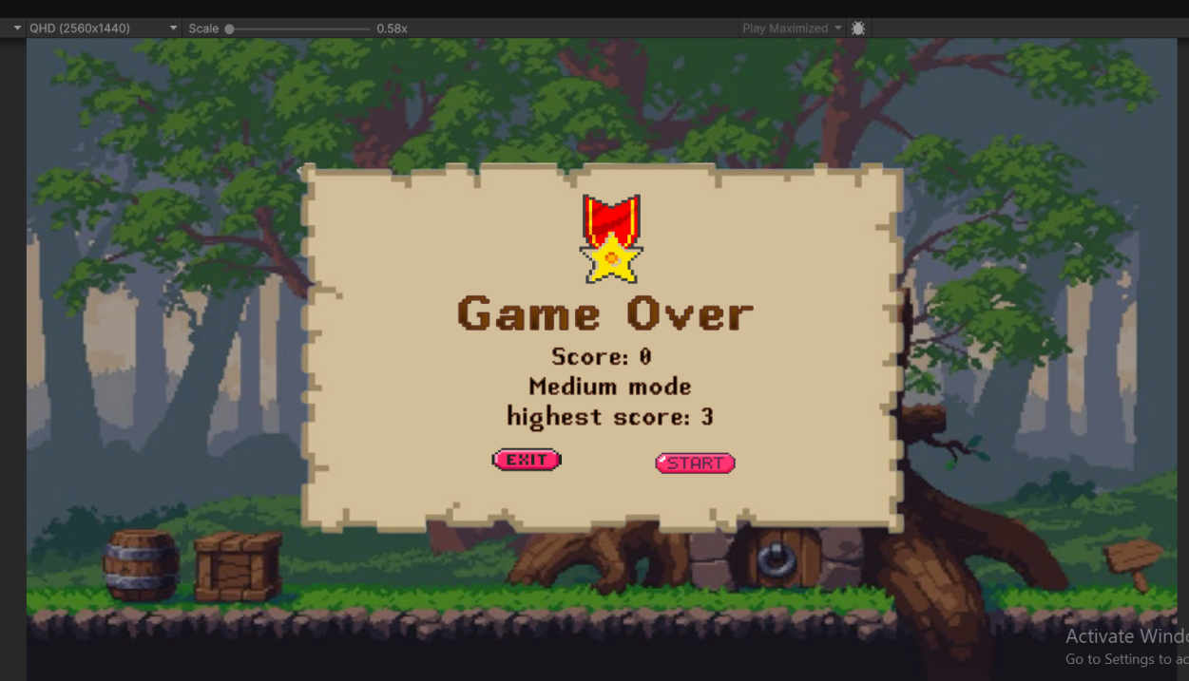
Fig: Game Interfaces

