

College: Engineering and Information Technology
Department: Information Technology
Program: Data Analytics

Text and Web Mining
course Project

Project Title : Human vs AI-Generated Essay Classification

Prepared by:
Abdullah Kheshfa: 202211479
Suliman Mohamed : 202211660
Khalfan Abdullah : 202211234
Omar Marwan : 202110606

Supervised by:
Dr. Mahmoud AbdelKarim Alshboul
Dr. Mahganj Durra

Academic Year 2025-2026 – Fall
Purpose of the Project
The main aim of this project is to come up with an automated system that can be used to differentiate between human written and artificial generated essays. With the introduction of more advanced and popular generative AI tools, teaching faculty and schools are getting an increasing challenge in preserving and sustaining academic integrity. The project Categorizes those issues by developing an entire pipeline in text analysis, which identifies the language patterns and puts them into the machine learning and deep learning systems to find out the origin of the text written in the article.

Dataset Description
The dataset in this project will be the Human vs AI-Generated Essays dataset of Kaggle. It includes some thousand English essays, all of which are marked as human-written (0) and AI-generated (1). The sample size is even and the two classes have the same representation which eliminates bias in the model. Every entry contains the entire text of the essay and its title making it to be appropriate in supervised learning. Human essays are more natural and personal whereas AI-generated essays are more formal and uniform. This data is a good base of training models that can differentiate human and AI writings.
Dataset Overview:
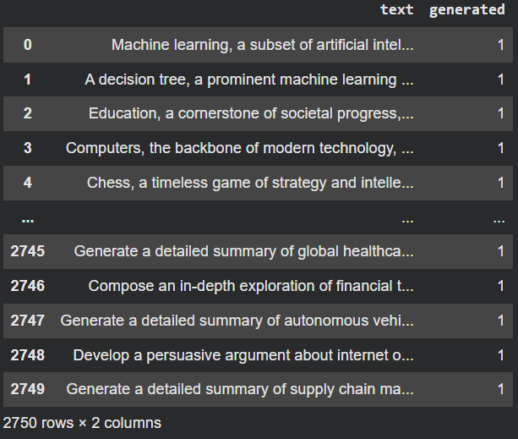
Exploratory Data Analysis (EDA)
When considering EDA phase, we analyze the data to see what the human and AI written essays are different before any type of models are developed. The step assists us in identifying trends, identifying problems, and ensuring that the information is trainable. To balance out the number of human and AI texts, we check the balance of the classes to make sure that they are approximately equal, which is notable to prevent the development of a biased model. We are also examining the distributions of word-counts to see whether a certain class has a tendency to write longer or shorter essays. Lexical diversity is checked to compare between the two groups that show the richness of vocabulary. Words and word clouds are visualized in order to identify the most common words used by humans and by artificial intelligence systems. Human writers are more likely to use more personal, informal and diverse words whereas AI-generated works are more structured, scholarly and repetitive. This is where we can form a basis of insights into the behavior of the dataset.
The dataset under consideration is comprised of 2751 records essay with two major fields:
text - the essay/prompt
generated - 0 = human, 1 = AI
The dataset is balanced such that the number of both classes is quite similar, which makes the model learning unbiased.
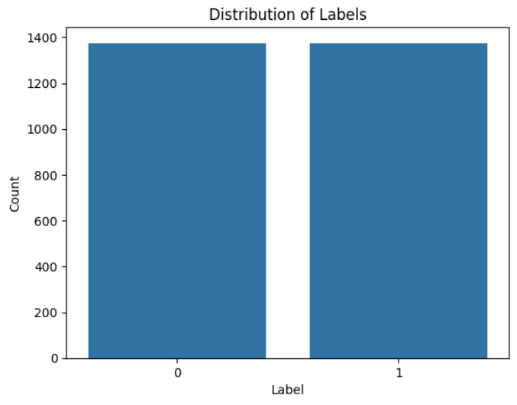
To learn more about the vocabulary discrepancies within the dataset, we made two word clouds one based on the list of words produced by the AI, and the other based on the list of words produced by humans. The visualizations allow visualization of which words occur the most in each category. The AI generated essays are more formal, structured, and academic, whereas human generated ones have more diverse, informal and personal words. Comparing the two sets of words cloud, we clearly get a visual perspective of the difference between AI and human writing styles in terms of the utilization of words.
generated by AI:
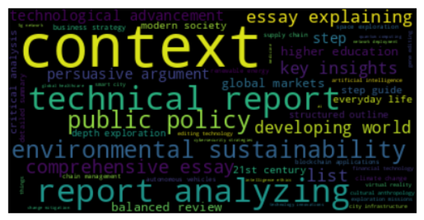

Not generated by AI
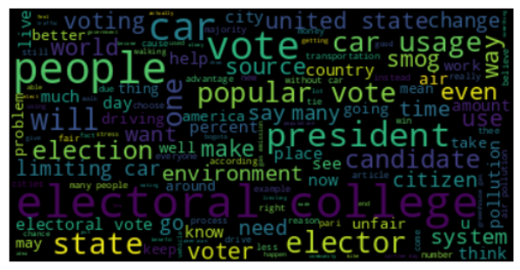
In order to gain a clearer insight into the form and nature of the essays in our dataset, we have obtained two useful textual variables, namely word count and lexical diversity. The word count statistics demonstrate the average length of the essays; the minimum length of the texts is very short, 13 words, whereas the maximum length of the essays is much longer, more than 1300 words. The distribution shows that the largest percentage of essays are of mid-range, of about 300-600 words, and there is also a large cluster of essays that are extremely short in length. This variability is easily shown in the histogram, which shows differences in writing length, and this can indicate varied writing behaviors of AI and human-written essays. Lexical diversity, in the form of words ratio of unique words to total words, gives the idea of the richness of vocabulary employed in each essay. The summary statistics indicate that the values between 0.32 and 1.0 with the majority of the essay having a diversity score between 0.5-0.7. As can be seen in the histogram, there are many texts which have moderate diversity, but there are groups of essays which have very high lexical diversity, i.e. texts which use a wide variety of unique words. These trends are helpful because human text tends to have more variety, creativity, and inconsistency, and sometimes an AI-generated text is perceived as either excessively monotonous or unnaturally refined. The analysis of these distributions will provide more insight into the differences in the length between human and AI essay and the richness of vocabulary used in both, which will support our future modeling and classifying processes.
display of basic statistics of word count. display of basic statistics of lexical diversity.
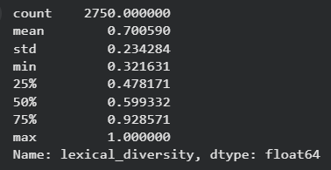
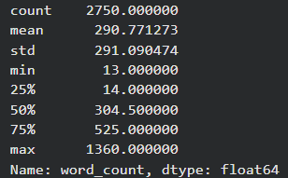

Plot
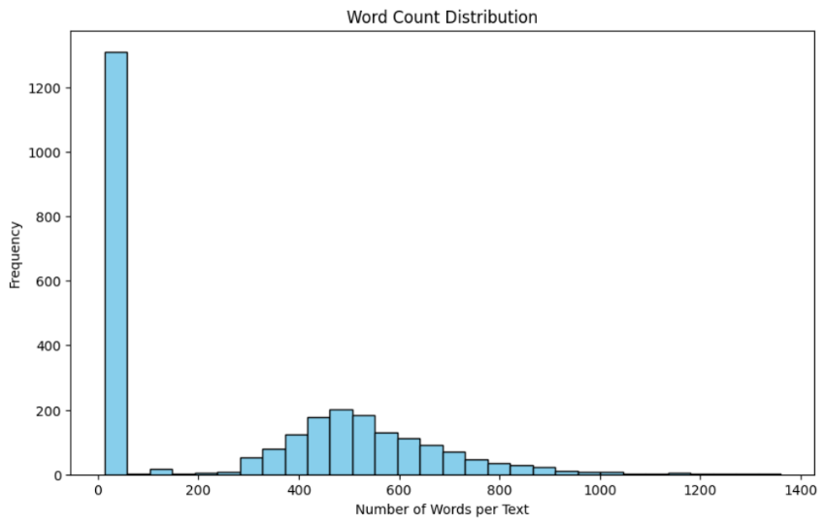
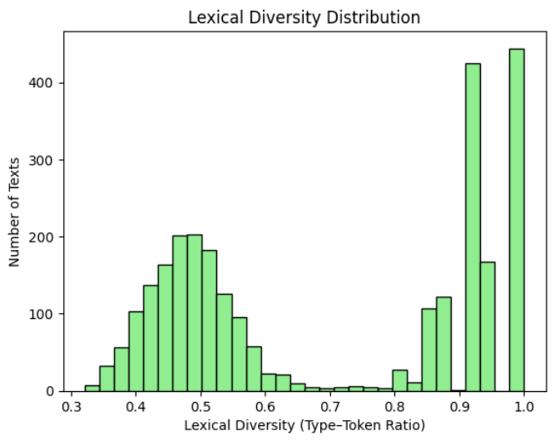

pre-processing and feature engineering:
Pre-processing involves the pre-processing of the raw text to be analyzed through cleaning and standardizing. Here, the text is turned to lowercase, punctuations are turned off and stopwords are erased to lessen the noise. Lemmatization would transform words into their roots and this can aid in standardizing of similar words such as running, runs and ran. A further useful information in the text is generated using feature engineering based on the text lengthening in word count, lexical diversity, and number of sentences. These characteristics assist the model to acquire writing style variations. This step makes sure that the text is clean, it has to be consistent and it has additional features that can enhance model performance.
the result of tokenized:
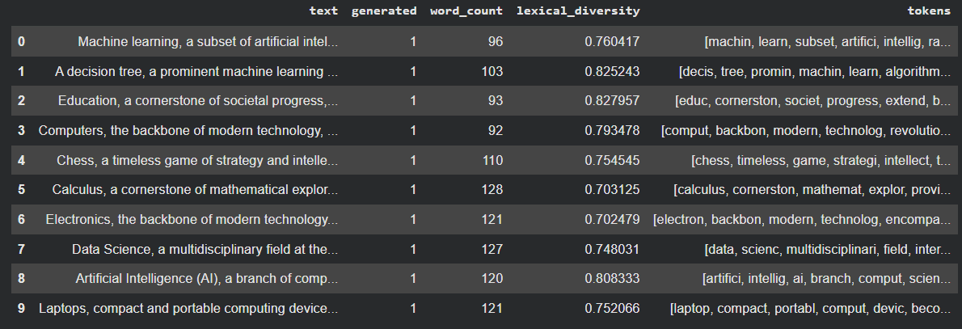
Text Representation:
The machine-learning models do not read the raw text and thus we have to find a method of transforming each essay into numbers. This is what is termed text representation. Text in the form of big numbers as the Bag-of-Words and TF-IDF methods are employed in the project. The figures represent the level of significance of a term or the usage rate. Our words too are cleaned and coded into tokens and converted to matrices that are understandable by the models. Without this step, the models would not analyze or learn the dataset. Inserted plot word vectors to a chart and observed where they are.

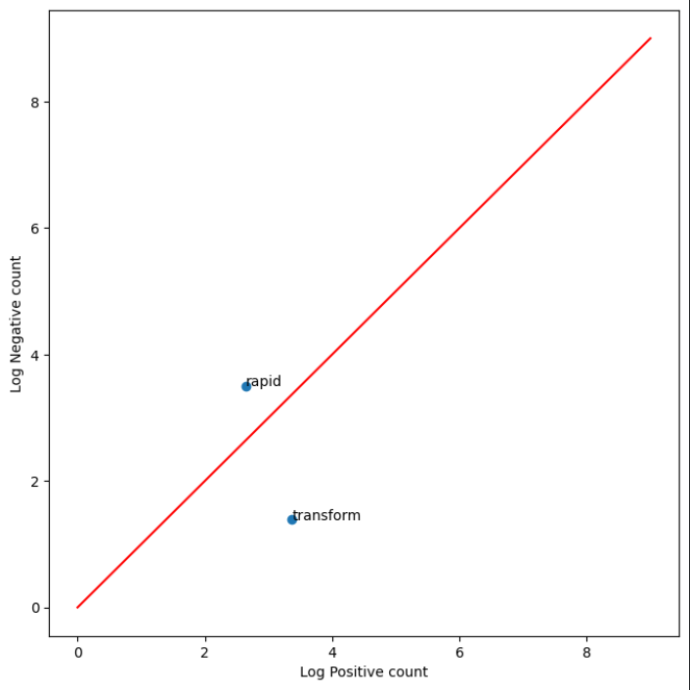
Plot word vectors in a chart and see where they locate

Constructing Features:
The feature building process consists in the creation of meaningful numerical data of the text which the model can learn. Other than the simple counts of words that we build the more advanced characteristics such as lexical diversity, number of sentences, and average word length. Such features are style of writing, design, and complexity, which can be used to distinguish between AI and human writers. In addition to these signature features, we construct feature matrices of Bag-of-Words, TF-IDF and Positive/ Negative word counts. These are all inputs on our different machine-learning models.

Term Frequency-Inverse Document Frequency (TF-IDF)
TF-IDF is a technique of converting text data to numeric vectors depending on the significance of each word in the collection. Term Frequency is used to find the frequency of occurrence of a word within an essay whereas Inverse Document Frequency decreases the significance of highly common words that are found across all the essays. TF-IDF assigns bigger weight to informative words and less weight to filler words such as the or and. It is specially effective in classification tasks since this technique is able to emphasize the words that really make a difference in human as well as AI writing. The project applies TF-IDF to train a machine-learning model which works well relative to other feature representations.

Model building
During the model-building phase we then train a few machine-learning models on the processed and represented text data. Bag-of-Words, Positive/Negative scoring and TF-IDF representations like classical models include Logistic Regression, Naive Bayes, and Support Vector Machine. They translate patterns and relationships in the collection of essays that aid them in classifying new essays. Each of the models involves varying mathematical methods to determine whether the writing is more of a human style or of AI-generated style. The models are also tested, and the predictions they give are also compared to select the most effective- performing method after training.
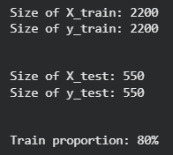

This is the positive negative model:
Positive-Negative model is calculated on sentiment features. Under this method, the text has been scanned to determine the number of positive and negative words used in each essay. These counts are stored in a feature matrix and a Logistic Regression classifier is trained on the feature matrix. This model tries to differentiate between AI and human text in terms of the emotional tone, since human texts have more expressive and emotional words by default, whereas AI writing is more neutral and formal. Although this is a simple model compared with TF-IDF, the model can still give good information regarding the emotional patterns in this dataset. Count vectors It is applicable to categorical datasets.

Count vectorizer model Bag of words:
Count vectors It may be applied to categorical information. In order to minimize the number of characters as the number of times when a certain word appears in an essay, the Bag-of-Words model helps to check how often words are repeated in an essay. The outcome is a massive matrix whereby each column represents a word and each row represents an essay. It is built with the help of CountVectorizer. This is then inputted into a machine leaning model to classify the text. The frequency-based sound that is absorbed under this strategy is the frequency of the usage of informal or emotional words on the part of the human writer compared to the more formal and more organised language in the AI-generated text.
Positive/Negative Frequency confusion matrix:
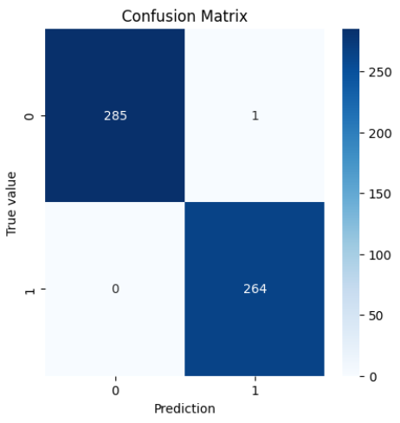

Count Vector Confusion Matrix
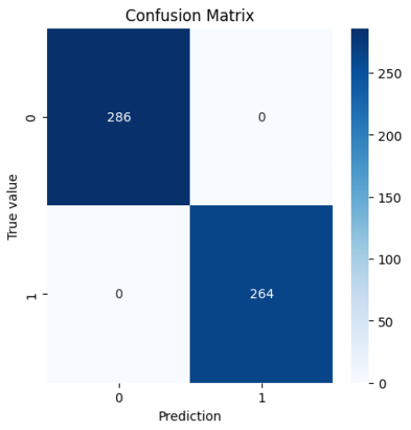

Confusion Matrix for TF_IDF :

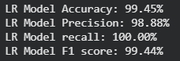

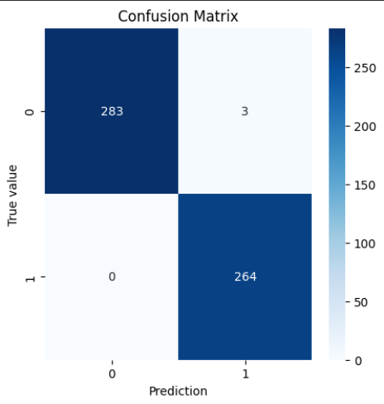

ROC curve:
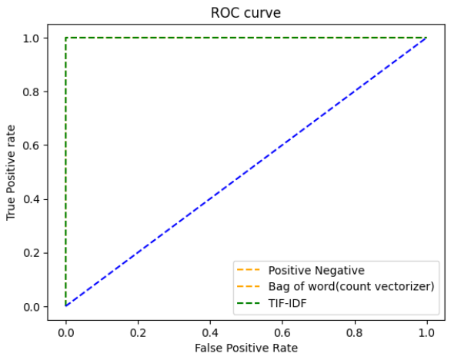
Predicitons for the PN
The PN model is then used to predict the test set upon training. The model gives 0 when it is written by human and 1 when it is written by AI. Accuracy is then used to evaluate the performance using a confusion matrix. The findings indicate the ability of sentiment-based features to distinguish human and AI writing. The model is typically moderately better than worse but fails to represent deeper linguistic structures thus is typically not as good as TF-IDF.
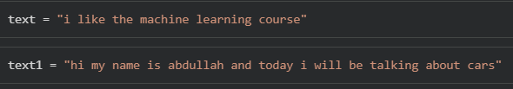
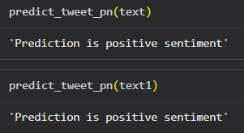

Predictions for The CV (Bag-of-Words)
The test data are processed by the Bag-of-Words model, which is used to obtain predictions between human vs AI essay. This model has the benefit of being better than PN but worse than TF-IDF because it captures pure frequency patterns. The predictions demonstrate the differences in the patterns of word use in the two classes. Evaluation measures are used to know the number of essays that the model correctly categorized and the errors of the model.
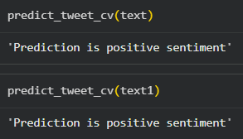
Predictions for the TF-IDF Model
The TF-IDF model is evaluated by applying it to the test set producing predictions. This model generally performs optimally compared to the other classical methodologies since the weighted word significance is adopted as opposed to the mere counts. The TF-IDF model predictions reveal that it is more effective in distinguishing between AI-generated and human writing. This feature representation is effective as demonstrated in the evaluation measures of accuracy, precision, recall, and confusion matrix.

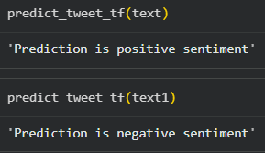

Light weight Neural Model(LSTM AND GRU)
The models used in this project have been a lightweight neural model that is both LSTM as well as GRU layers to analyze the text on a more sequential level. The LSTM (Long Short-Term Memory) is efficient in long-range dependencies of writing, including the tone, transitions, and sentence flow. GRU (Gated Recurrent Unit), is a more simplified form of LSTM and is faster though also capable of learning valuable context between surrounding words. The combination of the LSTM-GRU architecture enables the model to recognize the structure and rhythm of an essay and thus the model can distinguish subtle differences between human and AI writing. The text written by a human being may be inconsistent in the patterns, emotional, and irregular in grammar whereas the text that a robot produces is more regular and finished. This model learns these variations reading the essays word by word and recognizing the more profound writing way. LSTM and GRU models are lightweight and as such can be run on such systems as Google Colab and achieve good performance.
Evaluation
The assessment phase was about the measurement of the model performance in terms of the conventional classification measures like accuracy and loss. In every classical and neural model, the lightweight neural model (LSTM + GRU) had the most prominent results with nearly 99% accuracy and minimum loss. This means that the model was extremely successful in acquiring the latent mechanisms that distinguish human-composed essays and those composed by AI. Comparatively, other classical models like, Positive-Negative model, Bag-of-Words, and TF-IDF also performed excellently but not with the same precision as the neural model. All in all, the results of the evaluation prove that the system was trained properly and the neural model was the most valid approach to use when it came to this classification problem.

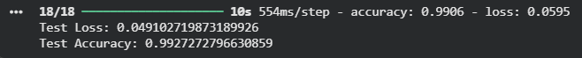

Testing
The trained models were used to entirely unseen test split data to determine actual generalization in the real world. The light neural model remained on a high level of performance scoring a test accuracy of around 99 which showed high levels of reliability and stability in the classification of new essays. The low test loss means that the model has not overfitted and can be relevant to differentiate human and AI-generated writing even when faced with unknown examples. These test outcomes can be taken as a good indication that the model can be generalized, and it can continue to perform highly even when it is not operating within the training context.
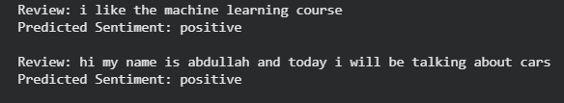

Almost perfect classification
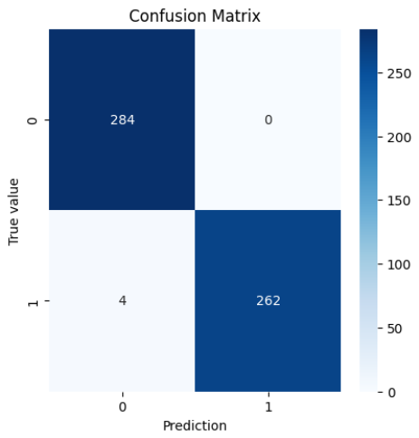
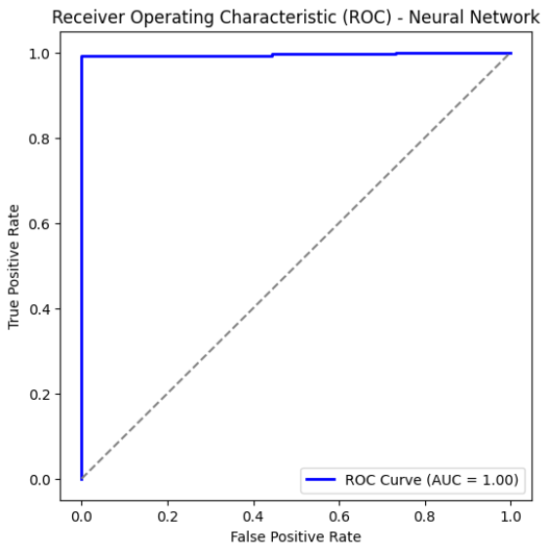

BERT
BERT is one of the latest models based on transformers that can be regarded as one of the most innovative practices in natural language processing. BERT reads the whole sentence simultaneously, unlike LSTM or GRU, which process the text sequentially and comprehends the meaning of each word in relation to other words in the sentence. This enables BERT to learn the complex context and semantic connectivity that potentially would be overlooked by classical models and recurrent networks. BERT, in the project, tokenizes the essays and forms contextual embeddings, which are a deeper meaning. Due to the similar structure of text produced by AI systems, repetitive shifts, and formal grammar, BERT can be used to detect such hidden patterns well. With irregularities and personal touch, human writing is especially clear when it is fed through a contextual model such as BERT. In spite of the BERT being slower to compute than LSTM-GRU, it is usually more accurate and offers a better interpretation of natural language.
finally our model ROC AUC indicates it nearly perfect which means the classifiation isnt random.


The confusion matrix also tells us the model is good.
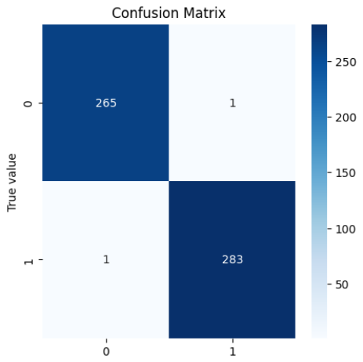

Conclusion
The project manages to illustrate that classical and neural models could differentiate the essays written by humans and AI with the help of effective preprocessing, engineering of features, and text representations. LSTM-GRU model is the best at capturing writing patterns in a sequence whereas BERT model gives deeper contextual awareness and therefore can be classified with a lot of precision. The choice of EDA, TF-IDF functions, Bag-of-Words, sentiment based features and neural embeddings helped to create a strong pipeline. We achieve high accuracy on a variety of models and BERT is the most successful in general since it has more sophisticated contextual abilities. These results prove that there are significant linguistic and structural distinctions between human and AI writing. All in all, the project has reached its objective, completed all the necessary steps and delivered reliable results and this shows that we have done a good and successful job.

