
Princess Sumaya University for Technology
King Abdullah II Faculty of Engineering

Autonomous Mobile Robots Challenge

M.Mahmoud 20220801
A.Musa 20220111
A.Ismail 20220601

Supervisor: Dr. Belal Sababha
Embedded Systems Final Design Project, Fall 2026

Submission Date :
19/5/2026

Table of Contents

Table of Contents…………………………………………………2
1. Abstract …………………………………………………………..3
2. Introduction and Background …………………………..3
3. Your Design ……………………………………………………..4
3.1 Mechanical Design ……………………………………..4
3.2 Electrical Design ………………………………………….5
3.3 Software Design ………………………………………….6
4. Problems and Recommendations …………………….8
5. Conclusion ……………………………………………………….8

1. Abstract
This project report details the design, construction, and programming of an autonomous mobile robot developed to complete a multi-stage navigation challenge. The robot is equipped with sensors and actuators that allow it to detect, interpret, and respond to different zones on the track-such as line-following sections, tunnels with reduced lighting, and wall-bordered navigation paths. It also features an automated parking system that uses ultrasonic ranging and servo actuation for precision. The embedded system was implemented using a PIC16F877A microcontroller, programmed in MikroC PRO for PIC, with all delays, logic, and bit operations manually coded. The result is a robot capable of real-time environmental adaptation and task completion without external control. This document outlines the hardware, software, and mechanical design, as well as challenges and recommendations for system improvement. In addition to meeting functional requirements, the work emphasized reliability under time constraints and repeatability across multiple test runs. The robot's design choices were driven by practical constraints such as limited I/O resources, sensor noise, and the need to coordinate several behaviors without human intervention. Throughout development, the system was refined through iterative testing, threshold tuning, and incremental integration of each stage to ensure smooth transitions between zones.

2. Introduction and Background
The "Autonomous Mobile Robot Challenge" is a comprehensive embedded systems project designed to test the student's ability to integrate hardware and software into a functioning autonomous platform. The robot must complete a series of zones that require distinct control logic and sensor-based decision-making. The challenge begins from a stationary start zone where the robot waits for a user input, transitions through line-following and tunnel navigation, detects walls(obstacles) using infrared and ultrasonic sensors, and finally parks autonomously in a designated zone.
The system's architecture reflects a modular design philosophy-each stage of navigation (line following, tunnel detection, wall following, and parking) was treated as a standalone behavior controlled by feedback from multiple sensors. The design was constrained by project requirements emphasizing manual coding (no built-in delays or unions) and efficiency under limited computational resources. From an engineering perspective, the challenge resembles a simplified real-world autonomous navigation problem where perception (sensing), decision-making (control logic), and actuation (motors/servo) must operate together under uncertainty. Because the track contains different environmental conditions (e.g., reduced light in the tunnel and an unmarked wall-bounded area), the robot must dynamically switch its navigation strategy while maintaining stability and safety. The project therefore provides strong practice in designing state-based controllers and validating them with systematic testing.

3. Your Design

3.1 Mechanical Design
The robot employs a differential-drive chassis powered by two DC motors, allowing for precise directional control by varying individual wheel speeds. The chassis dimensions are approximately 28 cm in length, 22 cm in width, and 13 cm in height, satisfying all project limitations. The mechanical design focuses on low center of gravity and modularity. The front section houses the IR sensors for line detection, the middle frame supports the electronic control unit, and the rear mount holds the servo-operated flag for parking indication. Rubber wheels provide traction for the line and bump zones, while the balanced weight distribution ensures smooth ascension over the incline section.
The differential-drive configuration was selected because it offers a good balance between simplicity and maneuverability, allowing tight turns and in-place rotation when required by obstacle avoidance or intersection handling. To reduce vibration and sensor misalignment, the sensor mounts were fixed using rigid supports, and wiring was routed to minimize mechanical strain during movement. The overall layout was planned so that the sensing components "see" the track clearly, while the electronics remain protected and accessible for troubleshooting.
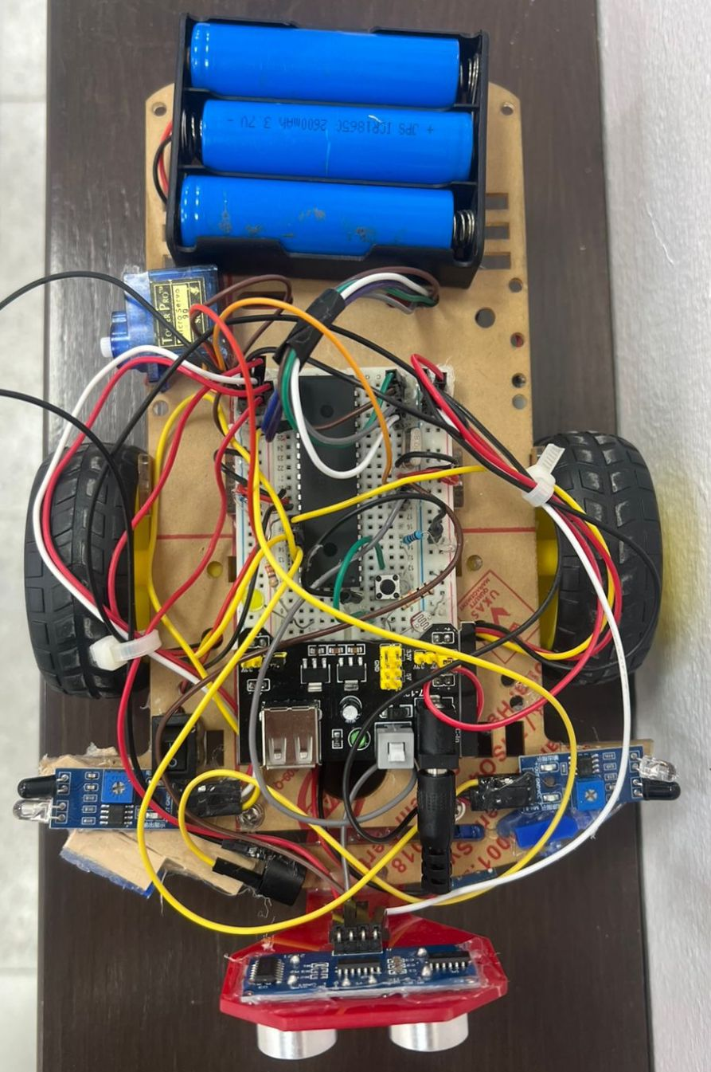
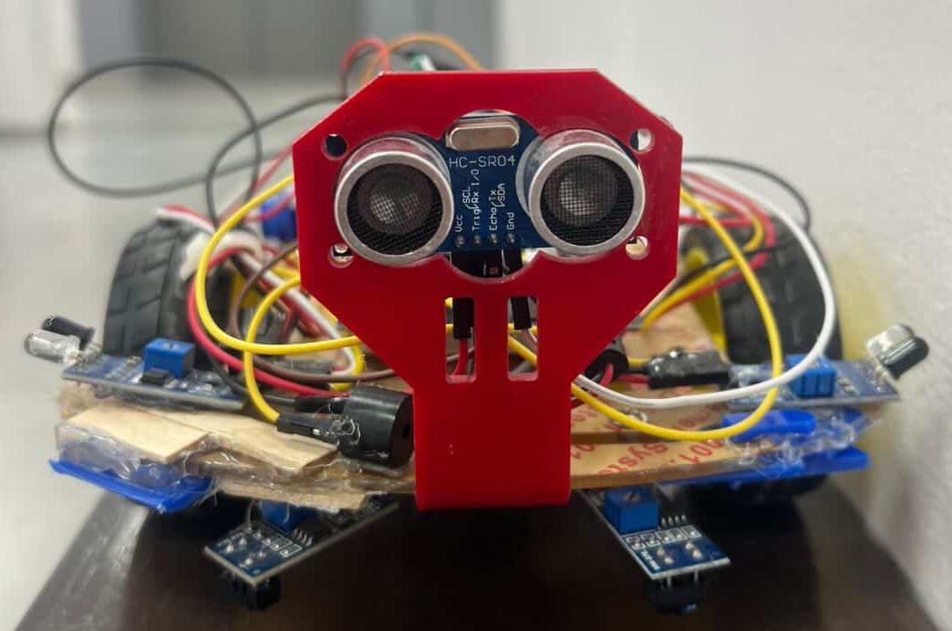

3.2 Electrical Design
The electrical architecture integrates multiple sensing and actuation components through the PIC16F877A microcontroller. Power is provided by an 11.1V Li-ion battery regulated to 5V for logic-level components. The main modules include:
• Microcontroller: PIC16F877A (8-bit, 8 MHz clock)
• Motor Driver: L298N dual H-bridge controlling the two drive motors
• Sensors: IR line trackers ,LDR (its directly connected to BB), ultrasonic and obstacle IR sensors
• Actuators: DC motors, buzzer , LED , and servo
Voltage regulation is achieved using a 7805 IC and decoupling capacitors. Pull-down resistors stabilize inputs to prevent floating signals. The schematic also includes manual reset and power switches for debugging and safety purposes.
Special attention was given to grounding and power distribution because motor switching can introduce noise that affects analog readings and digital thresholds. For this reason, the logic ground and motor ground were routed carefully, and regulator was placed near the microcontroller and to stabilize supply voltage during load changes.
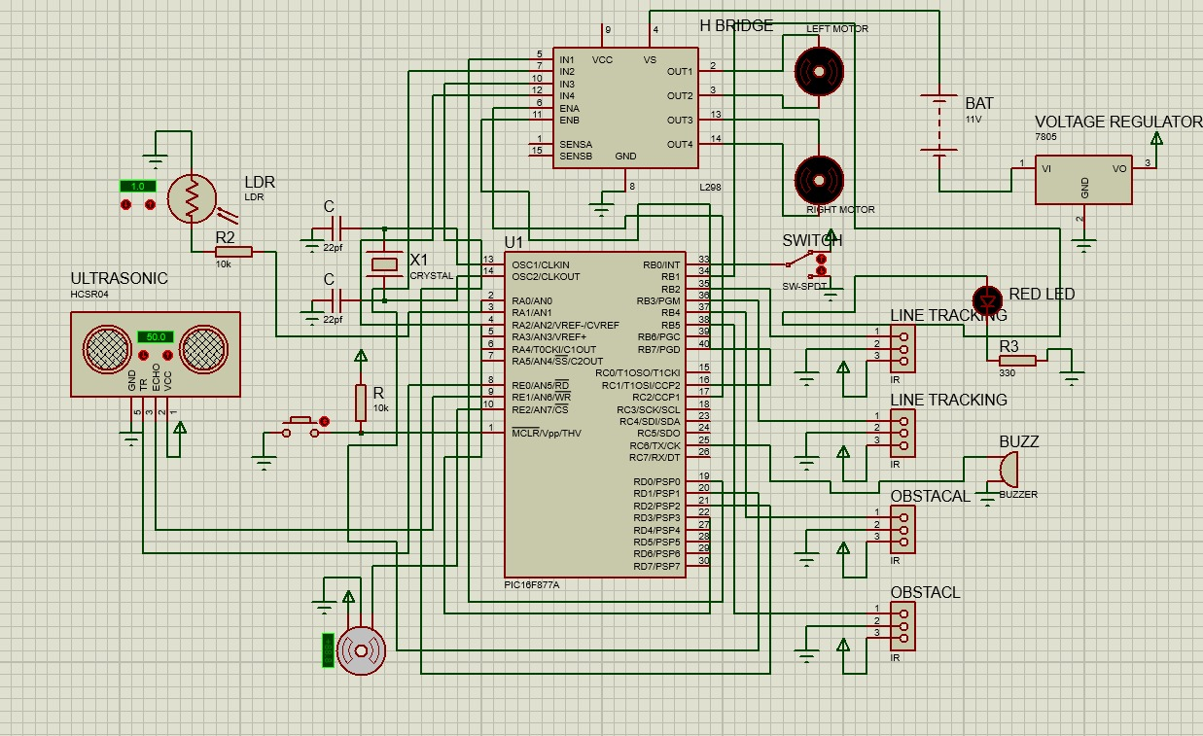

3.3 Software Design
The software architecture was built using the MikroC PRO for PIC compiler, with strict adherence to manual bitwise operations and timing control. The code uses modular routines for line following, wall following, and parking logic. System flow is organized through state transitions based on real-time sensor data. A timer-based delay routine replaces standard library delays, ensuring non-blocking timing accuracy. The control loop continuously reads sensor values to determine the robot's operating state.
To keep the firmware readable and maintainable, the code was structured into reusable functions for sensing, motion control, and special behaviors such as parking and wall(obstacle) avoidance. The main loop continuously evaluates the robot's current context and selects the next action based on sensor thresholds and mode flags. This approach reduces complexity compared to having one long routine, and it also makes it easier to test each module independently before full system integration.
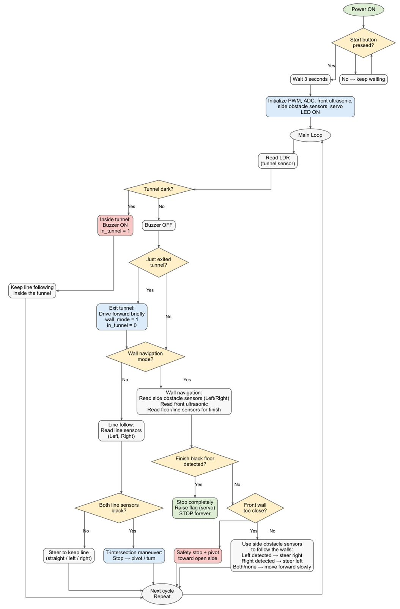

4. Problems and Recommendations
During testing, several performance issues were observed. Ultrasonic sensor readings occasionally fluctuated due to environmental noise, causing inconsistent wall-following behavior. Additionally, minor mechanical asymmetry between the two drive motors led to gradual drift, requiring real-time compensation in the software, the LDR was also highly sensitive to ambient lighting conditions, necessitating manual calibration during tunnel detection. In some cases. These issues were most visible during rapid transitions-such as tunnel exit to wall-following-where multiple sensors and behaviors change at once. Environmental factors such as reflective surfaces, uneven lighting, and slight wall angle differences also contributed to measurement variability.
The testing process highlighted the importance of tuning thresholds under the same conditions expected in the final evaluation track, as well as validating the robot's behavior across multiple repeated runs.
Some recommendations:
- 1- Secure all sensors firmly to avoid movement, since loose sensors can give wrong readings
- 2- Slow down the robot speed in critical areas like corners and parking to improve accuracy.
- 3- Test each sensor individually before running the full system to catch problems early and save dubbing time.

5. Conclusion
The final autonomous robot design successfully integrates sensor-based navigation, real-time control, and precise actuation using a fully custom-coded PIC16F877A microcontroller system. The robot demonstrates the ability to autonomously navigate through a multi-zone track, adapting its behavior to environmental conditions such as light intensity, and track patterns and walls . This project not only fulfilled all technical requirements but also provided valuable experience in low-level embedded design, circuit interfacing, and algorithmic motion control.
Future enhancements could include wireless telemetry, improved sensor fusion, and a feedback-based motor speed controller to further refine its performance. The completed system demonstrates how a constrained embedded platform can still achieve complex autonomous behavior when the design is carefully modularized and validated. The robot's performance reflects not only the correctness of the control logic, but also the quality of hardware integration, wiring discipline, and calibration of sensors. Overall, the project provides a strong foundation for more advanced enhancements such as multi-sensor fusion, adaptive control, and higher-level planning.

