

Capstone Project - Mohkam

Team
مُحْكَم –Mukam

Team Members
Abdulaziz Alqahtani

Abdulrahman Alkholaiﬁ

Ghaida Alzahrani

Mohammed Aldawood

Naif Aldrees

Raghad Aldosari

Supervisor: Hany Elshafey

Data Science and
Machine Learning Bootcamp
– Tuwaiq Academy

Table of content

Introduction 3
Problem Statement 4
The Solution 5
Automated Document Auditing 5
Sensitive Data Detection 5
Regulation-Aware Assistant (RAG System) 5
Database Auditing 5
Comprehensive Reports 5
Voice Interaction via Raspberry Pi 6
Benefits of this solution 6
The concept and platform vision 7
Core Modules in Mahkam 7
Platform Screenshots & Features 8

Introduction
Figure SEQ Figure \* ARABIC 11 Predict Mission Success (%) Model
In today’s fast-paced business environment, regulatory compliance has become a cornerstone for ensuring business continuity and mitigating risks. Organizations are increasingly required to adhere to strict regulations, such as the Personal Data Protection Law (PDPL) and National Cybersecurity Authority (NCA) standards, to safeguard sensitive information and maintain trust with stakeholders.
Traditional compliance auditing methods, however, are time-consuming, labor-intensive, and prone to human error. Auditors spend weeks manually reviewing documents, policies, and database structures, often struggling to deliver timely and accurate reports. Moreover, businesses under audit require clear, actionable insights to address compliance gaps efficiently, something that traditional methods often fail to provide.
To address these challenges, we developed MUHKAM, an advanced AI-powered compliance platform designed to revolutionize the auditing and compliance process. By integrating Artificial Intelligence (AI), Natural Language Processing (NLP), Optical Character Recognition (OCR), and Database Auditing, the platform significantly reduces audit time from weeks to minutes, while simultaneously improving accuracy and scalability.
MUHKAM is not just a tool—it is a comprehensive compliance ecosystem that empowers both auditors and organizations with real-time insights, intelligent reporting, and automated verification. The platform combines document auditing, sensitive data detection, database compliance checks, and an AI compliance assistant into a unified solution, deployed on Google Cloud Platform (GCP) for reliability and scalability.

Problem Statement

In today’s regulatory environment, compliance auditing remains a critical but highly challenging task for both organizations and auditors. Traditional methods of auditing, which rely heavily on manual reviews of documents, policies, and databases, present several issues:

Challenges in Manual Compliance Auditing

- Time-Consuming Processes:
Reviewing hundreds of compliance documents, policies, and records requires significant effort, often stretching over weeks or months.

- Human Error and Oversight:
Due to the complexity and volume of information, auditors may overlook certain violations or inconsistencies, leading to incomplete or inaccurate results.

- Resource-Intensive:
Companies must allocate large teams of compliance officers or external auditors, resulting in high operational costs.

- Difficulty in Data Sensitivity Identification:
Detecting sensitive personal data (emails, phone numbers, IDs, etc.) across large sets of documents is not only complex but also prone to misclassification.

- Limited Accessibility of Standards and Regulations:
Auditors and organizations may struggle to quickly reference official regulations (e.g., PDPL, NCA standards) during reviews, which delays the decision-making process.

Impact of These Challenges
- Organizations risk non-compliance penalties and reputational damage.
- Auditors face pressure to deliver results faster, often at the expense of accuracy.
- Decision-makers lack clear, structured reports that highlight violations and corrective actions.

The Solution
In response to the challenges faced in traditional compliance auditing, Mahkam introduces a smart, integrated platform designed to streamline and optimize the auditing process. By leveraging artificial intelligence, automation, and cloud-based infrastructure, the platform reduces manual effort, minimizes errors, and accelerates the delivery of compliance reports.

Key Features of the Solution

Automated Document Auditing
The platform allows users to upload corporate policies, contracts, and other documents for automated compliance checking. Using OCR (Optical Character Recognition) and AI-powered Natural Language Processing (NLP), the system extracts and analyzes text to identify violations or missing compliance requirements.

Sensitive Data Detection
Mahkam includes a PII (Personally Identifiable Information) detection system that scans through text to identify sensitive data such as names, phone numbers, emails, or identification numbers. This ensures compliance with privacy and data protection laws.

Regulation-Aware Assistant (RAG System)
A Retrieval-Augmented Generation (RAG) model is integrated into the platform. It enables managers and auditors to ask direct questions about specific laws or regulations and receive precise, reference-backed answers. For example: “What does Article 14 of the NCA regulation say about user privacy?”

Database Auditing
The platform can connect to company databases and check entries against compliance rules. This ensures that structured data (like employee records, financial logs, or security logs) follows official regulatory frameworks.

Comprehensive Reports
The system generates professional compliance reports that highlight detected violations, reference the violated law, and suggest corrective actions. Reports are designed to be boring-ready and understandable by both auditors and managers.

Voice Interaction via Raspberry Pi
Using a Raspberry Pi device with a microphone and speaker, managers can interact with the system through voice commands. This feature is particularly useful for executives who want quick answers without navigating the platform manually.

Benefits of this solution

- Speed: Reduces auditing from weeks to minutes.
- Accuracy: Eliminates oversight and human error.
- Transparency: Provides traceable references to laws and regulations.
- Integration: Unifies document auditing, database checks, and Q&A assistance into one platform.
- Scalability: Built on Google Cloud Platform (GCP), ensuring reliability and the ability to grow with organizational needs.

The concept and platform vision
The vision behind Mahkam is to go beyond traditional compliance auditing tools and provide a fully integrated compliance platform. The platform combines automation, artificial intelligence, and user-friendly interaction to cover all aspects of regulatory auditing.

Instead of requiring multiple tools for different purposes (document review, sensitive data detection, regulatory Q&A, and database validation), Mahkam unifies them into a single environment that ensures consistency, accuracy, and efficiency.

Core Modules in Mahkam
- Document Compliance Checker
Uploads and analyzes corporate policies, contracts, and operational logs to detect violations and missing compliance elements.
- Sensitive Data Scanner (PII NER)
Detects and highlights personal data such as names, IDs, and phone numbers to ensure compliance with PDPL and global privacy laws.
- Regulation Knowledge Base (RAG Assistant)
An AI-powered assistant that allows users to ask regulation-related questions and get instant, citation-backed answers.
- Database Compliance Auditing
Connects directly with structured databases (e.g., HR, Finance, Security Logs) and checks for compliance against official standards.
- Management Interface via Raspberry Pi
A dedicated hardware assistant for executives, enabling them to ask questions via voice (e.g., “How many companies were audited this quarter?”) and receive real-time answers.

Platform Screenshots & Features
1. Overview Page
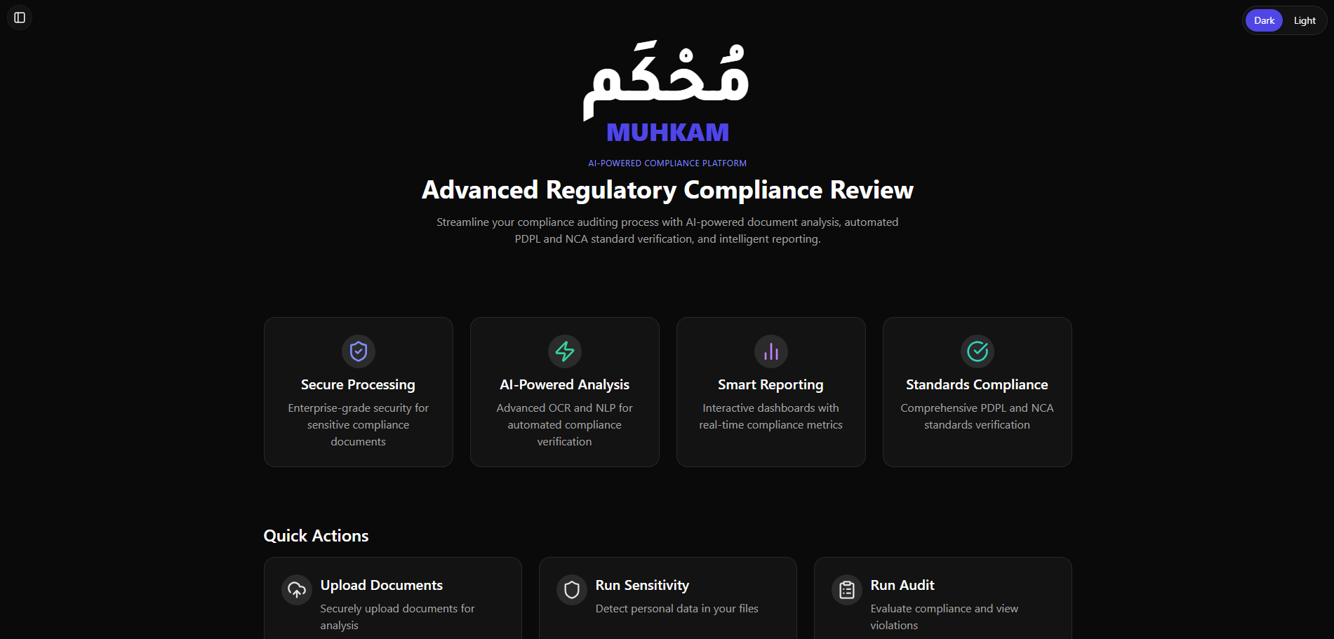
Figure 1: The overview page of Muhkam platform, providing a centralized entry point to all compliance modules, including secure document processing, AI-powered analysis, smart reporting, and standards compliance.

2. Dashboard – Compliance Score Distribution
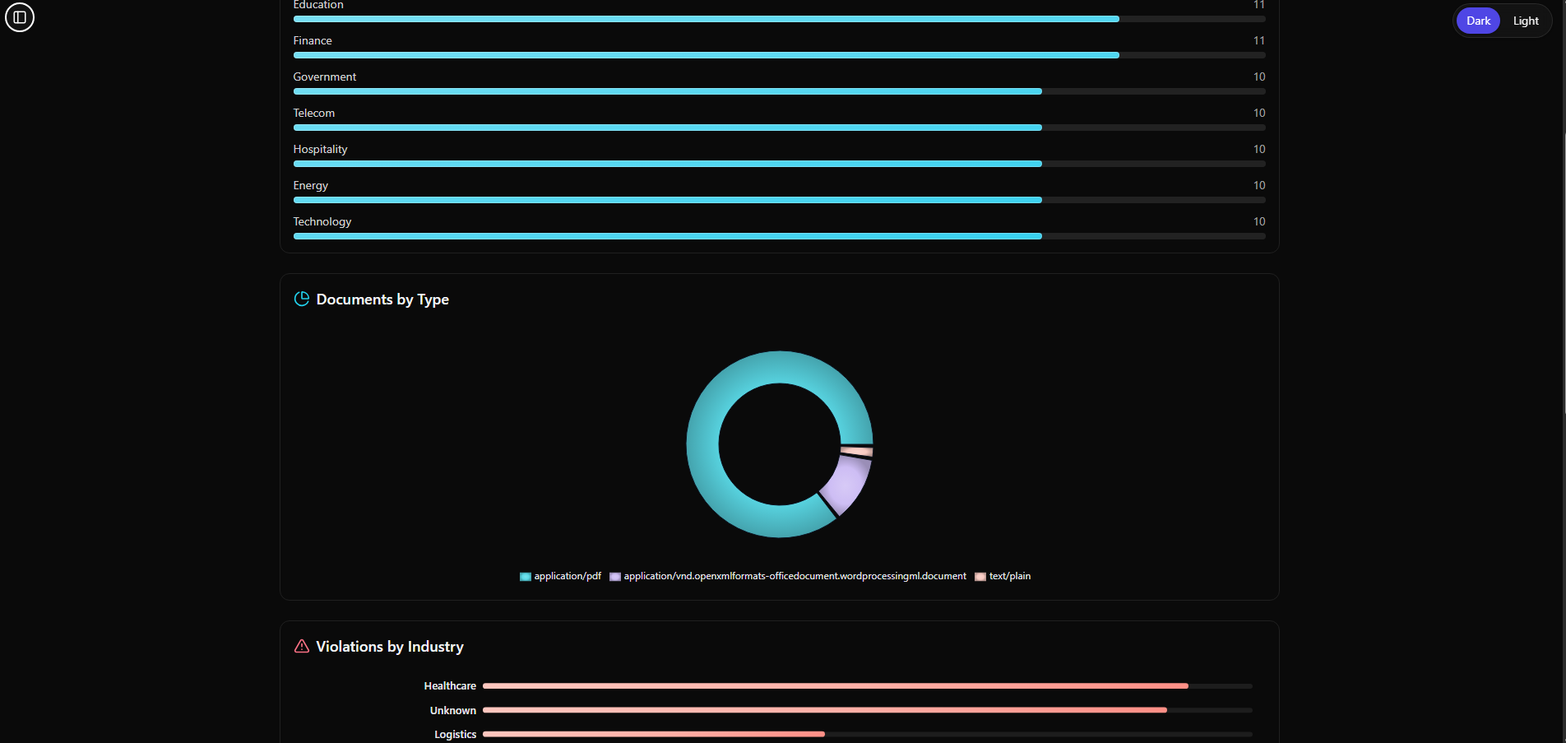
Figure 2: Compliance Score Distribution dashboard, showing statistical insights into the organization’s compliance performance, enabling auditors and managers to quickly identify trends and areas of concern.

3. AI Assistant (Regulatory Q&A)
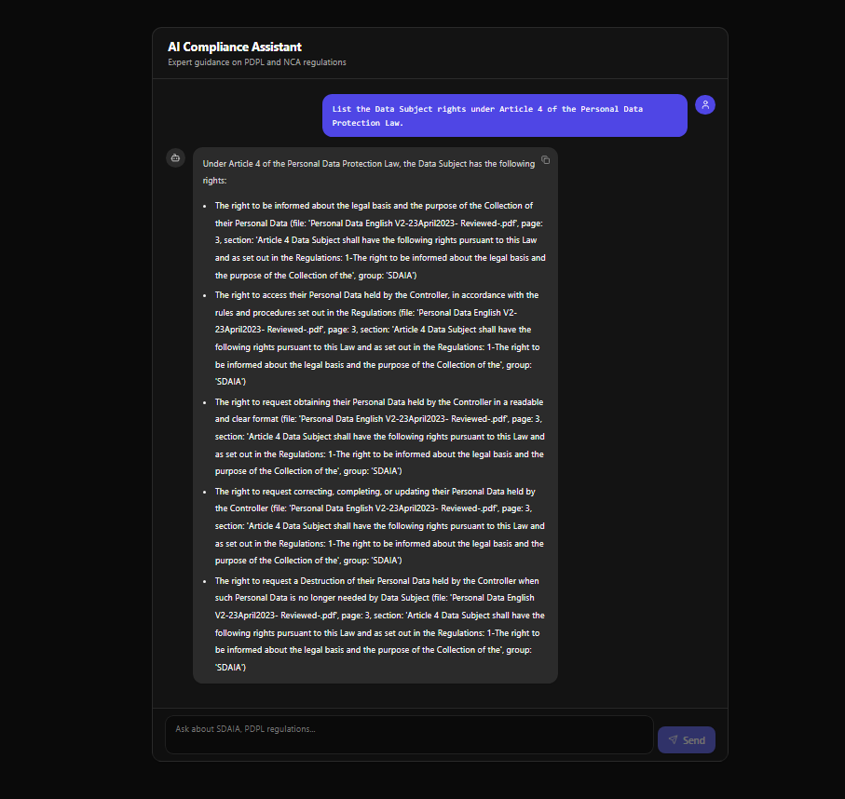
Figure 3: The AI Compliance Assistant module, where users can interact with an AI-powered chatbot to ask questions about PDPL and NCA regulations and receive instant, accurate guidance.

4. Document Upload (Compliance Checker)
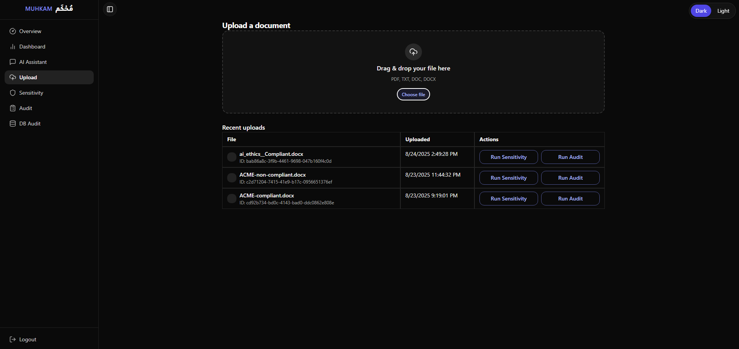
Figure 4: Document Compliance Checker interface, allowing secure upload of policies, contracts, and operational logs for automated analysis and detection of violations or missing compliance elements.

5. Sensitivity Reports
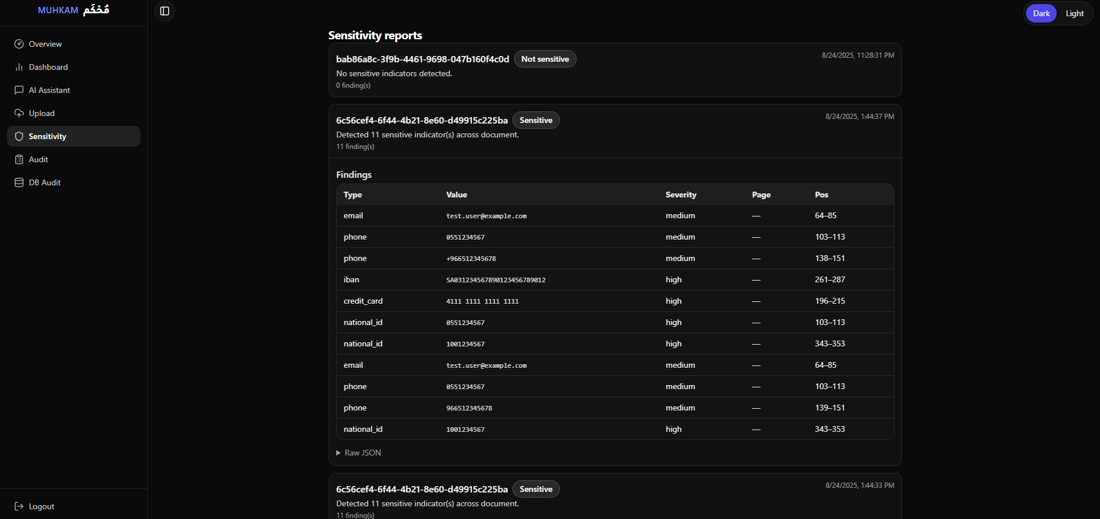
Figure 5: Sensitivity analysis module, detecting and flagging sensitive personal or organizational data within documents, ensuring protection of PII (Personally Identifiable Information) and compliance with data privacy standards.

6. Audit Reports
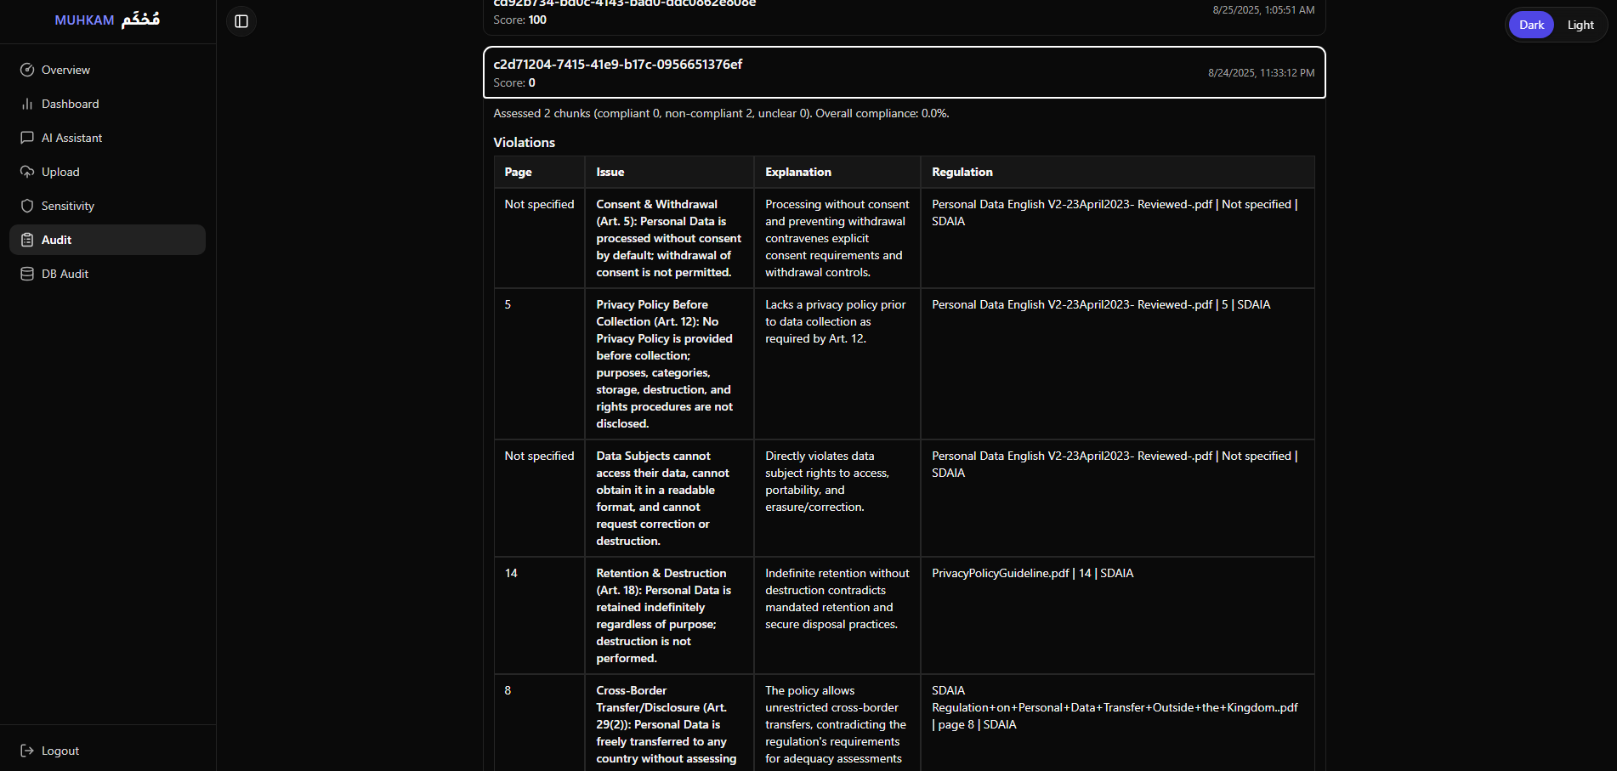
Figure 6: Audit reports module, presenting compliance evaluation results with detailed scores and violations. These reports provide a transparent record that can be used for regulatory submissions and internal reviews.

7. Database Audit
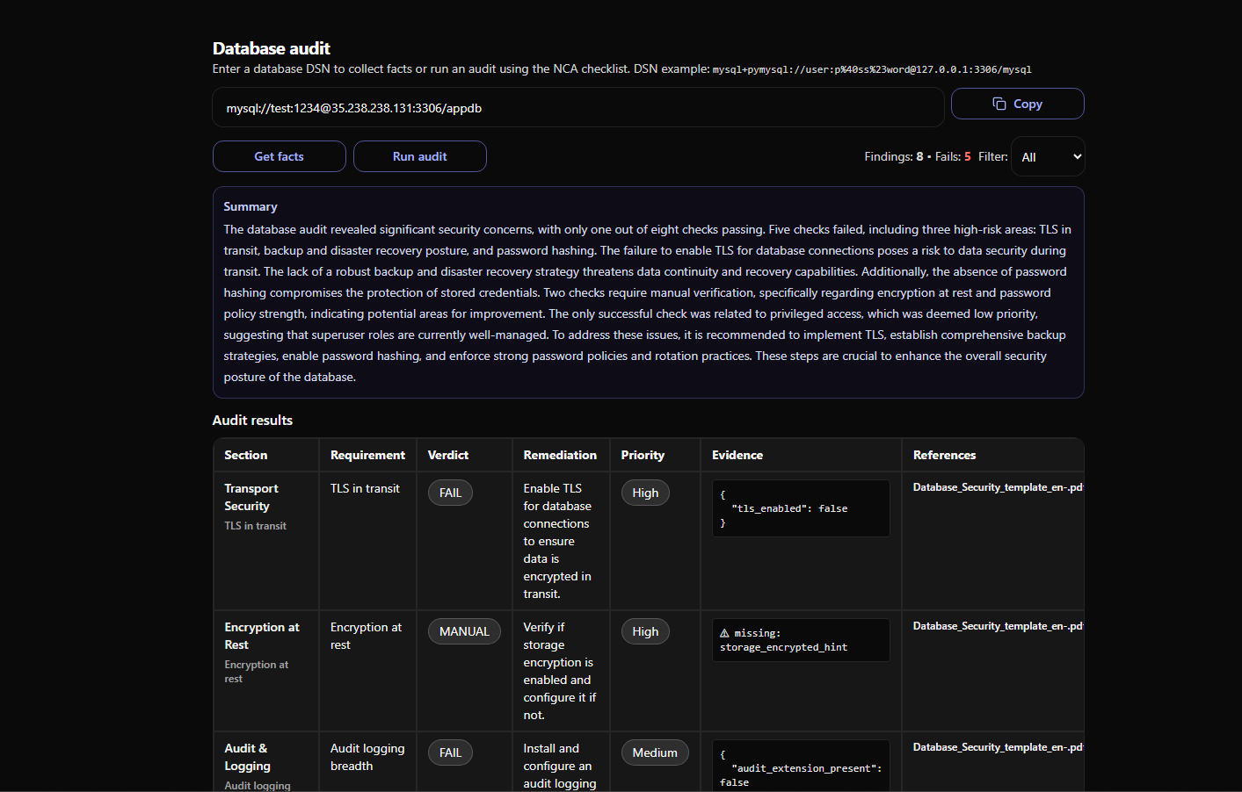
Figure 7: Database Audit interface, allowing organizations to connect to their databases and automatically verify compliance against NCA requirements through secure DSN connections.

