KAMYAAB
Solution Architecture and MVP Technical Model
Architecture Review Draft v1.0

Purpose: Define the review-ready product and technical architecture for an internal MVP that connects Karachi clients with agent-onboarded blue-collar workers through a client application, web portals, SMS/calls and a tracked booking workflow.

Document status | For team review
Target milestone | Internal MVP usable locally by end of August
Launch coverage | All Karachi supported technically
Primary users | Clients, workers, onboarding agents and operations administrators
Prepared from | Team requirements discussion and the two Kamyaab concept documents

Verified Work. Trusted Hands.

Document Map
Section | Content
1 | Executive architecture summary
2 | Product definition and boundaries
3 | Users, channels and trust model
4 | Architecture principles and key decisions
5 | System context and logical architecture
6 | Core user and booking workflows
7 | Application modules and API boundaries
8 | Domain and data architecture
9 | Authentication and authorization
10 | Worker availability and matching
11 | Voice and AI processing
12 | Notifications, SMS and calls
13 | Security, privacy and safety controls
14 | Pricing, payments and platform revenue
15 | Deployment, CI/CD and operations
16 | Testing and non-functional requirements
17 | Team delivery model and roadmap
18 | Risks, assumptions and review decisions
A | Appendix: state models and MVP scope

Review method: Items marked as a recommendation are proposed architecture decisions. Items marked as open decisions must be confirmed by the team before public launch. The internal MVP may use mocked SMS and payments.

1. Executive Architecture Summary
Kamyaab should be designed as a two-sided local-services marketplace, not as a conventional employment portal or pure worker directory. The client uses a smartphone application, while a worker may participate through an agent-managed profile, SMS/calls or an optional worker web portal. All client-worker contact must be linked to a tracked request or booking so that reviews, complaints and future fees are measurable.
Decision area | Recommended baseline
Product model | Managed directory plus open-job marketplace, using one tracked booking domain.
Client channel | React Native / Expo mobile application.
Worker channel | Agent-managed by default; SMS/call communication; optional phone-authenticated worker portal.
Operations channels | Next.js agent and admin portals.
Backend | TypeScript modular monolith API. No microservices for the MVP.
Data platform | PostgreSQL plus private object storage; Supabase is suitable for the internal MVP.
Matching | Deterministic rules using skill, area, availability, verification and rating.
Voice | Speech-to-text and AI field extraction, followed by client confirmation.
Payments | No real payment integration in internal MVP; free controlled pilot; fixed client booking fee later.
Coverage | All Karachi represented in the data model, with supply density measured by area and category.

Non-negotiable control: Worker phone numbers and exact client addresses should not be published in search results. They should be released only after a tracked request is accepted.

2. Product Definition and Boundaries

2.1 Product statement
Kamyaab helps households and small businesses in Karachi find identity-checked blue-collar workers across approximately 10-12 service categories. Clients browse or post a job through the application. Workers are onboarded in person and may receive opportunities by SMS or call without owning a smartphone.

2.2 What Kamyaab is
- A managed marketplace: the platform records requests, worker responses, bookings, completion, reviews and complaints.
- An assisted-access platform: agents represent workers who cannot maintain a digital profile.
- A trust layer: verification checks, review history and operational complaint handling reduce uncertainty.
- A discovery and dispatch platform: clients may select a specific worker or submit an open job to eligible workers.

2.3 What Kamyaab is not in the MVP
- An employment/payroll platform.
- A guarantee of workmanship, theft prevention or property-damage compensation.
- An escrow or salary-payment platform.
- An AI-first matching engine.
- A multi-city production system.
- A microservices system.

2.4 Initial service categories
Recommended initial categories | Notes
Electrician | High-frequency and urgent household demand.
Plumber | High-frequency and urgent household demand.
Carpenter | Common repair and custom work.
Painter | Project-based work with negotiable scope.
Gardener | Recurring and one-time work.
AC technician | Seasonal but high-urgency service.
Appliance repair technician | Broad domestic demand.
Mason | Project-based repair and construction.
Welder | Specialized household and small-business work.
Cleaner | Short-duration household or office jobs.
Driver | Temporary or contract driving requirements.
General handyman | Small mixed repair tasks.

Safety recommendation: Domestic live-in work, childcare and private security should be excluded from the initial MVP. These categories create substantially higher screening, safeguarding and dispute-resolution requirements.

3. Users, Channels and Trust Model
Actor | Primary channel | Capabilities
Client | Mobile application | Search workers, record voice request, create booking, negotiate price, call after acceptance, review and complain.
Keypad-phone worker | SMS/calls through platform or agent | Receive offers, accept/reject, communicate after acceptance, confirm completion.
Smartphone worker | Optional worker portal | Claim profile, browse open work, accept/reject, update availability, view history.
Onboarding agent | Web portal | Create and maintain worker profiles, inspect CNIC, record checks, service areas and availability.
Operations administrator | Admin portal | Approve/suspend users, manage requests, manually match, resolve complaints, inspect audit logs.
System services | Background jobs and integrations | SMS, call orchestration, AI processing, expiry, reminders and retries.

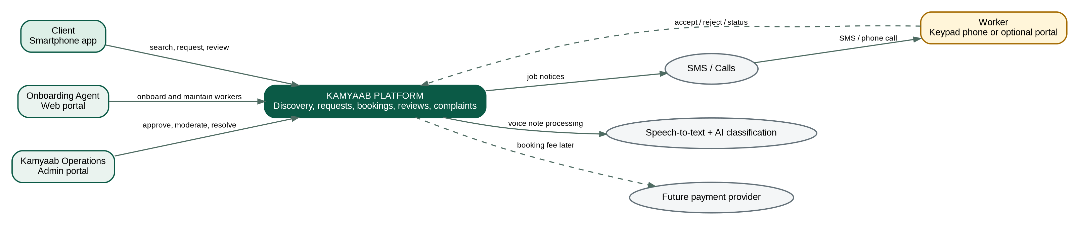
Figure 1 - Kamyaab system context

3.1 Verification language
A single “verified” badge is too broad. The UI should show explicit checks so clients understand what was actually validated.
Badge | Meaning
Identity checked | Agent inspected the original CNIC and recorded the document.
Phone confirmed | Worker phone number was confirmed by OTP or call.
Reference checked | At least one reference was contacted and recorded.
Background checked | A documented background-screening process was completed.
Skill assessed | Certificate review, demonstration or agent assessment was recorded.
Kamyaab experience | Worker completed a defined number of tracked bookings.

4. Architecture Principles and Key Decisions
1. Mobile-first for clients; assisted access for workers.
2. One tracked booking workflow for both directory selection and open-job posting.
3. Contact and address privacy until a booking is accepted.
4. Modular monolith before microservices.
5. Rule-based matching before AI matching.
6. Human override for assignment, verification and dispute handling.
7. Private-by-default storage for CNIC, audio and complaint evidence.
8. Every status change creates an auditable history record.
9. External vendors are accessed through adapters so SMS, AI and payments can be replaced.
10. All Karachi is represented by structured areas; operational coverage is measured rather than assumed.
Decision | Rationale | Status
Separate backend API | Required by mobile app, multiple portals and background processing. | Recommended
Express or NestJS modular monolith | Fits a five-person team and short timeline. | Team choice
Supabase PostgreSQL and Storage | Low operational burden for internal MVP. | Recommended
Supabase Auth or equivalent | Supports client phone OTP and staff login. | Recommended
No real telecom dependency locally | Use adapters and mock providers for internal testing. | Recommended
No payment integration in MVP | Payment model is not finalized. | Locked for internal MVP
AI classification requires confirmation | Prevents incorrect automatic job creation. | Locked

5. System Context and Logical Architecture
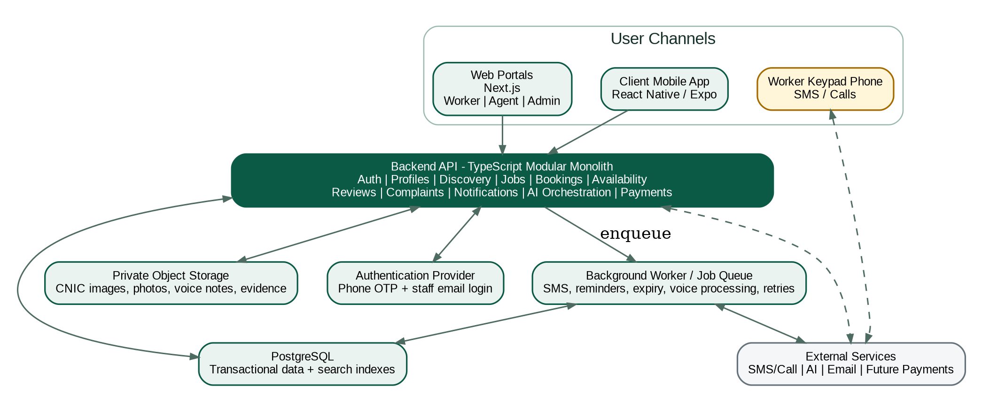
Figure 2 - Logical application architecture

5.1 Technology baseline
Layer | Recommended technology | Purpose
Client application | React Native with Expo | Android-first application, with iOS capability retained.
Web portals | Next.js and TypeScript | Shared worker, agent and admin web interfaces.
Backend API | TypeScript with Express or NestJS | REST API and business rules in a modular monolith.
Database | PostgreSQL | Transactional records, filtering and indexed discovery.
Object storage | Supabase Storage or S3-compatible storage | Private CNIC images, profile photos, voice notes and evidence.
Background work | Database-backed queue or Redis queue | SMS dispatch, AI processing, retries, reminders and expiry.
Authentication | Supabase Auth or equivalent | Phone OTP for clients/workers and staff email authentication.
Testing | Vitest/Jest, API integration tests, Playwright, mobile test tooling | Automated validation across all channels.

6. Core User and Booking Workflows
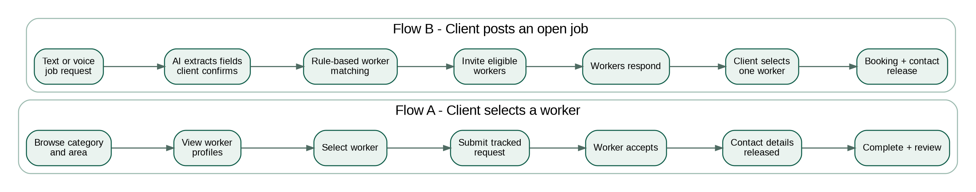
Figure 3 - Two discovery paths converging on one booking model

6.1 Worker onboarding
1. Agent signs in to the agent portal.
2. Agent creates a worker record and captures profile data.
3. Agent inspects the original CNIC and uploads front/back images to private storage.
4. Agent records phone confirmation, address, references, skills, tools, service areas and expected rates.
5. Background or skill checks are recorded as separate verification records.
6. Administrator reviews and approves the worker.
7. Worker becomes searchable only after approval.

6.2 Specific-worker request
1. Client selects category and Karachi area.
2. Search returns approved workers ranked by rules.
3. Client opens a profile and submits a job request to that worker.
4. Worker receives SMS/call or sees the request in the portal.
5. Worker accepts, rejects or lets the request expire.
6. On acceptance, client contact and job address are released to the worker.
7. The parties agree final work price and payment method.
8. Completion is confirmed and the client may review or complain.

6.3 Open-job request
1. Client describes the work by text or voice.
2. AI extracts structured fields and the client confirms them.
3. Matching rules identify eligible workers.
4. A controlled number of workers are invited in batches.
5. Workers accept or reject.
6. Client selects from accepted workers, or operations assigns one manually.
7. A booking is created and contact is released.
Operational safeguard: The platform must always support manual assignment. Automated matching will fail when availability is stale, service areas are incomplete or supply is sparse.

7. Application Modules and API Boundaries
Backend module | Responsibilities
Identity and Access | Authentication mapping, user roles, sessions and account status.
Client Profiles | Client identity, optional email, complaint/no-show flags and address book.
Worker Profiles | Worker data, profile claim, skills, service areas, photos and public summary.
Agents and Verification | Agent ownership, CNIC checks, references, background checks and approval workflow.
Categories and Areas | Configurable service taxonomy and Karachi geographic hierarchy.
Availability | Current state, expiry, update source and history.
Discovery | Filtering and ranking of eligible workers.
Job Requests | Text/voice request data, target worker or open request, budget and urgency.
Matching and Invitations | Eligibility calculation, invitations, response deadlines and batch dispatch.
Bookings | Accepted assignment, price, contact release, status transitions and completion.
Reviews | Booking-gated ratings and comments.
Complaints and Moderation | Complaint intake, evidence, severity, resolution and suspension.
Notifications | SMS, email, in-app events, retry and delivery status.
Voice AI | Audio orchestration, transcript, extraction, confidence and fallback.
Payments | Provider-neutral records for future booking fees and refunds.
Audit | Immutable record of sensitive actions and status transitions.

7.1 API conventions
- Version routes under /api/v1.
- Use JSON request/response contracts validated with schemas such as Zod.
- Return stable machine-readable error codes.
- Authorize each resource by role and ownership, not only by login status.
- Use idempotency keys for booking creation and future payments.
- Use cursor or page-based pagination for listings.
- Do not expose storage object paths directly; issue short-lived signed URLs.
Example endpoint | Purpose
POST /api/v1/job-requests | Create a text or confirmed voice-derived request.
GET /api/v1/workers | Search workers by category, area and availability.
POST /api/v1/job-requests/{id}/invitations | Invite eligible workers.
POST /api/v1/invitations/{id}/accept | Worker accepts a request.
POST /api/v1/bookings/{id}/complete | Confirm completion.
POST /api/v1/bookings/{id}/reviews | Create a booking-gated review.
POST /api/v1/bookings/{id}/complaints | Report a booking issue.
PATCH /api/v1/workers/{id}/availability | Update worker availability.
POST /api/v1/voice-jobs/classify | Transcribe and extract structured fields.

8. Domain and Data Architecture
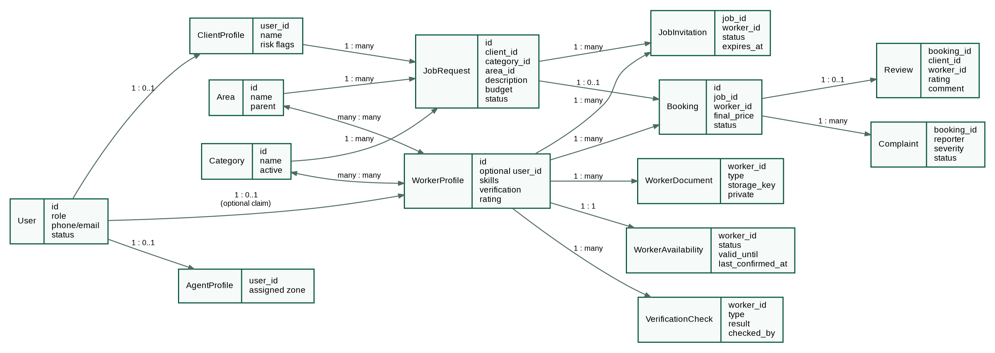
Figure 4 - Simplified domain model

8.1 Core records
Entity group | Key records
Identity | users, roles, client_profiles, agent_profiles, worker_profiles
Verification | worker_documents, worker_references, verification_checks
Catalog | categories, skills, areas, worker_skills, worker_service_areas
Operations | worker_availability, availability_history
Marketplace | job_requests, job_voice_notes, job_matches, job_invitations, job_responses, bookings
Trust | reviews, complaints, complaint_evidence, moderation_actions
Communication | notifications, sms_logs, call_logs
Revenue | payment_records, platform_fees, refunds
Governance | audit_logs, status_history

8.2 Data rules
- Only approved workers are visible in client search.
- Only completed tracked bookings may create public reviews.
- CNIC numbers and images are never returned by public worker-profile APIs.
- A booking references exactly one worker, even if a request invited many workers.
- Every state change is appended to history with actor, reason and timestamp.
- Voice audio, CNIC files and complaint evidence use private storage buckets.
- Worker phone numbers and client addresses are encrypted at rest where supported and masked in logs.

8.3 Karachi area model
Represent Karachi as a configurable hierarchy rather than a free-text address. The MVP can use district/town/area labels without map routing. A worker may serve multiple areas and may optionally define a travel radius later.
Level | Example | Usage
City | Karachi | Top-level tenant/coverage boundary.
District or zone | East, Central, South | Reporting and operational coverage.
Area | Gulshan-e-Iqbal, Clifton, North Nazimabad | Search and service eligibility.
Address | Client-provided exact location | Visible only after acceptance.

9. Authentication and Authorization
Actor | Authentication | Authorization model
Client | Phone OTP; name required; email optional | CLIENT role; own requests, bookings, reviews and complaints only.
Keypad worker | No account required | Agent/admin acts on profile; acceptance may use verified phone interaction.
Smartphone worker | Phone OTP and secure profile-claim flow | WORKER role; own profile, invitations, bookings and availability only.
Agent | Email/password; MFA recommended before live pilot | AGENT role; assigned workers and onboarding operations only.
Administrator | Email/password and MFA | ADMIN or OPS role; moderation and platform operations.
System worker | Service credentials | Minimum service permissions; no interactive login.

9.1 Worker profile claim
1. Agent-created worker record stores a confirmed phone number.
2. Worker signs in with OTP using the same number.
3. System locates the unclaimed worker profile.
4. Additional confirmation is requested, such as CNIC last digits or an agent-issued claim code.
5. Profile is linked to the authenticated user ID.
6. Claim event is written to the audit log.

9.2 Role controls
Sensitive action | Allowed roles
View CNIC documents | Assigned agent, verification operator, administrator
Approve worker | Administrator or verification operator
Change another user’s status | Administrator only
View exact client address | Selected worker after acceptance, assigned operations staff
Release worker contact | System after acceptance; operations override is audited
Delete public review | Moderator/administrator with reason
Export user data | Restricted administrator role

10. Worker Availability and Matching

10.1 Availability model
Status | Meaning | Default expiry
AVAILABLE | Worker confirmed ability to take work. | 24 hours
BUSY | Worker is engaged until a defined time. | At busy_until
UNAVAILABLE | Worker has explicitly paused work. | Configured date or manual update
UNKNOWN | No recent confirmation. | No expiry; lower search rank

- Smartphone workers update status through the worker portal.
- Keypad workers inform an agent; the agent updates the record and the system sends an SMS confirmation.
- Inbound SMS codes can be added after the internal MVP.
- Availability changes must retain update source: worker portal, SMS, agent, admin or automatic expiry.

10.2 Matching rules
The MVP should use an explainable score. It should first eliminate ineligible workers, then rank the remaining set.
Stage | Rule
Eligibility | Worker approved, category/skill match, service area match, account active.
Priority 1 | AVAILABLE workers before UNKNOWN workers.
Priority 2 | Recently confirmed availability.
Priority 3 | Verification level and safety flags.
Priority 4 | Rating and completed Kamyaab jobs.
Priority 5 | Distance/area preference and recent workload balance.
Fallback | Operations manually assigns or expands the service area.

Do not use AI matching in the MVP: With tens or hundreds of workers, deterministic rules are cheaper, testable and easier to explain when a client or worker challenges a match.

11. Voice and AI Processing
Figure 5 - Voice-note classification pipeline

11.1 Extracted structure
Field | Example
category | Electrician
area | Gulshan-e-Iqbal
description | Ceiling fan is not working
urgency | Today
preferred time | After 5 PM
client budget | Rs. 1,500
materials mentioned | None / fan capacitor

11.2 Controls
- Never submit a job directly from the model output; require client confirmation.
- Store transcript, extracted JSON, model version, confidence and user corrections.
- Apply schema validation and permitted-category validation after AI output.
- Use a low-confidence fallback to manual category and area selection.
- Redact or avoid sending CNIC and unrelated personal data to AI providers.
- Delete voice audio according to a defined retention period after the booking is closed.

12. Notifications, SMS and Calls
Event | Client | Worker | Agent/Admin
Request submitted | In-app confirmation | No notification until invited | Visible in operations queue
Worker invited | Status update | SMS or portal notification | Delivery/failure visible
Worker accepted | Push/in-app/SMS | Confirmation SMS | Booking created
Request expired | In-app/SMS | Expiry SMS optional | Manual fallback queue
Booking reminder | Push/SMS | SMS | Failure alert if undelivered
Completion | Prompt to confirm/review | SMS confirmation | Booking appears in closure queue
Complaint opened | Acknowledgement | Notice where safe | Moderation task

12.1 Provider abstraction
Use an interface such as NotificationProvider with mock, SMS-vendor and future call/IVR implementations. Local development must not depend on a live telecom provider.
- Persist outbound message, provider reference, status, attempts and last error.
- Retry only retryable failures using exponential backoff.
- Prevent duplicate notifications with idempotency keys.
- Mask phone numbers in application logs.
- Provide operations with a failed-delivery queue.

13. Security, Privacy and Safety Controls
Risk | Required control
CNIC exposure | Private bucket, signed URLs, restricted roles, audit reads, retention rules.
Phone/address leakage | Mask in search; release only after acceptance; never log full values.
Fake reviews | Only completed bookings can be reviewed; one client review per booking.
Agent fraud | Agent ownership, approval separation, audit log and periodic verification sampling.
Client harassment | Verified phone, complaint history, suspension and worker reporting.
Worker misconduct | Explicit verification badges, complaint severity, immediate suspension for high-risk reports.
Account takeover | OTP throttling, staff MFA, session revocation and suspicious-login monitoring.
AI data leakage | Send only job content required for classification; no CNIC or stored profile documents.
File abuse | Validate MIME type, extension, size; malware scan before administrative download.
Privilege misuse | Role-based access, least privilege and immutable audit records.

13.1 Platform responsibility
Kamyaab provides | Kamyaab does not initially guarantee
Identity/background-check status | Quality of every job
Tracked booking records | Property-damage compensation
Replacement attempt for no-show/cancellation | Theft compensation
Complaint intake and account suspension | Payment recovery from either party
Review history and evidence trail | Employment benefits or worker insurance

Policy recommendation: For a worker no-show, offer one replacement attempt. Refund the future Kamyaab booking fee when no replacement is available. Do not promise compensation for service quality or property damage until insurance and legal terms exist.

14. Pricing, Payments and Platform Revenue

14.1 Work pricing
1. Platform displays a category-specific suggested starting price or range.
2. Client enters an estimated budget.
3. Worker and client negotiate after acceptance.
4. Final agreed price and payment method may be recorded in the booking.
5. The client pays the worker using any mutually agreed method.
Price disclaimer: Suggested prices are guidance, not guaranteed quotes. Materials, scope, travel and urgency may change the final amount.

14.2 Revenue sequence
Stage | Revenue approach | Architecture impact
Internal MVP | Free; payment records are mocked or optional. | No live payment provider.
Controlled external pilot | Fixed client booking fee before contact release. | Payment adapter and refund record required.
Later marketplace | Percentage commission only if money flows through Kamyaab or contractual billing exists. | Provider settlement, ledger, refunds and reconciliation required.

Critical business constraint: A percentage commission cannot be reliably enforced when client and worker negotiate and settle directly in cash. Contact release must be tied to an upfront fixed fee or the complete payment must pass through Kamyaab.

15. Deployment, CI/CD and Operations
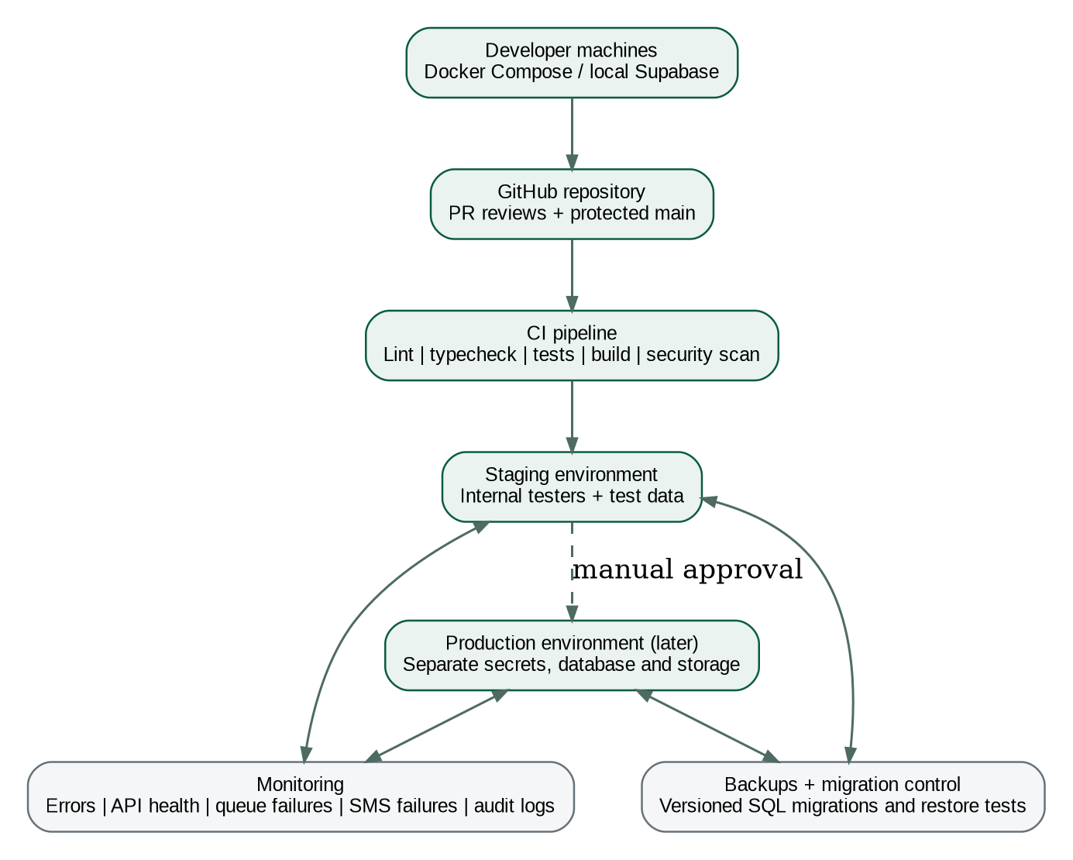
Figure 6 - Delivery and deployment model

15.1 Environments
Environment | Purpose | Data
Local development | Developer feature work and integration through Docker Compose/local services. | Synthetic data only.
Shared staging | Internal testing and demonstrations. | Test workers, clients and mocked communications.
Production later | Controlled pilot and public operations. | Real personal data with separate secrets and storage.

15.2 Repository structure
Area | Suggested repository path
Mobile app | apps/client-mobile
Web portals | apps/portal-web
Backend API | apps/api
Background worker | apps/worker
Shared contracts | packages/contracts
UI/components | packages/ui
Database migrations | database/migrations
Architecture and ADRs | docs/architecture
Infrastructure | infra

15.3 CI pipeline
1. Install dependencies with a locked package manager.
2. Run formatting and lint checks.
3. Run TypeScript type checking.
4. Run unit and API integration tests.
5. Run database migration validation.
6. Build mobile/web/API artifacts.
7. Run dependency and secret scanning.
8. Deploy to staging after merge to main.
9. Run smoke tests.
10. Require manual approval for any later production deployment.

15.4 Operational monitoring
- API error rate, latency and health.
- Background queue depth and failed jobs.
- SMS delivery and retry failures.
- Voice processing failure rate and low-confidence rate.
- Authentication/OTP failures and abuse throttling.
- Booking funnel counts and stalled statuses.
- Database backup success and restoration test results.
- High-severity complaint and suspension events.

16. Testing and Non-Functional Requirements

16.1 Test layers
Layer | Required coverage
Unit | Matching score, status transitions, price validation, availability expiry, permission helpers.
Database | Constraints, migrations, review gating, unique invitation/booking rules and private-data access.
API integration | Authentication, authorization, workflow transitions, file upload and error contracts.
End-to-end web | Agent onboarding, admin approval, worker maintenance and complaint handling.
Mobile integration | Client login, browse, voice request, booking, contact release, completion and review.
Contract | API schema compatibility between mobile, web and backend.
Security | Role isolation, IDOR tests, OTP abuse, file validation and signed URL expiration.
Failure | SMS provider outage, AI timeout, duplicate callback, expired request and queue retry.

16.2 Internal MVP acceptance journeys
1. Agent creates a worker with CNIC, skill and service areas; administrator approves the worker.
2. Client logs in, searches and submits a request to a specific worker.
3. Keypad worker acceptance is simulated through agent/admin or mock SMS.
4. Contact details become visible only after acceptance.
5. Client completes the booking and submits a review.
6. Client records a voice request; AI classifies it; client corrects and submits.
7. Smartphone worker claims a profile and accepts an open job.
8. Administrator manually assigns a worker when automated matching fails.
9. Client opens a complaint and operations suspends an account with an audit reason.

16.3 Non-functional targets for internal MVP
Area | Target
Availability | Best effort for local/internal use; no public SLA.
Performance | Typical API responses under 1 second excluding AI and external providers.
Search | Return the first page of workers under 1 second on test data.
Security | No public access to private documents; role tests must pass.
Recoverability | Versioned migrations; reproducible staging database setup.
Accessibility | Readable labels, large controls and minimal typing in client flows.
Auditability | Sensitive status changes and contact release are recorded.
Maintainability | Modules own business rules; no direct cross-module database writes without service boundaries.

17. Team Delivery Model and Roadmap

17.1 Suggested five-person ownership
Owner | Primary responsibility | Secondary responsibility
Developer 1 | Client React Native application | Mobile test automation and UI integration.
Developer 2 | Next.js worker/agent/admin portals | Shared UI components and accessibility.
Developer 3 | Identity, worker, verification, categories and discovery APIs | Database migrations and seed data.
Developer 4 | Jobs, invitations, bookings, notifications and voice AI | Background worker and provider adapters.
Developer 5 | QA strategy, CI/CD, integration tests and release coordination | Observability, security tests and documentation.

17.2 Seven-week execution plan
Week | Architecture milestone | Demonstrable outcome
1 | Requirements freeze, wireframes, ERD, API contracts and repositories. | Team approves end-to-end flows and ownership.
2 | Authentication, roles, categories, areas and worker onboarding. | Agent creates worker; admin approves.
3 | Worker discovery, profiles, verification badges and service areas. | Client browses workers by category/area.
4 | Job requests, invitations, response and booking state machine. | Specific-worker booking works end to end.
5 | Open jobs, worker portal, availability and operations override. | Smartphone worker accepts; admin can manually assign.
6 | Voice AI, mock SMS, reviews, complaints and audit trail. | Voice request and trust workflows demonstrated.
7 | Integration, security testing, bug fixing, local deployment and team handover. | Internal MVP acceptance journeys pass.

18. Risks, Assumptions and Review Decisions
Risk | Why it matters | Mitigation
All-Karachi launch with thin supply | Clients may see workers who are too far away or unavailable. | Measure coverage by category/area; rank by service area; permit manual expansion.
Stale worker availability | Directory results become unreliable. | 24-hour expiry, UNKNOWN status and agent refresh workflow.
Commission bypass | Direct contact allows off-platform settlement. | Use tracked requests; future fixed fee before contact release.
Verification overclaim | CNIC inspection may be misunderstood as skill/safety guarantee. | Use separate badges and explicit definitions.
Agent fraud or poor data | Profiles and checks depend on agent quality. | Approval separation, audit logs, sampling and agent performance metrics.
AI classification errors | Wrong category/area produces bad matches. | Confidence threshold, validation and client confirmation.
Telecom dependency | SMS delivery may fail or be expensive. | Provider adapter, mock local provider, failure queue and agent-call fallback.
Scope overload | Mobile, multiple portals, AI and 12 categories may exceed deadline. | Reuse shared contracts, keep payments mocked, exclude advanced AI and public launch.
Sensitive-data breach | CNIC and addresses create high impact. | Private storage, least privilege, signed URLs and retention controls.
Dispute expectations | Users may assume Kamyaab guarantees work or compensation. | Clear terms, limited replacement policy and documented complaint procedure.

18.1 Decisions to confirm during team review
Decision | Recommended default | Owner / deadline
Backend framework | NestJS if team accepts structure; Express if team prefers minimal framework. | Engineering lead - Week 1
Authentication provider | Supabase Auth for MVP. | Backend team - Week 1
Background-check definition | Document exact checks and badge text. | Product/operations - Week 1
Initial area taxonomy | Agree Karachi district/area seed list. | Product - Week 1
Minimum-price source | Admin-configured guidance by category. | Product/operations - Week 2
SMS/call vendor | Mock internally; evaluate local providers before pilot. | Operations/engineering - Post-MVP
Background queue | Database-backed queue first or Redis/BullMQ based on hosting. | Backend team - Week 2
Voice providers | Select speech-to-text and LLM based on Urdu quality and cost. | AI owner - Week 3
Data retention | CNIC, voice and complaint evidence retention periods. | Product/legal - Before pilot
Fee model | Fixed booking fee before contact release. | Founders - Before external pilot

Appendix A. State Models and MVP Scope

A.1 Job request state model
State | Meaning | Possible next states
DRAFT | Client has not submitted. | SUBMITTED, CANCELLED
SUBMITTED | Request is accepted by the platform. | MATCHING, CANCELLED
MATCHING | Eligibility and invitation process active. | WORKER_CONTACTED, EXPIRED, CANCELLED
WORKER_CONTACTED | At least one worker has been invited. | ACCEPTED, EXPIRED, CANCELLED
ACCEPTED | One worker accepted and was selected. | CONTACT_SHARED, CANCELLED
CONTACT_SHARED | Both sides may communicate. | IN_PROGRESS, CANCELLED, NO_SHOW
IN_PROGRESS | Work has started. | COMPLETED, DISPUTED, CANCELLED
COMPLETED | Work closure confirmed. | DISPUTED
EXPIRED | No worker accepted in time. | MATCHING through manual retry
NO_SHOW | Assigned worker did not arrive. | MATCHING, CANCELLED
DISPUTED | Complaint requires operations action. | COMPLETED, CANCELLED

A.2 Invitation state model
State | Meaning
PENDING | Created but not yet dispatched.
SENT | Provider accepted the message.
DELIVERED | Provider confirmed delivery where available.
ACCEPTED | Worker accepted before expiry.
REJECTED | Worker rejected.
EXPIRED | No response before deadline.
FAILED | Delivery or processing failed.

A.3 Internal MVP - in scope
- Client phone login and worker browsing.
- 12 configurable worker categories and Karachi areas.
- Agent onboarding with private CNIC upload.
- Admin approval, suspension and manual assignment.
- Specific-worker and open-job requests.
- Optional worker profile claim and worker portal.
- Rule-based matching and expiring availability.
- Voice recording, AI classification and client confirmation.
- Mock SMS/call events.
- Booking state history, review and complaint handling.
- Local/staging deployment with automated tests.

A.4 Internal MVP - explicitly out of scope
- Public production launch.
- Real percentage commission or escrow.
- Automated police/NADRA integration.
- Call masking or IVR short code.
- Insurance and damage guarantees.
- AI worker-ranking model.
- Materials/supplier marketplace.
- Housing-society B2B dashboard.
- Multi-city operations.

A.5 Source inputs
This architecture draft consolidates and resolves product assumptions from:
- Kamyaab - AI Dot (Straw Hats).pdf
- Kamyaab_first draft.pdf
- Team answers captured during the architecture discovery discussion.

Architecture Review Sign-off
Reviewer | Role | Decision | Comments / required changes
 |  | Approve / Approve with changes / Reject
 |  | Approve / Approve with changes / Reject
 |  | Approve / Approve with changes / Reject

Recommended approval condition: Approve the architecture baseline after the team confirms the verification definition, Karachi area taxonomy, backend framework, queue choice and fee model. These decisions do not block the first two weeks of internal MVP development if interfaces remain provider-neutral.

