PoultryConnect
A Cloud-Based Web Marketplace Connecting Poultry Farmers with Wholesale Buyers
Master's Degree Project Report
Module: Cloud-Based Web System Design
Prepared by: Abood Jamal Salim
Programme: Master's in Computer Science
Date: September 2026

Abstract
Smallholder poultry farmers in many developing regions sell through multiple layers of intermediaries before their stock reaches wholesale buyers such as hotels, distributors, and market traders. This chain compresses farmer margins and leaves buyers with limited visibility into supply, price, and provenance. This report presents PoultryConnect, a cloud-native, full-stack web application designed to shorten that chain by connecting poultry farmers directly with wholesale buyers through a role-based marketplace. The system is built with a React single-page front end, a Node.js and Express REST API, and a MongoDB Atlas cloud database, and is deployed using continuous, git-based deployment on Vercel and Render. The report documents the research motivation behind the project, the system's architecture and data model, the technology choices and their justification, the security and scalability measures implemented, the deployment process, and the limitations and future direction of the work. The resulting system demonstrates, at a scope appropriate for a single-developer academic project, the core engineering competencies required to design, build, and operate a production-oriented cloud web application: authentication and authorisation, RESTful API design, cloud data persistence, responsive front-end engineering, and automated cloud deployment.

1. Introduction
Agricultural value chains in many parts of the world remain longer and less transparent than the underlying trade requires. A farmer who raises broilers, layers, or table eggs frequently has no direct channel to the businesses that consume poultry in bulk — hotels, restaurants, market wholesalers, and food distributors — and instead relies on one or more intermediaries to aggregate, transport, and resell the produce. Each additional link in that chain adds a mark-up that the farmer does not receive and the buyer still pays, while neither party gains reliable information about the other. The proliferation of affordable smartphones and mobile internet access has made it technically and economically feasible to shorten such chains with lightweight, web-based marketplaces, and a number of agri-tech platforms across East Africa and beyond (for example business-to-business food distribution platforms) have shown that a simple, direct-order model can work at scale.
This project, PoultryConnect, applies that model narrowly to the poultry sub-sector. It was undertaken as the practical component of a master's-level module on cloud-based web system design, with the objective of designing, developing, and deploying a production-oriented, cloud-native web application that solves a genuine real-world problem while demonstrating the software-engineering, security, and cloud-deployment competencies the module requires.
The remainder of this report is organised as follows. Section 2 sets out the problem in more depth and situates it against existing research and practice. Section 3 describes the system architecture and data model. Section 4 justifies the technology stack. Section 5 describes the implementation. Section 6 discusses security. Section 7 describes the deployment pipeline. Section 8 evaluates the system and its limitations, and Section 9 concludes.

2. Problem Statement and Research Justification
The difficulty smallholder farmers face in reaching formal, wholesale markets is well documented in agricultural-economics literature. Studies of smallholder market participation across Sub-Saharan Africa consistently find that farm-gate sale to an intermediary remains the dominant channel, chosen not because it offers the best price but because farmers lack storage, transport, and reliable buyer information, and because the transaction cost of finding a direct buyer is high. Work specifically on middlemen in African agricultural marketing similarly finds that marketing margins are generally high but decline where market access conditions improve, indicating that the intermediary's mark-up is, at least in part, a structural consequence of poor market information rather than an unavoidable service cost.
The poultry sub-sector illustrates the same dynamic. Technical assessments of poultry value chains in Eastern and Southern Africa describe fragmented small-scale broiler and indigenous-chicken supply chains running through several intermediaries before reaching urban consumption points, and note that limited information regarding both input and output markets is one of the persistent constraints on smallholder poultry producers. Separate value-chain research on live bird markets in Kenya notes that poultry contributes a substantial share of agricultural GDP and that the large majority of birds are still raised in small, backyard-type operations rather than integrated commercial systems — precisely the population for whom a low-cost, direct digital sales channel would be most valuable. Government and NGO responses to this information gap, such as national agricultural market-information hotlines and SMS/voice-based commodity price services, confirm that market information asymmetry — not merely a lack of produce — is recognised as a central barrier, and that lightweight digital tools are considered a credible partial remedy.
Two implications follow for the design of PoultryConnect. First, the platform must be usable by non-specialist users on modest devices and connections, which argues for a simple web application rather than a heavier native-app or IoT-based solution. Second, the platform's core value is not a novel algorithm but a reliable, trustworthy channel: an authenticated farmer identity, an accurate live listing, and a traceable order and status history are more important than sophisticated matching or recommendation logic. This shaped the decision to keep the feature set intentionally narrow — authenticated listings, search and filtering, and an explicit order-and-status workflow — rather than building a broad e-commerce platform with payments, logistics, and reviews, which would dilute engineering effort away from the core problem and away from the cloud-architecture competencies the module assesses.
PoultryConnect's proposed solution is therefore a two-sided marketplace with two authenticated roles. Farmers list available stock — poultry type, quantity, unit, price, and location — and manage that inventory and any incoming orders from a dashboard. Wholesale buyers browse and filter live listings, view farmer contact details, and place orders that the farmer can accept, reject, or mark complete. By removing the intermediary from the discovery and negotiation step, the platform aims to let farmers capture more of the final sale price and gives buyers a transparent, direct view of available local supply.

3. System Architecture
PoultryConnect follows a conventional three-tier, cloud-native architecture: a React single-page application (SPA) as the presentation tier, a stateless Node.js/Express REST API as the application tier, and a managed MongoDB Atlas cluster as the data tier. The three tiers are deployed and scaled independently — the front end on Vercel's global edge network, the API on Render as a containerised web service, and the database on MongoDB Atlas's managed cloud infrastructure — which is the standard pattern for horizontally scalable web systems and allows each tier to be redeployed or scaled without affecting the others.
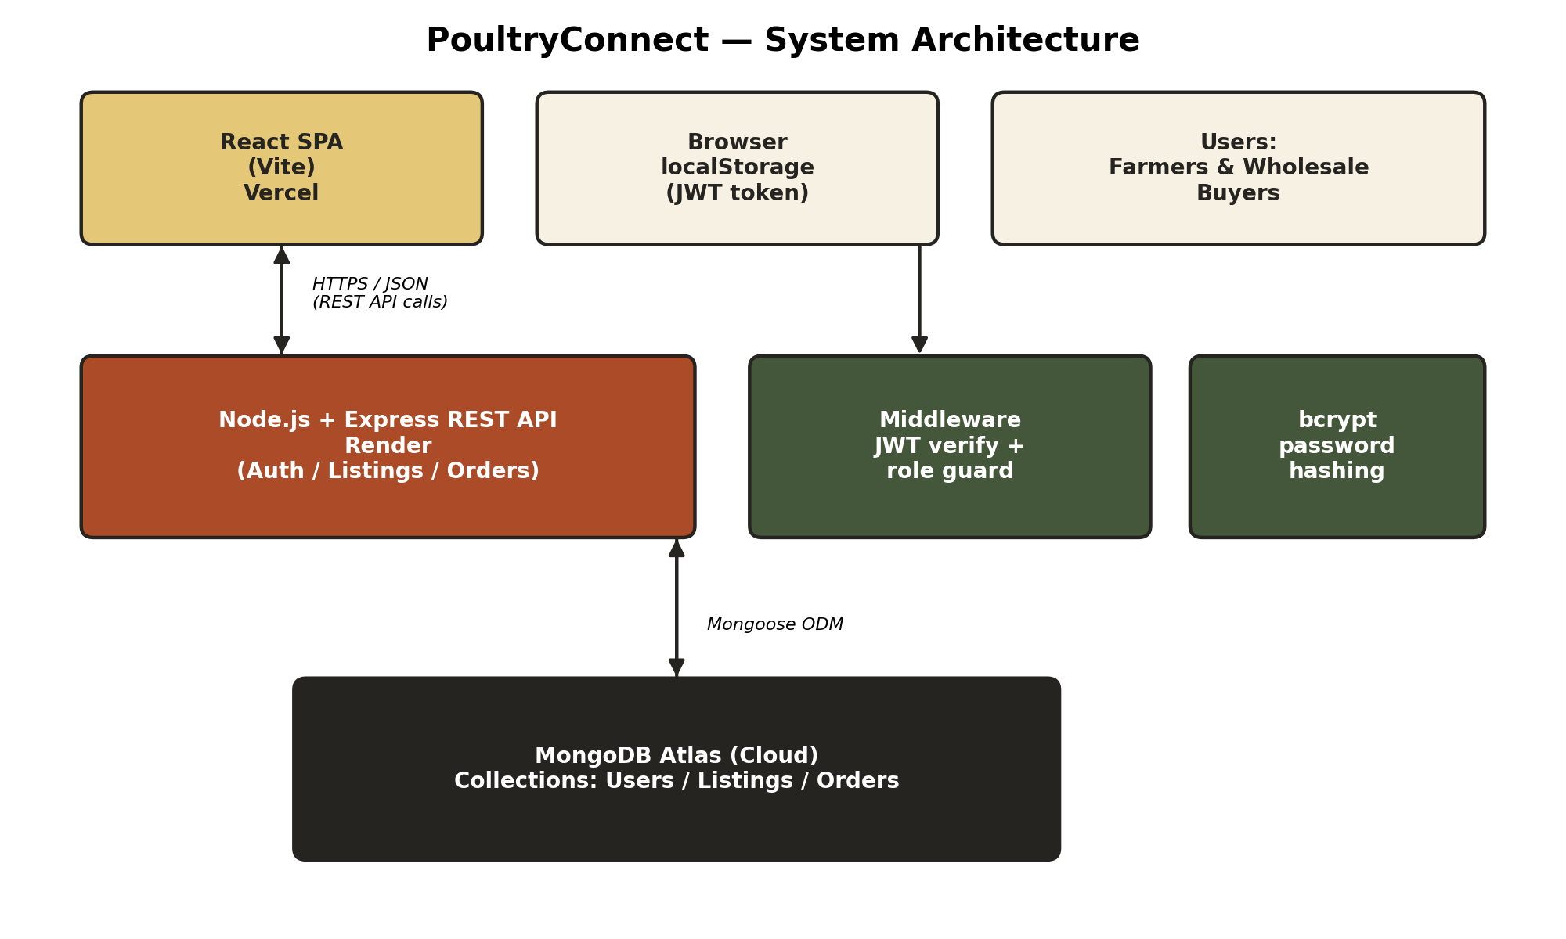
Figure 1. PoultryConnect system architecture.
The browser holds no server-side session state: after a successful login, the API issues a signed JSON Web Token (JWT) that the SPA stores in localStorage and attaches as a Bearer token to every subsequent request. This statelessness is what allows the API tier to be scaled horizontally (behind a load balancer, if required) without needing sticky sessions or a shared session store, and is a deliberate scalability decision rather than a default.
The data model (Figure 2) has three collections. A User document represents either a farmer or a buyer and stores a hashed password, contact details, and a role flag that the API uses for authorisation. A Listing document belongs to exactly one farmer and describes an available batch of stock. An Order document links a Listing, the buyer who placed it, and the farmer who owns the listing, and carries its own status field so that the order lifecycle (pending → accepted/rejected → completed) is tracked independently of the listing's own availability status.
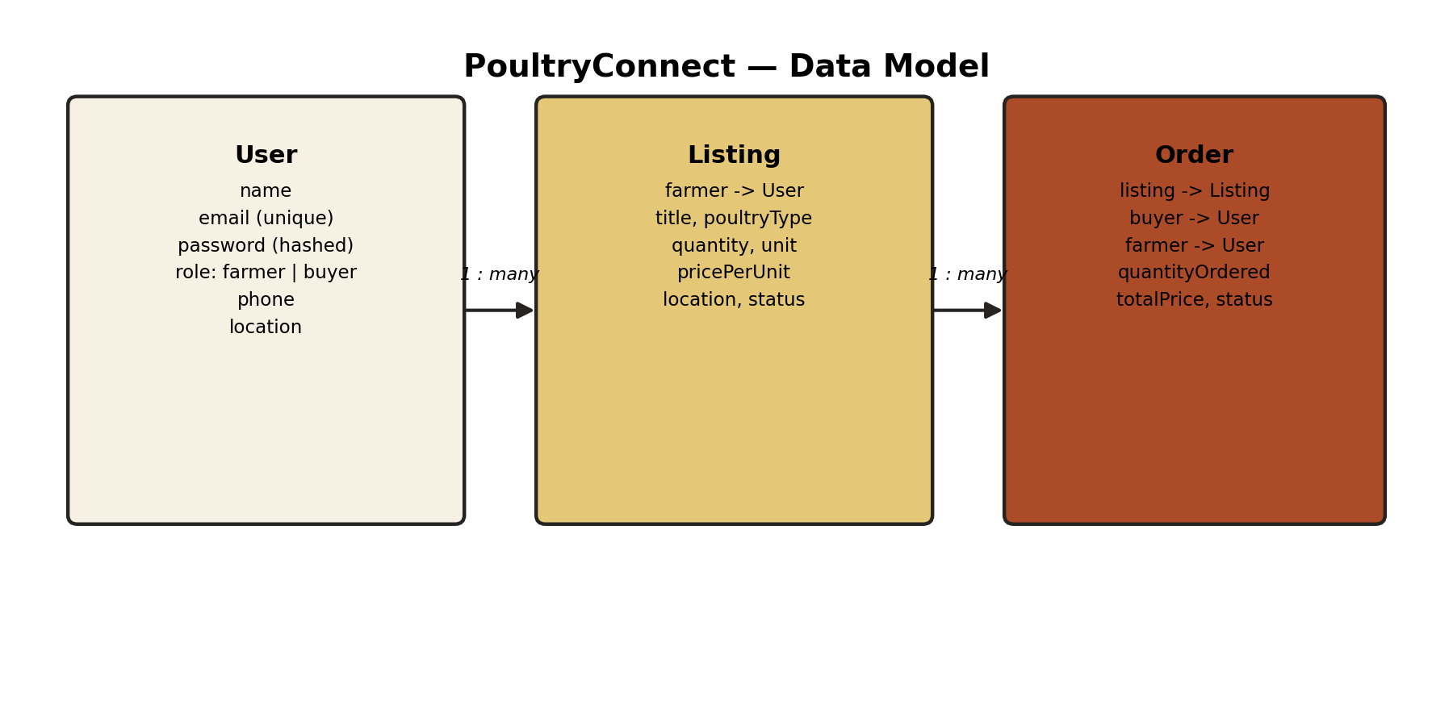
Figure 2. PoultryConnect data model (MongoDB collections and relationships).
Because MongoDB is a document database, the one-to-many relationships between User → Listing and Listing/User → Order are implemented with referenced ObjectIds (populated at query time with Mongoose's .populate()) rather than embedded sub-documents, since listings and orders are queried and updated independently of the user record and are expected to grow considerably faster than the user collection.

4. Technology Stack and Justification
The table below summarises the main technology choices and the reasoning behind each.
Layer | Technology | Justification
Front end | React 18 + Vite | Component-based UI suits the role-specific dashboards (farmer vs buyer); Vite gives a fast development/build cycle appropriate for a solo, time-boxed project.
Routing | React Router | Enables protected, role-aware client-side routes (e.g. /farmer/dashboard) without a full page reload.
API layer | Node.js + Express | Lightweight, unopinionated, and widely documented; a single JavaScript runtime across front and back end reduces context-switching for a single developer.
Database | MongoDB Atlas | Managed, free-tier cloud database removes the need to operate database infrastructure; a flexible document schema suits listings whose optional fields (description, etc.) vary; native Node.js driver support via Mongoose.
ODM | Mongoose | Schema validation, hooks (used for password hashing) and population of referenced documents on top of the native MongoDB driver.
Auth | JSON Web Tokens + bcrypt | Stateless authentication suited to a decoupled SPA/API architecture; bcrypt is the standard for password hashing (salted, adaptive cost).
Frontend hosting | Vercel | Git-integrated continuous deployment; automatic HTTPS and global CDN distribution for the static SPA build.
API hosting | Render | Git-integrated continuous deployment for Node services with a genuinely free tier suitable for coursework deployment.

This stack was chosen over alternatives such as a relational database (PostgreSQL/MySQL) because the entities in this domain (a listing's optional fields, potential future poultry-type-specific attributes) map more naturally onto a flexible document schema than a rigid relational one, and because MongoDB Atlas's free managed tier removes an entire category of database-administration work that is out of scope for the module's learning objectives. Similarly, Render and Vercel were chosen over a lower-level provider such as raw AWS EC2 because both offer git-push continuous deployment out of the box, which satisfies the module's continuous-integration/deployment requirement without needing to hand-configure a CI pipeline, while still deploying to genuine public cloud infrastructure.

5. Implementation

5.1 Backend
The API is organised into a conventional layered structure: routes define the URL surface and attach middleware, controllers contain the request-handling logic, and Mongoose models define schema and validation. Three route groups implement the whole system:
- /api/auth — register, login, and a protected "who am I" endpoint, returning a signed JWT on success.
- /api/listings — public read endpoints for browsing and filtering the marketplace by poultry type and location, and farmer-only, ownership-checked endpoints for creating, editing, and deleting listings.
- /api/orders — buyer-only order creation (with server-side validation that the ordered quantity does not exceed the listed quantity), and farmer-only endpoints to view orders received and to update an order's status.
Two pieces of Express middleware enforce access control on every protected route: protect verifies the JWT and attaches the authenticated user to the request, and restrictTo(role) rejects the request with HTTP 403 if the authenticated user's role does not match what the route requires. Ownership checks (a farmer may only edit or delete their own listings, and only the farmer who owns a listing's parent may change an order's status) are enforced again inside the controller, since role alone is not sufficient to guarantee ownership.

5.2 Frontend
The SPA is organised around a small set of pages (Home, Login, Register, Listings, Listing Detail, Farmer Dashboard, Buyer Dashboard) and a React Context (AuthContext) that holds the logged-in user and exposes login/register/logout functions to any component. A ProtectedRoute wrapper component redirects unauthenticated users to the login page and redirects users whose role does not match a route's required role, implementing client-side route guarding that mirrors the server-side authorisation rules. A single Axios instance attaches the stored JWT to every outgoing request via an interceptor, so individual page components never handle the authentication header directly.

5.3 Testing and quality assurance
Given the project's scope and timeline, testing was carried out primarily through structured manual end-to-end verification of every user flow (registration for both roles, listing creation/edit/delete, order placement, and order status transitions) against the deployed environment, supplemented by direct testing of API endpoints. Input validation is enforced at two levels — Mongoose schema validation at the data layer, and explicit checks in controllers (e.g. rejecting an order that exceeds available stock) at the application layer — so that malformed requests are rejected before they can corrupt stored data, which is the same defence-in-depth principle a larger automated test suite would otherwise exist to verify.

6. Security Considerations
- Passwords are never stored in plain text: bcrypt generates a salted hash before the User document is saved, and the password field is excluded from query results by default (select: false) so it cannot be accidentally leaked in an API response.
- Authentication uses signed, time-limited JWTs; the signing secret is held only in server-side environment variables and never committed to source control.
- Authorisation is role-based (farmer vs buyer) and re-checked at the resource level (a user can only modify records they own), preventing horizontal privilege escalation between two accounts of the same role.
- Cross-Origin Resource Sharing (CORS) on the API is restricted to the known frontend origin rather than left open to any origin, reducing the surface for cross-site request abuse.
- Environment variables (.env) hold all secrets and connection strings and are excluded from the git repository via .gitignore, so credentials are never pushed to GitHub.
- MongoDB Atlas network access and database-user credentials provide a second layer of access control in front of the data tier itself.
These measures follow standard OWASP guidance for web applications (authentication, access control, and sensitive-data exposure are three of the OWASP Top Ten risk categories) and represent a reasonable, proportionate baseline for a coursework deployment; Section 8 discusses further hardening that a production deployment beyond this module would need.

7. Deployment
The system uses git-based continuous deployment rather than a hand-run deployment step. The source code is hosted in a single GitHub repository with separate backend and frontend directories. Render is connected directly to that repository and configured to build and deploy the backend directory automatically on every push to the main branch (npm install then npm start); Vercel is connected the same way for the frontend directory, running its Vite build and serving the resulting static bundle from its global edge network. Both platforms inject the required secrets (the MongoDB Atlas connection string, the JWT signing secret, and the API's public URL) as environment variables configured in their respective dashboards rather than in source-controlled files, so the same codebase behaves correctly in local development and in the cloud without code changes between environments.
This satisfies the module's requirement for continuous integration and deployment in a way that is appropriate for the project's scale: every accepted change to main is automatically reflected in the live, publicly reachable system within minutes, and a broken build fails visibly on the hosting platform's dashboard rather than silently reaching production.

8. Evaluation, Limitations, and Future Work
The delivered system meets its stated objectives: it is a working, cloud-deployed, role-based marketplace that lets a farmer publish stock and a buyer discover and order it, with an explicit order-status workflow connecting the two. Manual end-to-end testing across both roles confirmed that registration, authentication, listing management, filtering, ordering, and status updates all function correctly against the live deployment.
The current implementation has some deliberate scope limitations, which are opportunities for future work rather than defects:
- No payment integration — orders are agreed and tracked on-platform, but payment is arranged directly between the two parties, as is common for early-stage B2B agricultural marketplaces.
- No image upload for listings — a future version could add photo evidence of stock using a cloud object store such as Amazon S3 or Cloudinary.
- No SMS/USSD channel — given that some target farmers may have only basic feature phones, an SMS-based listing and ordering channel (as used by several agricultural information services) would materially widen the platform's reach beyond smartphone owners.
- Free-tier hosting constraints — Render's free web-service tier suspends the API after a period of inactivity, introducing a cold-start delay on the first request; a production deployment would use a paid always-on tier or a serverless API design.
- No automated test suite or CI pipeline beyond the hosting platforms' own build step; introducing unit and integration tests (e.g. with Jest and Supertest) and a dedicated CI workflow (e.g. GitHub Actions) would be the natural next step before any real-world pilot.
- No ratings, dispute-resolution, or ratings-based trust mechanism between farmers and buyers, which repeat-usage marketplaces typically require once they scale beyond a trusted pilot group.

9. Conclusion
PoultryConnect demonstrates, at a scope appropriate for a single-developer master's project, the full lifecycle the module requires: identifying a genuine, evidenced real-world problem in agricultural market access; designing a scalable three-tier cloud architecture; implementing that architecture with modern, industry-standard tools (React, Express, MongoDB Atlas); applying baseline security practice throughout; and deploying the result to public cloud infrastructure with continuous, git-based delivery. The narrow, deliberately-scoped feature set — authenticated listings and an explicit order workflow — keeps the system easy to explain and demonstrate while still exercising every layer of a production web stack. The limitations identified in Section 8 outline a credible path from this coursework prototype toward a system that could be piloted with a small group of real farmers and buyers.

References
Enete, A. A. Middlemen and Smallholder Farmers in Cassava Marketing in Africa. ResearchGate.
Current Agriculture Research Journal. Smallholder Farmers' Market Participation: Concepts and Methodological Approach from Sub-Saharan Africa.
Bureau for Food and Agricultural Policy (BFAP). Modelling Poultry Markets in Eastern and Southern Africa: A Technical Report.
Cordaid International. Breaking Down the Barriers for African Smallholder Farmers.
Mississippi State University Extension Service. Poultry Industry Grows across East Africa, but Challenges Remain.
Value chain and public health analysis of live bird markets, Busia, Kenya. PMC (National Center for Biotechnology Information).
Factors influencing small-scale farmers' participation in livestock markets, Western Province, Zambia. PMC (National Center for Biotechnology Information).
Lack of Market Information Impoverishing Smallholder Farmers. FarmBiz Africa.
MongoDB, Inc. MongoDB Atlas Documentation. https://www.mongodb.com/docs/atlas/
OpenJS Foundation. Express.js Documentation. https://expressjs.com/
Meta Platforms, Inc. React Documentation. https://react.dev/
OWASP Foundation. OWASP Top Ten. https://owasp.org/www-project-top-ten/
Render Services, Inc. Render Documentation. https://render.com/docs
Vercel Inc. Vercel Documentation. https://vercel.com/docs

