<!--自定义表单-->  
<link href="/plugins/formGenerator/formGenerator.css" rel="stylesheet">  
<script src="/plugins/formGenerator/formGenerator.js"></script>  
<script src="/plugins/formGenerator/formGenerator-plugin.js"></script>

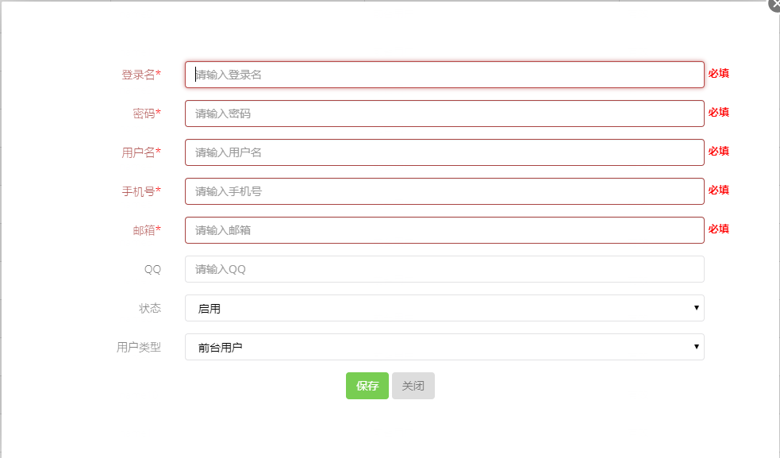

<div id="add_div"></div>

<script>  
 ***formGenerator***.addFormInit({  
 elem: '#add_div',  
 data: ***rowData***,//全局赋值来源  
 inputs: [  
 {name: "userName", text: '登录名', required: 'required'},  
 {name: "password", text: '密码', required: 'required'},  
 {name: "name", text: '用户名', required: 'required', data: ***rowData***.userInfo},  
 {name: "phone", text: '手机号', required: 'required', data: ***rowData***.userInfo},//局部赋值来源  
 {name: "email", text: '邮箱', required: 'required', data: ***rowData***.userInfo},  
 {name: "qq", text: 'QQ', data: ***rowData***.userInfo},  
 {  
 name: "status",  
 text: '状态',  
 type: 'select',  
 options: [{text: '启用', value: '1'}, {text: '禁用', value: '0'}]  
 },  
 {  
 name: 'type',  
 text: '用户类型',  
 type: 'select',  
 options: [{text: '前台用户', value: 1}, {text: '后台用户', value: 2}],  
 },  
 ],  
 save: function (layerIndex) {  
 let param = $('#add_div_form').serializeJson();  
 param.userId = ***rowData***.userId;  
 ***console***.log(param);  
 $.post("/user/save", param, function (data) {  
 layer.msg(data.msg, {  
 time: 1000 //s后自动关闭  
 }, function () {  
 layer.close(layerIndex);  
 ***table***.refresh();  
 });  
 });  
 return false;  
 }  
 });  
</script>

# 表格参数

|  |  |  |  |  |
| --- | --- | --- | --- | --- |
| 名称 | 类型 | 默认 | 示例 | 描述 |
| elem | string | 必填 | '#add_div' | id,class,$(属性) |
| data | object | {} | {name: "张山", age: 12} | 初始化赋值,适用用于编辑自动赋值 |
| inputs | array | 必填 |  | 参考inputs 属性 |
| validate | function | -- | validate:function(from) | 自定义验证,默认用jquery.validate.min.js |
| save | Function | -- | save: function (layerIndex) { | 表单 验证通过,回调 |
| close | Function |  |  | 关闭按钮 |

# inputs参数

|  |  |  |  |  |
| --- | --- | --- | --- | --- |
| 名称 | 类型 | 默认 | 示例 | 描述 |
| name | string | 必填 | {name: "userName",… | name 属性值 |
| text | string | 必填 | text: '登录名' | text 属性值 |
| required | Boolean/String | -- | required:true or required: 'required' | 是否启用验证 |
| data | obj | -- |  | 优先级 value > data >全局 data |
| type | **String** | **text** |  | **text/number/time/dateTime/select/textarea/button更多请到formGenerator-plugin.js自定义** |
| value | obj | -- | value:1 | 赋值:优先级 value > data >全局 data |
| options | array | -- | [{text: '启用', value: '1'}, {text: '禁用', value: '0'}] | 设置 option 时,自动切换成 select |
| url | String |  | /menu/list | 远程option 参数地址,会自动叠加到 options,如果数据格式不是[{text: '启用', value: '1'}, {text: '禁用', value: '0'}],请设置data |
| data |  |  | url: '/menu/list', data: {text: 'name', value: 'menuId'} | 当设置 url 是,data不在是赋值,而是数据转换声明 |