
Introduction to Artificial intelligence
Prof. Ahmad Hassanat
Dr. Ahmad Altarawneh

Outline
•What is AI
•Topics covered in this course•Knowledge representation•Fuzzy logic
•Searching algorithms
•Machine learning
•Deep learning



Meet HAL
•2001: A Space Odyssey  •classic science fiction movie from 1969  •Part of the story centers around an intelligent computer called HAL  •HAL is the “brain” of an intelligent spaceship  •in the movie, HAL can  •speaks easily with the crew  •sees and understands the emotions of the crew•navigates the ship automatically  •diagnoses on-board problems  •makes life-and-death decisions  •displays emotions  •In 1969 this was science fiction: is it still science fiction? | 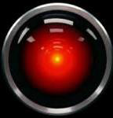

Different Types of Artificial Intelligence
•Modeling exactly how humans think
•cognitive models of human reasoning
•Planning, solving puzzles, playing chess, math formulas, optimization (approximations, not just the optimal solutions)
•Modeling exactly how humans act
•models of human behavior (what they do, not how they think)
•Shopping, how a student moves around a university campus
•human actions are often influenced by underlying cognitive processes. However, the primary focus is on the actions themselves.

Cont.
•Modeling how ideal agents “should think”
•  • | models of “rational” thought (formal logic), reasoning, expert systems  note: humans are often not rational! Many things can influence humans' thinking (anger,
love)
•Modeling how ideal agents “should act”
•  •  • | Rational actions but not necessarily formal rational reasoning  i.e., more of a black-box/engineering approach, based on experience, machine learning) E.g., self-driving vehicles
•Modern AI focuses on the last definition
•  • | success is judged by how well the agent performs  modern methods are also inspired by cognitive & neuroscience (how people think).

Acting humanly: Turing Test•Turing (1950) "Computing machinery and intelligence":
•"Can machines think?" →"Can machines behave intelligently?"
•Operational test for intelligent behavior: the Imitation Game
•Suggested major components of AI: - knowledge representation  - reasoning,  - language/image understanding,- learning | 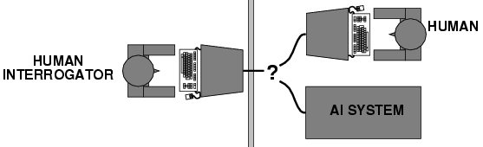

Acting rationally: rational agent
•Rational behavior: Doing what is expected to maximize a “utility function” in a given environment.
•An agent is an entity that perceives and acts.
•A rational agent acts rationally.
•This course is about designing rational agents
•Abstractly, an agent is a function that maps percept histories to actions: [f: P* →A]
•For any given class of environments and tasks, we seek the agent (or class of agents) with the best performance
•Note: computational limitations make perfect rationality unachievable
→design the best program for given machine resources

Academic Disciplines important to AI.
•Philosophy  •Mathematics  •Economics  •Neuroscience  •Psychology/  •Computer  engineering  •Control theory  •Linguistics | Logic, methods of reasoning, mind as physical  system, foundations of learning, language,  rationality.  Formal representation and proof, algorithms,  computation, probability.  utility, decision theory, rational economic agents  neurons as information processing units.  how do people behave, perceive, process Cognitive Science information, represent knowledge.  building fast computers  design systems that maximize an objective  function over time  knowledge representation, grammar

•1965
•1966—73 discovering computational complexity (Cook's theorem)
•1969—79 Early development of knowledge-based systems
•1980-- AI becomes an industry
•1986-- Neural networks return to popularity (Backpropagation popularity)•1987-- AI becomes a science
•1995-- The emergence of intelligent agents
•2011-- Deep learning revolution (2012 AlexNet)
principle)
Robinson's complete algorithm for logical reasoning (resolution
Neural network research almost disappears 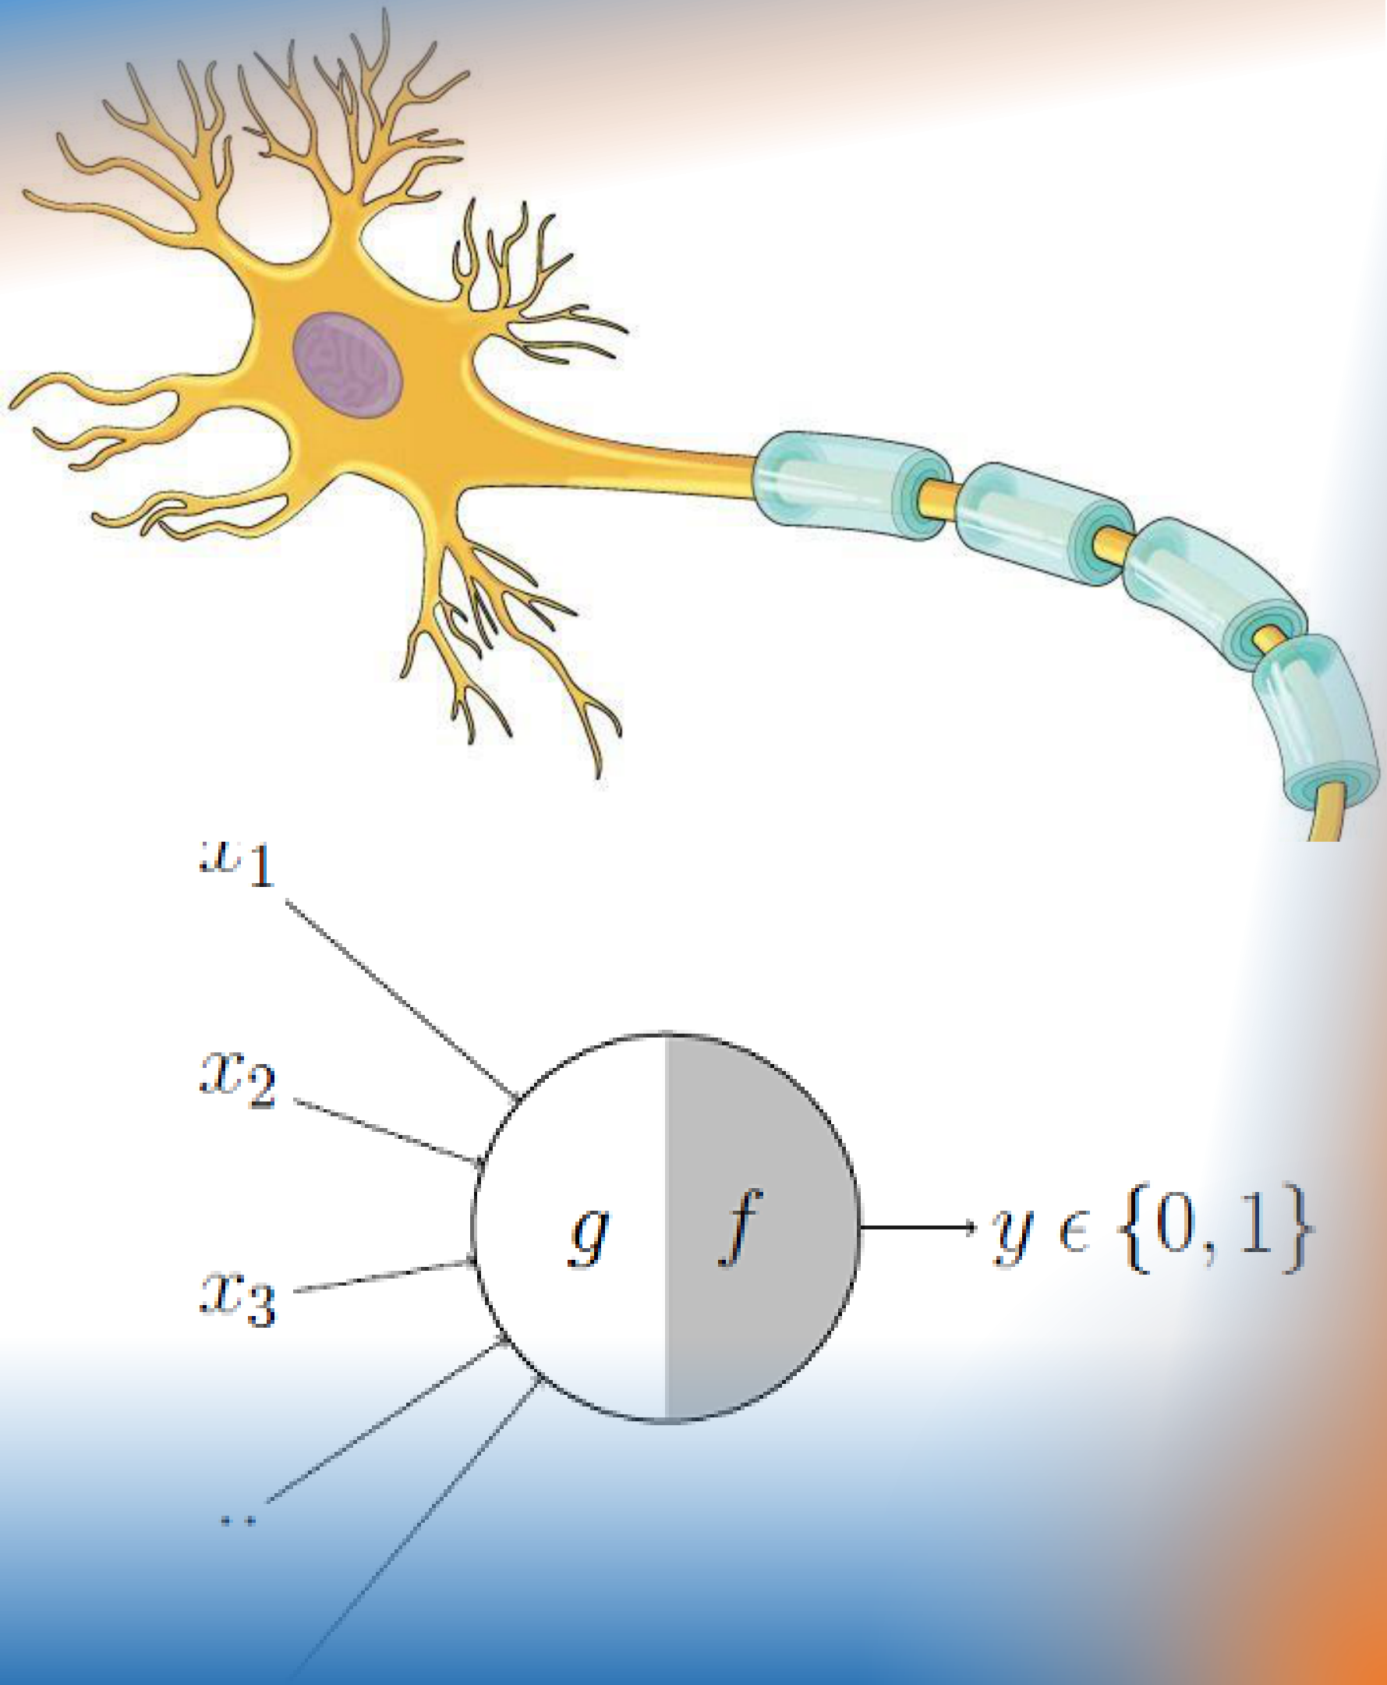
History of AI
•1943 McCulloch & Pitts: Boolean circuit model of brain
•1950 Turing's "Computing Machinery and Intelligence"
•1956 Dartmouth meeting: "Artificial Intelligence" adopted
•1950s Early AI programs, including Samuel's checkers
program, Newell & Simon's Logic Theorist,

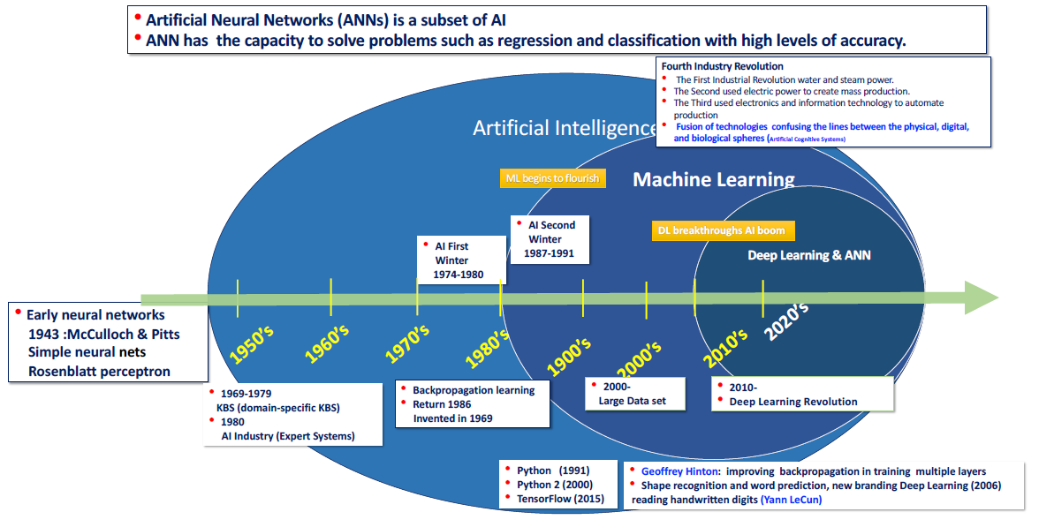

Successes of AI
•Deep Blue defeated the reigning world chess champion Garry Kasparov in 1997 (4-2)
•No hands across America (driving autonomously 98% of the time from Pittsburgh to San Diego)
•During the 1991 Gulf War, US forces deployed an AI logistics planning and scheduling program that involved up to 50,000 vehicles, cargo, and people, (also known as Dynamic Analysis and Replanning Tool (DART))
•NASA's on-board autonomous planning program controlled the scheduling of operations for a spacecraft |  | 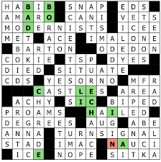
•Proverb solves crossword puzzles better than most humans | 
•Stanford vehicle in Darpa challenge completed autonomously a 132-mile desert track in 6 hours 32 minutes.

Consider what might be involved in building an “intelligent” computer….

•What are the “components” that might be useful?
•Fast hardware?
•Foolproof software?
•Chess-playing at grandmaster level?
•Speech interaction?
•speech synthesis (text-to-speech (TTS))
•speech recognition
•speech understanding
•Image recognition and understanding ?
•Learning?
•Planning and decision-making?

Can we build hardware as complex as the
brain?
•How complicated is our brain?
•a neuron, or nerve cell, is the basic information processing unit
•estimated to be on the order of 10 11 neurons in a human brain
•many more synapses (10 14) connecting these neurons
•cycle time: 10 -3 seconds (1 millisecond): the time taken for a cognitive process to occur
•How complex can we make computers?
•106 or more transistors per CPU
•Conclusion
•cycle times: order of 10 - 9 seconds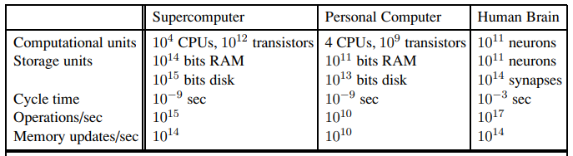
•supercomputer: hundreds of CPUs, 10 14 bits of RAM
•YES: soon we can have computers with as many basic processing elements as our brain, but with
•far fewer interconnections (wires or synapses) than the brain
•much faster updates than the brain
•but building hardware is very different from making a computer behave like a brain!

Must an Intelligent System be Foolproof?
•A “foolproof” system is one that never makes an error: •Types of possible computer errors
•hardware errors, e.g., memory errors
•software errors, e.g., coding bugs
•“human-like” errors: incorrect or unexpected decisions, misinterpret speech in human communication, etc.
•Clearly, hardware and software errors are possible in practice•what about “human-like” errors?
•An intelligent system can make errors and still be intelligent •humans are not right all of the time
•we learn and adapt from making mistakes
•e.g., consider learning to surf or ski
• we improve by taking risks and falling
• an intelligent system can learn in the same way
•Conclusion:
•NO: intelligent systems will not (and need not) be foolproof


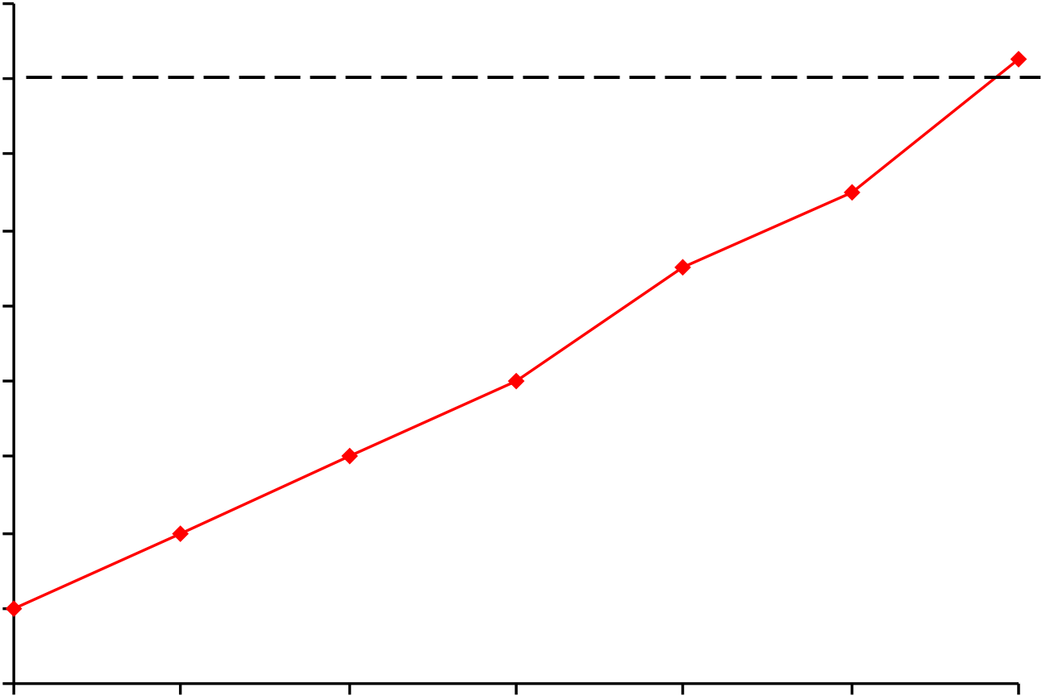
Can Computers play Humans at Chess?
• Chess Playing is a classic AI problem
•well-defined problem  •very complex: difficult for humans to play well |  |  | 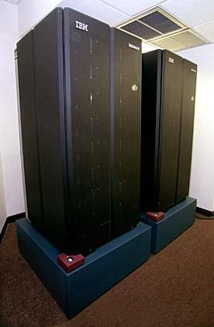
3000 | Garry Kasparov | Deep Blue
2800
2600
2400
2200  2000 | Ratings
1800
1600
1400
1200
1966 | 1971 | 1976 | 1981 | 1986 | 1991 | 1997
•Conclusion: YES: today’s computers can beat even the best human

Can Computers Talk?
•This is known as “speech synthesis”
•translate text to phonetic form
•e.g., “fictitious” -> fik-tish-es
•use pronunciation rules to map phonemes to actual sound •e.g., “tish” -> sequence of basic audio sounds
•Difficulties
•sounds made by this “lookup” approach sound unnatural
•sounds are not independent
•e.g., “act” and “action”: the system should recognize that the addition of the suffix "-ion" modifies the sound •modern systems (e.g., at AT&T) can handle this pretty well
•a harder problem is emphasis, emotion, etc.
•humans understand what they are saying
•machines don’t: so, they sound unnatural
•Conclusion: NO, for complete sentences, but YES for individual words •However, there are many serious improvements done recently

Can Computers Recognize Speech?
• Speech Recognition:
•mapping sounds from a microphone into a list of words.
•Hard problem: noise, more than one person talking, speech variability,.. •Even if the system recognize each word, it may not understand its meaning.
• Recognizing single words from a small vocabulary
•systems can do this with high accuracy (order of 99%)
•e.g., directory inquiries
•limited vocabulary (area codes, city names)
•computer tries to recognize you first, if unsuccessful hands you over to a human operator
•saves millions of dollars a year for the phone companies

Recognizing human speech (ctd.)
•Recognizing normal speech is much more difficult
•speech is continuous: where are the boundaries between words?
•e.g., “John’s car has a flat tire”
•large vocabularies
•can be many tens of thousands of possible words
•we can use context to help figure out what someone said
•try telling a waiter in a restaurant:
“I would like some dream and sugar in my coffee” •background noise, other speakers, accents, colds, etc.
•on normal speech, modern systems are only about 60% accurate
•Conclusion: NO, normal speech is too complex to accurately recognize, but YES for restricted problems
•(e.g., recent software for PC use by IBM, Dragon systems, etc.)

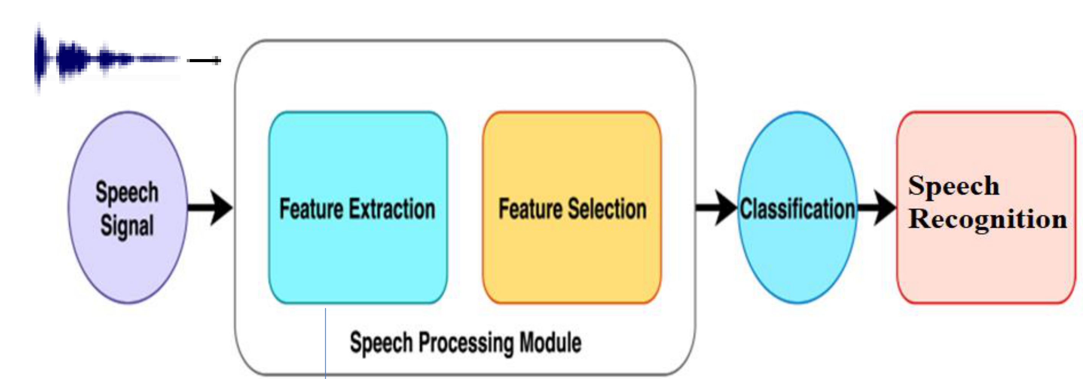
Typical speech recognition system
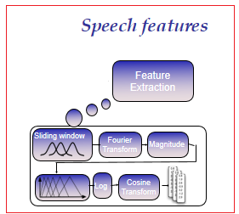

Can Computers Understand Speech?
• Understanding is different to recognition: •“Time flies like an arrow”
•assume the computer can recognize all the words •but how could it understand it?
•1. time passes quickly like an arrow?
•2. time flies the way an arrow flies
•3. only time that flies is like an arrow
•only 1. makes sense, but how could a computer figure this out?
•clearly humans use a lot of implicit commonsense knowledge in communication•Many other examples: “give me a hand”, “put yourself in my shoes”
• Conclusion: Partially yes, some of what we say is beyond the capabilities of a computer to understand.
•However, modern chatbots, like chatgpt 4, are somewhat good at this

Can Computers Learn and Adapt ?
• Learning and Adaptation  •consider a computer learning to drive on the freeway•we could code lots of rules about what to do  •and/or we could have it learn from experience  Darpa’s Grand Challenge. Stanford’s “” drove  150 miles without supervision in the Mojave desert | 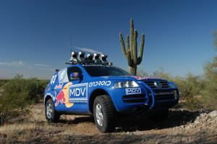
•machine learning allows computers to learn to do things without explicit programming
• Conclusion: YES, computers can learn and adapt, when presented with information in the appropriate way

Can Computers “see”?
•Recognition v. Understanding (like Speech)
•Recognition and Understanding of Objects in a scene
• look around this room
• you can effortlessly recognize objects
• human brain can map 2d visual image to 3d “map”
•Why is visual recognition a hard problem?
 |  |  |  | 
•Conclusion: mostly NO: computers can only “see” certain types of objects under limited
circumstances: but YES for certain constrained problems (e.g., face and palmprint recognition)

Diagram for a Palm print recognition system
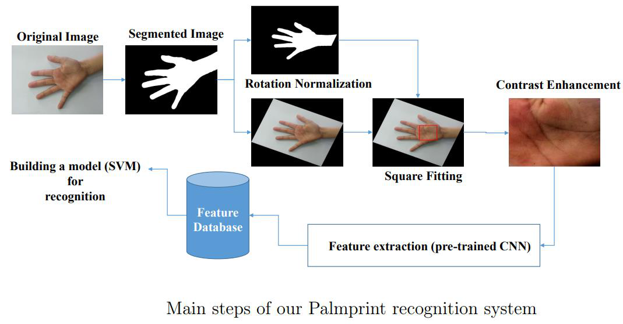

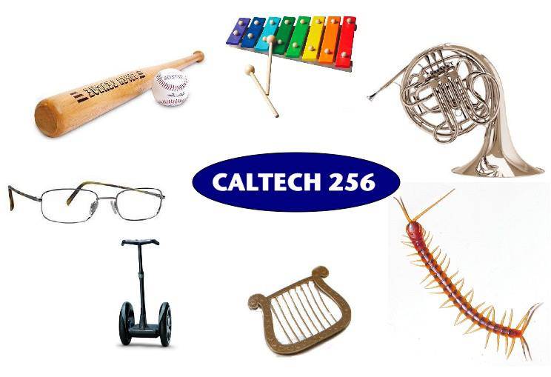 | In the computer vision community  research compete to improve recognition performance on standard datasets  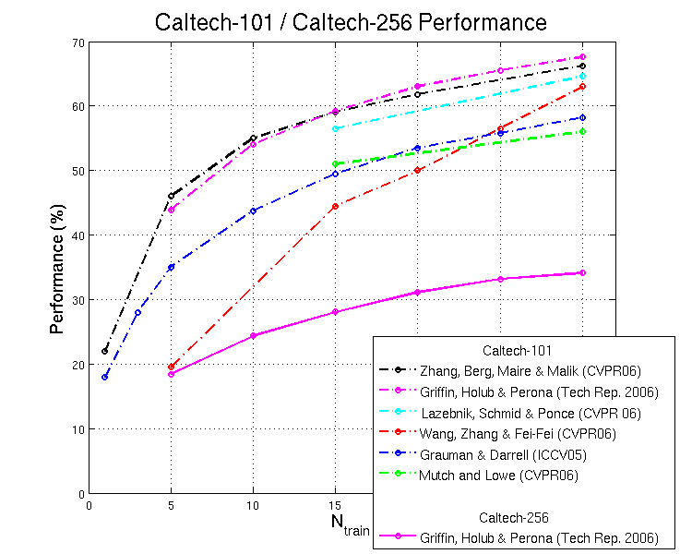

Can Computers plan and make decisions?
•Intelligence
•involves solving problems and making decisions and plans
•e.g., you want to visit your cousin in Aqaba
•  •  • | you need to decide on dates, flights, buses, cars you need to get to the airport, bus station, etc. involves a sequence of decisions, plans, and actions
•What makes planning hard?
•the world is not predictable:
• | your flight is canceled, the rented car broke down, etc.
• | there is a potentially huge number of details
• | do you consider all flights? all dates?
• |  | no: commonsense constrains your solutions.
• AI systems are only successful in constrained planning problems
•Conclusion: NO, real-world planning and decision-making is still beyond the capabilities of modern computers
•exception: very well-defined, constrained problems

Intelligent Systems in Your Everyday Life
•Post Office
•automatic address recognition and sorting of mail
•Banks
•automatic check readers, signature verification systems
•automated loan application classification (give loan or don't)
•Telephone Companies
•automatic voice recognition for directory inquiries
•Credit Card Companies
•automated fraud detection
•Computer Companies
•automated diagnosis for help-desk applications
•Netflix:
•movie recommendation
•Google:
•Search Technology

AI Applications: Consumer Marketing
•Have you ever used any kind of credit/ATM/store card while shopping? •if so, you have very likely been “input” to an AI algorithm
•All of this information is recorded digitally
•Companies like Nielsen gather this information weekly and search for patterns •general changes in consumer behavior
•tracking responses to new products
•identifying customer segments: targeted marketing, e.g., they find out that consumers with sport cars who buy textbooks respond well to offers of new credit cards.
•Currently a very hot area in marketing
•How do they do this?
•Algorithms (“data mining”) search data for patterns
•based on mathematical theories of learning
•completely impractical to do manually

AI Applications: Identification Technologies
•ID cards
•e.g., ATM cards
•can be an annoying and security risk:
•cards can be lost, stolen, passwords forgotten, etc.
•Biometric Identification
•walk up to a locked door
•camera
•fingerprint device
•microphone
•iris scan
•computer uses your biometric signature for identification •face, eyes, fingerprints, voice pattern, iris pattern

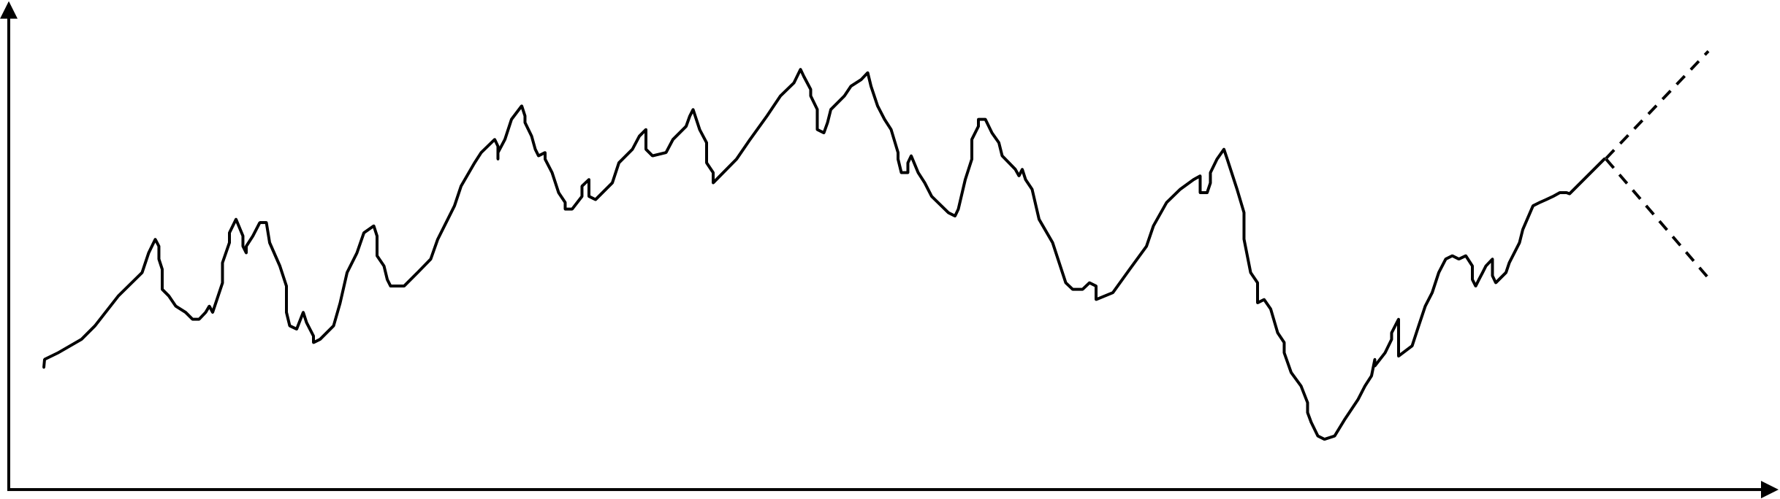
AI Applications: Predicting the Stock Market
Value of  the Stock | ?
?
•The Prediction Problem time in days
•given the past, predict the future
•very difficult problem!
•we can use learning algorithms to learn a predictive model from historical data •prob(increase at day t+1 | values at day t, t-1,t-2....,t-k)
•such models are routinely used by banks and financial traders to manage e-wallets worth millions of dollars

AI-Applications: Machine Translation
•Language problems in international business
•e.g., at a meeting of Japanese, Korean, Vietnamese and Swedish investors, no common language.
Or imagine you are shipping your software manuals to 127 countries•solution; hire translators to translate (expensive)
•would be much cheaper if a machine could do this!
•How hard is automated translation
•very difficult!
•e.g., English to Russian
• | “The spirit is willing, but the flesh is weak” (English)
• | “the vodka is good, but the meat is rotten” (Russian)
•not only must the words be translated, but their meaning also!
•Nonetheless....
•commercial systems can do a lot of the work very well (e.g., restricted vocabularies in software documentation)
•algorithms which combine dictionaries, grammar models, etc.
•see for example www.babelfish.com, translate.google.com•Recently, Deep auto encoders can improve this task significantly.
•Deep learning for Large language models (LLM), e.g., Chatgpt can perform translation better than old approaches

Summary of chapter one
•Artificial Intelligence involves the study of:
•automated recognition and understanding of speech, images, etc•learning and adaptation
•reasoning, planning, and decision-making
•AI has made substantial progress in
•recognition and learning
•some planning and reasoning problems
•AI Applications
•improvements in hardware and algorithms => AI applications in industry, finance, medicine, and science.
•AI Research
•many problems still unsolved: AI is a fun research area!

