LAP-5 Router configuration in Cisco Packet Tracer PCS and two Switch using POOL-ex

Lab Objectives:
Make student to know how making a network in Packet Tracer using a router.

Lab instructions:

- Add two Switches (includes number of PC’s) and a router.
- Connect between them using Straight cable.
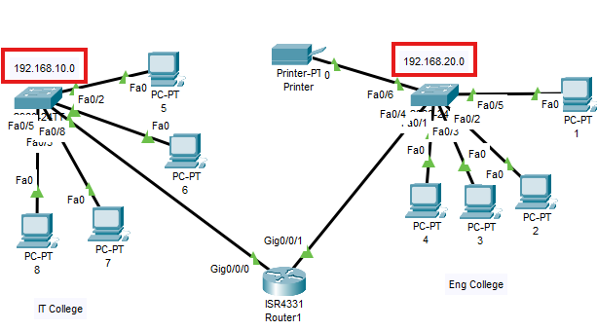
- Using CLI Add the IP address for each Interfaces as following.

Router#enable
Router#configure terminal
Router(config)#interface gi0/0/0
Router(config-if) # IP address 192.168.10.1 255.255.255.0
Router(config-if) # No shutdown
Exit
Router(config)# ip dhcp pool EmadPOOL
Router(dhcp-config)# network 192.168.10.0 255.255.255.0
Router(dhcp-config)# default-router 192.168.10.1
Exit

Router(config)#interface gi0/0/1
Router(config-if) # IP address 192.168.20.1 255.255.255.0
Router(config-if) # No shutdown
Exit
Router(config)# ip dhcp pool EZZPOOL
Router(dhcp-config)# network 192.168.20.0 255.255.255.0
Router(dhcp-config)# default-router 192.168.20.1

- Click on any Pc and go to Desktop select DHCP

PC from interface 0/0/0
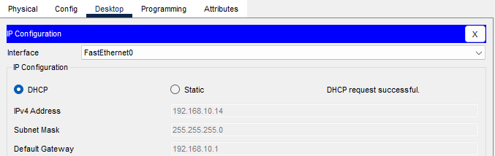

PC from interface 0/0/1
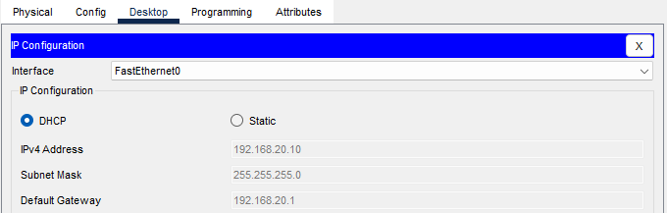

- For Printer we must use static IP Address but before that we must config the router to exclude the static IP by the following configuration.

Router(config)# ip dhcp excluded-address 192.168.10.2 192.168.10.20 [exclude from 2~20 IP]

