1. **Main site**
2. Deploying contracts(on Remix)
3. BitDogeStarToken.sol

* deploying

Making new file

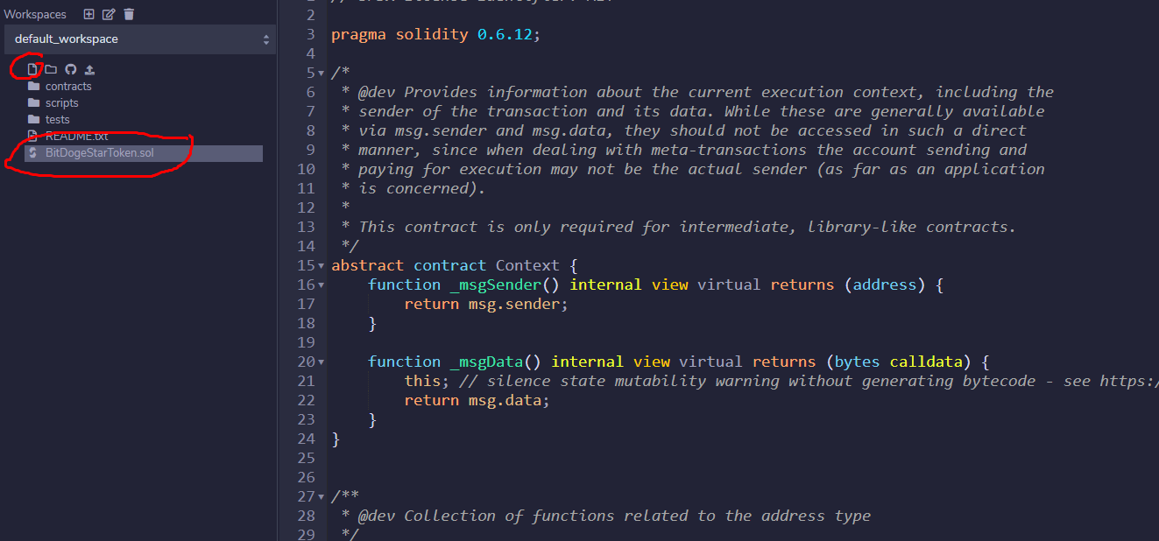

Compiling contract

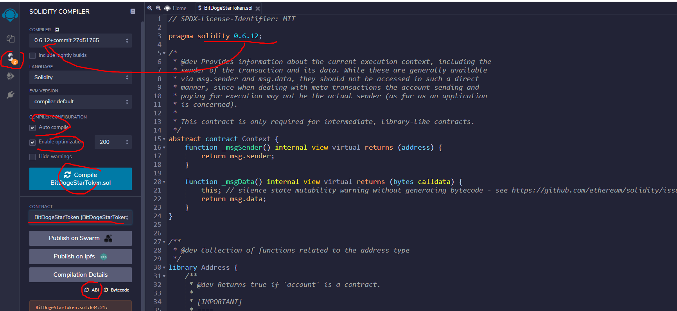

Deploying contract

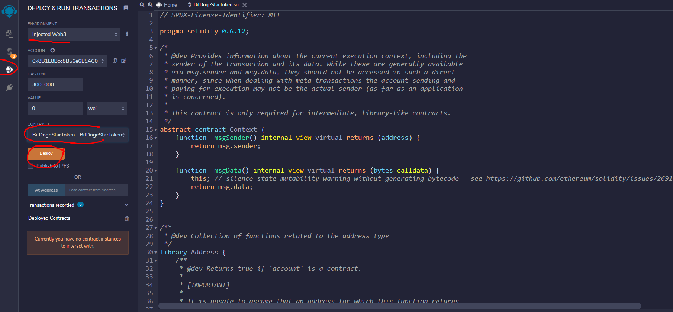

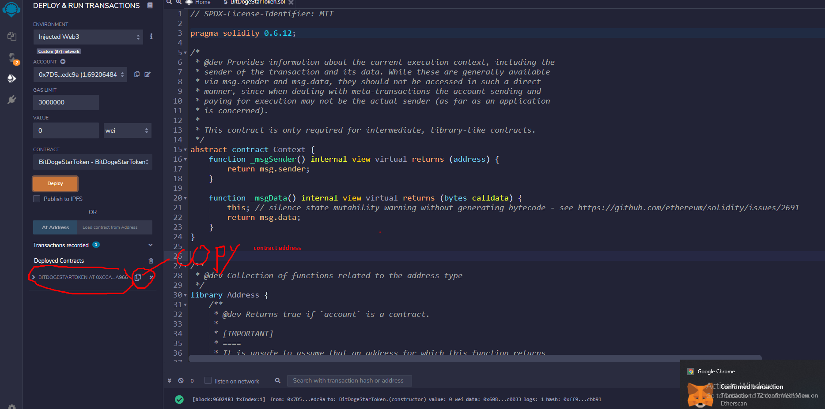

* Verifying

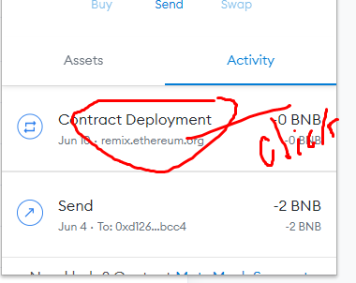

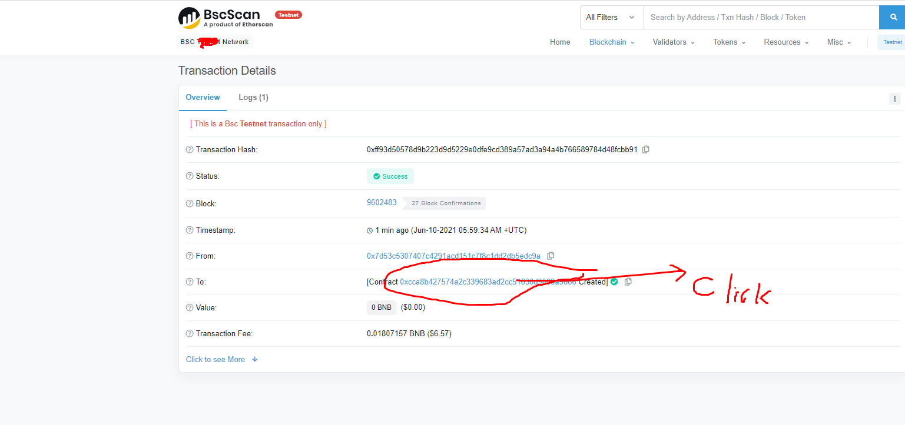

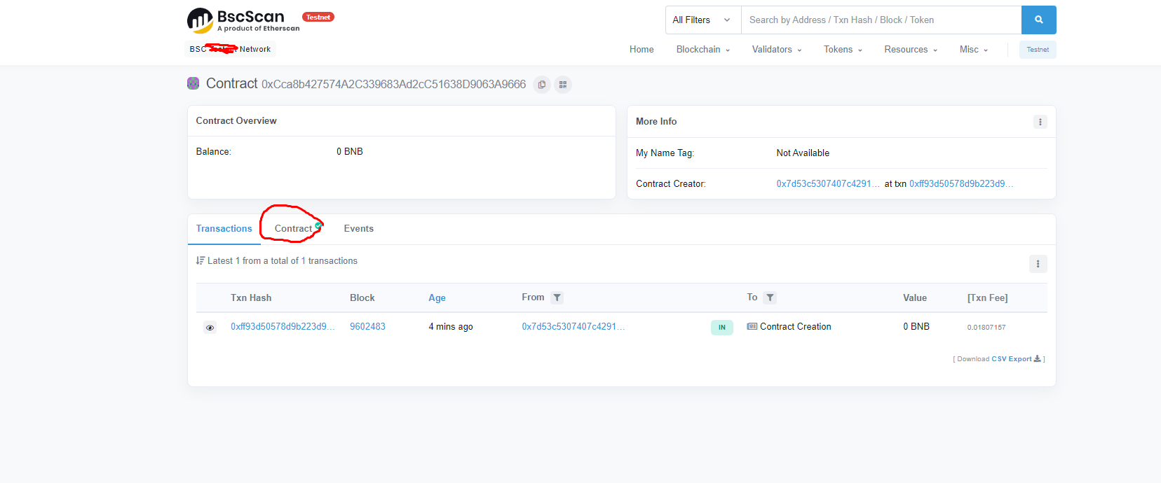

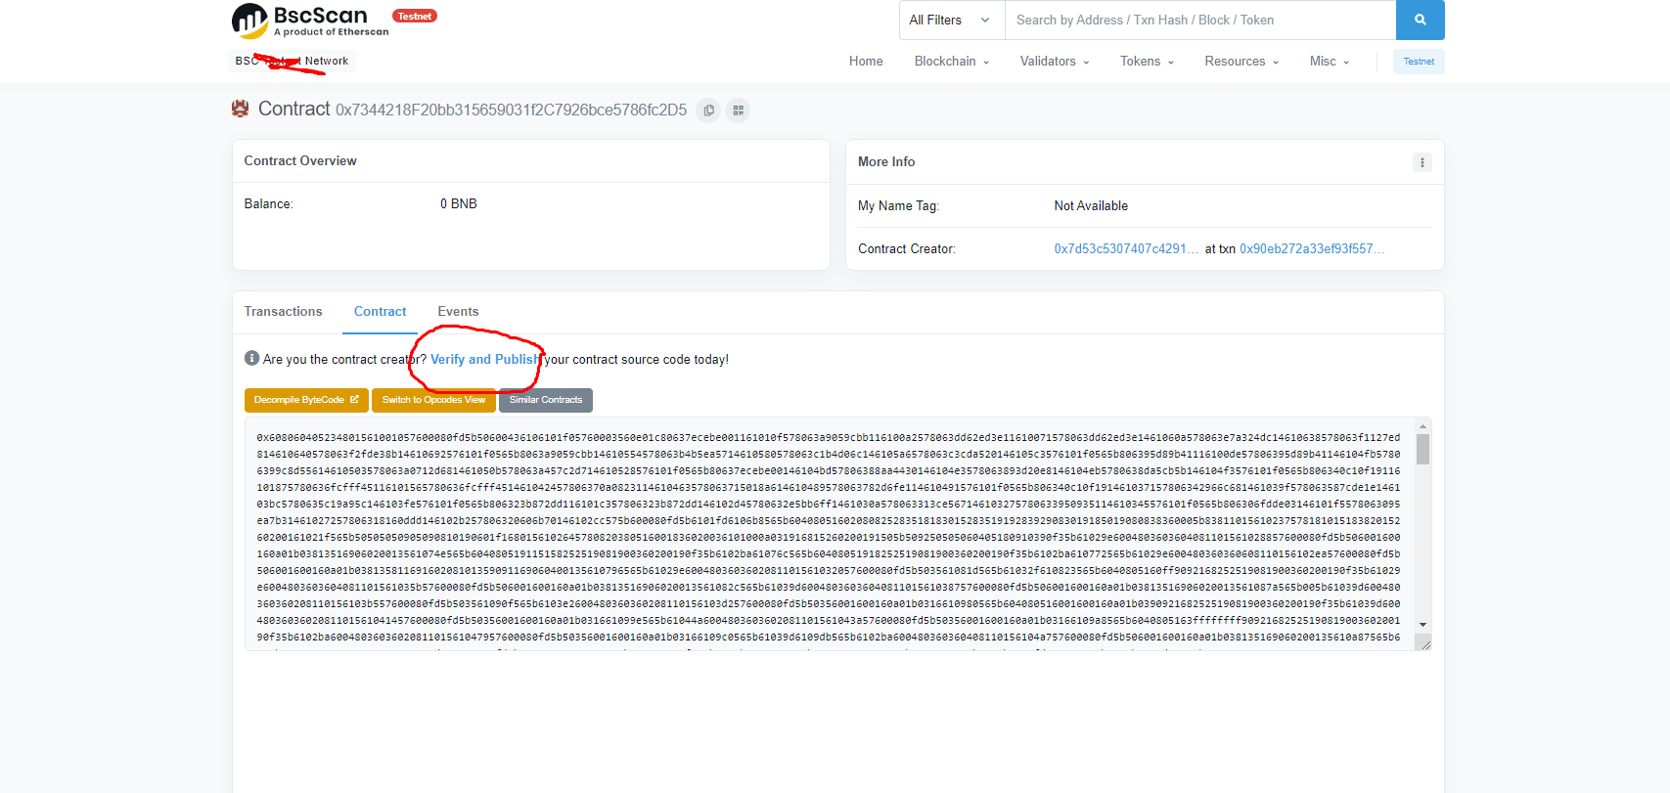

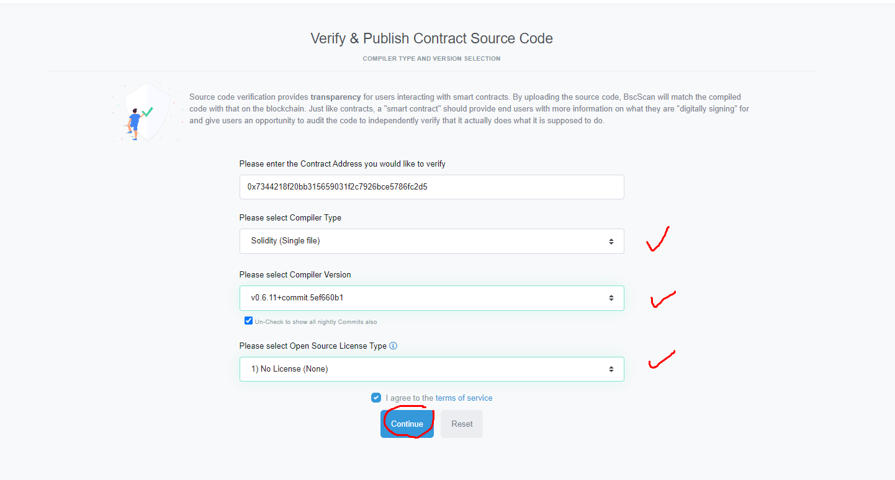

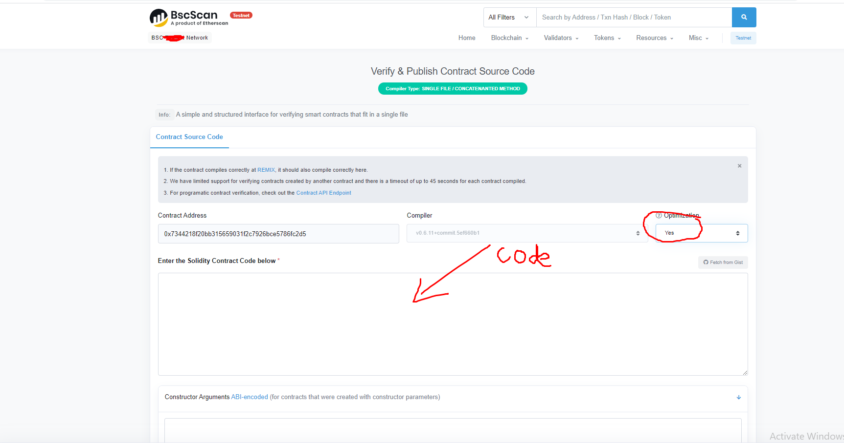

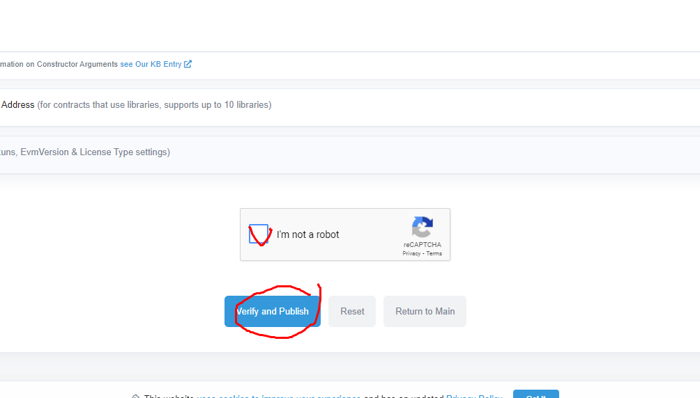

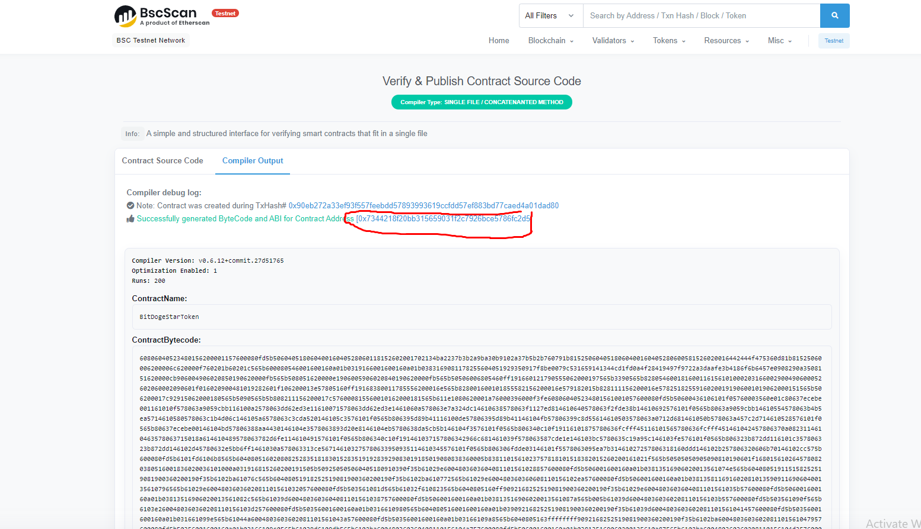

1. MasterChef.sol

* deploying and verifying are same with token contract.

Caution::

On deploying masterchef, we must input the initial values

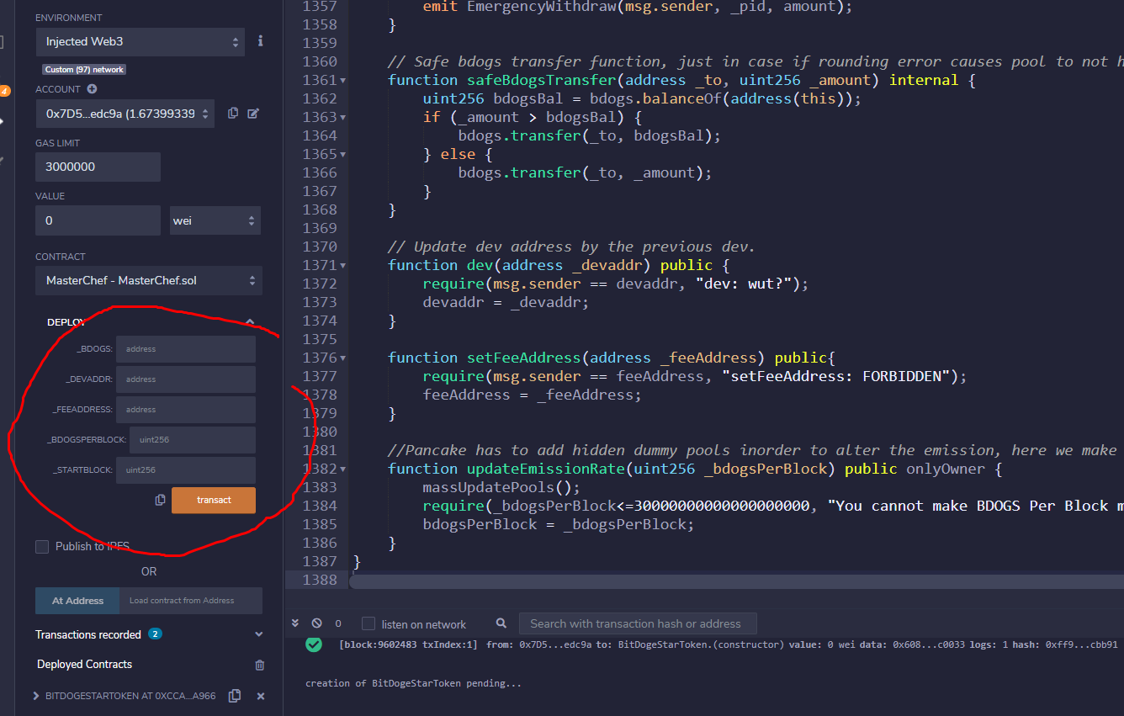

Parameter1: BDOGS token address

Parameter2: Dev address( 10 % of minted token to this address)

Parameter3: tax address

Parameter4: the number of token per block

Parameter5: startblock(the block number that minting starts)

1. Minting

On bscscan.com

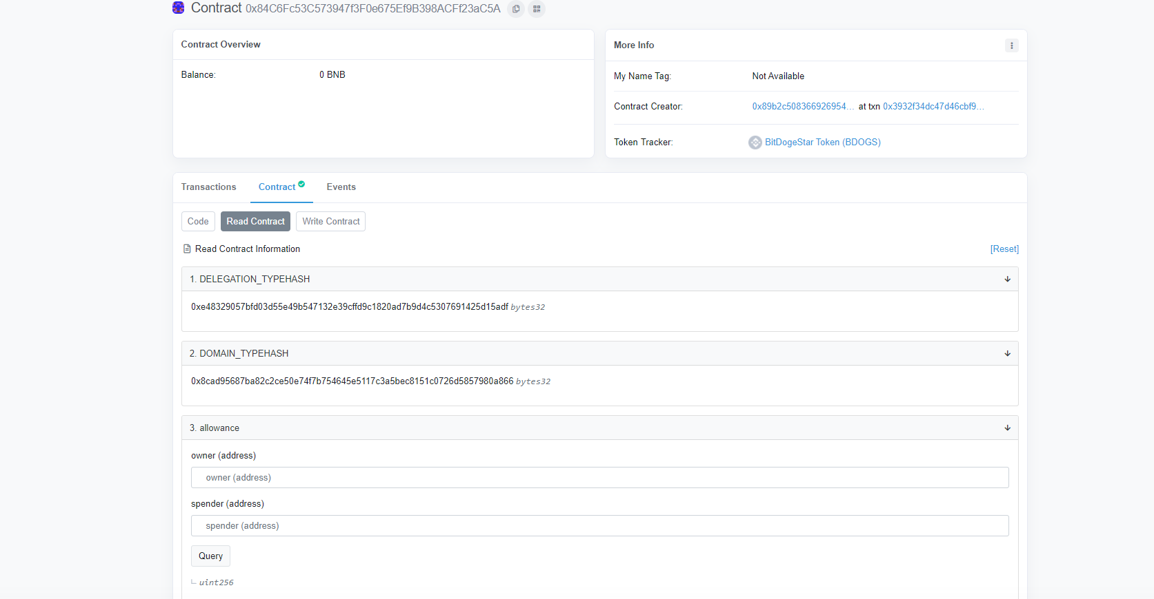

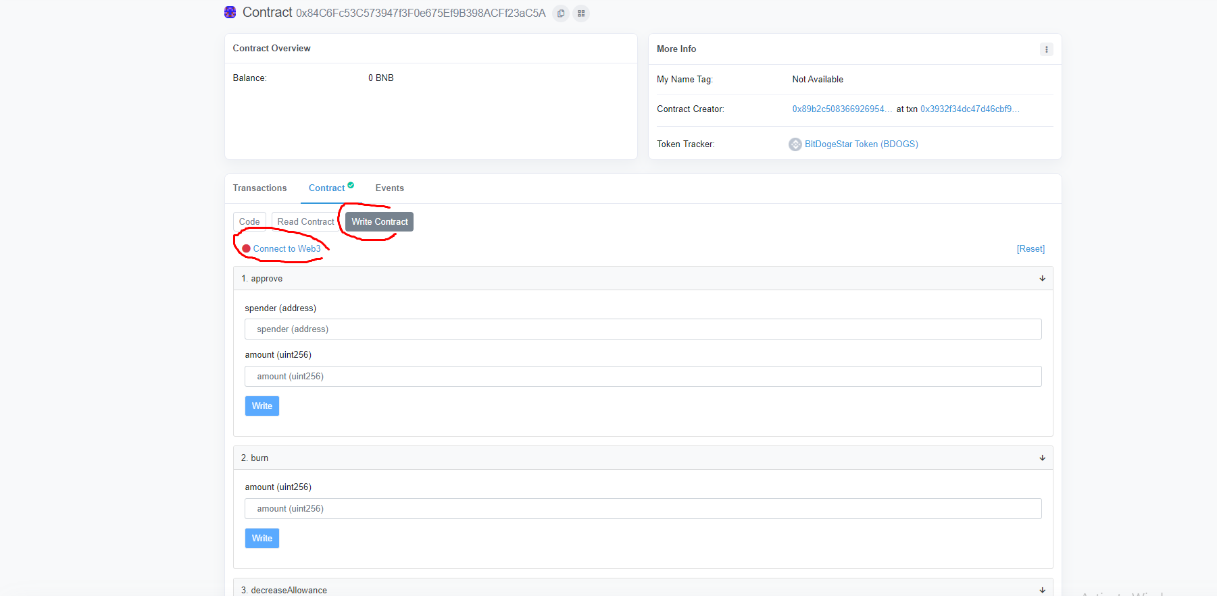

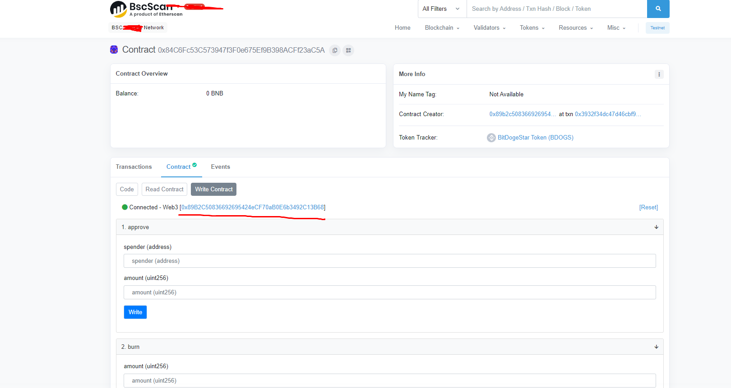

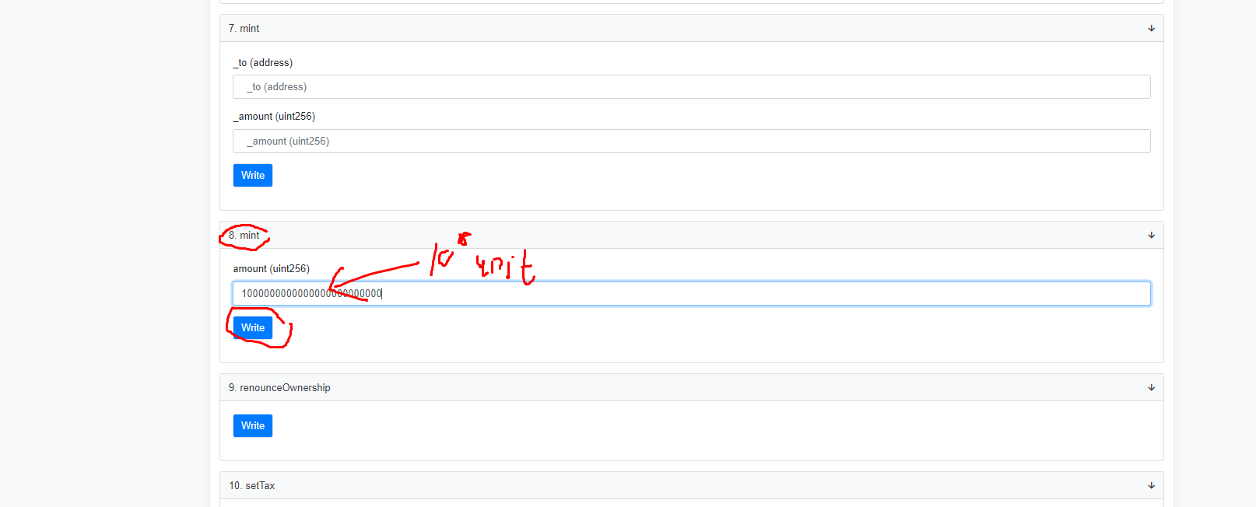

1. Linking(token contract and MasterChef contract)

On bscnet(token contract)

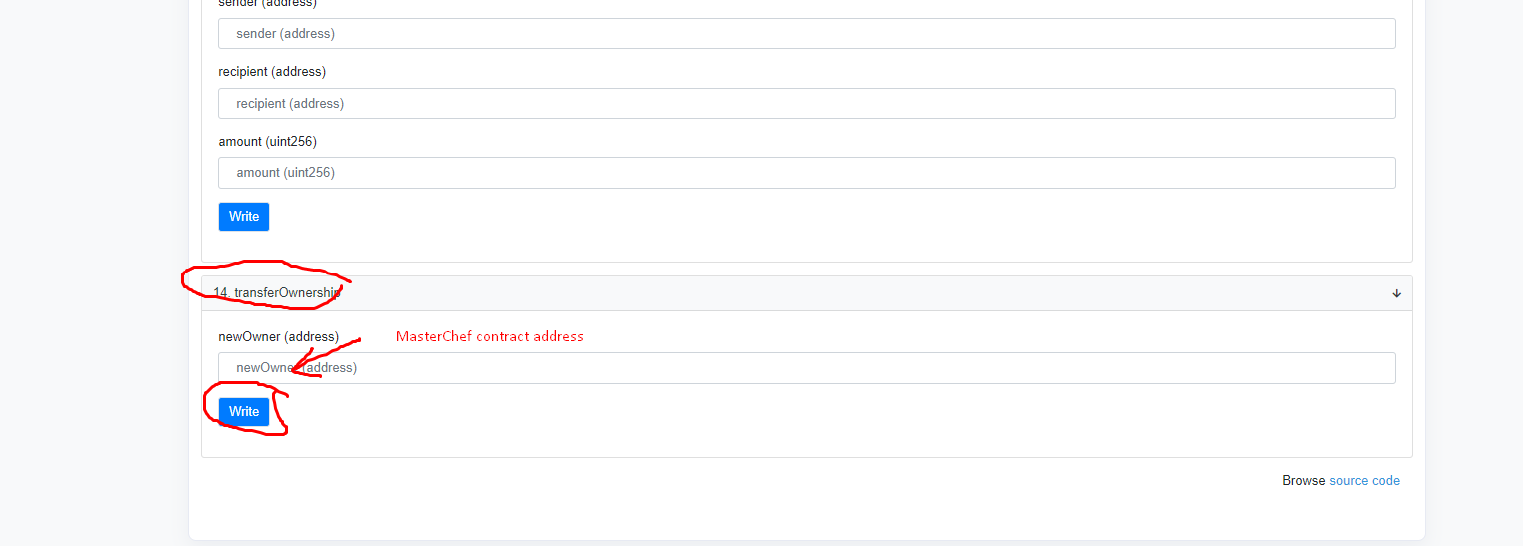

The owner of token contract must be MasterChef.

(2) Inserting addresses and abis

Src/config/constants.ts

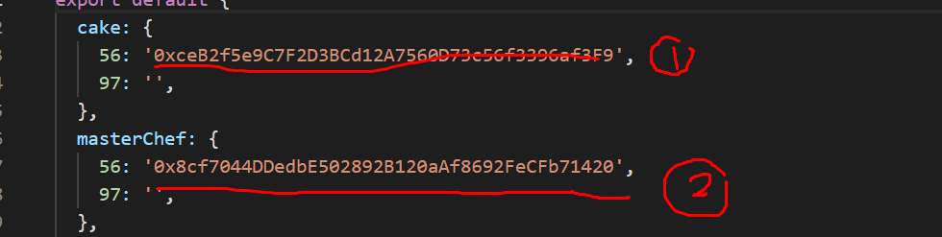

1: token address

2: MasterChef address

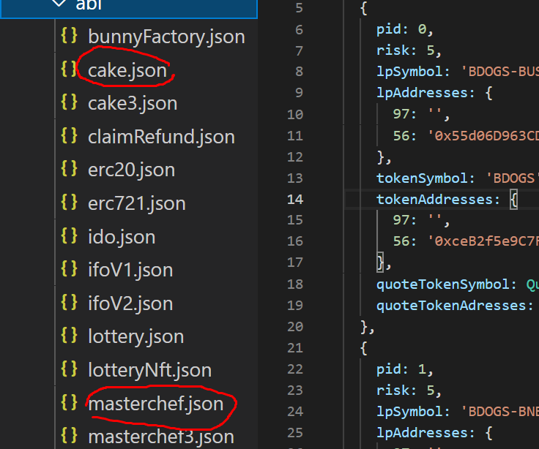

Cake.json: the abi of token contract

Masterchef.json: the abi of masterchef contract

1. Making LPs and inserting LP addresses

Src/config/farms.ts

We need to make and replace native LPs.

We can make cake-LP on pancakeswap.

Or we can make BDOGS-LP on our dex.

1. **dex**
2. deploying contracts

first, BitDogeStarFactory.sol

second, BitDogeStarRouter.sol

When deploy router contract, initial variables are like these::

_factor : the address of BitDogeStarFactory

_WETH: [0x094616f0bdfb0b526bd735bf66eca0ad254ca81f](https://testnet.bscscan.com/address/0x094616f0bdfb0b526bd735bf66eca0ad254ca81f)

1. blinking and replacing addresses of contracts

* src/constants/token/pancakeswap.json

We can change the addresses and logo images of tokens here.

* src/constants/v1/index.ts

We must change factory address here.

* src/constants/eggPriceContracts.ts

cakeaddress: BDOGS token address

busdaddress: BUSD token address

lpaddress: BDOGS-BUSD LP address

* src/constants/index.ts
* const ROUTER_ADDRESS

router_address: BitDogeStarRouter.sol address

const PINNED_PAIRS

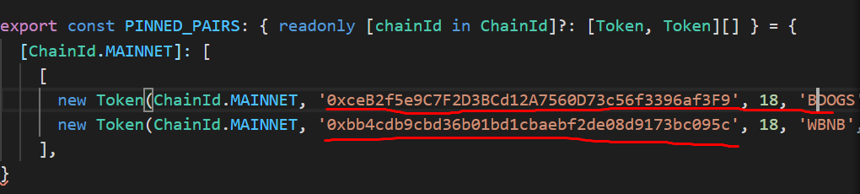

We must insert BDOGS token address here.