**Relational Database Design Process**

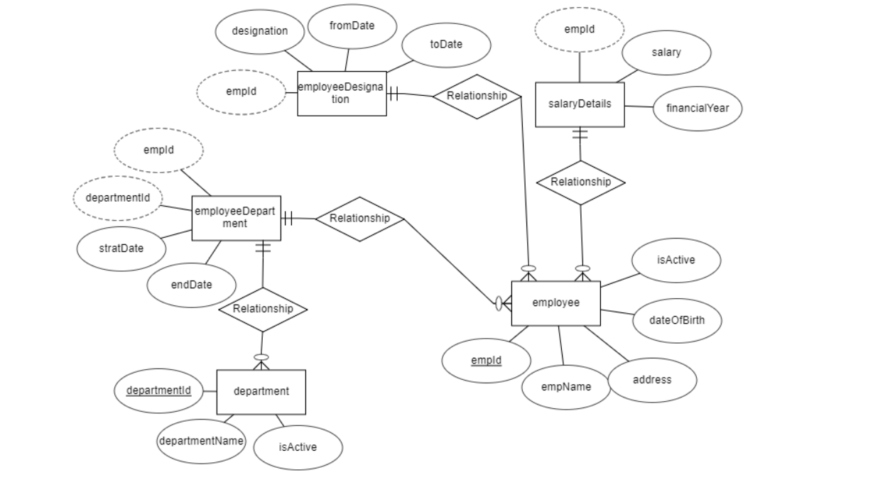

**Data Definition Language Scripts** 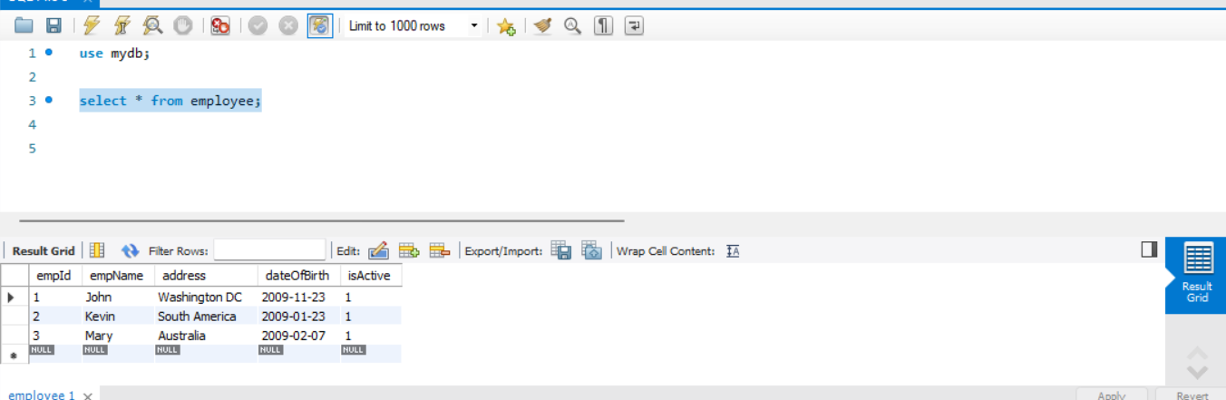

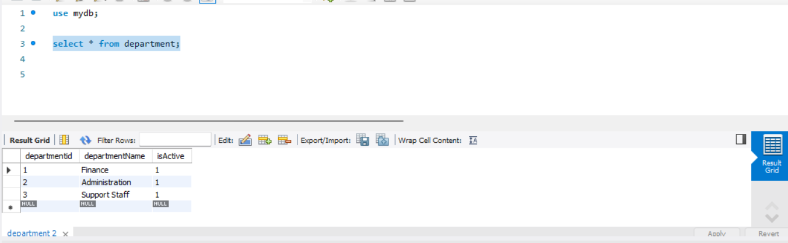

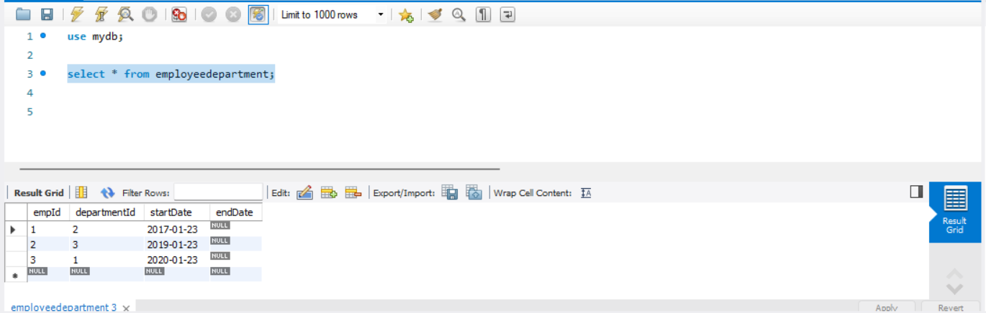

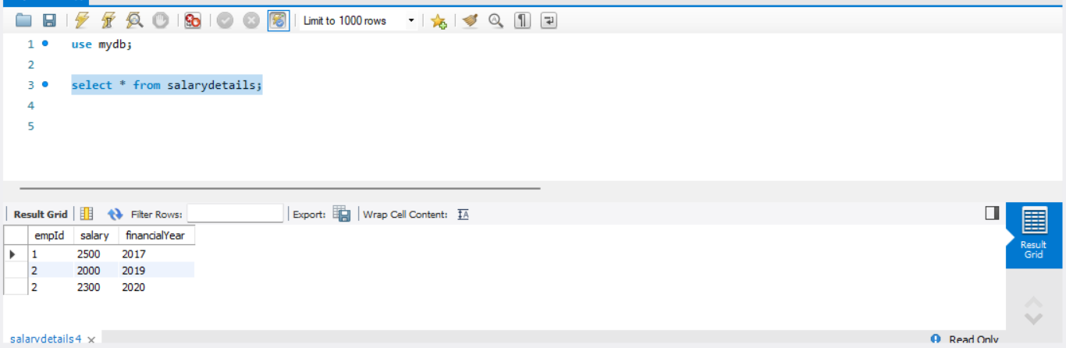

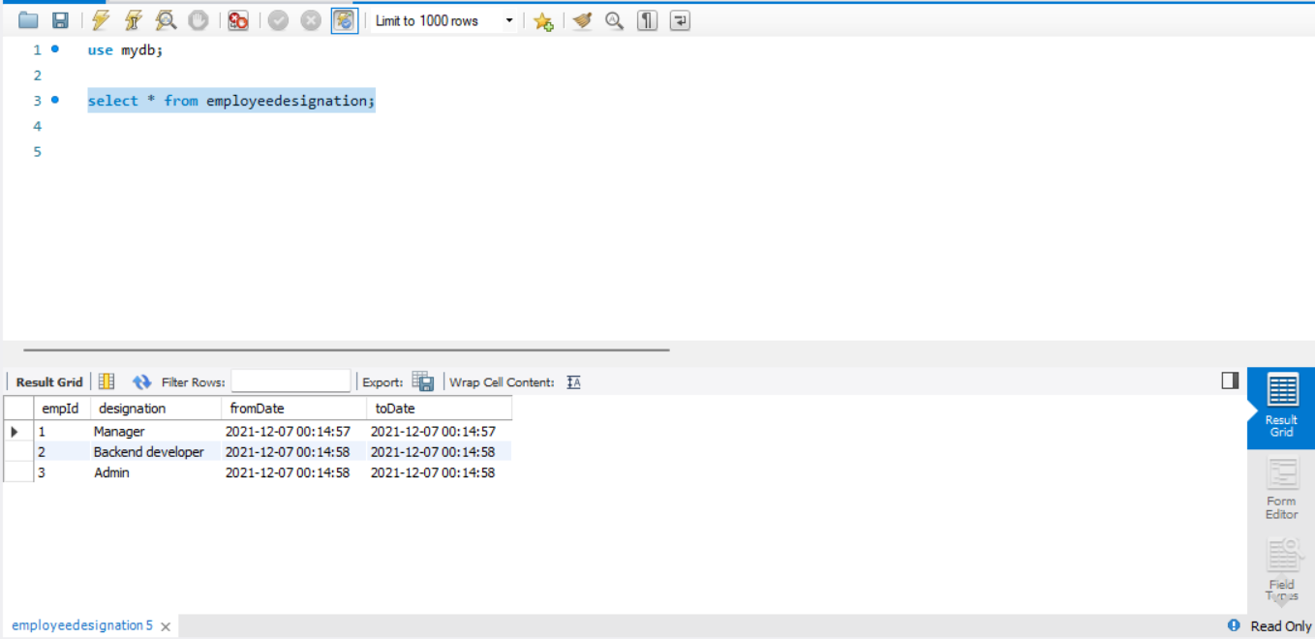

**Data Manipulation Language Scripts**

insert into employee(empName, address, dateOfBirth) values('Diya','South Africa','2009-03-07');

insert into department(departmentName) values('Backend');

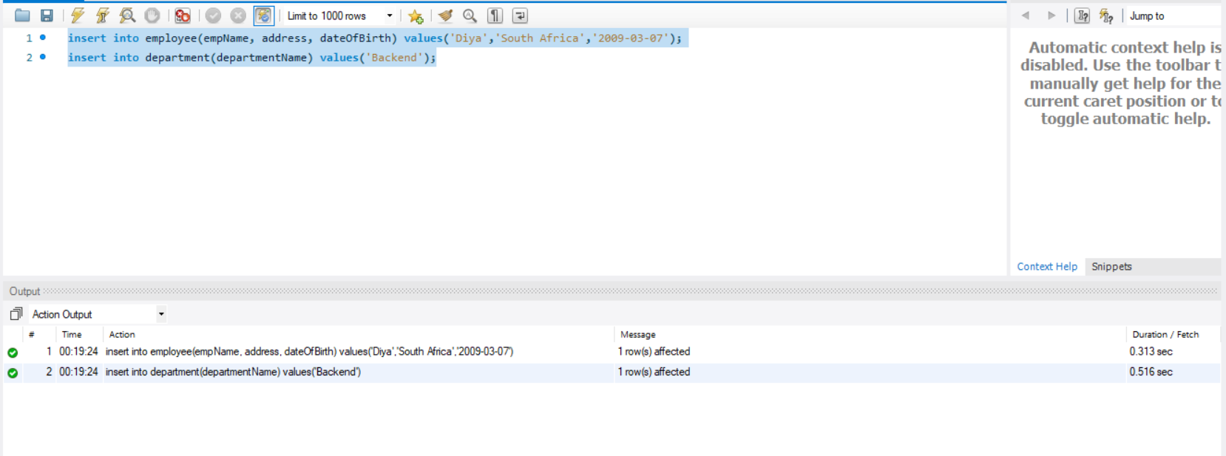

update employeedepartment set departmentId=4 where empId=3;

update salarydetails set salary='2600' where empid=1;

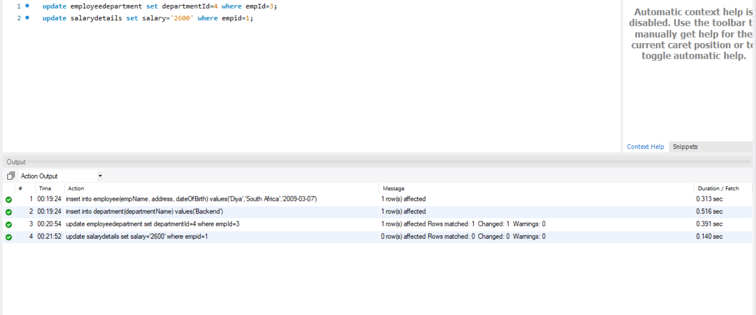

delete from department where departmentid=1;

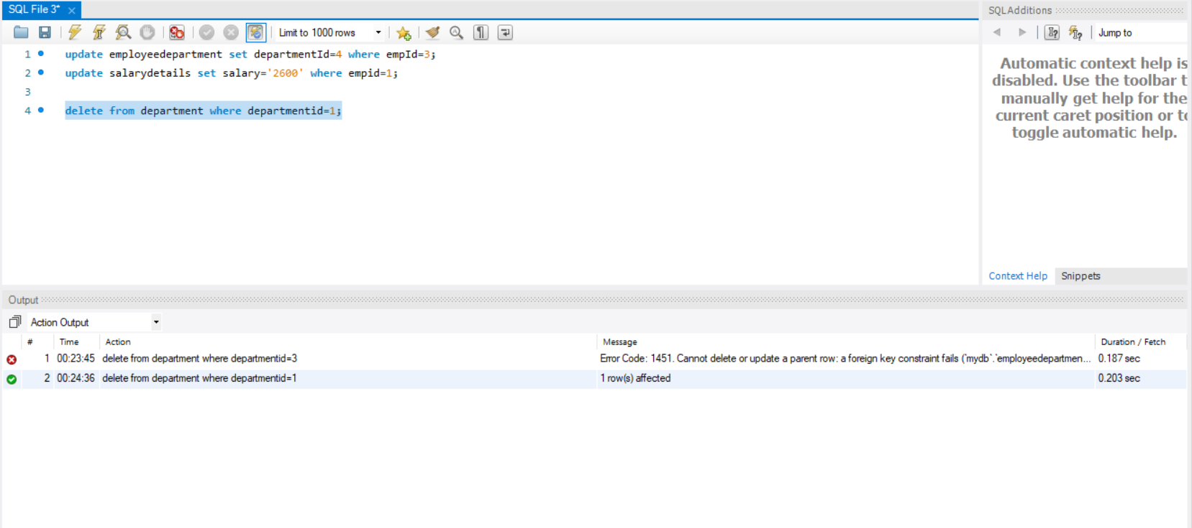

select * from employeedepartment;

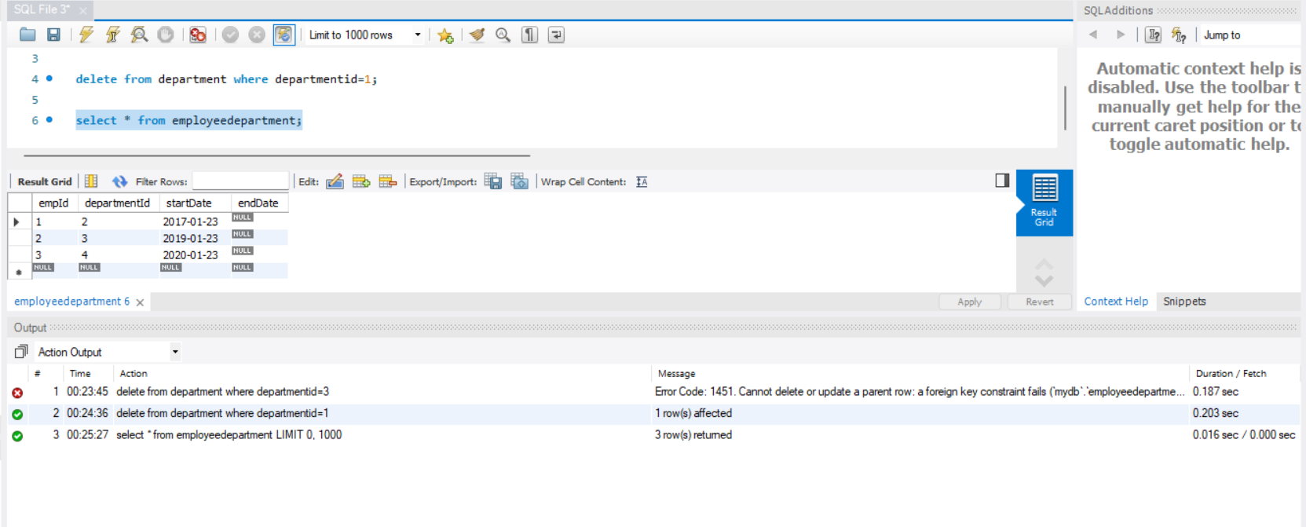

select * from department d, employeedepartment ed where d.departmentId = ed. departmentId;

select e.empName, s.salary from employee e join salarydetails s on e.empId = s.empId;

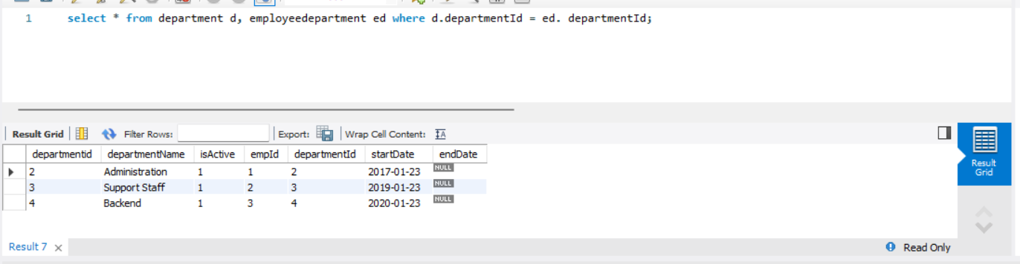

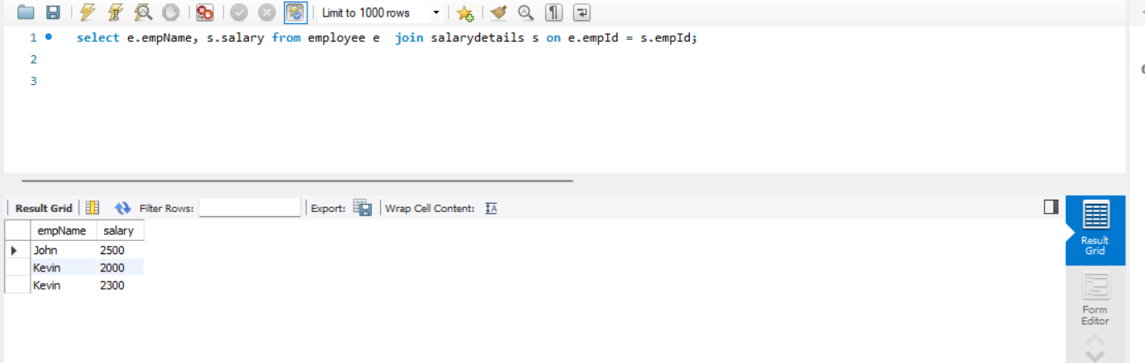

select * from salarydetails s, employeeDesignation d where s.empId=d.empId;

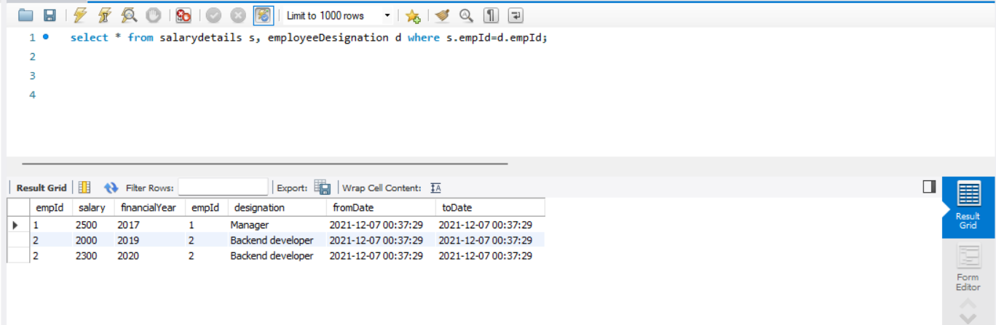

select * from employeedepartment where empId=3;

