

How to Submit a Business Trip Request in YouTrack
Finance Requests / Business Trip online form

1. Purpose
This guide explains how to submit a business trip request or a post-trip report through the Business Trip form in YouTrack.
Use this form to request approval for a business trip, request payment for tickets, accommodation, and related expenses, or submit a report after the trip.
Form link: https://platipus.myjetbrains.com/youtrack/form/2e75718b-65ab-4913-aa41-42536ec0a30e

2. Before you start
• Prepare a short request title for the Summary field.
• Prepare the travel dates, destination, estimated or actual amount, and currency.
• Prepare supporting files if available: tickets, invoices, receipts, hotel bookings, or other confirmations.
• Fields marked with an asterisk (*) are mandatory. Some fields can also be required by the approval process even if no asterisk is shown in the form.

3. Filling in the form
1. Open the Business Trip form in YouTrack.
2. Check that Request Type is set to Business Trip. Do not change this value.
3. In Summary, enter a short request title, for example: Business trip to Warsaw, 10-12 Jul 2026.
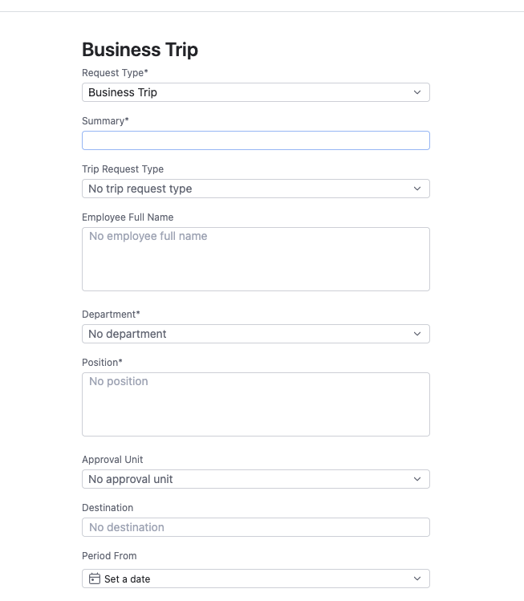
Screenshot 1. Top part of the Business Trip form
4. In Trip Request Type, select the correct request type.
Value | When to use it
Before Trip | Use before the trip when you need approval or payment before departure.
After Trip Report | Use after the trip when you need to submit the report and supporting documents.
Combined / Погодження + звіт | Use when both approval and report details are included in one request.
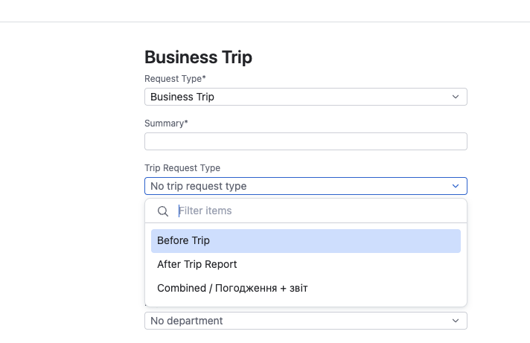
Screenshot 2. Selecting the trip request type
5. Fill in Employee Full Name, Department, and Position. Employee Full Name should contain the full name of the employee for whom the request is submitted.
6. In Approval Unit, select the unit or business area responsible for approval. YouTrack uses this value to assign the request to the correct manager.
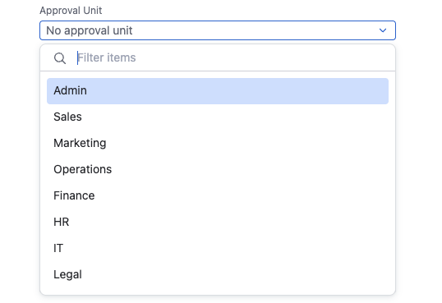
Screenshot 3. Selecting Approval Unit
7. Fill in Destination, Period From, Period To, Amount, Currency, and Payment Due Date.
Field | How to fill it in
Destination | City and country of the trip, for example Warsaw, Poland.
Period From / Period To | Start and end dates of the business trip. Period To cannot be earlier than Period From.
Amount | Estimated or actual total amount of expenses.
Currency | Expense currency: EUR, USD, UAH, or USDT.
Payment Due Date | Date by which payment or reimbursement is required.
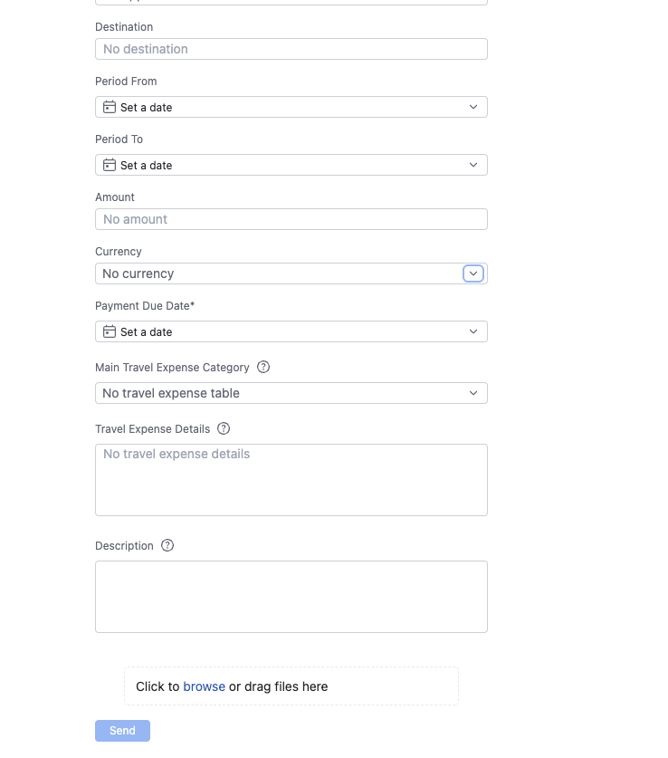
Screenshot 4. Dates, amount, currency, payment due date, and expense details
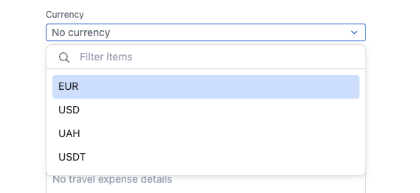
Screenshot 5. Selecting currency
8. In Main Travel Expense Category, select the main expense category. If the request includes several different expense types, select Mixed expenses.
Category | Example
Hotel expenses | Hotel or accommodation costs.
Daily expenses / Per diem | Daily allowance or daily expenses.
Insurance expenses | Travel insurance.
Transport expenses | Taxi, transfer, or local transport.
Flight tickets | Airline tickets.
Client dinner / Gifts | Client meeting, dinner, or gifts.
Visa request | Visa or consular expenses.
eSIM / Phone / Internet | Mobile connection, internet, eSIM.
Other expenses | Any other expenses.
Mixed expenses | Several different categories in one request.
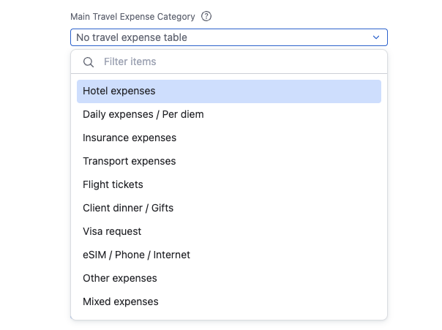
Screenshot 6. Selecting the main travel expense category
9. In Travel Expense Details, list each expense as a separate block. If you attach a file, specify its file name in the Document file name line.
Expense 1
Date:
Expense Category:
Description:
Amount:
Currency:
Document file name:
Expense 2
Date:
Expense Category:
Description:
Amount:
Currency:
Document file name:
10. In Description, briefly describe the purpose of the trip or the context of the expenses.
11. In Attachments, add supporting documents. Click browse or drag files into the upload area.
12. After checking all details, click Send.
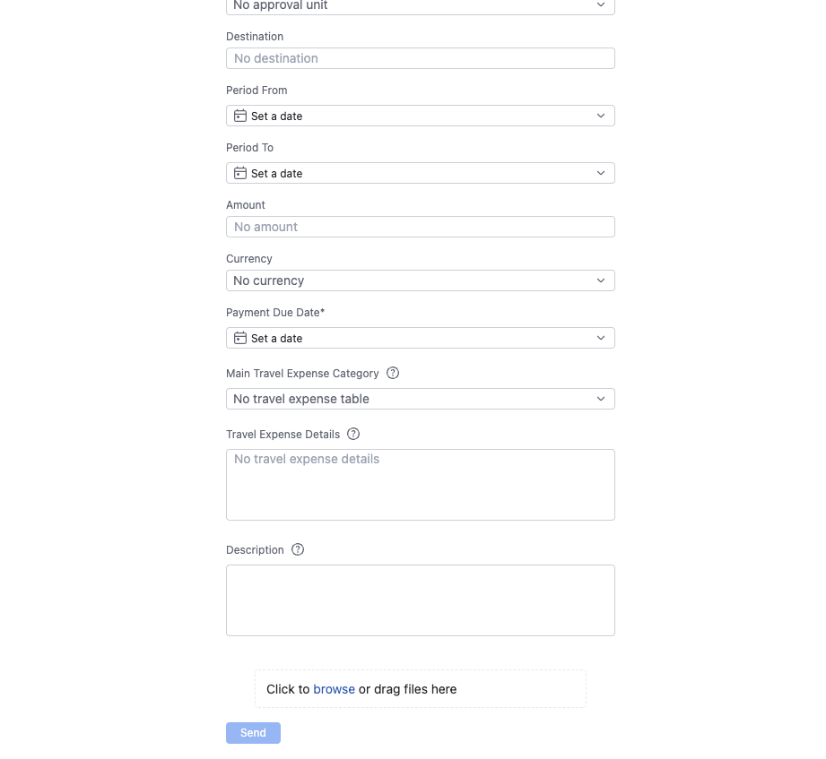
Screenshot 7. Bottom part of the form: Travel Expense Details, Description, Attachments, and Send

4. Checklist before sending
Check | Yes/No
Request Type is Business Trip.
Trip Request Type is selected.
Employee Full Name, Department, and Position are filled in.
Approval Unit is selected correctly.
Destination and trip period are filled in.
Amount, Currency, and Payment Due Date are filled in.
Travel Expense Details contains a breakdown of expenses.
Supporting documents are attached if available.
Description and Summary are filled in.

5. What happens after submission
• YouTrack creates a ticket in the Finance Requests project.
• The request is automatically moved to Manager Approval.
• The responsible manager is selected based on the Approval Unit field.
• After manager approval, the request moves to CEO Approval, then to Accounting, then to payment, and finally to Paid.
• If more information is required, the request can be returned for revision. Check the comment or the Return Reason field.

6. Common issues
Issue | What to do
The form does not submit. | Check all required fields, including Trip Request Type, Approval Unit, Destination, Period From/To, Amount, Currency, and Travel Expense Details.
Approval Unit is selected incorrectly. | Change it before sending, or contact the finance team after the ticket is created.
There are several expense types. | Select Mixed expenses in Main Travel Expense Category and provide a detailed breakdown in Travel Expense Details.
Documents are not ready yet. | Mention this in Description and add documents later if the process allows it.

