Cairo University  
Faculty of Computers and Information



**CS251**

**Software Engineering I**

Project Name

Software Design

Team Names

Month & Year

Contents

Team 3

Document Purpose and Audience 3

System Models 4

I. System Decomposition 4

II. Class diagrams 5

III. Sequence diagrams 7

Class - Sequence Usage Table 15

Ownership Report 16

Policy Regarding Plagiarism: 16

References 16

Authors 16

# Team

|  |  |  |  |
| --- | --- | --- | --- |
| **ID** | **Name** | **Email** | **Mobile** |
| **20170041** | Osama Tarek Mohamed | Osamatarek290@gmail.com | **01100405217** |
| **20170012** | Ahmed Ayman Abd-Elfattah | Ahmed.ayman16899@gmail.com | **01019139159** |
| **20170024** | Ahmed Abd-Elnaby fouad | Ahmedalsaket011@gmail.com | **01026731836** |
| **20170004** | Abo-Taleb Khaled Abo-Taleb | Abotalebkhaled222@gmail.com | **01069857991** |

# Document Purpose and Audience

* **This document describes the system decomposition, class diagram and sequence diagrams for a specific system to be illustrated.**
* **Mainly the targets of that document are: Developers – Analysts.**

# System Models

## I. System Decomposition

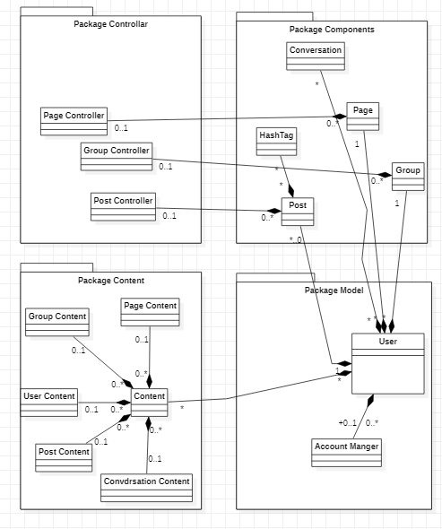

## II. Class diagrams

| **Class ID** | **Class Name** | **Subsystem ID** | **Description & Responsibility** |
| --- | --- | --- | --- |
| 1 | User | 2 | This class devoted for the user. It provides the most functions that the user wants to interact with the system. |
| 2 | Account_Manger | None | This class is devoted for the login and signup for the users |
| 3 | Content | 12,13,14,15,16 | This class used for the database and search stuff in general. |
| 4 | Group | 10 | The group class contains information about an object of group that is used by GroupControler to manage the object. |
| 5 | Hash_Tag | None | The hashtag responsibility is to categorize posts in any kind. Used by the user in case of searching for a specific thing. |
| 6 | Conversation | None | Its responsibility is to show text messages among users. |
| 7 | Page | 8 | The page class contains information about an object of page that is used by PageControler to manage the object. |
| 8 | PageControler | None | This class created to manage all the pages in the system. |
| 9 | Post | 11,5 | Mainly it shows the content of specific post to the user to interact with. |
| 10 | GroupControler | None | This class created to manage all the groups in the system. |
| 11 | PostControler | None | This class created to manage all the Posts in the system. |
| 12 | GroupContent | None | This class contains information about all the groups inside the system. |
| 13 | PageContent | None | This class contains information about all the Pages inside the system. |
| 14 | UserContent | None | This class contains information about all the Users inside the system. |
| 15 | PostContent | None | This class contains information about all the Posts inside the system. |
| 16 | ConversationContent | None | This class contains information about all the Conversations inside the system. |

## III. Sequence diagrams

ID = 1, Use Case = Add Friend

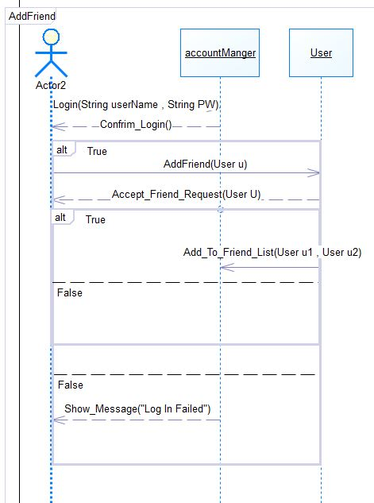

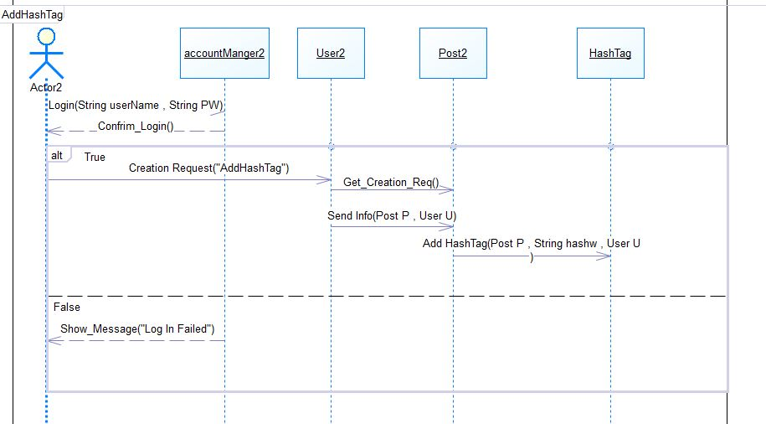ID = 2, Use case = Using Hash Tag

ID = 3, Use case = Create Account

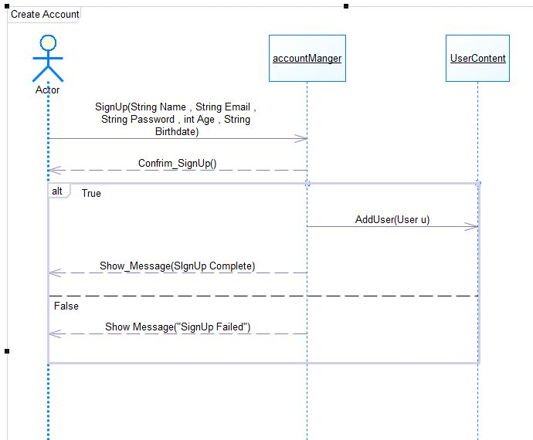

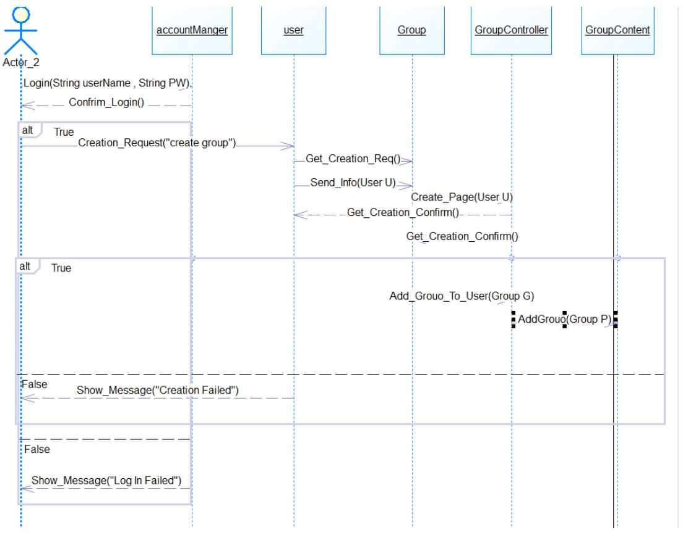ID = 4, Use Case = Create Group

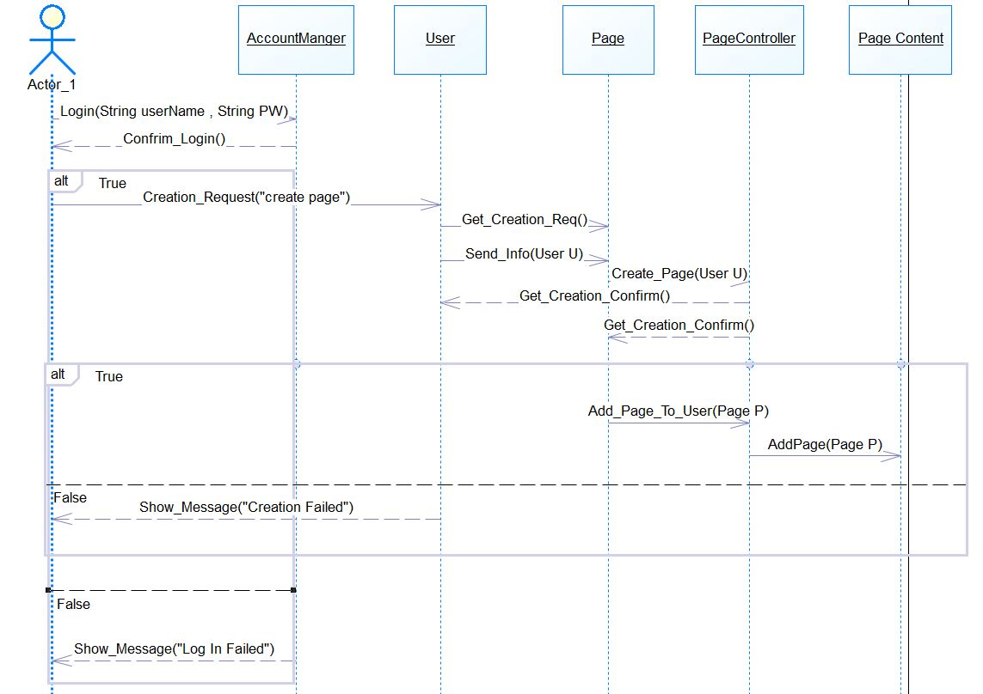ID = 5, Use Case = Create Page.

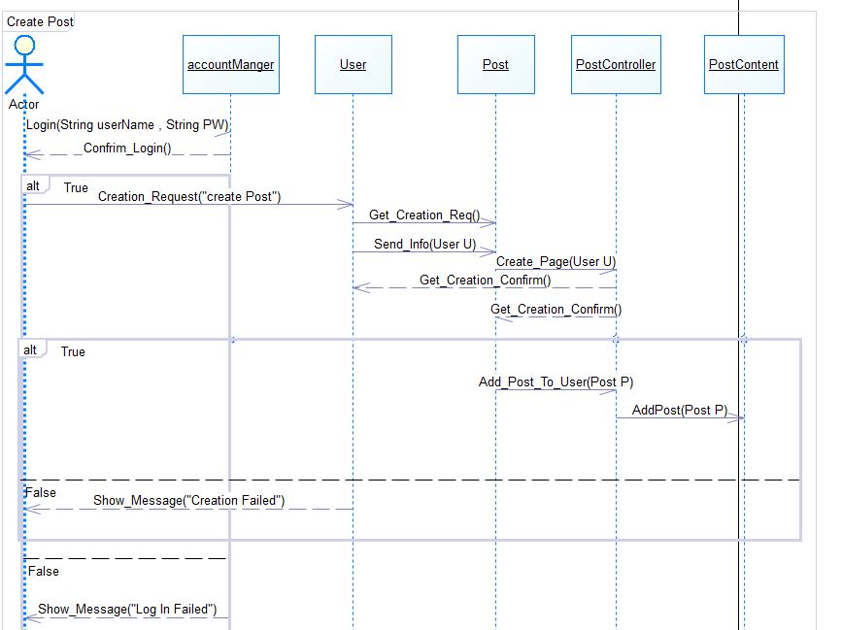ID = 6, Use Case = Create Post.

ID = 7, Use Case = Upload Content

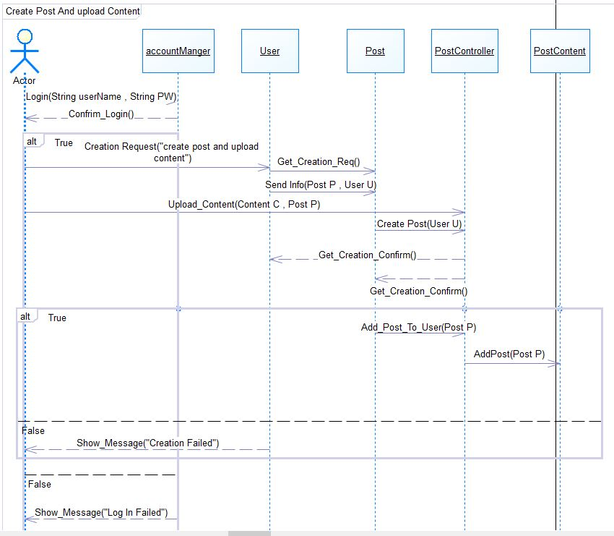

ID = 8, Use Case = Download Content

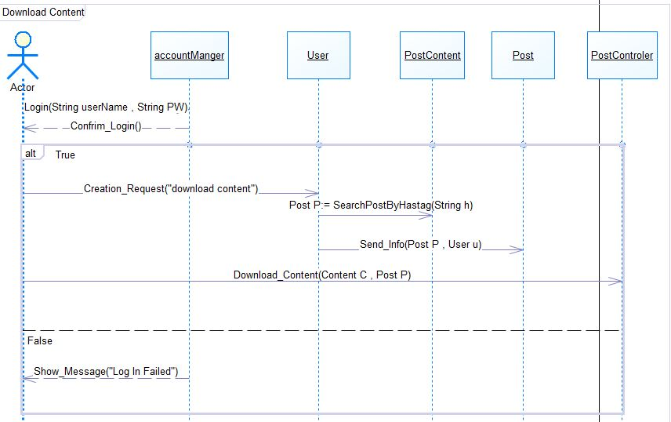

### Class - Sequence Usage Table

| **Class Name** | **Sequence Diagrams** | **Overall used methods** |
| --- | --- | --- |
| User | 1,2,4,5,6,7,8 | Add_To_Friend_List, AddFriend, Creation_Request |
| Account_Manger | 1,2,3,4,5,6,7,8 | Login, SignUp, Confirm_SignUp, Confirm_Login. |
| Post | 2,6,7,8 | Get_Creation_Request, Send_Info |
| Page | 5 | Get_Creation_Request, Send_Info |
| Group | 4 | Get_Creation_Request, Send_Info |
| Content | NotUsed | NotUsed |
| Hash_Tag | 2 | Add_HashTag, |
| PostControler | 6,7,8 | Create_Post, Download_Content, Upload_Content |
| GroupControler | 4 | Create_Group, Add_Group_To_User |
| PageControler | 5 | Create_Page |
| UserContent | 3 | AddUser |
| PageContent | 5 | AddPage, Add_Page_To_User |
| PostContent | 6,7,8 | AddPost, Add_Post_To_User, Search_Post_By_HashTag |
| ConversationContent | NotUsed | NotUsed |
| GroupContent | 4 | AddGroup |

# Ownership Report

|  |  |
| --- | --- |
| **Item** | **Owners** |
| Component diagram | *Ahmed Alsaket and Ahmed Ayman* |
| Class Diagram and sequence diagrams | *Abotaleb Khaled, Osama Tarek* |

# Policy Regarding Plagiarism:

**Students have collective ownership and responsibility of their project. Any violation of academic honesty will have severe consequences and punishment for ALL team members.**

1. تشجع الكلية على مناقشة الأفكار و تبادل المعلومات و مناقشات الطلاب حيث يعتبر هذا جوهريا لعملية تعليمية سليمة
2. ساعد زملاءك على قدر ما تستطيع و حل لهم مشاكلهم فى الكود و لكن تبادل الحلول غير مقبول و يعتبر غشا.
3. أى حل يتشابه مع أى حل آخر بدرجة تقطع بأنهما منقولان من نفس المصدر سيعتبر أن صاحبيهما قد قاما بالغش.
4. قد توجد على النت برامج مشابهة لما نكتبه هنا أى نسخ من على النت يعتبر غشا يحاسب عليه صاحبه.
5. إذا لم تكن متأكدا أن فعلا ما يعد غشا فلتسأل المعيد أو أستاذ المادة.
6. فى حالة ثبوت الغش سيأخذ الطالب سالب درجة المسألة ، و فى حالة تكرار الغش سيرسب الطالب فى المقرر.

# References

* http://www.mhhe.com/engcs/compsci/pressman/graphics/Pressman5sepa/common/cs1/design.pdf

# Authors

* Mostafa Saad and Mohammad El-Ramly