**Software Engineer Project Phase 1:**

**Project name: 360 learning**

**Version: 1.0**

**By: Ahmad Ghraieb – Anwar Zaindani – Ali Aoun**

# Table of contents

Contents

Table of contents 2

**1.Introduction**: 2

1.1 SDLC Model: 2

1.2 Feasibility Study: 2

1.3 Product scope: 3

1.4 Product value: 3

1.5 Intended audience: 4

1.6 Intended use: 4

1.7 General description: 4

2.Functional requirements 5

2.1 Design Requirements: 5

2.2 Graphics Requirements: 5

2.3Constraints: 5

3. External interface requirements: 6

3.1 User interface requirements: 6

3.2 Hardware interface requirements: 6

3.3 Software interface requirements: 6

3.4 Communication interface requirements: 6

4.Non-functional requirements: 7

4.1 Security: 7

4.2 Capacity: 7

4.3 Compatibility: 7

4.4 Reliability: 7

4.5 Scalability: 7

4.6 Maintainability: 8

4.7 Usability: 8

4.8 Other: 8

5.Definitions and acronyms 9

6.Phase 2:Diagrams 10

7.Phase 3:Gantt and pert charts 22

8.Phase 4: Jira 24

# **1.Introduction**:

## 1.1 SDLC Model:

Agile Model:

Why: Agile is well-suited for projects with changing requirements and a need for frequent releases. In the case of an online learning platform, where user feedback and evolving educational trends are crucial, Agile allows for flexibility and continuous improvement. It supports iterative development, which is beneficial for adapting to changing educational needs and incorporating user feedback throughout the development process. This helps ensure the website caters to the specific needs and learning styles of your target audience.

## 1.2 Feasibility Study:

**1. Technical Feasibility:**

* + Skill set of the development team.
  + Compatibility with existing browsers.
  + Potential technical challenges and their solutions.

**2. Economic Feasibility:**

* + Cost estimation for development, deployment, and maintenance.
  + Revenue generation potential.

**3. Market Feasibility:**

* + Identification of target audience.
  + Market trends and competition analysis.
  + Marketing and distribution strategies.

**4. Legal Feasibility:**

* + Licensing and permissions.
  + Identification and reduction of legal risks.

**5. Operational Feasibility:**

* + User acceptance and training.
  + Support and maintenance requirements.
  + Compatibility with existing organizational culture.

**6. Scheduling Feasibility:**

* + Realistic development timelines.
  + Phasing of project deliverables.

## 1.3 Product scope:

* **Benefits:**
* **Enhanced accessibility to quality education.**
* **Foster interactive learning through a user-friendly platform.**
* **Objectives:**
* **Provide a diverse range of courses and lessons.**
* **Facilitate collaborative learning experiences.**
* **become a trusted resource for learners seeking to expand their knowledge and skills**
* **Goals:**
* **Increase user engagement and satisfaction.**
* **Support various learning styles through a feature-rich platform.**
* **Generate revenue through subscriptions, course fees, or corporate training.**

## 1.4 Product value:

* **Allow learners to access quality educational content anytime, anywhere on their schedule.**
* **Personalized learning experiences.**
* **Focus on in-demand skills or knowledge relevant to your audience's career goals or personal interests**
* **Progress tracking and achievement recognition.**

## 1.5 Intended audience:

* **Students of all ages.**
* **Educators and instructors.**
* **Lifelong learners seeking flexible educational resources.**
* **Companies or organizations seeking training programs for their employees on specific skills or industry knowledge.**

## 1.6 Intended use:

* **Enroll in courses.**
* **Participate in interactive lessons.**
* **Collaborate with colleagues.**
* **Track their learning progress.**

## 1.7 General description:

* **Course management (creation, enrollment).**
* **Interactive lessons (videos, quizzes).**
* **Collaborative tools (forums, group projects).**
* **Progress tracking tools**

# 2.Functional requirements

## 2.1 Design Requirements:

* **Intuitive and responsive web interface.**
* **The website should be easy to navigate and understand, with clear menus, intuitive icons, and consistent layout across all pages.**

## 2.2 Graphics Requirements:

* **Clear and engaging visual elements for course content.**
* **Visual aids for interactive lessons.**
* **Graphics should be optimized for different screen sizes and web formats to ensure proper display**
* **File Size Optimization: Balance image quality with file size to avoid slow loading times.**

## 2.3Constraints:

* **Compliance with relevant educational standards and regulations.**
* **Adherence to data protection and privacy laws.**

# 3. External interface requirements:

## 3.1 User interface requirements:

* **Users can navigate with ease.**
* **Clear screen layouts and style guides.**
* **Allow users to manage their profile information, track progress, and view completed courses.**

## 3.2 Hardware interface requirements:

* **Supported different devices Computers, laptops, tablets, and smartphones.**
* **Stable internet connection, Consider offering downloadable resources or offline access options for users on limited data plans.**

## 3.3 Software interface requirements:

* **Combination with libraries for specific functionalities**
* **User-Friendly Navigation.**
* **Appealing Design.**
* **Responsive Design.**
* **User Interaction.**
* **Personalization Features.**
* **Performance Optimization.**

## 3.4 Communication interface requirements:

* **System notifications for updates and announcements.**
* **Embedded forms for user feedback.**
* **Email notifications for important communications**

# 4.Non-functional requirements:

## 4.1 Security:

* Protect user data (login credentials, payment information) with strong encryption protocols and secure storage practices.
* Implementation of encryption protocols for secure data transmission
* Safeguard learning materials (course content, quizzes, assessments) from unauthorized access or modification.

## 4.2 Capacity:

* Current storage needs: Estimate the initial volume of course content, user data, and multimedia files.
* Future storage needs: Plan for scalability and increased user-generated content.

## 4.3 Compatibility:

* Ensure compatibility with major web browsers, including but not limited (Google Chrome/ Mozilla Firefox/ Apple Safari/ Microsoft Edge)
* Expected User Traffic: It depends on the number of users interact with the system.

## 4.4 Reliability:

* Define the acceptable downtime under normal usage.
* Set recovery time objectives to ensure quick system restoration.
* Implement Proactive Maintenance.
* Monitor System Performance.

## 4.5 Scalability:

* Determine the maximum number of concurrent users the system should handle.
* Assess the system's ability to scale under increased user loads.

## 4.6 Maintainability:

* Documentation for developers and administrators for codebase understanding and system maintenance
* If the build or tests fail, the CI tool notifies developers with detailed reports pinpointing the issue, If successful, the CI tool can move the code to a staging environment for further testing.

## 4.7 Usability:

* Implement an intuitive and user-friendly interface.
* Conduct usability testing to ensure ease of navigation and understanding.

## 4.8 Other:

* Offline Functionality: Consider providing offline access to certain course materials for users with limited internet connectivity.
* Accessibility: Comply with accessibility standards (WCAG) to ensure the platform is usable by individuals with disabilities.

# 5.Definitions and acronyms

|  |  |
| --- | --- |
|  |  |
|  |  |
|  |  |
|  |  |
|  |  |
|  |  |
|  |  |
|  |  |
|  |  |
|  |  |

# 6.Phase 2:Diagrams

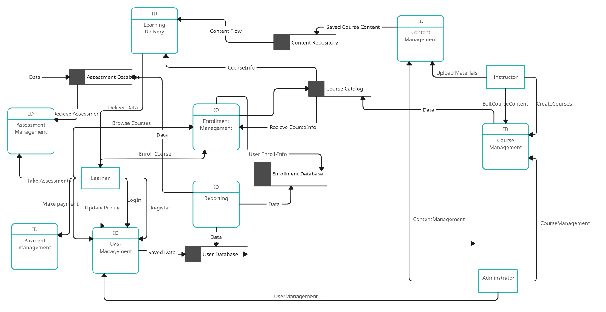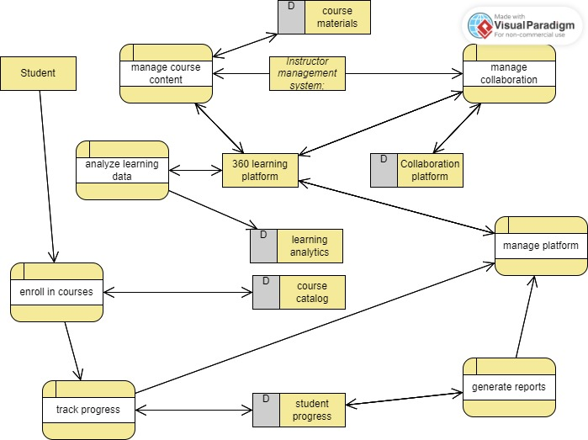

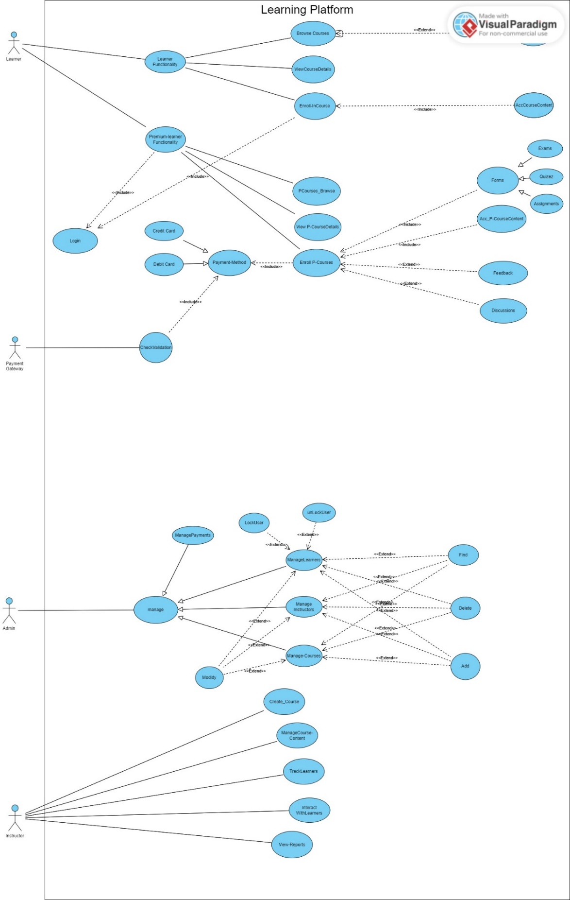

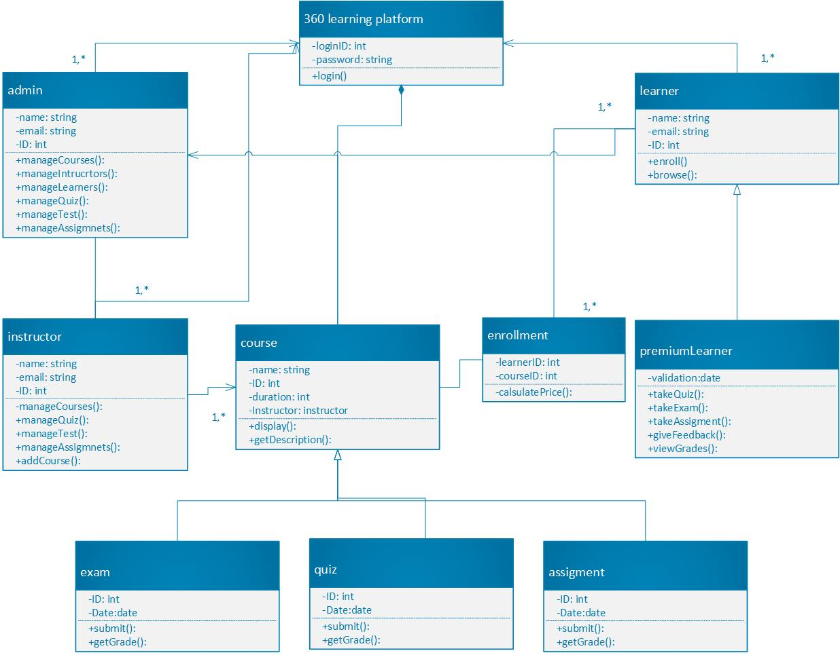

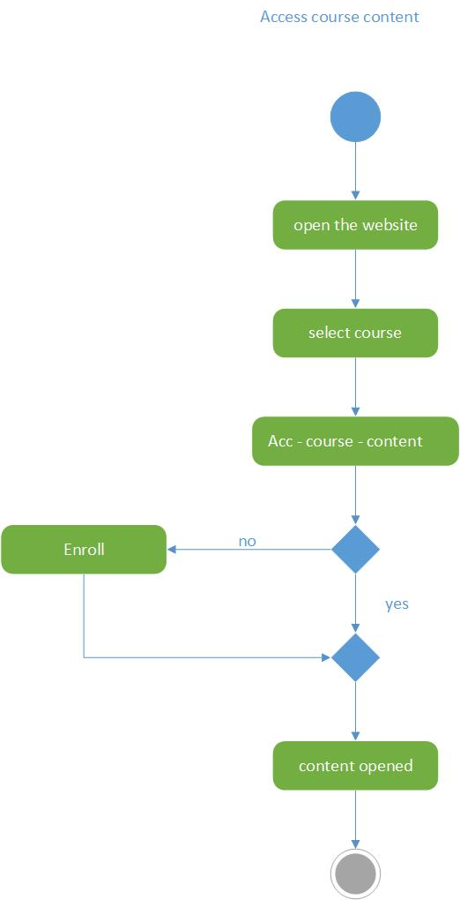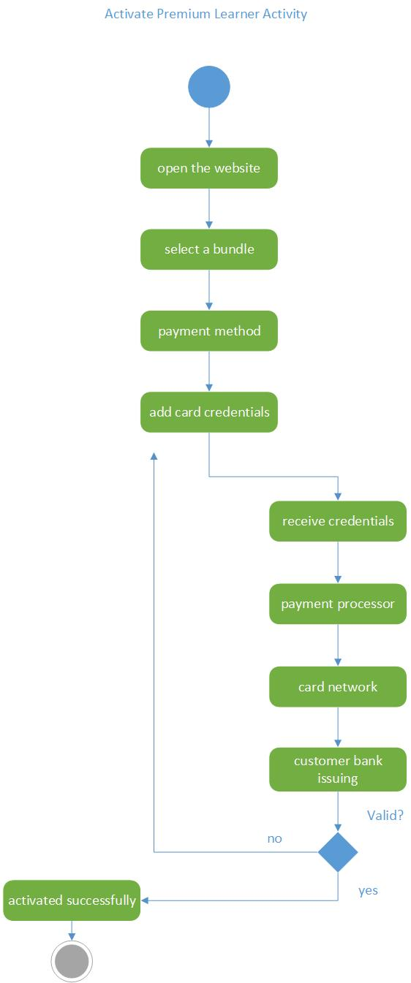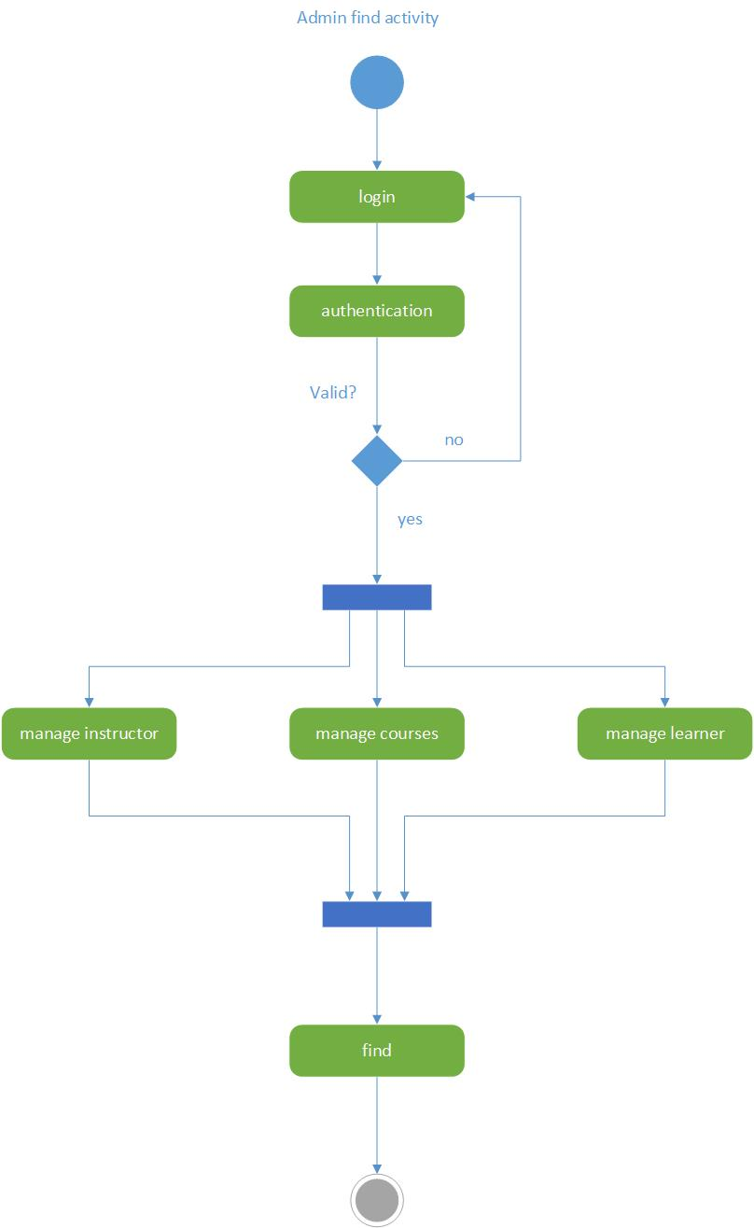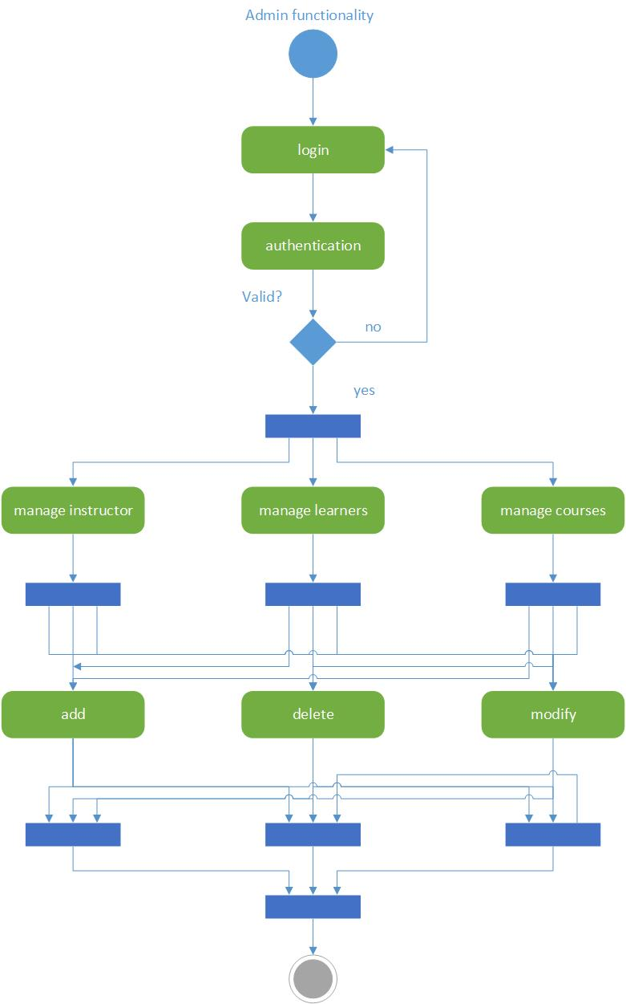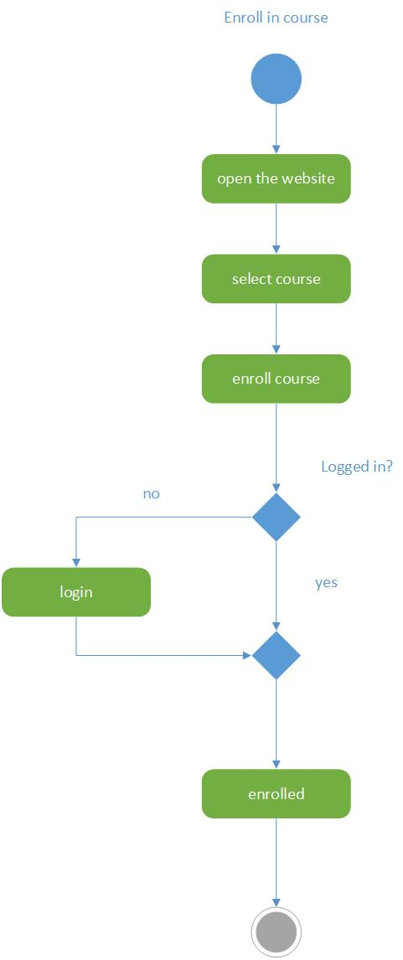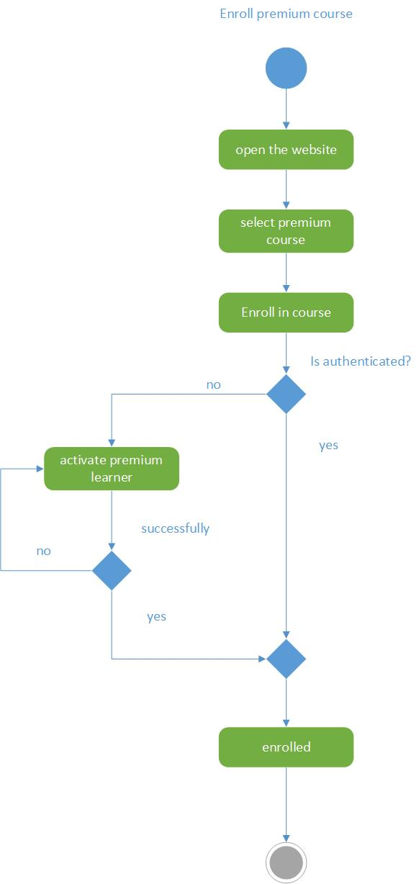

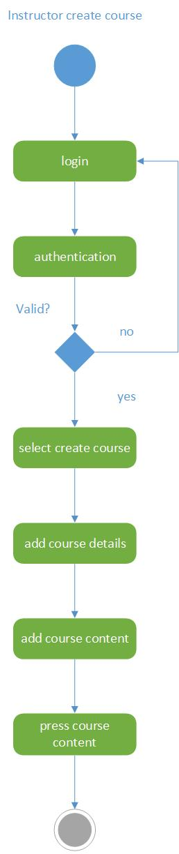

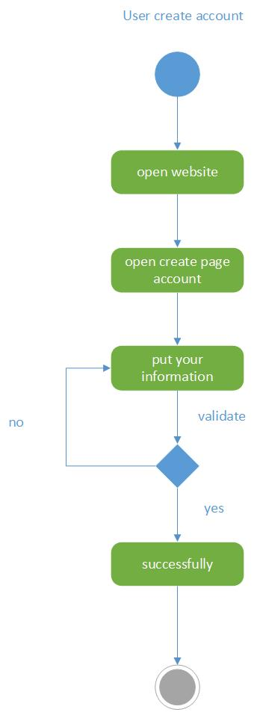

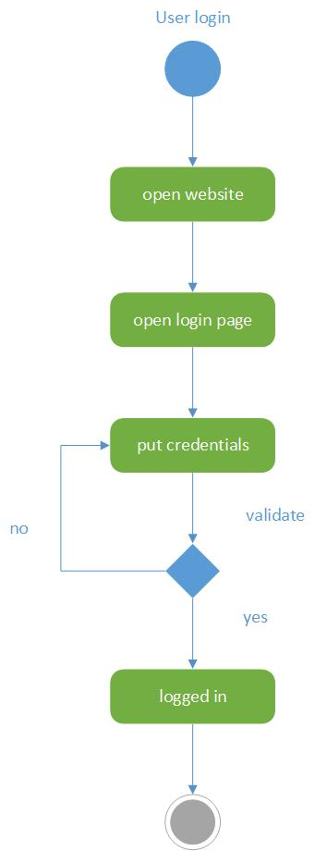

# 7.Phase 3:Gantt and pert charts

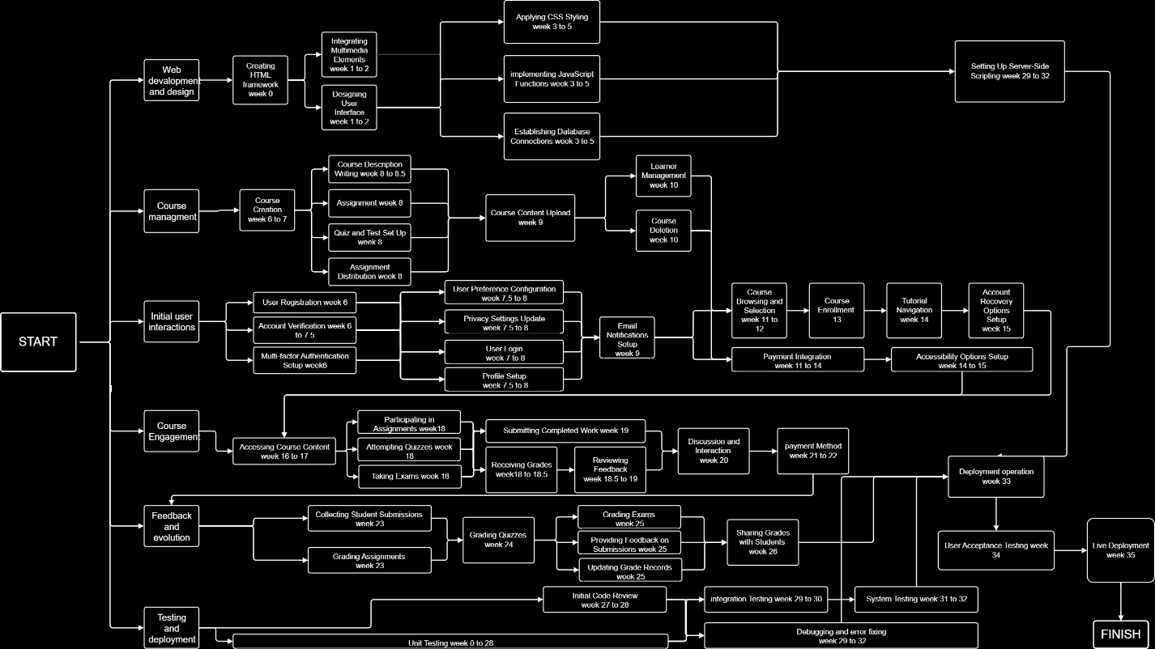

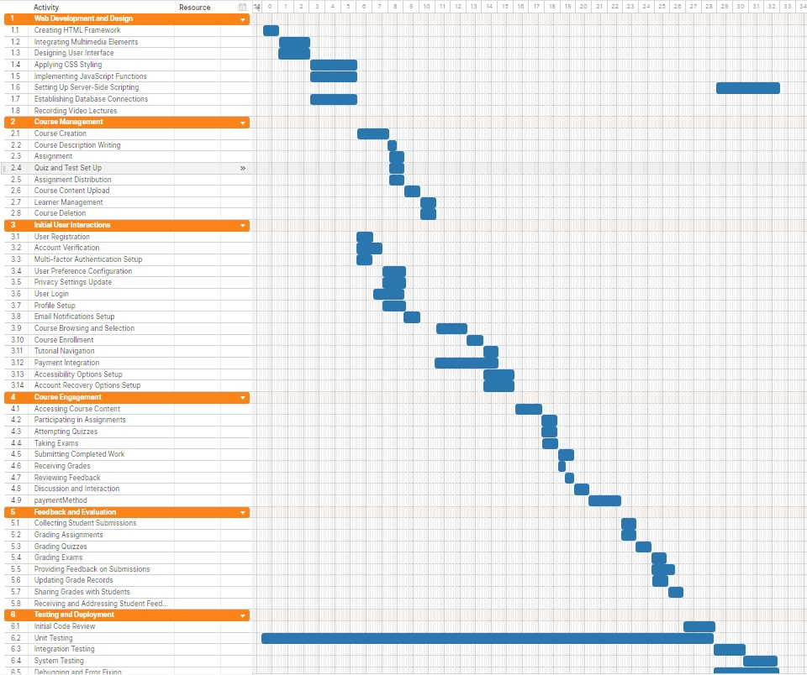

8.Phase 4: Jira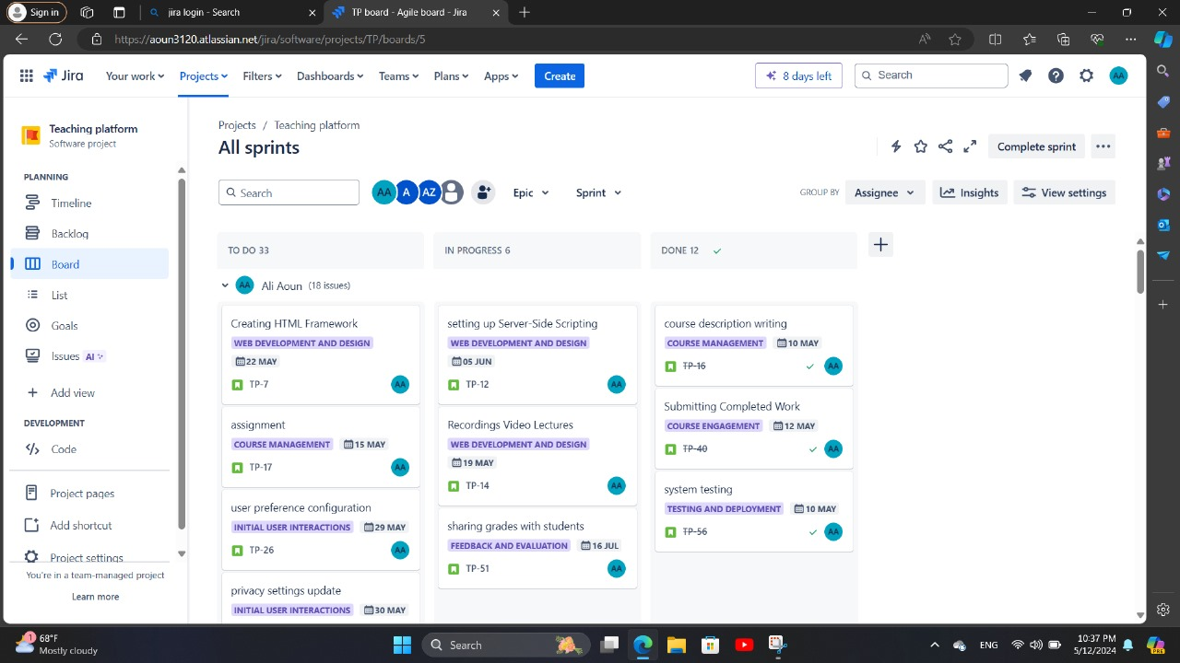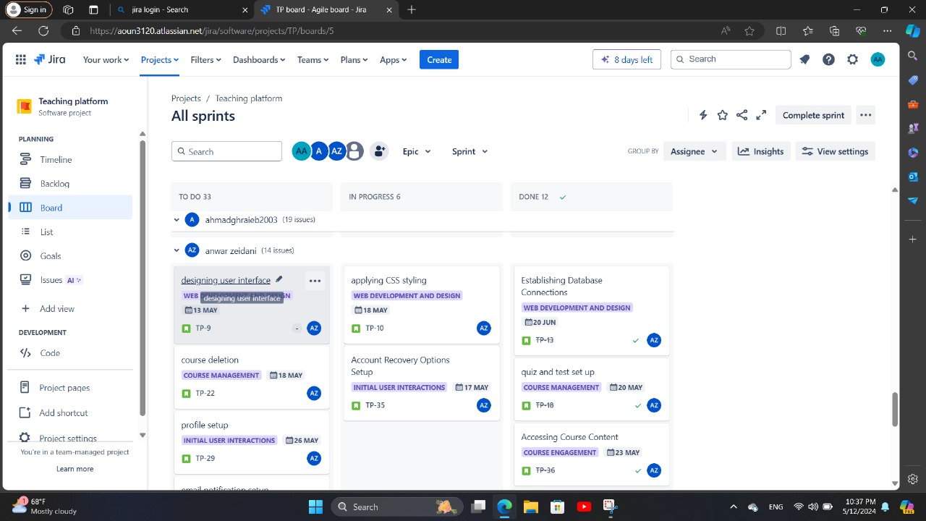

9.Phase 5:Github

