**Database Tables**

|  |  |  |
| --- | --- | --- |
| **users** | | |
| id | integer | Unique identifier |
| email | character varying (255) | User email address (not verified) |
| encrypted_password | character varying (255) | Encrypted user password |
| salt | character varying (255) | Salt created for encrypted password |
| created_at | timestamp with time zone | Time of user registration |
| enabled | boolean | User is active (currently unused) |

|  |  |  |
| --- | --- | --- |
| **user_details** | | |
| id | integer | Unique identifier |
| user_id | bigint | Foreign key to users table |
| first_name | character varying (255) | First name of user |
| middle_initial | character varying (8) | Middle initial of user |
| last_name | character varying (255) | Last name of user |

|  |  |  |
| --- | --- | --- |
| **syncing** | | |
| id | integer | Unique identifier |
| class_id | bigint | Foreign key to classrooms table |
| coder_user_id | bigint | Foreign key to users table |
| student_id | integer | Student identifier within classroom |
| sync_timestamp | timestamp with time zone | Time of sync initiation |

|  |  |  |
| --- | --- | --- |
| **classrooms** | | |
| id | integer | Unique identifier |
| creator_user_id | bigint | Foreign key to users table |
| teacher_name | character varying (255) | Name of the teacher |
| class_name | character varying (255) | Title of the class |
| grade | character varying (255) | Grade level of the class |
| subject | character varying (255) | Subject matter of the class |
| n_students | integer | Number of students in the class |
| code | character varying (255) | Interpretable class code* |
| created_at | timestamp with time zone | Time of class creation |

* ‘code’ column in classrooms table denotes completion of the class registration. NULL value indicates the entry was started but not completed. Value otherwise is simply “CL” + the hex of the row id

|  |  |  |
| --- | --- | --- |
| **coding_logs** | | |
| id | integer | Unique identifier |
| class_id | bigint | Foreign key to classrooms table |
| coder_user_id | bigint | Foreign key to users table |
| student_id | integer | Student identifier within class |
| student_name | character varying (255) | Student name (defaults to student_id) |
| coding_timestamp | timestamp with time zone | Observation end time (end of timer) |
| submission_timestamp | timestamp with time zone | Time of observation submission |
| shows_mental_effort | integer | Coding for mental effort |
| is_on_task | integer | Coding for on/off task |
| affect_state | character varying (255) | Observed affective state |
| focus | character varying (255) | Observed subject of student focus |
| is_writing | integer | Coding for student was writing |
| rec_aid | integer | Coding for student receiving aid |
| hand_raised | integer | Coding for student hand was raised |
| collab_peer | integer | Coding for student collaborating |
| is_fidgeting | integer | Coding for student was fidgeting |
| teacher_speaking | integer | Coding for teacher was speaking |
| log_state | integer | Logging indicator* |

*log_state: intended to indicate both the completion of the coding form and the action of the coder. Negative value indicates that the form was started but not completed while positive denotes that the form was completed and submitted. Also indicates whether the coding was done via syncing (value = 5 or -5) or individual (start) observation (value = 1 or -1).

**Application Pages and States**

|  |  |  |  |
| --- | --- | --- | --- |
| **Page** | **State** | **Flask Function** | **Description** |
| Root | Root/Login | root | Renders the login page |
| Login | Root/Login | login (POST) | Compares login information to db |
| Register | Registration | registration_landing (GET)  register (POST) | Allows a new user to register an account |
| Dashboard | Dashboard | dashboard (GET) | Landing page after logging in; allows users to begin a session or create a new class |
| Add Class | Create Class | add_class_landing (GET)  add_class (POST) | Allows a user to create a new class; displays class code upon completion |
| Session (observe/sync) | Session (Landing)  Session (Waiting)  Session (Countdown) | session_landing (GET) | Randomly selects a student for observation; allows for start, sync, skip, or return to dashboard |
| Session (logging) | Session (Logging) | log_session (POST) | Records observation codings in the database upon submitting the coding form |

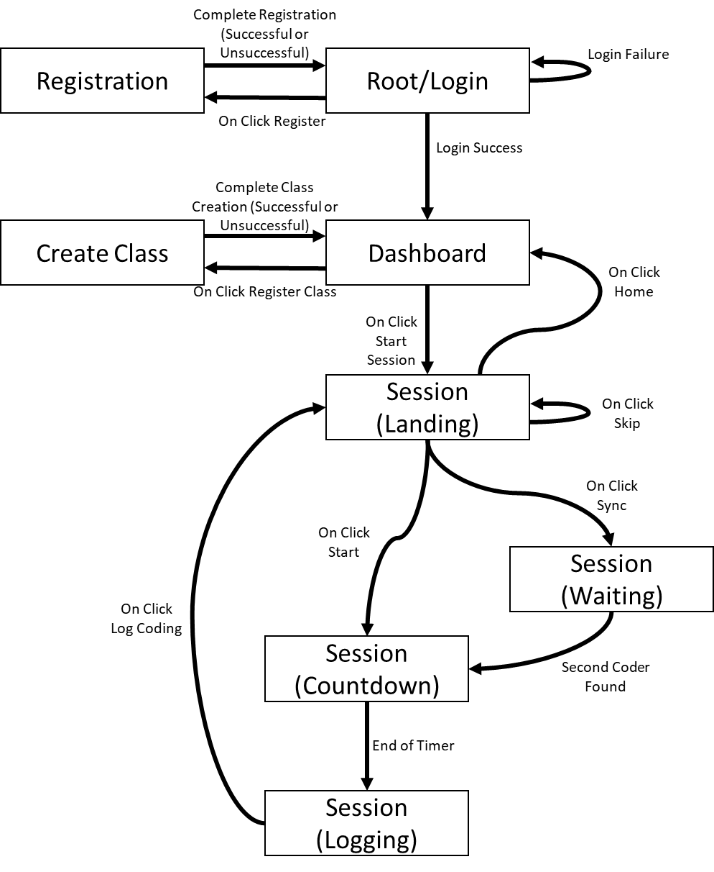**State Transition Diagram**

**Application Pages**

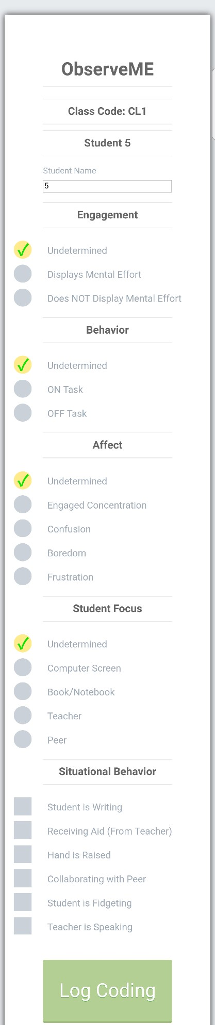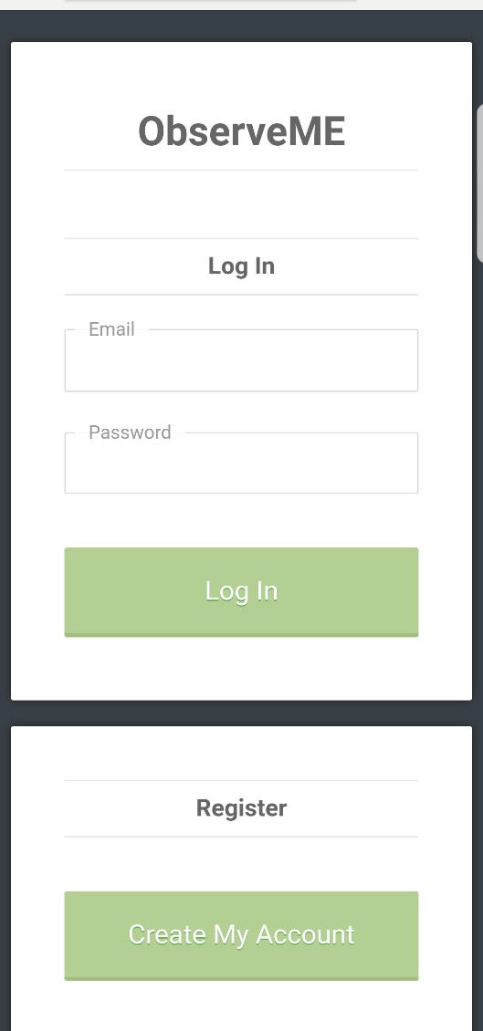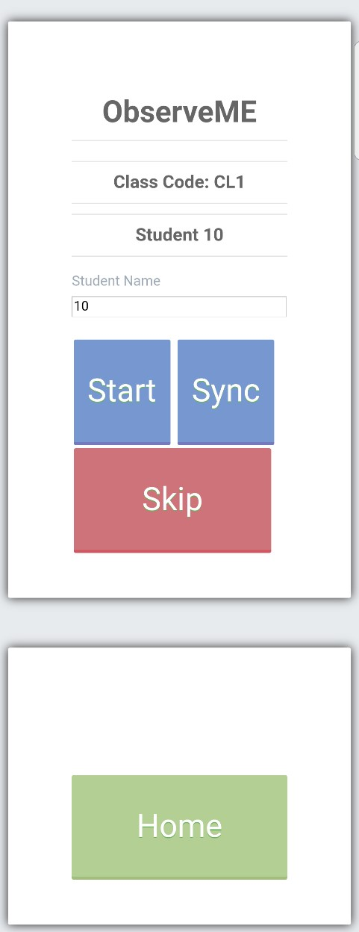

(Left to Right: Login, Dashboard, Session (Logging))