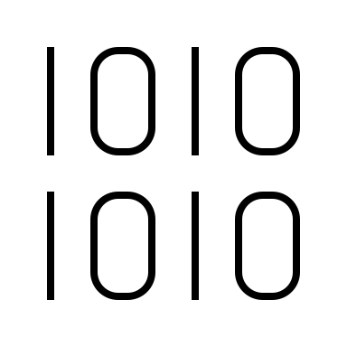

|  |
| --- |
| **Phone**: 647 450 4855 |
| **Email**: ataolbo@gmail.com |
| **Location**: Toronto, Canada |
| **Linkedin**: /ataolbo |
| **Website**: ataolboray.web.app |

ATAOL ORAY

Web Developer / Designer

Front-end developer

# ABOUT ME

My Portfolio

I work with companies and agencies around the world, building Websites and application UIs, with a strong focus on responsive design, accessibility, performance, and the latest in the field of front-end.

I also speak at and run workshops across the globe, focusing on CSS, SVG, Responsive Design and accessibility, covering practical tips on how to build full stack using modern tools and techniques that scale and are future-proof.

# EDUCATION

2018 - present  
UNIVERSITY OF TORONTO  
Computer Science / Political Science

|  |
| --- |
| LANGUAGES English – Fluent  Turkish – Native / Mother tongue  German – B1 (Goethe) |
|
|  |

# RECENT EXPERIENCE

* 2020 – Present

FREELANCE  
Services across different IT fields, including Web development & design, app development, front-end development, algorithm building, IT technician, support specialist & more.

|  |
| --- |
| SKILLS  * Python, Numpy, Pandas, Matplotlib * Javascript, Node.js, and React.js * SQL and MongoDB * PyTorch and Tensorflow * Linux and Unix Shell * C/C++ and Bash * Structures and Algorithms |
|
|  |

Customers: ODO, G&L translations, Serve24, GOZ Toronto, & more.   
References available upon request.

* 2022 October – 2023 January  
  MADO TORONTO (YONGE)  
  Pre-opening Software & Network Administrator   
  / IT technician   
  (Project based)

## PERSONAL

I am a 4th year International Student at the University of Toronto studying Computer and Political Science. I have experience working as an intern and working in start-ups. I have been freelancing and teaching since the beginning of the pandemic and continued working on my projects. In addition to my professional accomplishments, I also love traveling, making music and the culinary arts.

* 2022 May – 2023 January  
  MADO TORONTO  
  Server / Baker

* October 2020 – April 2021

Greatr

UI/UX DESIGNER, Website Developer)