Aboti Akshay B.

1. Check the current working directory command, then get a list of all files
& folders including hidden file as well as file-size of each file and folder.

OUTPUT
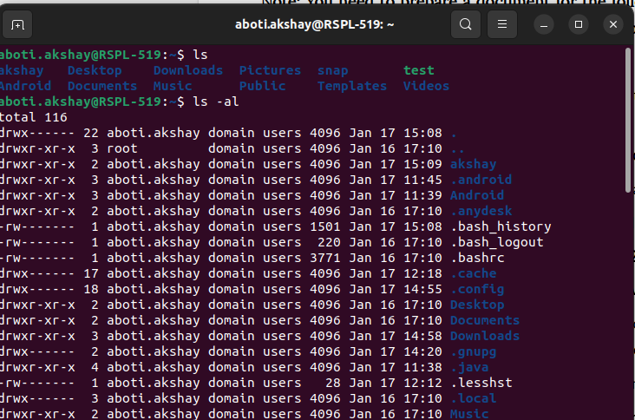

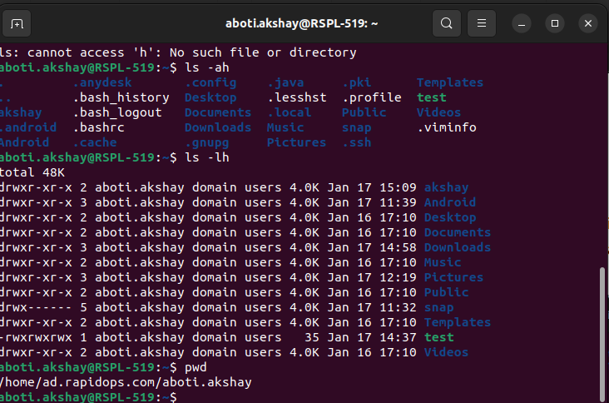

2. Then create two folders named as 'intern-2021' & 'rapidops-2021',

OUTPUT
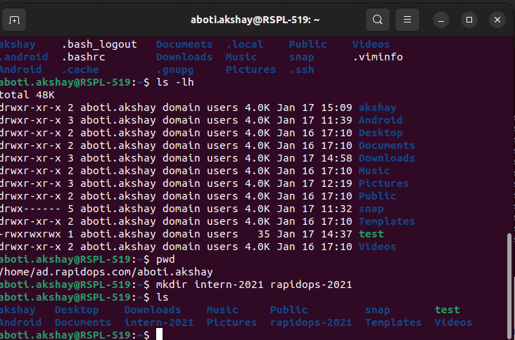

3. Then create two files within 'intern-2021' folder, names are 'dev.txt' & 'helloworld.txt',

OUTPUT
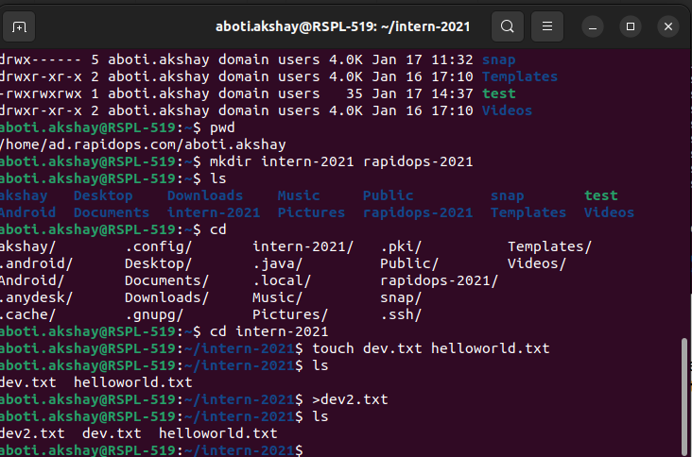

4. Then open the 'dev.txt' file and write something in it, and in 'helloworld.txt' file write 'helloworld' using echo command,

OUTPUT
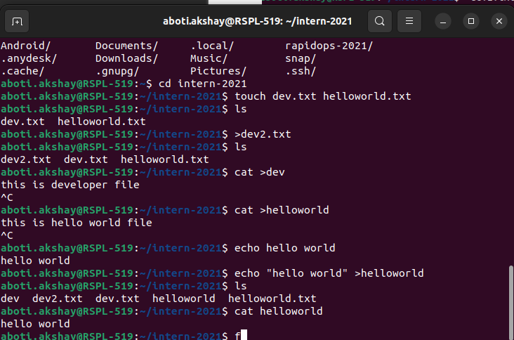

5. Now copy 'dev.txt' and 'helloworld.txt' into rapidops-2021 folder,

OUTPUT
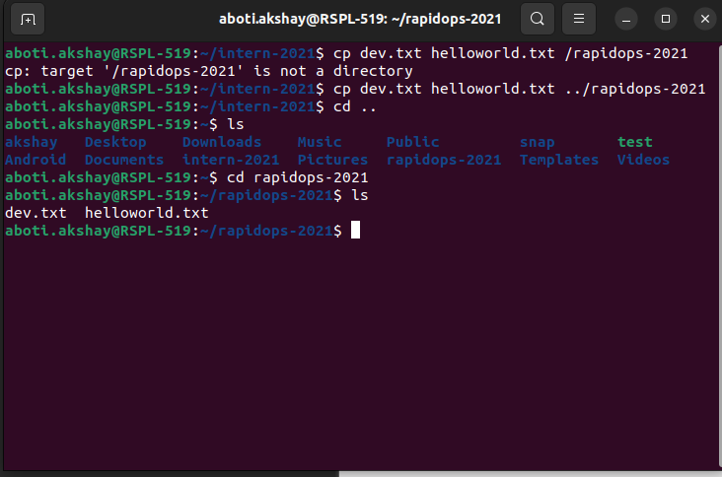

6. Now go to the rapidops-2021 folder and rename those two (dev.txt, helloworld.txt) files.

OUTPUT
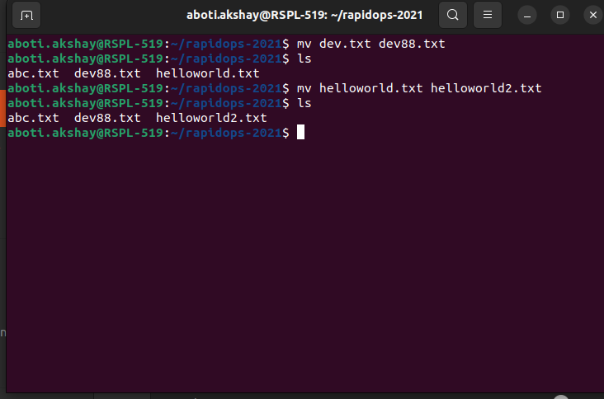

7. In the same directory path, give 'read only' permission to dev.txt for file’s owner, and for helloworld.txt give 'read-write-execute' permission to it's owner & 'read-write' permission to it's group.

OUTPUT
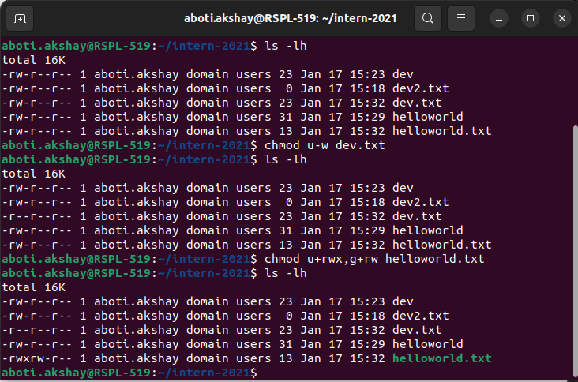

8. Now create archive file within same directory and shift into intern-2021 directory.
OUTPUT
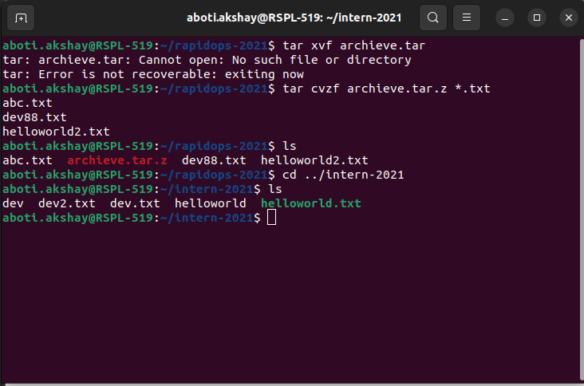

9. Now copy that archive file in this directory location and remove that older archive
file.

OUTPUT

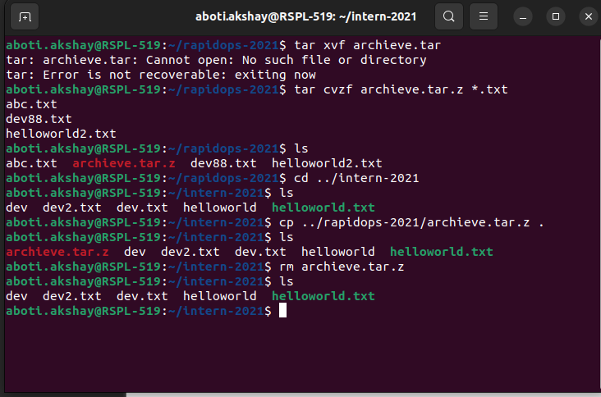

10. Using the command find out the dev.txt file.
OUTPUT
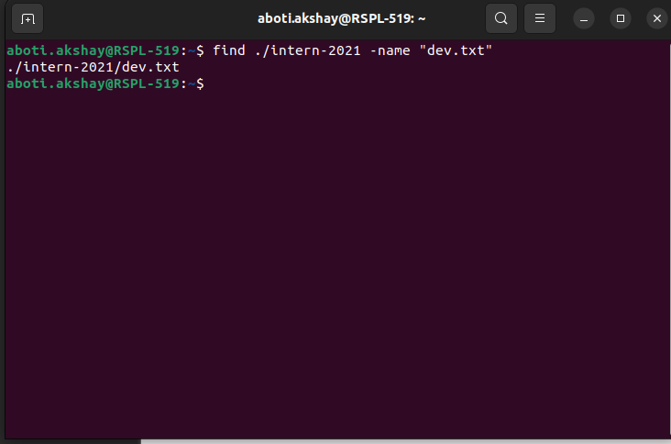

11. Check the CPU, memory usage using CLI.

OUTPUT
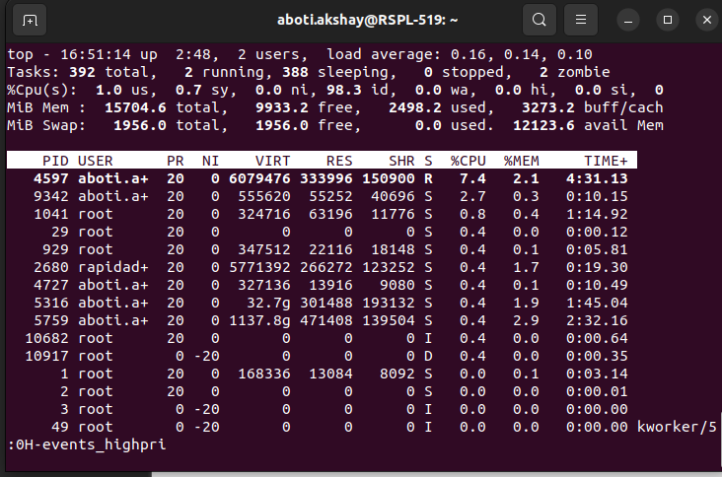

12. Check the disk usage and free disk space using CLI.

OUTPUT

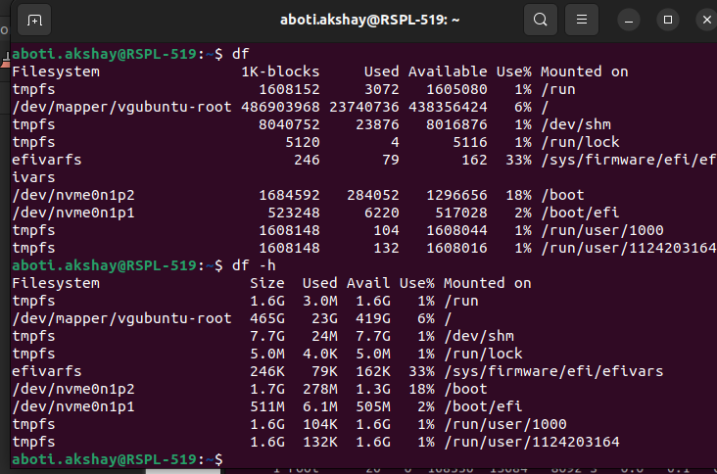

13. Check the all system process and filter out any of one process service using CLI.

OUTPUT
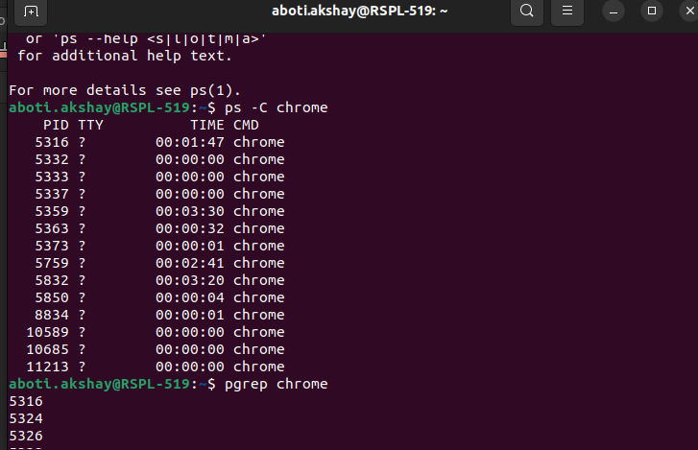

14. Retrieve the content from web server using CLI. Here Link

OUTPUT
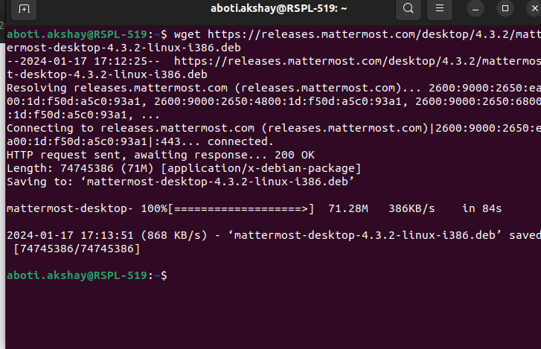

15. Check your network interface information using CLI.

OUTPUT
