Project Title: HOSPITAL MANAGEMENT SYSTEM

Description: The Hospital Management System is a RESTful backend application designed to streamline and automate the management of hospital activities. Developed using Node.js, Express.js, and MongoDB, the system enables efficient handling of patient registrations, doctor information, appointments, medical histories, and departmental records.
The application serves as a centralized platform where hospital administrators can store, retrieve, update, and manage healthcare-related data through secure APIs. MongoDB provides a flexible document-oriented database for storing hospital data, while Express.js handles API routing and request processing.
Objective:
- To automate hospital record management through a centralized backend system.
- To develop RESTful APIs for handling healthcare-related operations.
- To maintain accurate information about patients, doctors, appointments, and treatments.
- To implement efficient database models and entity relationships using MongoDB.
- To demonstrate practical implementation of backend development concepts using Node.js and Express.js.
Features:
- Patient registration and management
- Doctor profile management
- Appointment scheduling system
- CRUD operations for all entities
- RESTful API architecture
- Scalable MongoDB database structure

System Modules:

Patient Module: Handles patient registration and stores personal information such as name, age, gender, contact details, address, and medical history references.

Doctor Module: Maintains doctor profiles including specialization, qualifications, availability, consultation fees, and department details.

Department Module: Organizes doctors into different hospital departments and manages departmental information and responsibilities.

Appointment Module: Facilitates appointment booking, rescheduling, cancellation, and tracking between doctors and patients.

Treatment & Medical Records Module: Stores diagnosis reports, prescribed medications, treatment plans, and follow-up information for patients.

Technologies used:
Backend: Java Script, Node.js, Express.js
Database: MongoDB, Mongoose ODM
Development Tools: Visual Studio Code, MongoDB Atlas, GitHub

OUTPUT SCREENSHOTS:
- Server Creation and Database connection
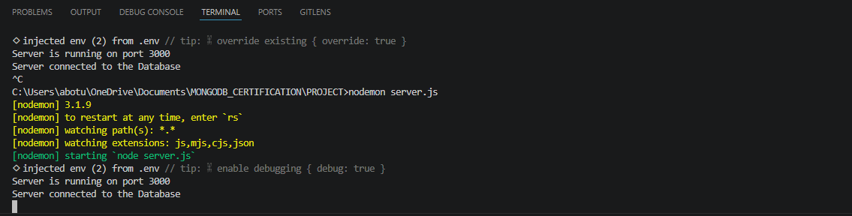

- Default route
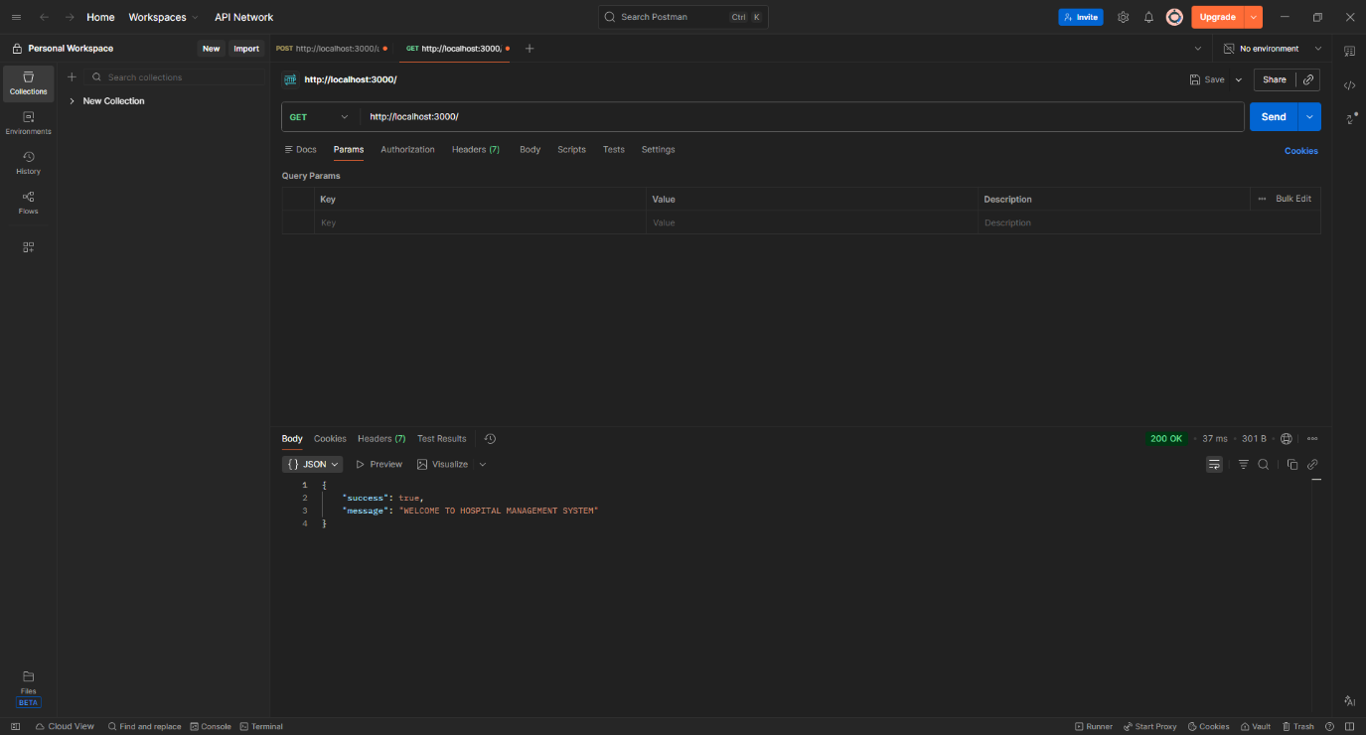

- Registration for doctor
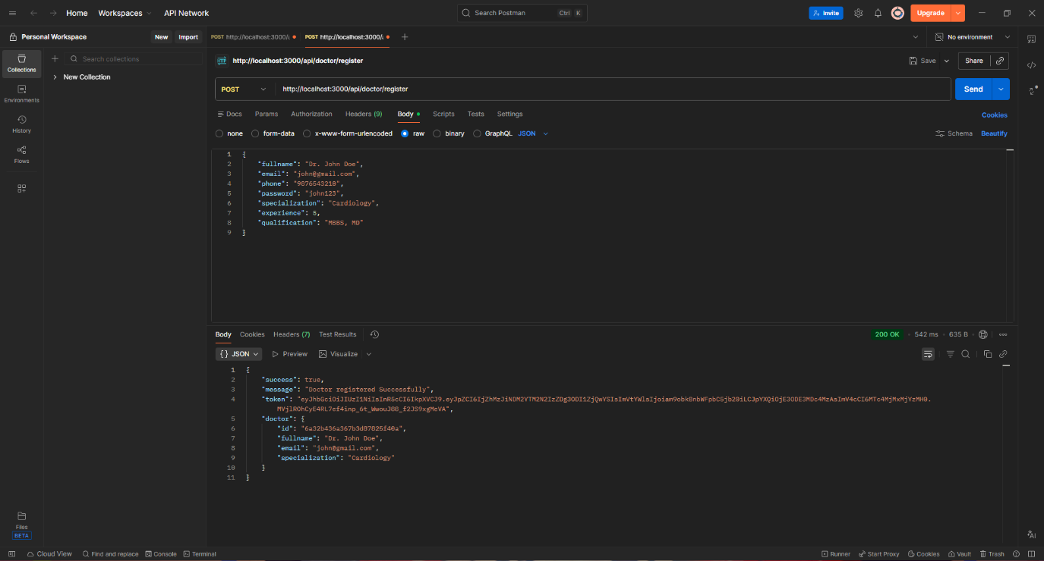
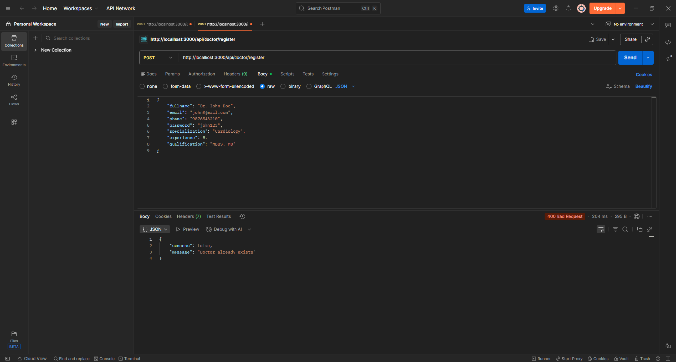

- Login for Doctor
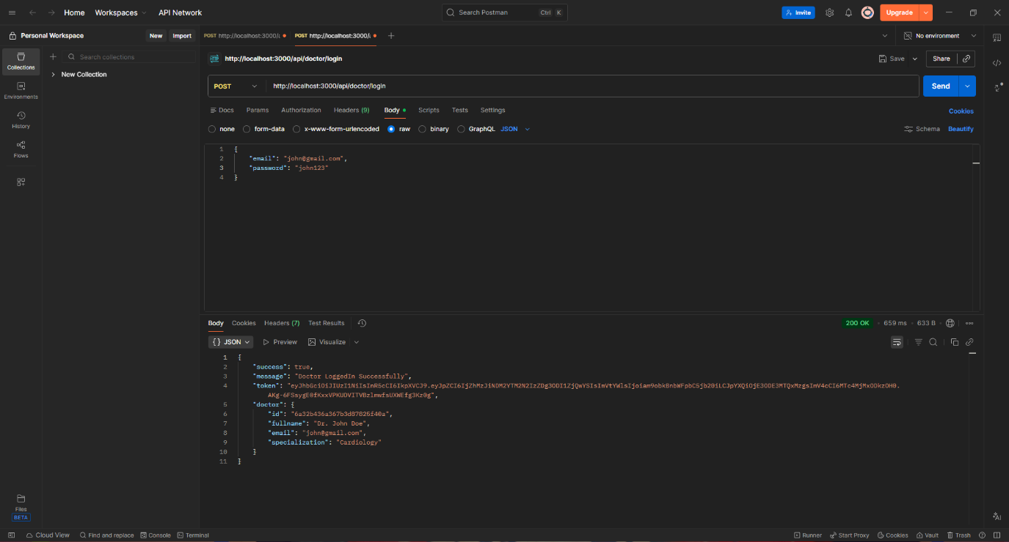
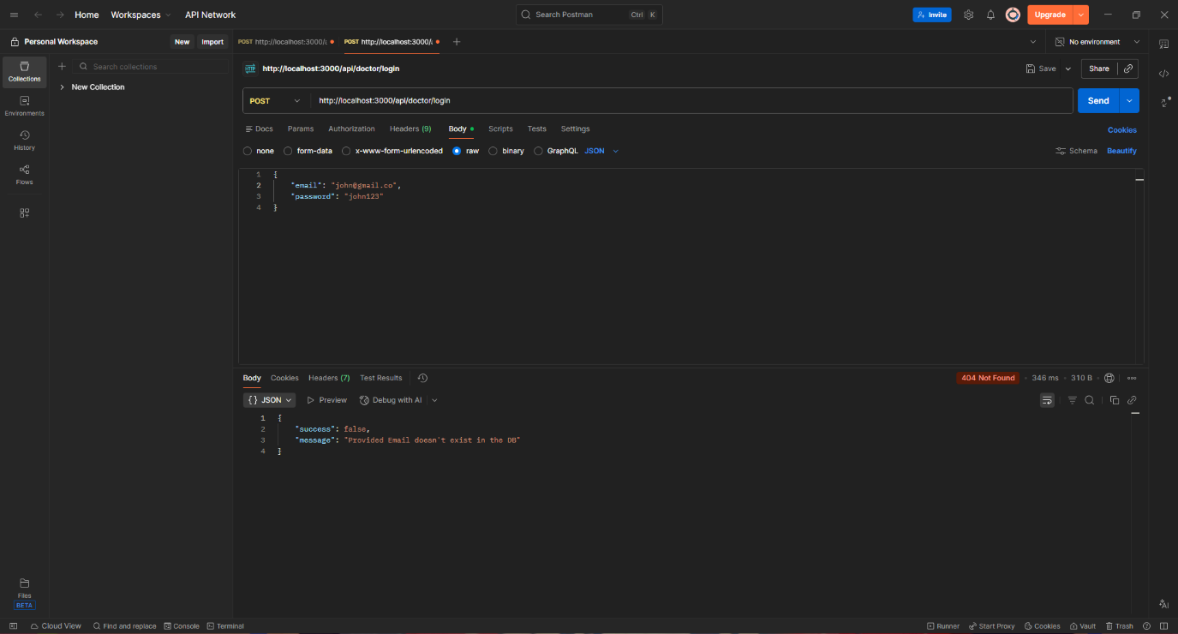
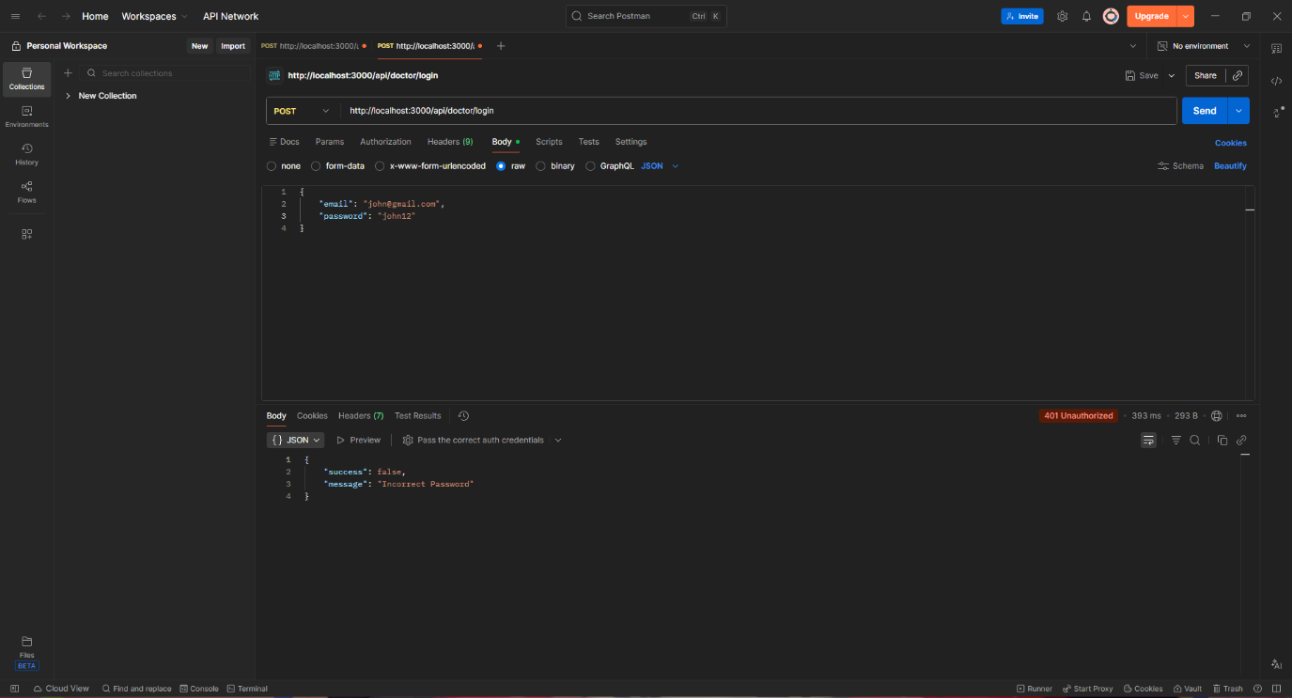

- Patient Registration

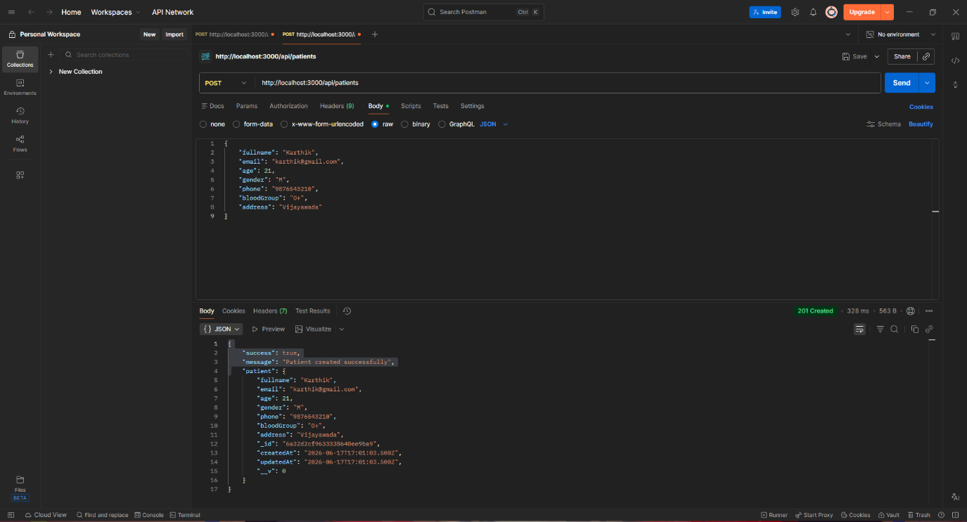

- Appointment Booking for the patient with a particular doctor
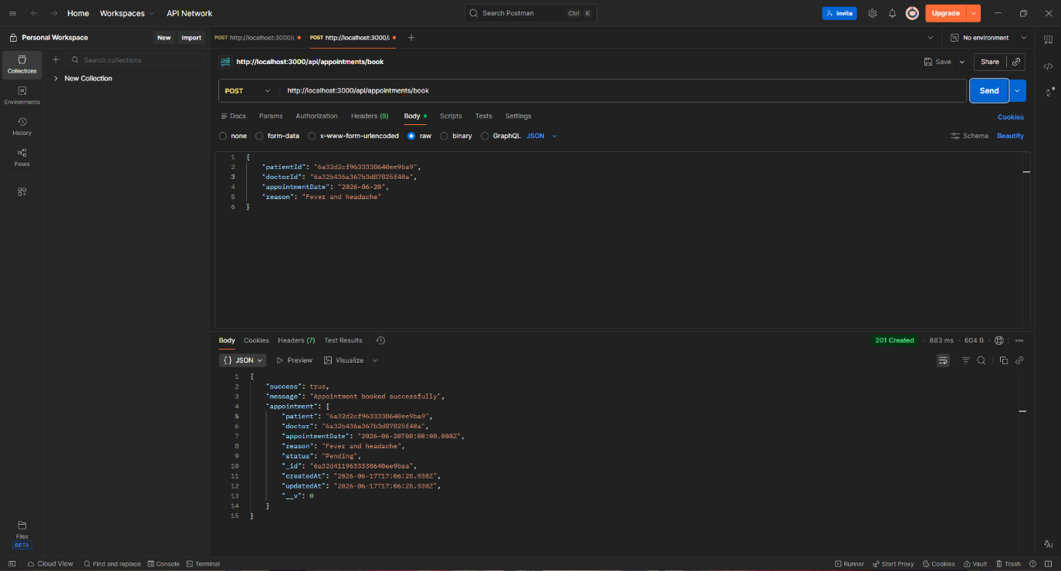

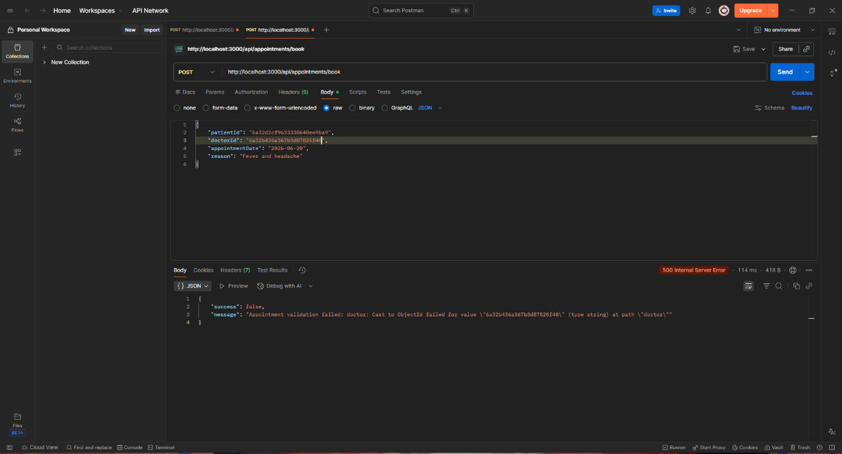
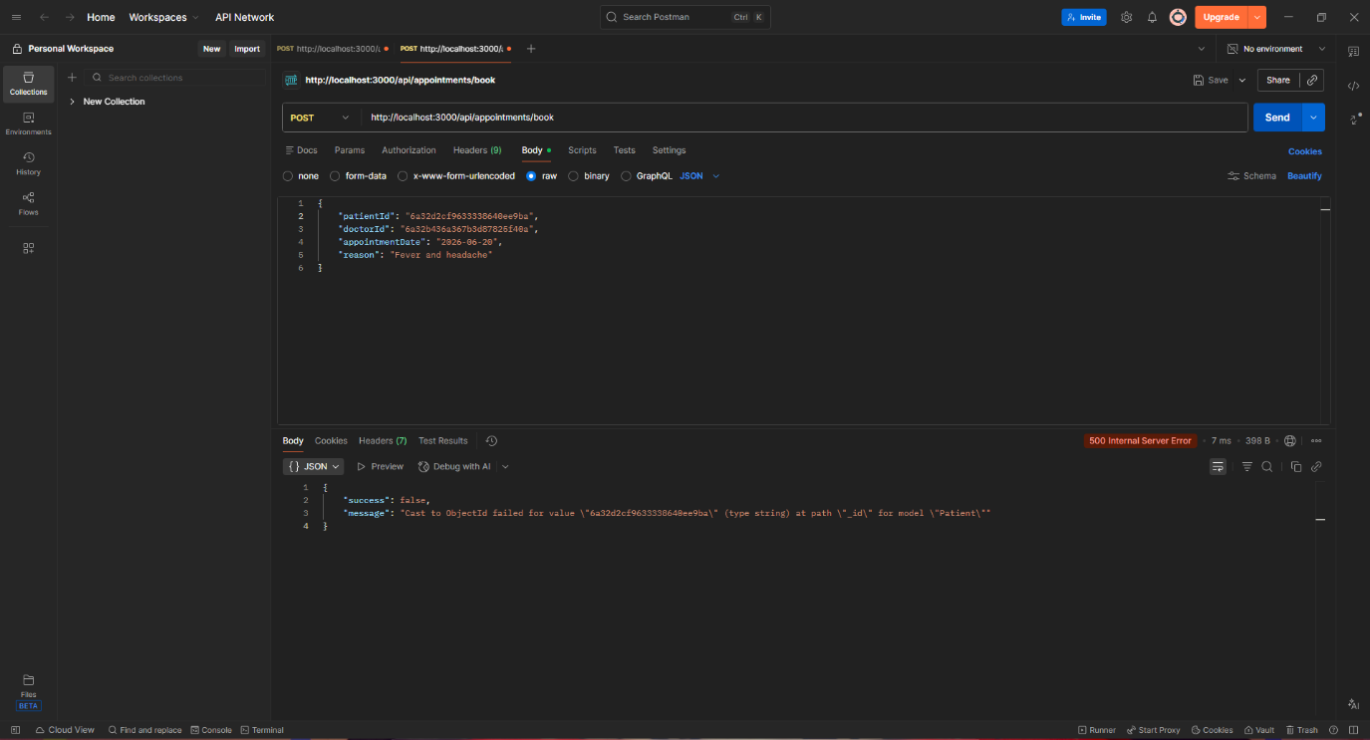

- Status updation after the consultation
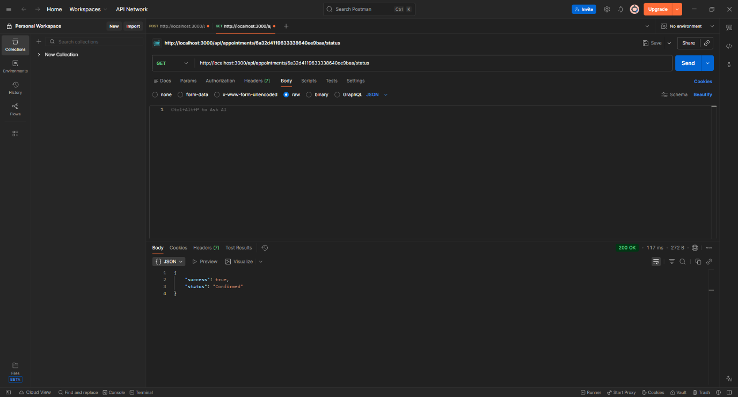

- Viewing the appointments
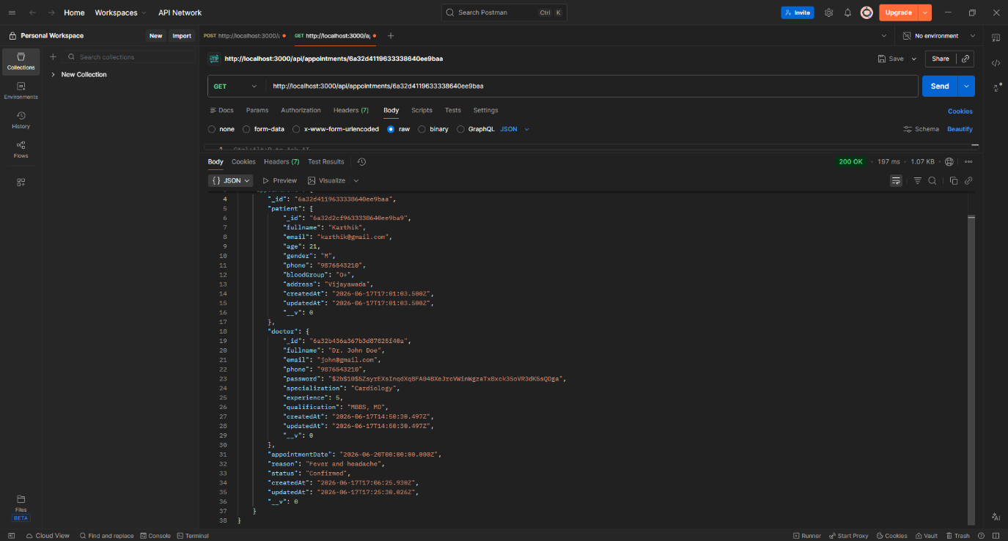

- Deletion of the appointment after consultation
