**c)轮播图**

参考“Bootstrap轮播”：

<https://www.runoob.com/bootstrap/bootstrap-carousel-plugin.html>

详情：“可选的标题”

**d)用户登录模态框**

参考“Bootstrap模态框”：

<https://www.runoob.com/bootstrap/bootstrap-carousel-plugin.html>

参考“Bootstrap表单”：

<https://www.runoob.com/bootstrap/bootstrap-forms.html>

详情：“水平表单”

用户登录表单说明：

用户名文本框name属性值为”name”

密码文本框name属性值为”password”

登录按纽type属性值为”submit”

表单action属性值为”login”，method为”post”

**登录模态框**

|  |
| --- |
| *<!--登录模态框-->* <**div class="modal fade" id="loginModal" tabindex="-1" role="dialog" aria-labelledby="myModalLabel" aria-hidden="true"**>  <**div class="modal-dialog"**>  <**div class="modal-content"**>  <**form class="form-horizontal" role="form" action="login" method="post"**>  <**div class="modal-header"**>  <**button type="button" class="close" data-dismiss="modal" aria-hidden="true"**>  **&times;** </**button**>  <**h4 class="modal-title" id="myModalLabel"**>  用户登录  </**h4**>  </**div**>  <**div class="modal-body"**>  <**div class="form-group"**>  <**label for="name" class="col-sm-2 control-label"**>账号:</**label**>  <**div class="col-sm-10"**>  <**input type="text" class="form-control" id="name" name="name" placeholder="请输入账号..."  value="${**cookieNameString**}"**>  </**div**>  </**div**>  <**div class="form-group"**>  <**label for="password" class="col-sm-2 control-label"**>密码:</**label**>  <**div class="col-sm-10"**>  <**input type="password" class="form-control" id="password" name="password"  placeholder="请输入密码..." value="${**cookiePasswordString**}"**>  </**div**>  </**div**>  <**div class="form-group"**>  <**div class="col-sm-offset-2 col-sm-10"**>  <**div class="checkbox"**>  <**label**>  <**input type="checkbox" checked="checked" name="rememberMe"**>请记住我  </**label**>  </**div**>  </**div**>  </**div**>  </**div**>  <**div class="modal-footer"**>  <**button type="button" class="btn btn-default" data-dismiss="modal"**>关闭  </**button**>  <**button type="submit" class="btn btn-primary"**>  登录  </**button**>  </**div**>  </**form**>  </**div**>*<!-- /.modal-content -->* </**div**>*<!-- /.modal -->* </**div**> |

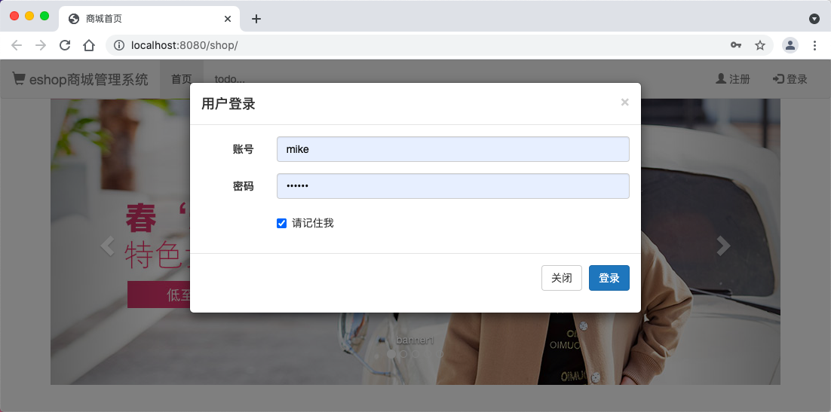

登录模态框