Task

Amit learning:

# Search the documentation for the definition of the third argument of the tensor dot () method:

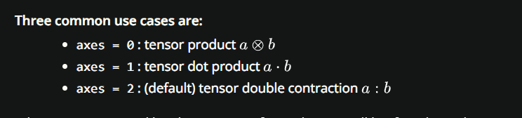

## Frist case:

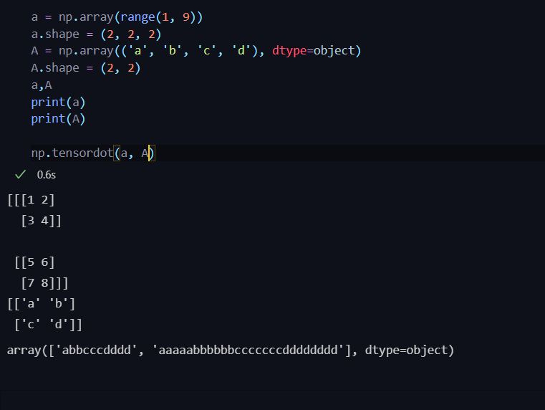

The default value to axes is 2 and it product each cell from matrix A with the each cell in matrix a and concat them with each other

## Second case:

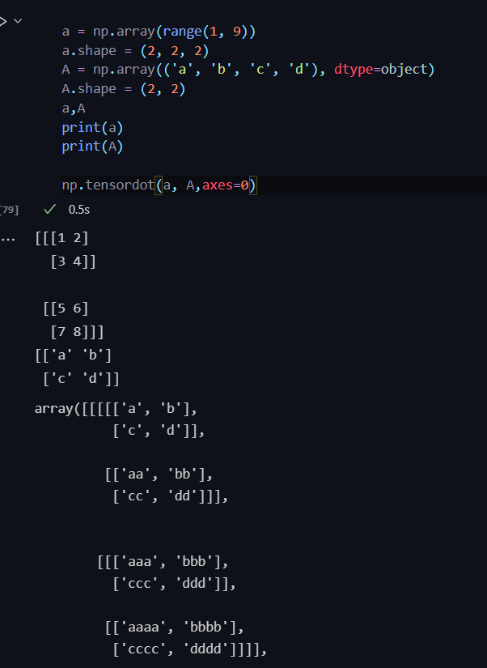

When axes value is zero here the whole matrix of A multiply with the a cells as scalars and save them all together in the

Same tensor and that is what called tensor product

## Third case:

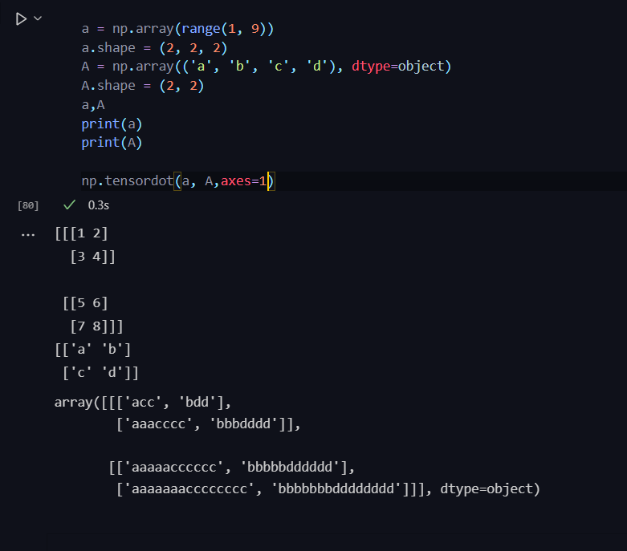

Here when the value is 1 what happen is a normal dot product between the two matrices and save in new tensor

# Tensor dot() method and investigate the difference between tensor products and tensor dot product with

Tensor products provide a most “natural” method of combining two matrices. They may be thought of as the simplest way to combine modules in a meaningful fashion. As we will see, polynomial rings are combined as one might hope, so that R[x] ⊗ R R[y] ∼= R[x, y]

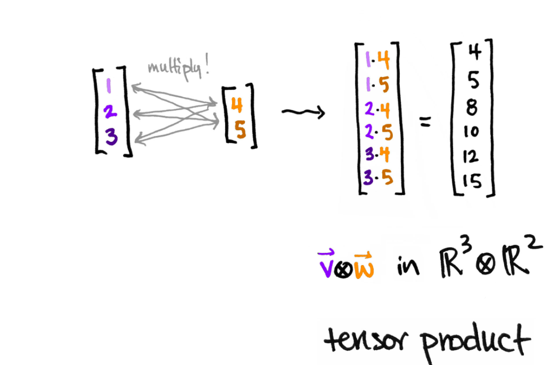

Tensor dot product is an algebraic operation that takes two equal-length sequences of tensor and returns a matrix.

