Wrangling and Visualizing Data with R

Abu Ali

2024-08-08

## The Titanic Dataset

we will use R packages to explore the Titanic dataset and visualize key patterns and insights, and their relations to the survival rate of the passengers.

You can download the the titanic dataset here: <https://www.kaggle.com/datasets/yasserh/titanic-dataset>

### LOADING THE DATASET:

library(readxl)  
titanic_ds <- read_excel("titanic_ds.xls")

## Warning: Coercing text to numeric in M1306 / R1306C13: '328'

str(titanic_ds)

## tibble [1,309 × 14] (S3: tbl_df/tbl/data.frame)  
## $ pclass : num [1:1309] 1 1 1 1 1 1 1 1 1 1 ...  
## $ survived : num [1:1309] 1 1 0 0 0 1 1 0 1 0 ...  
## $ name : chr [1:1309] "Allen, Miss. Elisabeth Walton" "Allison, Master. Hudson Trevor" "Allison, Miss. Helen Loraine" "Allison, Mr. Hudson Joshua Creighton" ...  
## $ sex : chr [1:1309] "female" "male" "female" "male" ...  
## $ age : num [1:1309] 29 0.917 2 30 25 ...  
## $ sibsp : num [1:1309] 0 1 1 1 1 0 1 0 2 0 ...  
## $ parch : num [1:1309] 0 2 2 2 2 0 0 0 0 0 ...  
## $ ticket : chr [1:1309] "24160" "113781" "113781" "113781" ...  
## $ fare : num [1:1309] 211 152 152 152 152 ...  
## $ cabin : chr [1:1309] "B5" "C22 C26" "C22 C26" "C22 C26" ...  
## $ embarked : chr [1:1309] "S" "S" "S" "S" ...  
## $ boat : chr [1:1309] "2" "11" NA NA ...  
## $ body : num [1:1309] NA NA NA 135 NA NA NA NA NA 22 ...  
## $ home.dest: chr [1:1309] "St Louis, MO" "Montreal, PQ / Chesterville, ON" "Montreal, PQ / Chesterville, ON" "Montreal, PQ / Chesterville, ON" ...

### CLEANING THE DATASET:

#### 1. Check for missing values

library(Amelia)

## Loading required package: Rcpp

## ##   
## ## Amelia II: Multiple Imputation  
## ## (Version 1.8.2, built: 2024-04-10)  
## ## Copyright (C) 2005-2024 James Honaker, Gary King and Matthew Blackwell  
## ## Refer to http://gking.harvard.edu/amelia/ for more information  
## ##

missmap(titanic_ds, col = c("red", "green"))

## Warning: Unknown or uninitialised column: `arguments`.  
## Unknown or uninitialised column: `arguments`.

## Warning: Unknown or uninitialised column: `imputations`.

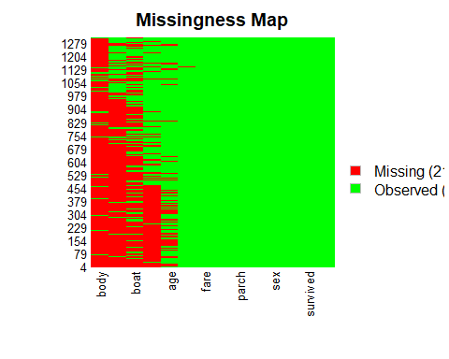

Note that you can add echo = FALSE parameter to the code chunk to prevent printing of the R code that generated the plot.

#### 2. Select relevant columns for the analysis

library(tidyverse)

## ── Attaching core tidyverse packages ──────────────────────── tidyverse 2.0.0 ──  
## ✔ dplyr 1.1.4 ✔ readr 2.1.5  
## ✔ forcats 1.0.0 ✔ stringr 1.5.1  
## ✔ ggplot2 3.5.1 ✔ tibble 3.2.1  
## ✔ lubridate 1.9.3 ✔ tidyr 1.3.1  
## ✔ purrr 1.0.2   
## ── Conflicts ────────────────────────────────────────── tidyverse_conflicts() ──  
## ✖ dplyr::filter() masks stats::filter()  
## ✖ dplyr::lag() masks stats::lag()  
## ℹ Use the conflicted package (<http://conflicted.r-lib.org/>) to force all conflicts to become errors

selected_titanic <- titanic_ds %>%  
 select (age, pclass, sex, survived, embarked, home.dest, fare, parch, sibsp)

#### 3. Merge columns parch and sibsp to create a new column, FamilySize

selected_titanic$FamilySize <- selected_titanic$sibsp + selected_titanic$parch + 1  
str(selected_titanic)

## tibble [1,309 × 10] (S3: tbl_df/tbl/data.frame)  
## $ age : num [1:1309] 29 0.917 2 30 25 ...  
## $ pclass : num [1:1309] 1 1 1 1 1 1 1 1 1 1 ...  
## $ sex : chr [1:1309] "female" "male" "female" "male" ...  
## $ survived : num [1:1309] 1 1 0 0 0 1 1 0 1 0 ...  
## $ embarked : chr [1:1309] "S" "S" "S" "S" ...  
## $ home.dest : chr [1:1309] "St Louis, MO" "Montreal, PQ / Chesterville, ON" "Montreal, PQ / Chesterville, ON" "Montreal, PQ / Chesterville, ON" ...  
## $ fare : num [1:1309] 211 152 152 152 152 ...  
## $ parch : num [1:1309] 0 2 2 2 2 0 0 0 0 0 ...  
## $ sibsp : num [1:1309] 0 1 1 1 1 0 1 0 2 0 ...  
## $ FamilySize: num [1:1309] 1 4 4 4 4 1 2 1 3 1 ...

#### 4. Categorize the fare column and assign label to each category

selected_titanic$FareCategory <- cut(selected_titanic$fare,   
 breaks = c(0, 10, 20, 50, 100, Inf),   
 labels = c("Lowest", "Lower Middle",   
 "Upper Middle", "Higher", "Highest"))  
str(selected_titanic)

## tibble [1,309 × 11] (S3: tbl_df/tbl/data.frame)  
## $ age : num [1:1309] 29 0.917 2 30 25 ...  
## $ pclass : num [1:1309] 1 1 1 1 1 1 1 1 1 1 ...  
## $ sex : chr [1:1309] "female" "male" "female" "male" ...  
## $ survived : num [1:1309] 1 1 0 0 0 1 1 0 1 0 ...  
## $ embarked : chr [1:1309] "S" "S" "S" "S" ...  
## $ home.dest : chr [1:1309] "St Louis, MO" "Montreal, PQ / Chesterville, ON" "Montreal, PQ / Chesterville, ON" "Montreal, PQ / Chesterville, ON" ...  
## $ fare : num [1:1309] 211 152 152 152 152 ...  
## $ parch : num [1:1309] 0 2 2 2 2 0 0 0 0 0 ...  
## $ sibsp : num [1:1309] 0 1 1 1 1 0 1 0 2 0 ...  
## $ FamilySize : num [1:1309] 1 4 4 4 4 1 2 1 3 1 ...  
## $ FareCategory: Factor w/ 5 levels "Lowest","Lower Middle",..: 5 5 5 5 5 3 4 NA 4 3 ...

#### 5. Remove the columns that are being merged to form new columns

selected_titanic <- selected_titanic %>%   
 select(-fare, -parch, -sibsp)

#### 6. Change the values of columns pclass, survived, and embarked

selected_titanic <- selected_titanic %>%  
 mutate(  
 survived = ifelse(survived == 0, "No", "Yes"),  
 age = ifelse(age >= 18, "Adult", "Child"),  
 pclass = case_when(  
 pclass == 1 ~ "1st",  
 pclass == 2 ~ "2nd",  
 pclass == 3 ~ "3rd"  
 ),  
   
 embarked = case_when(  
 embarked == "C" ~ "Cherbourg",  
 embarked == "Q" ~ "Queenstown",  
 embarked == "S" ~ "Southampton"  
 )  
 )

#### 7. Change the name of column pclass to Class, and home.dest to Destination

selected_titanic <- selected_titanic %>%   
 rename(  
 Class = pclass,  
 Destination = home.dest  
 )

#### 8. Capitalize the initials of all the columns name

selected_titanic <- selected_titanic %>%   
 rename_all(~str_to_title(.))

#### 9. Check for missing values again

missmap(selected_titanic, col = c("red", "green"))

## Warning: Unknown or uninitialised column: `arguments`.  
## Unknown or uninitialised column: `arguments`.

## Warning: Unknown or uninitialised column: `imputations`.

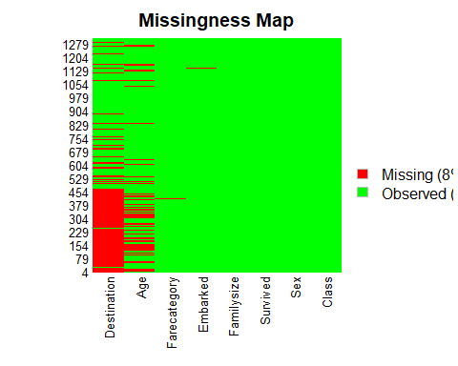

#### 10. Drop all the missing values from the dataset

selected_titanic <- drop_na(selected_titanic)

## Warning: Unknown or uninitialised column: `arguments`.  
## Unknown or uninitialised column: `arguments`.

## Warning: Unknown or uninitialised column: `imputations`.

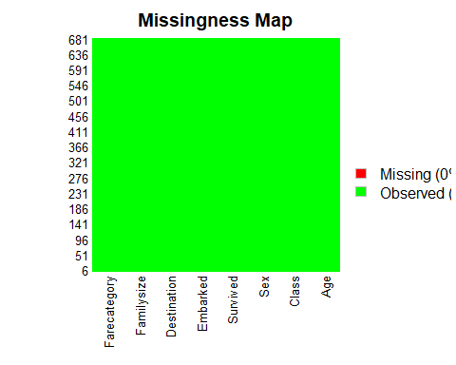

### EXPLORING THE DATASET: