Ouedraogo Aboubacar Sidiki
Cybersecurity Home Lab: ELK (Elasticsearch, Logstash, and Kibana)

ELK (Elasticsearch, Logstash, and Kibana) is a tool used to collect, store, and view logs from computers and servers.
Elasticsearch stores the logs, Logstash collects the logs, and Kibana shows the logs on a dashboard.
In this project, I will install and configure ELK using virtual machines (VMs). I will use Windows and Ubuntu as monitored systems and Kali Linux to simulate attacks and suspicious activity. I will then use Kibana to view the logs, detect the activity, and investigate what happened.
This home lab will help me practice security monitoring, log analysis, threat detection, and security investigation.

Install Elasticsearch
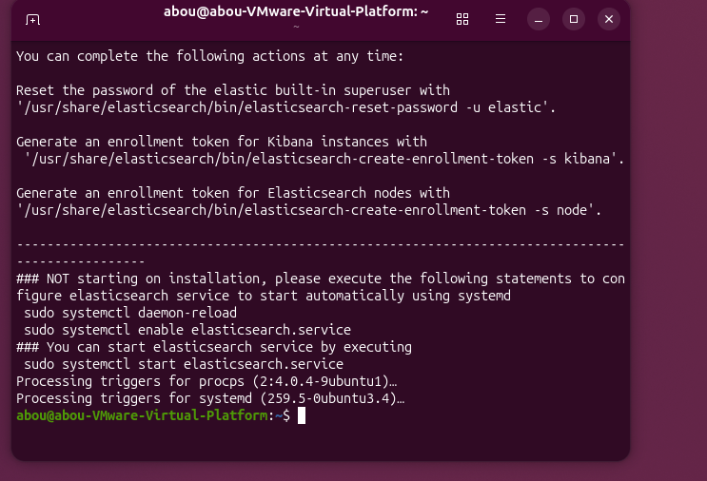

Start Elasticsearch

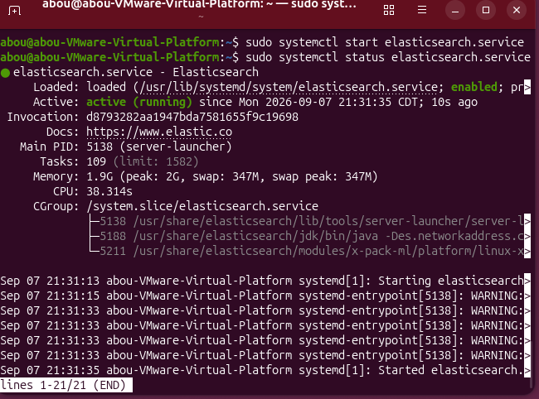
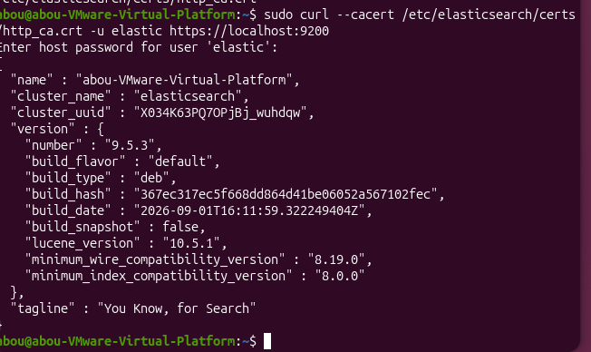

Install Kibana

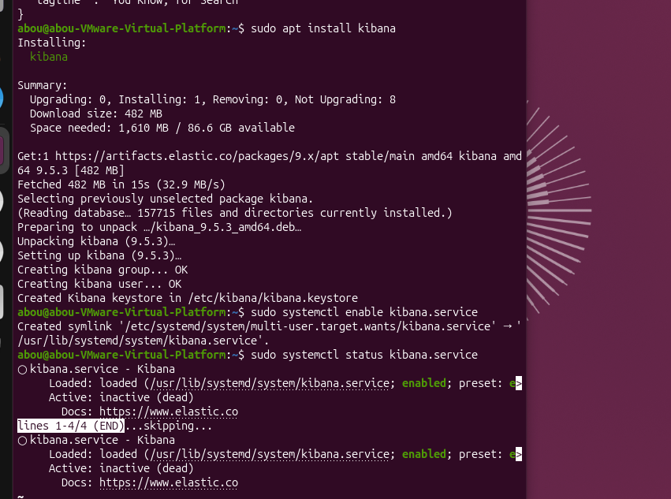

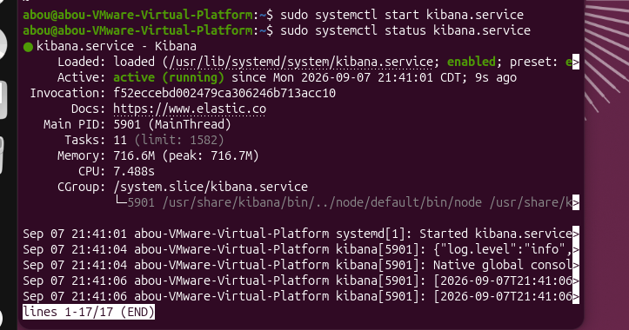

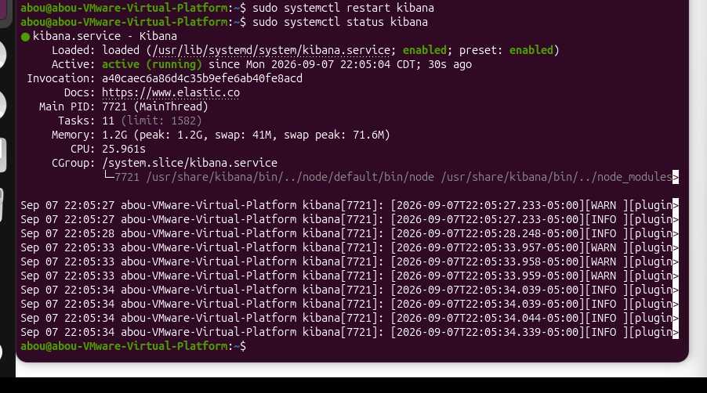

Open Kibana in a Web Browser

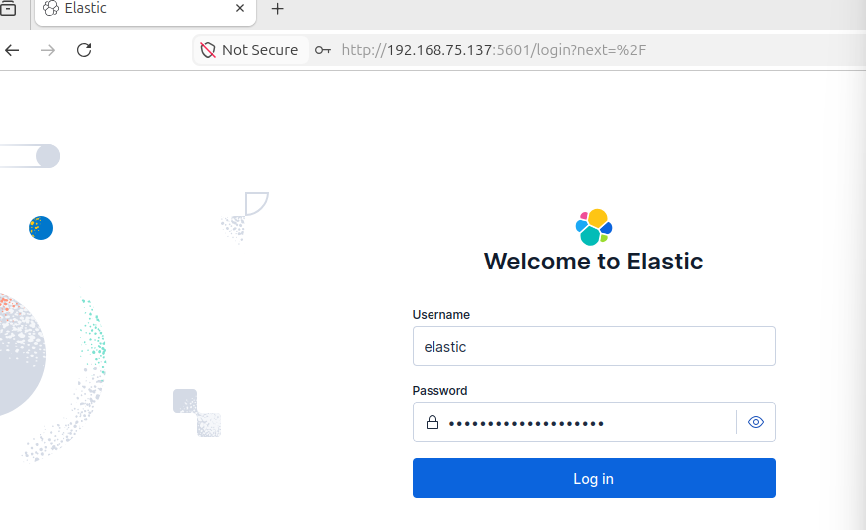
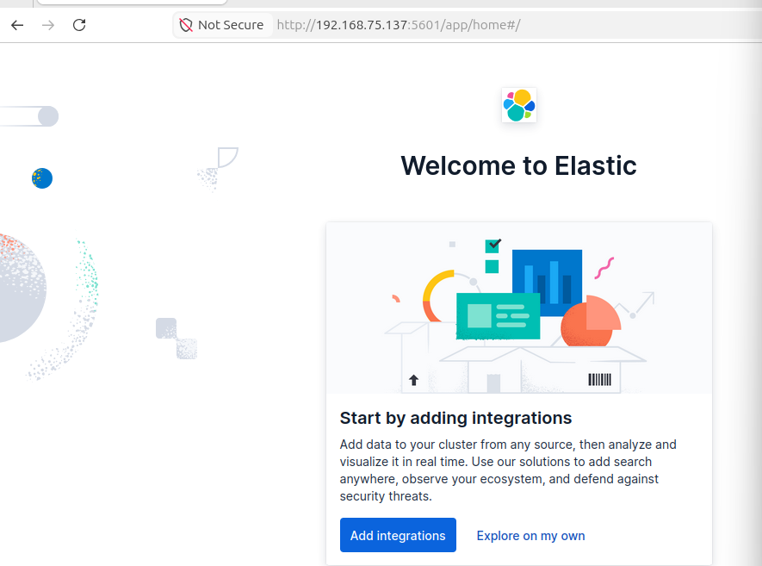

I opened Kibana in a web browser using the IP address of my Ubuntu ELK server. The Elastic dashboard loaded successfully, confirming that Elasticsearch and Kibana were connected and working correctly.

Add the Windows VM

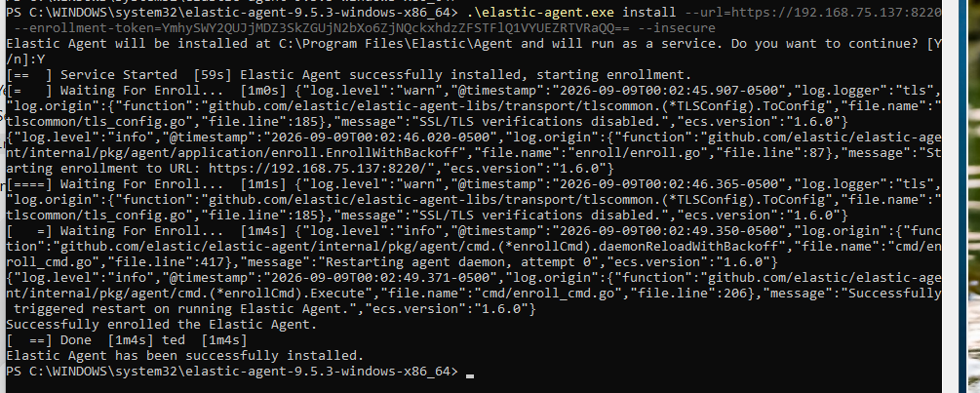
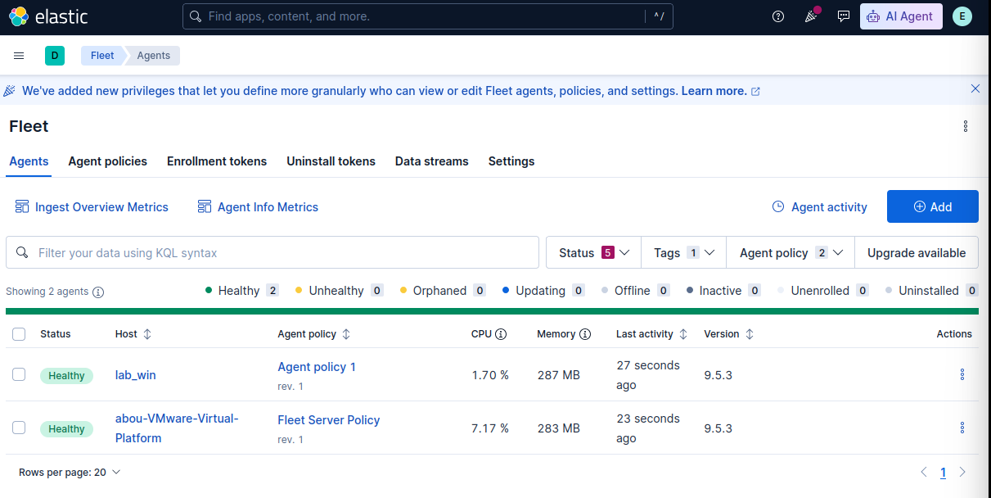
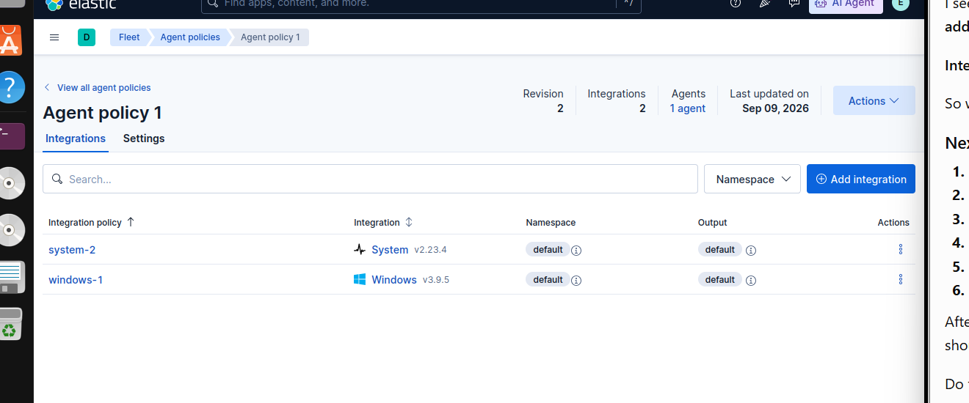

Windows Security Log Collection in Kibana Discover
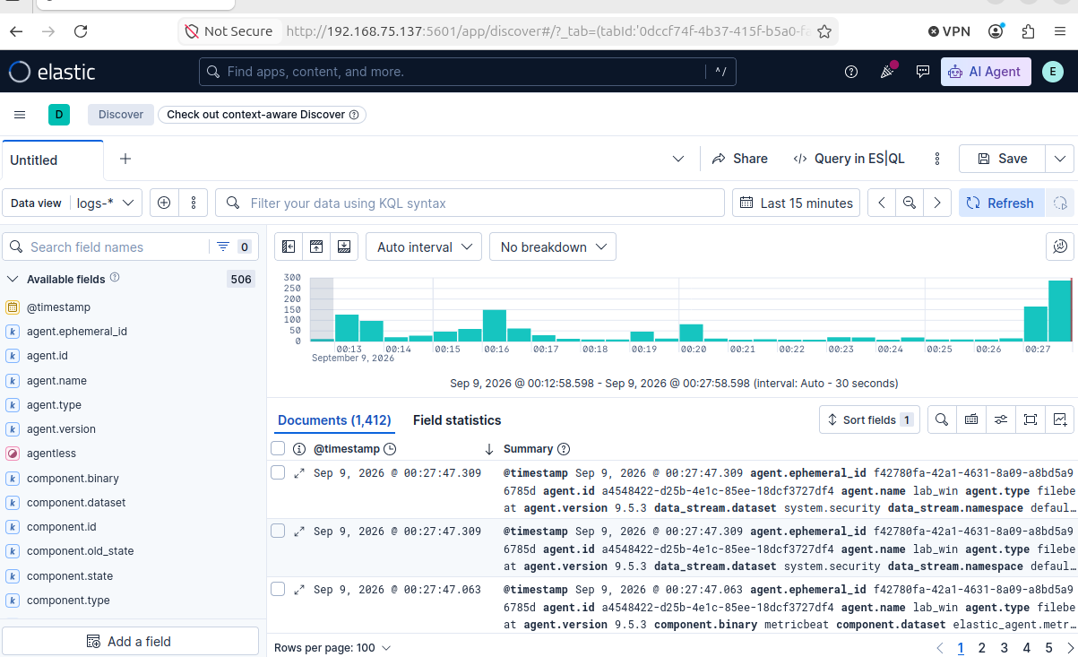

This screenshot shows Windows security logs from my Windows VM in Kibana. The Elastic Agent collects the logs and sends them to Elasticsearch. I can use Kibana to view and analyze the logs for security threats and suspicious activity.

Security Event Simulation and Analysis
- Simulation 1: Failed Windows Login Attempt
Let’s use PowerShell to simulate failed login attempts.
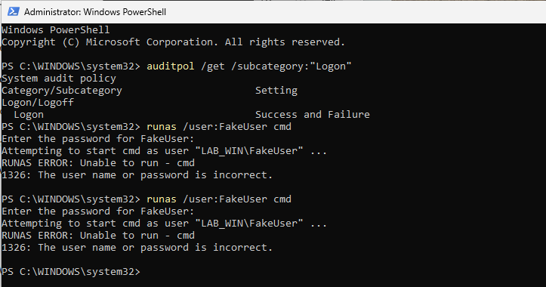
Detecting Failed Login Event in Kibana
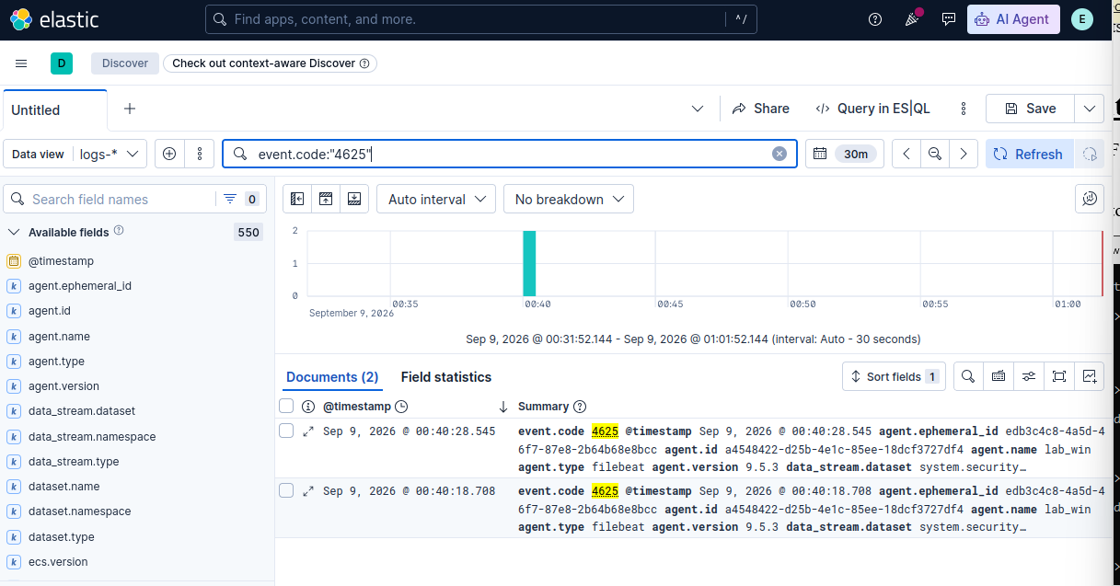
Let investigate:
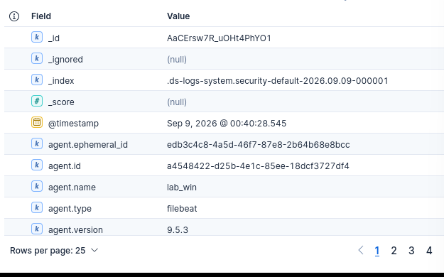
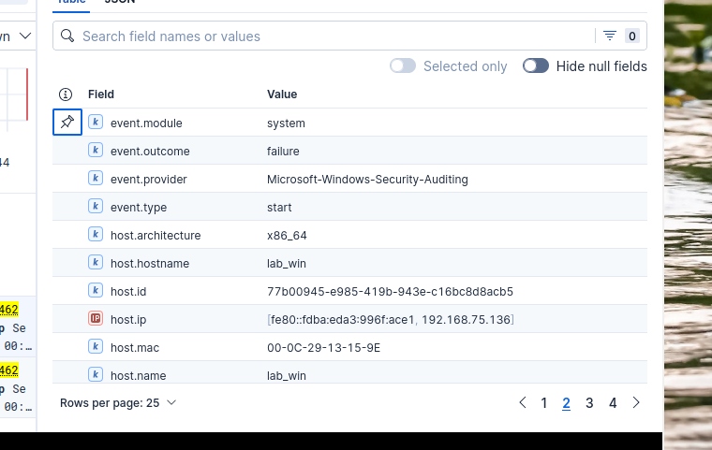

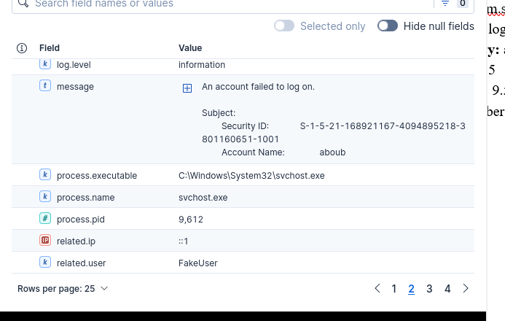

- ID: AaCErsw7R_uOHt4PhYO1
- Account Name: aboub
- Failed/related user: FakeUser
- Host MAC Address: 00-0C-29-13-15-9E
- Related IP: ::1
- Agent: lab_win
- Dataset: system.security
- Event action: logon-failed
- Event category: authentication
- Event ID: 4625
- Process: C:\Windows\System32\svchost.exe
- Time: Sep 9, 2026 at 00:40:30.235
- MITRE ATT&CK Tactic: Credential Access
- MITRE ATT&CK Technique: Brute Force
Summary:
Kibana detected a failed login attempt on the Windows VM. Event ID 4625 confirmed that the login failed. The attempted username was FakeUser, and the related IP was ::1, showing that the attempt came from the local computer.
Remediation:
Monitor for repeated failed login attempts. If the activity is not authorized, investigate the account and source and take action to prevent unauthorized access.

- Simulation 2: Nmap Network Scan
For this simulation, I will use my Kali Linux VM to scan my Windows VM with Nmap. The goal is to simulate network reconnaissance and see if I can identify the activity in Kibana. This will help me practice how a security analyst detects and investigates suspicious network scanning.

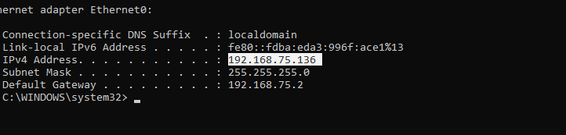

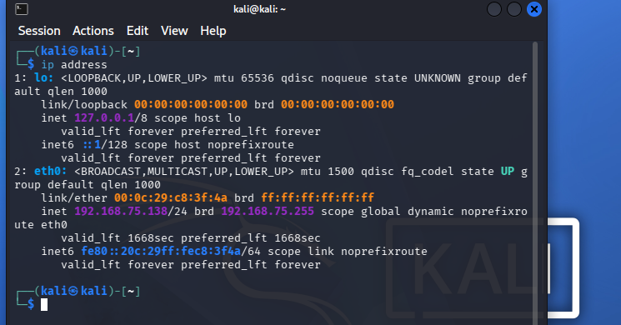

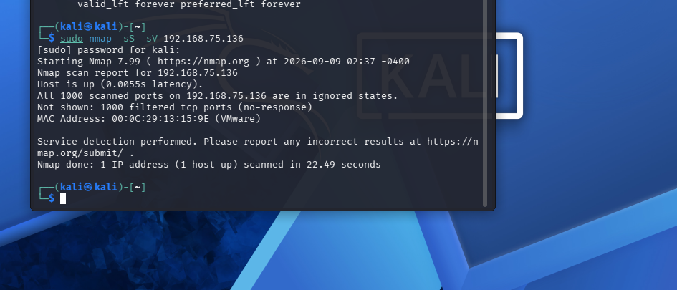
Detecting Nmap Network Scan in Kibana

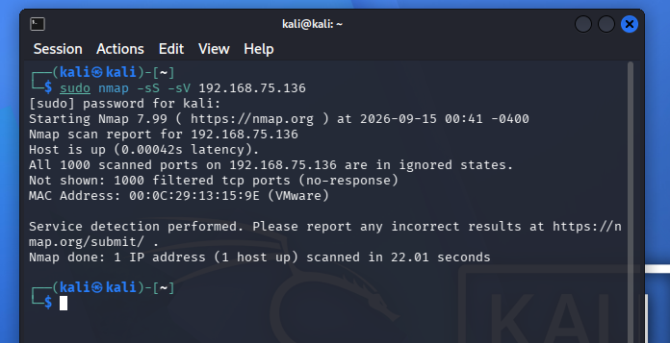

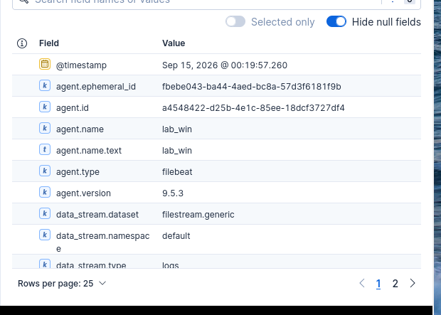

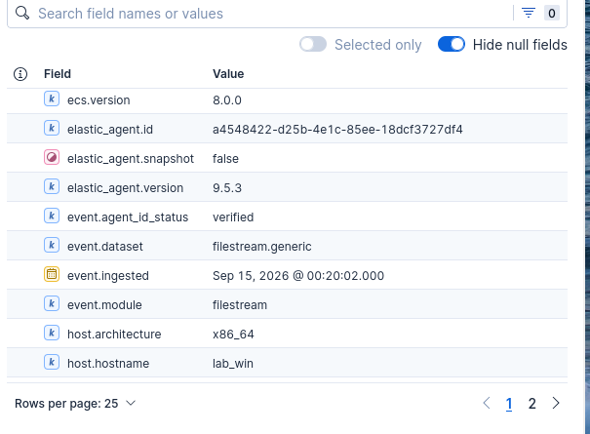
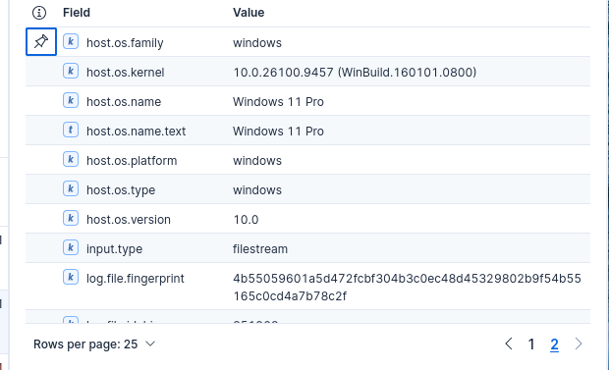

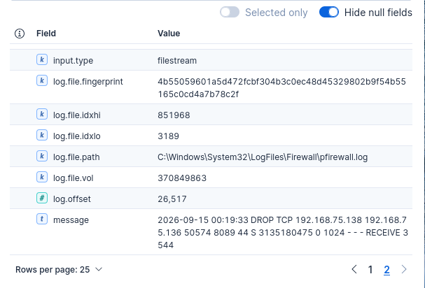
Investigation
Ticket Title: Nmap Port Scan Detected from Kali Linux
Host Name: Lab_win
Source IP: 192.168.75.138
Destination IP: 192.168.75.136
Source Port: 50574
Destination Port: 8089
Protocol: TCP
Action: DROP
Detection Source: Windows Firewall / Elastic Kibana
Path: C:\Windows\System32\LogFiles\Firewall\pfirewall.log
Date and Time: Sep 15, 2026 at 00:19:57.260
MITRE ATT&CK Tactic: Discovery
MITRE ATT&CK Technique: Network Service Discovery

Summary:
I reviewed the Windows Firewall logs in Kibana and found network traffic from my Kali Linux VM. The firewall log showed a TCP connection from 192.168.75.138 to my Windows VM 192.168.75.136. The traffic was marked DROP, meaning Windows Firewall blocked the connection. This confirmed that the Nmap scan was detected and collected by Elastic. This shows that my ELK lab can monitor and investigate suspicious network activity.
Remediation:
Keep the firewall enabled, block unnecessary ports, and monitor repeated connection attempts from the same IP address.

- Simulation 3: PowerShell Suspicious Activity Alert

For this simulation, I will use PowerShell on my Windows VM to generate activity. I will use Elastic and Kibana to collect the logs, detect the PowerShell activity, and investigate the event. This will help me practice how a security analyst monitors and investigates PowerShell activity on a Windows system.

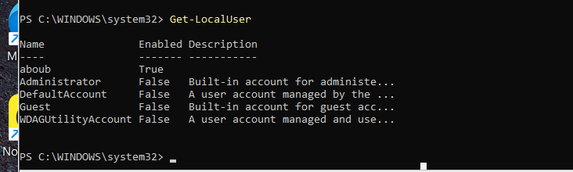

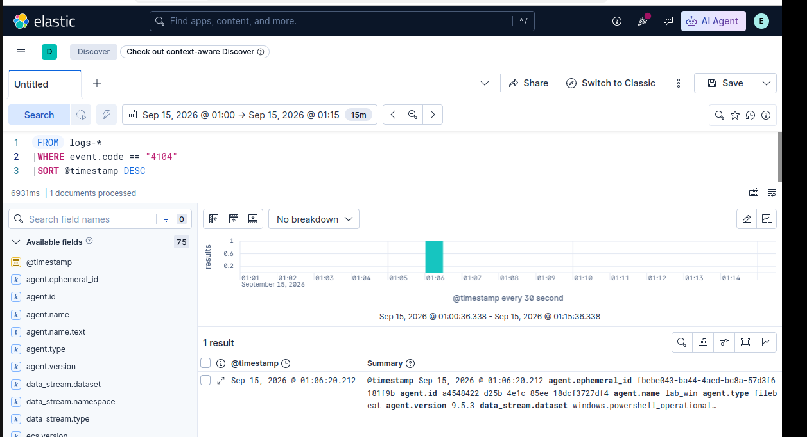

Investigation

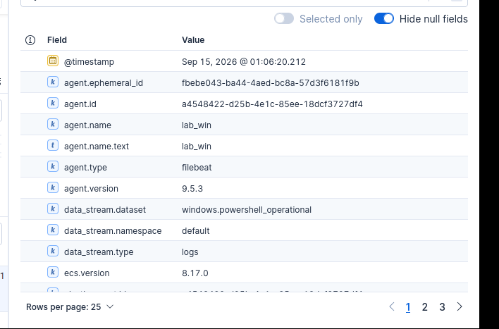
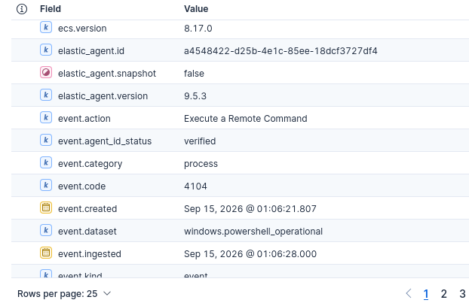
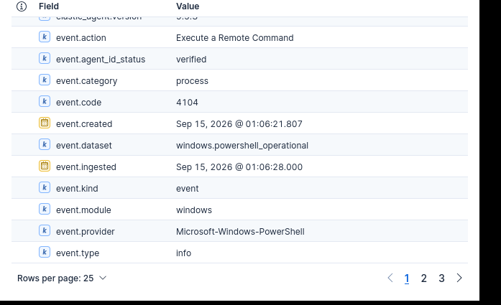
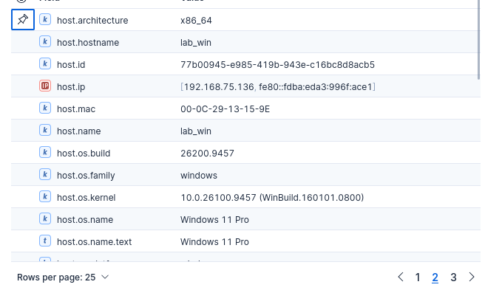
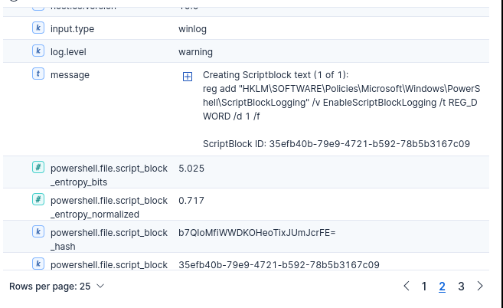
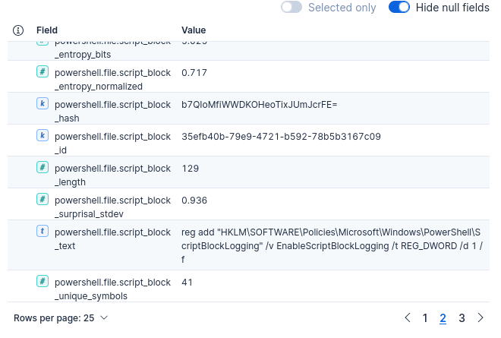

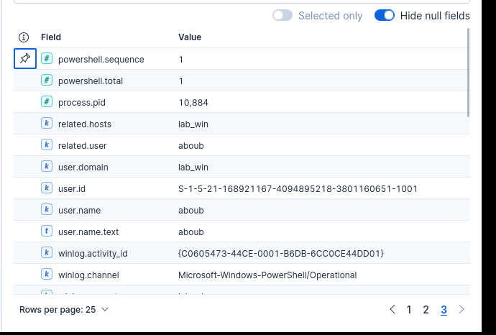

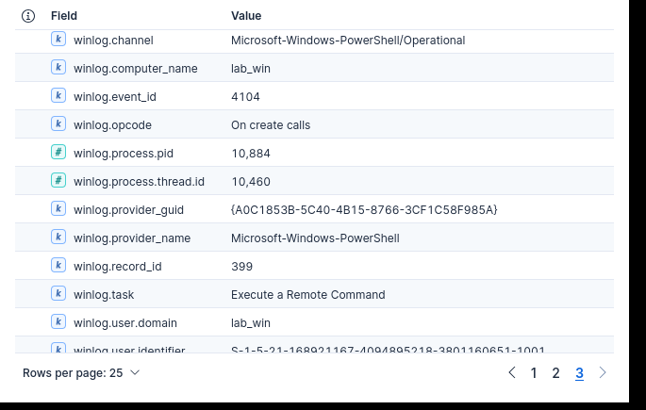
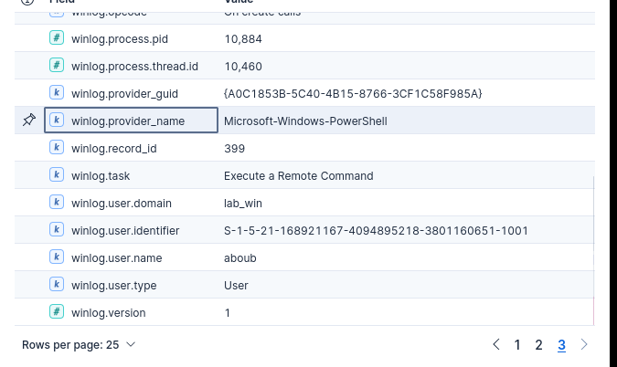

Alert Name: PowerShell Script Block Activity
Severity: Low
Status: Investigated
Time: Sep 15, 2026 at 01:06:20
Event ID: 4104
Action: Execute a Remote Command
Event Category: Process
Host: lab_win
Host IP: 192.168.75.136
Host MAC: 00-0C-29-13-15-9E
User: aboub
Process ID: 10884
Log Path/Channel: Microsoft-Windows-PowerShell/Operational
Provider: Microsoft-Windows-PowerShell
MITRE ATT&CK Tactic: Execution
MITRE ATT&CK Technique: PowerShell

I investigated PowerShell Event ID 4104 on my Windows VM. The event showed PowerShell activity from user aboub on lab_win. The action was Execute a Remote Command, and the activity was recorded in the Microsoft-Windows-PowerShell/Operational log. I confirmed that this activity came from my authorized home lab test.

Remediation:
No remediation was required because this was authorized lab activity. Continue monitoring PowerShell events for unexpected or suspicious commands.

