Ouedraogo Aboubacar Sidiki
Cybersecurity Home lab: Splunk

- Project Overview

I built this home lab to gain hands-on experience with Splunk SIEM, log monitoring, and security alert investigation. I created three virtual machines using VMware: Windows 11 Pro for the Splunk server, Ubuntu as the monitored endpoint, and Kali Linux to simulate security activity. The goal of this project is to generate security events, collect the logs in Splunk, and investigate suspicious activity

- Lab Environment

- Windows 11 VM: Splunk Enterprise server used to collect, search, and analyze logs.
- Ubuntu VM: Monitored endpoint running Splunk Universal Forwarder, Nginx, and SSH.
- Kali Linux VM: Used to simulate security activity such as Nmap scans, suspicious web requests, and SSH login attempts.

Screenshots:

- Kali Linux
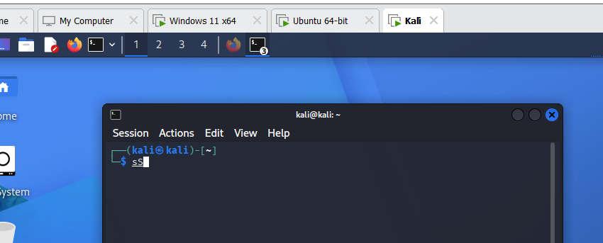

- Windows VM

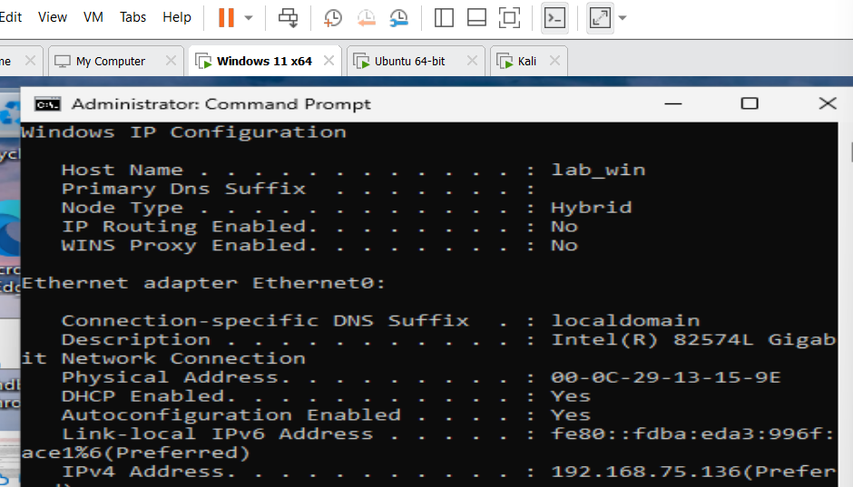

Ubuntu VM

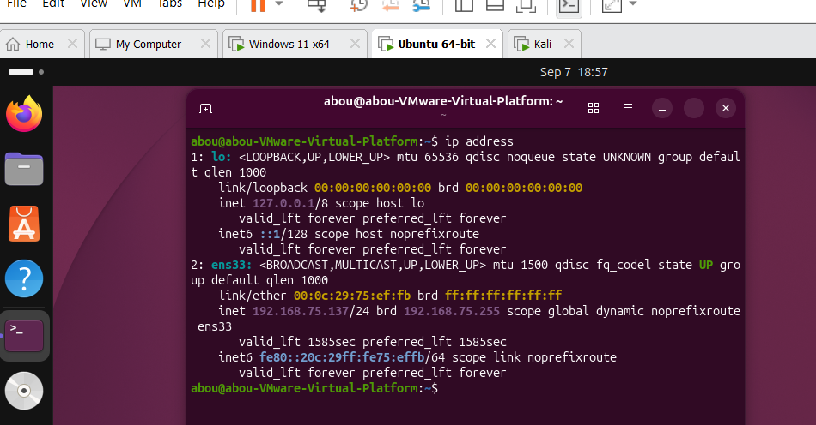

- Splunk Configuration

Configuring Splunk Receiving Port

I configured Splunk to listen on port 9997. This allows my Ubuntu machine to send security logs to the Splunk server on my Windows VM.

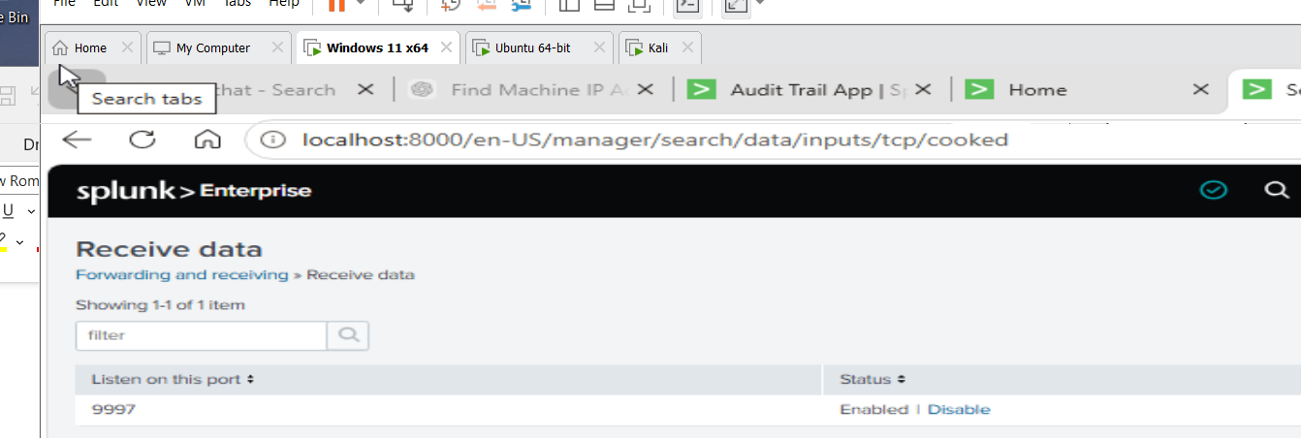

Downloading Splunk forwarding

I downloaded the Splunk Universal Forwarder on my Ubuntu VM. The forwarder will be used to collect logs from Ubuntu and send them to the Splunk Enterprise server running on my Windows VM.

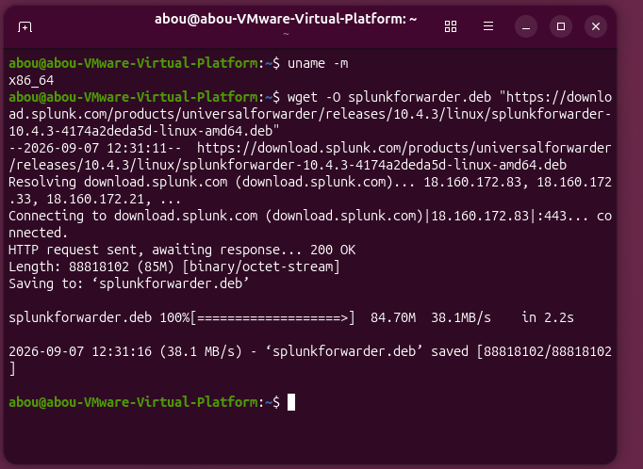

Installing Splunk Universal Forwarder

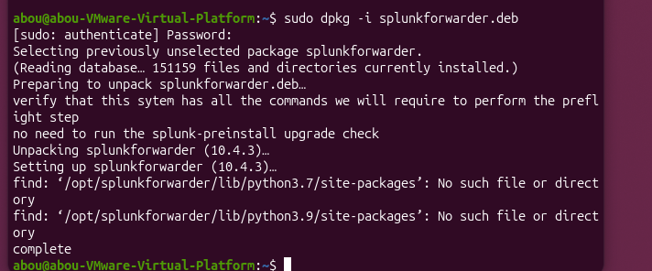

Starting Splunk Universal Forwarder
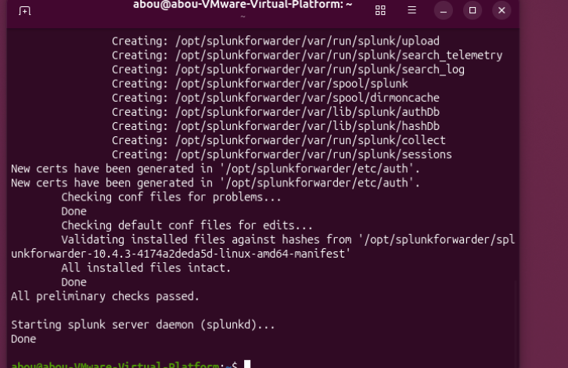

Connecting Ubuntu Forwarder to Windows Splunk

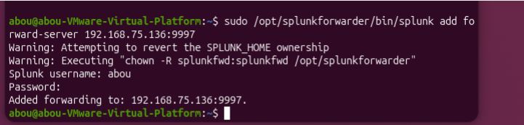

Verifying the Forwarder Connection

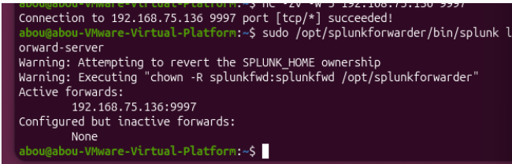

Configuring Ubuntu Log Monitoring

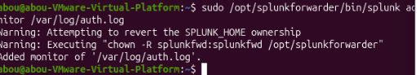

Configuring System Log Monitoring

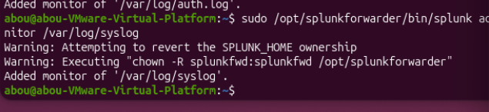

Verifying Logs in Splunk

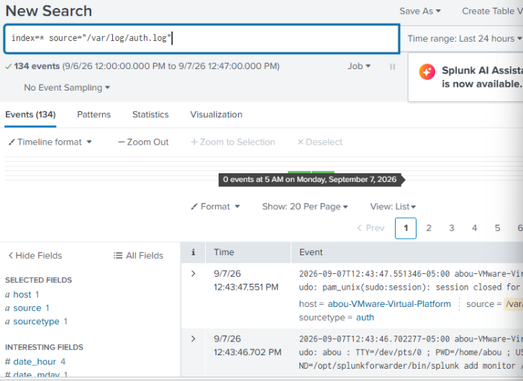

Attack Simulation and Detection

Simulation 1 Network Reconnaissance with Nmap

I used Kali Linux to simulate an attacker performing network reconnaissance against my Ubuntu VM. The goal was to identify open ports and running services before attempting further activity.

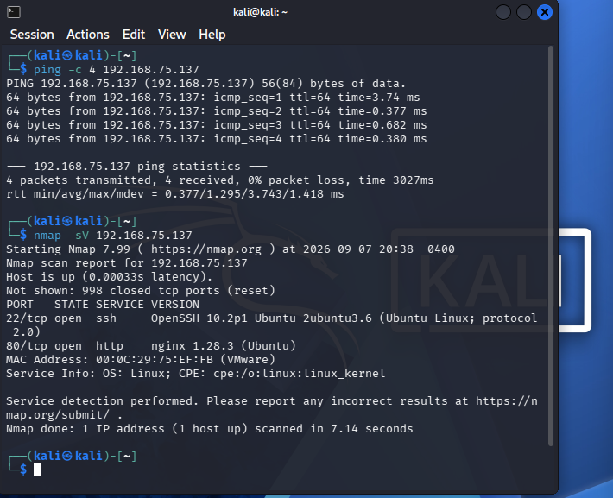

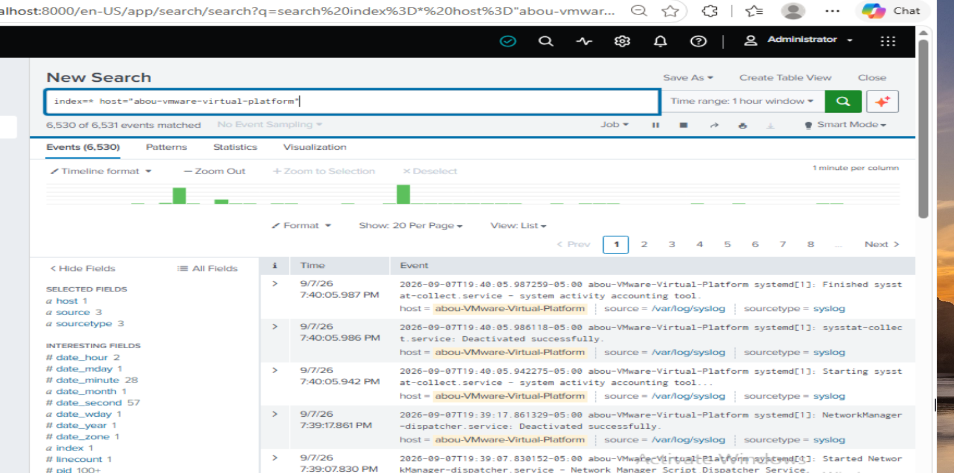

After running the Nmap scan from Kali Linux, I reviewed the Ubuntu events in Splunk. Splunk was successfully receiving system logs from the Ubuntu VM. However, the current log sources did not provide enough network-level information to clearly identify the Nmap port scan. This showed me the importance of collecting the right data sources for network attack detection.

Simulation 2 Suspicious Web Requests

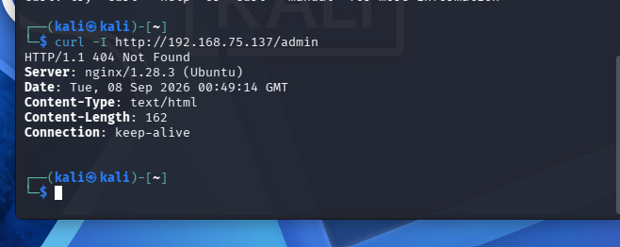

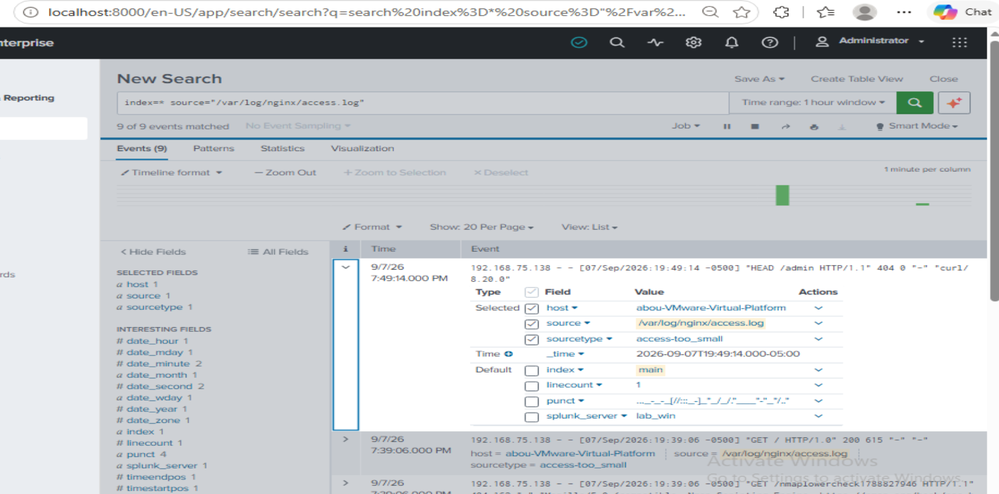

Splunk detected activity from the Kali machine at IP address 192.168.75.138. The logs show requests sent to the Ubuntu web server. This shows that Splunk is collecting and monitoring the Ubuntu logs correctly.”
Simulation 3

- Failed login
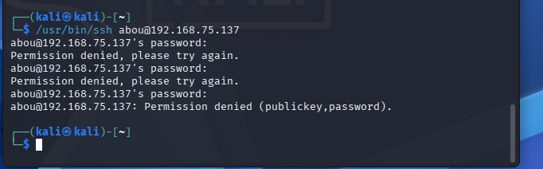

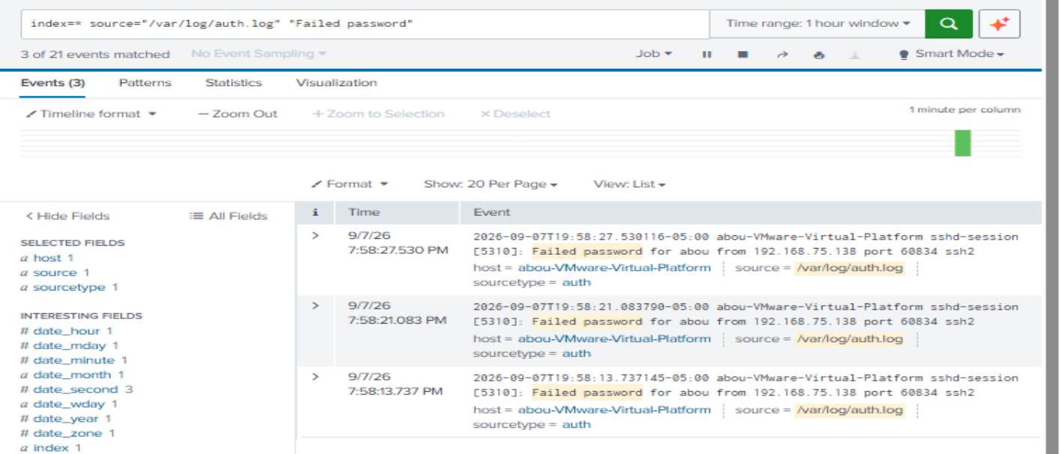

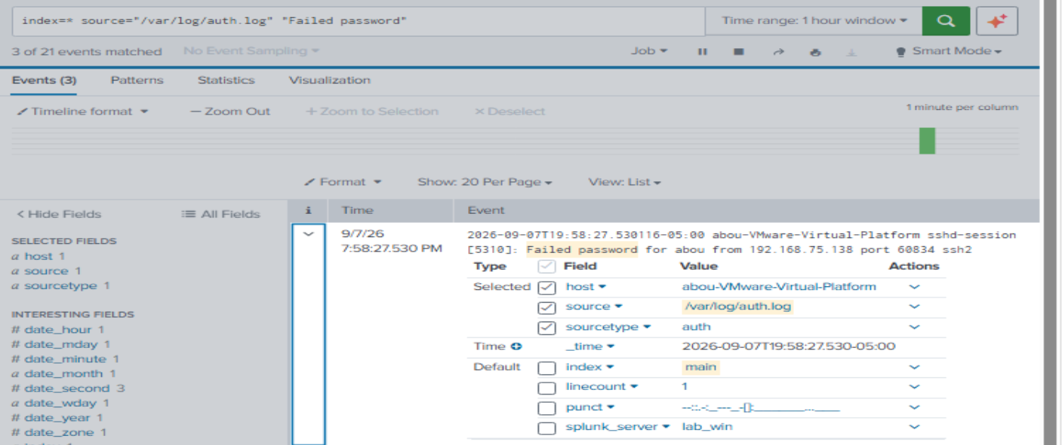
The failed SSH login attempts from the Kali machine were detected and recorded in Splunk.

success login

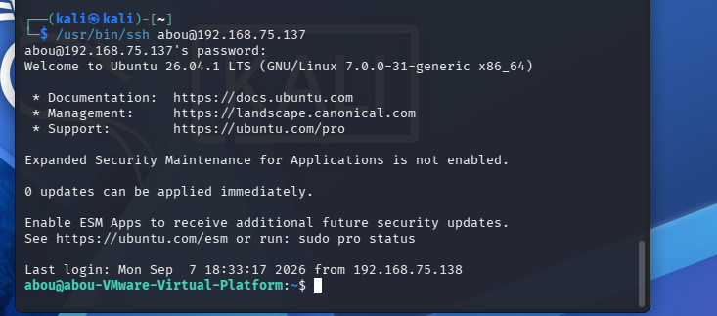

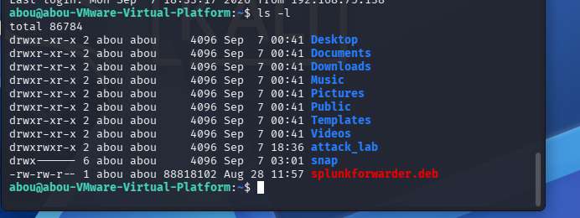

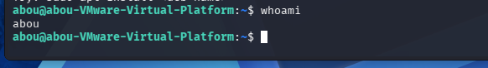

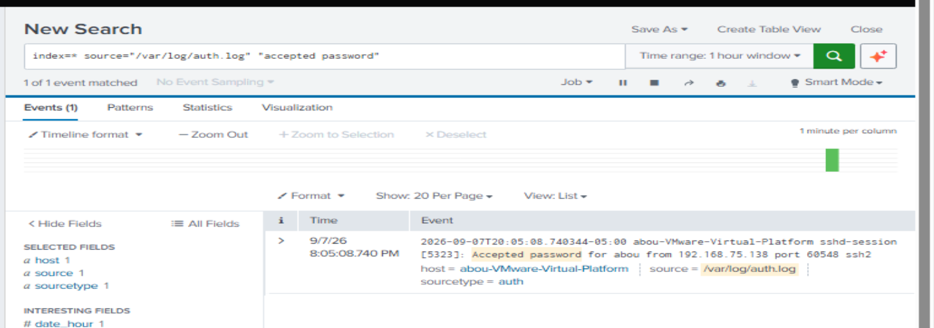

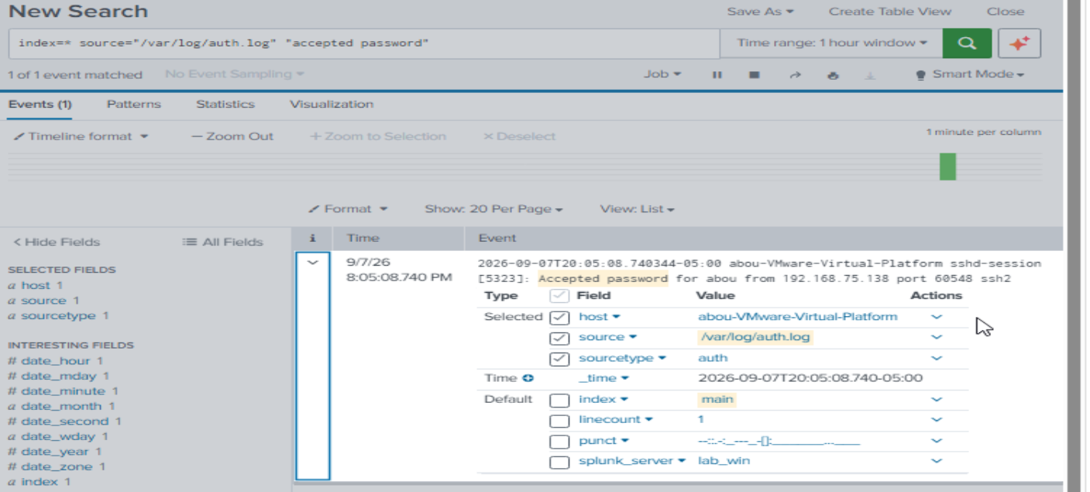

Splunk detected and recorded the successful SSH login from the Kali machine to the Ubuntu server.

Final Reflection:
This project helped me get hands-on experience with Splunk and understand how a SIEM works. I learned how to connect my Ubuntu VM to Splunk using the Universal Forwarder and collect logs for monitoring. I also used Kali Linux to simulate activities like Nmap scanning, suspicious web requests, and SSH login attempts.
Overall, this project helped me improve my skills in Splunk, log analysis, Linux, Nmap, SSH, and security monitoring. I learned how to search logs and investigate security events in Splunk. I also learned that having the right logs is important for detecting suspicious activity. I plan to continue improving this lab by creating alerts and security dashboards.

