SIEM-Based Brute Force Attack Detection Using Splunk

Introduction :-
In this project, a Security Information and Event Management (SIEM) solution was implemented using Splunk to monitor and detect potential brute-force attacks on a Windows system. The objective of the project is to analyze Windows Security Event Logs and identify suspicious login activities, particularly repeated failed login attempts that may indicate unauthorized access attempts.
Windows Event Logs, specifically Event ID 4625 (failed login) and Event ID 4624 (successful login), were collected and analyzed within Splunk. By leveraging Splunk’s powerful search and visualization capabilities, detection logic was developed to identify patterns associated with brute-force attacks, such as multiple failed login attempts within a short time frame.
Additionally, a real-time alerting mechanism was configured to automatically detect and notify when suspicious login behavior exceeds a defined threshold. A comprehensive dashboard was also created to visualize security events, including login trends, targeted accounts, and potential compromise indicators.
This project demonstrates the practical application of SIEM tools in cybersecurity operations, providing insights into threat detection, log analysis, and security monitoring workflows used by Security Operations Centers (SOC).

Figure 1: Raw Windows Security Logs Showing Failed Login Events (Event ID 4625)
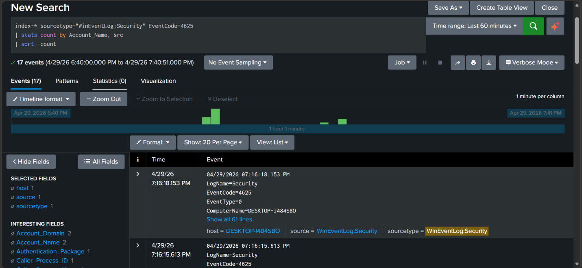
This figure displays raw Windows Security Event Logs ingested into Splunk, specifically focusing on Event ID 4625, which represents failed login attempts. The logs include important fields such as timestamp, host name, and source, allowing analysts to investigate authentication failures in detail.
These events are critical for detecting potential brute-force attacks, as repeated failed login attempts may indicate unauthorized access attempts.

Figure 2: Aggregated Failed Login Attempts by Account and Host
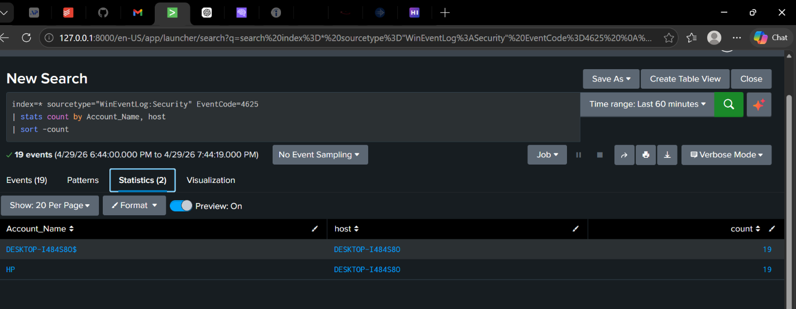
This figure shows the aggregation of failed login attempts using Splunk’s statistical query. The search groups events by account name and host, providing a summarized view of which user accounts are experiencing the highest number of failed login attempts.
This type of aggregation is essential in SOC environments, as it helps analysts quickly identify abnormal login behavior and prioritize accounts that may be under attack.

Figure 3: Correlation of Successful (4624) and Failed (4625) Login Events
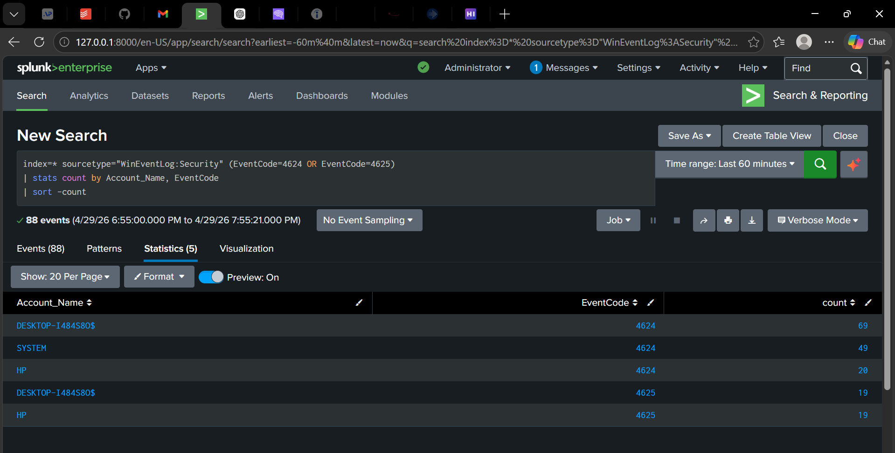
This figure presents a correlation between successful login events (Event ID 4624) and failed login events (Event ID 4625) grouped by account name. By analyzing both event types together, it becomes possible to identify accounts that experienced multiple failed login attempts followed by a successful login.
This correlation is critical in identifying brute-force attacks that result in successful authentication, which may indicate that an attacker has successfully guessed the user’s credentials.

Figure 4: Possible Compromised Accounts Based on Failed vs Successful Logins
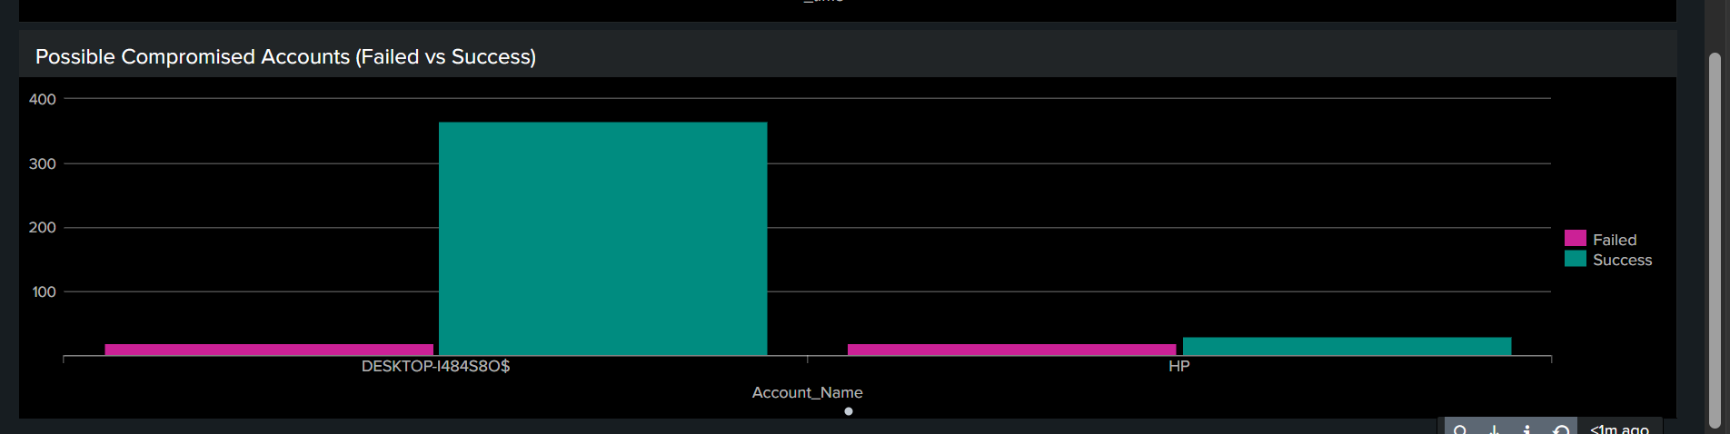
This figure visualizes the comparison between failed and successful login attempts for each account. By displaying both values together, it highlights accounts that have experienced multiple failed login attempts followed by successful logins, which may indicate potential compromise.
Accounts with a high number of failed attempts followed by successful logins are considered high-risk, as this pattern may indicate that an attacker successfully gained access after multiple login attempts.

Figure 5: Failed Login Attempts Over Time
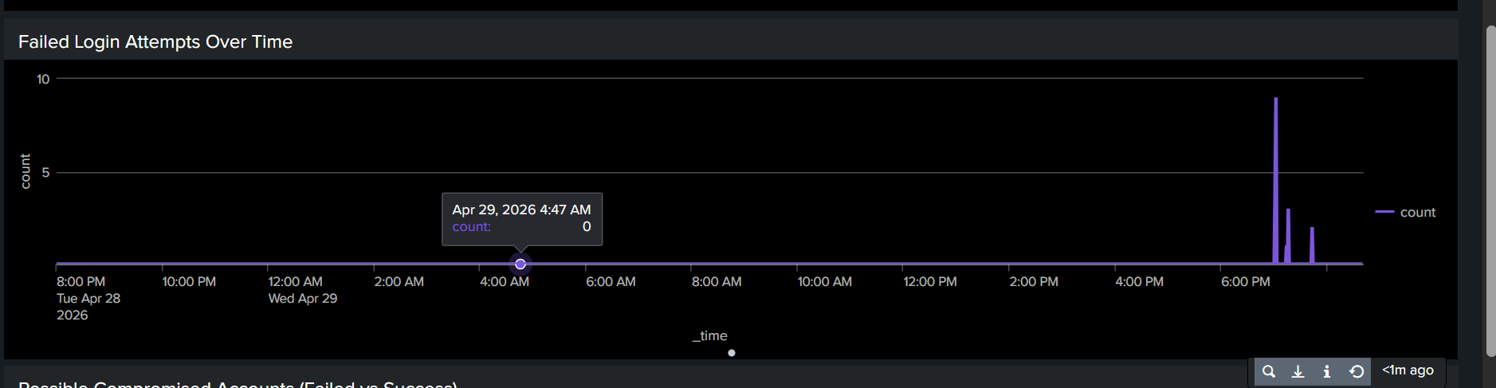
This figure shows the number of failed login attempts over time using a time-based visualization. It highlights patterns and spikes in authentication failures, allowing analysts to observe when suspicious activity occurs.
Sudden spikes in failed login attempts within a short period are strong indicators of brute-force attacks, enabling security analysts to quickly identify and respond to potential threats.

Figure 6: SOC Brute Force Monitoring Dashboard Overview
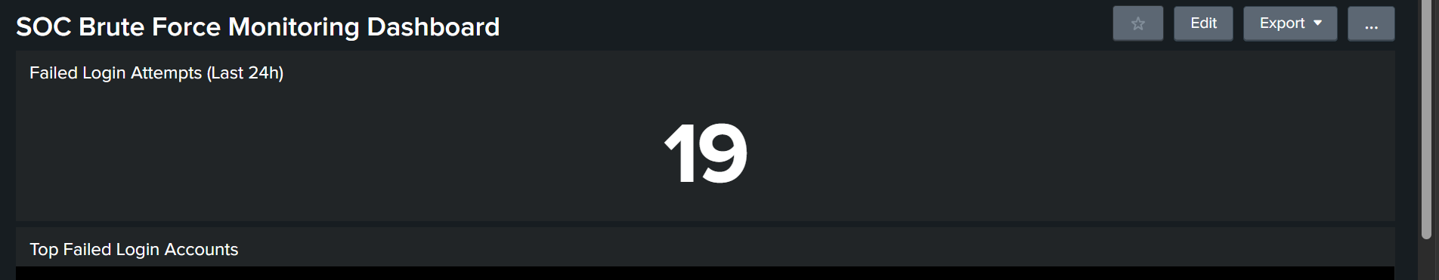
This figure shows the main SOC dashboard created in Splunk to monitor brute-force login activity. It provides a high-level summary of failed login attempts within the last 24 hours, allowing analysts to quickly assess the security status of the system.
Dashboards are essential in SOC environments as they provide real-time visibility into security events, enabling faster detection and response to potential threats.

Figure 7: Top Failed Login Accounts
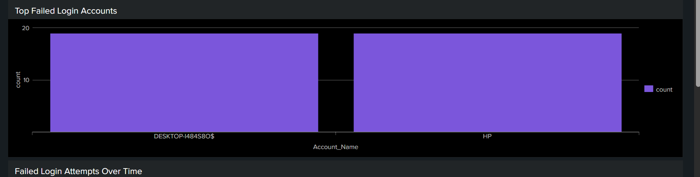
This figure displays a bar chart of user accounts with the highest number of failed login attempts. It highlights which accounts are being targeted the most, allowing security analysts to quickly identify potential attack targets.
Accounts with a high number of failed login attempts are considered high-risk and may be targeted by attackers attempting to gain unauthorized access.

Figure 8: Top Source Hosts for Failed Login Attempts
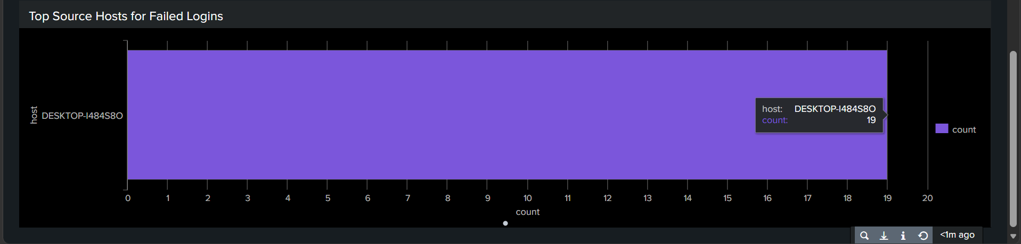
This figure shows the source hosts responsible for generating failed login attempts. It identifies the system or host from which the authentication failures originated, providing insight into the source of suspicious activity.
Monitoring the source of failed login attempts is essential for identifying whether the attack originates from within the network or from an external attacker.

Figure 9: Failed Login Attempts by Account and Source Network Address
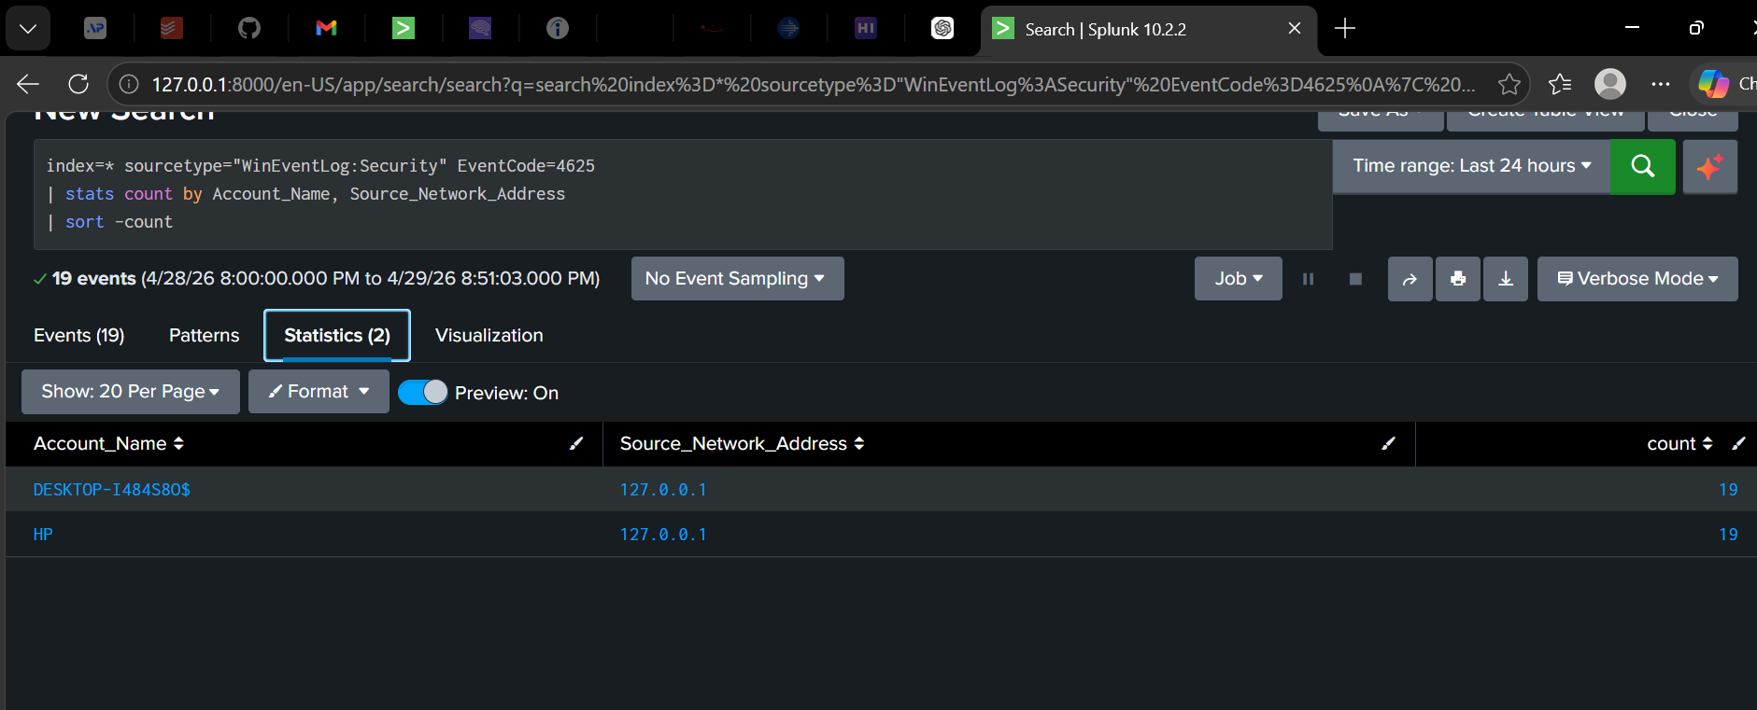
This figure shows failed login attempts grouped by both account name and source network address. It provides a detailed view of which accounts are being targeted and from which IP address the login attempts are originating. In this project, the source IP address (127.0.0.1) indicates that the attack was simulated locally within a controlled testing environment.

Figure 10: Brute Force Detection Alert Configuration in Splunk
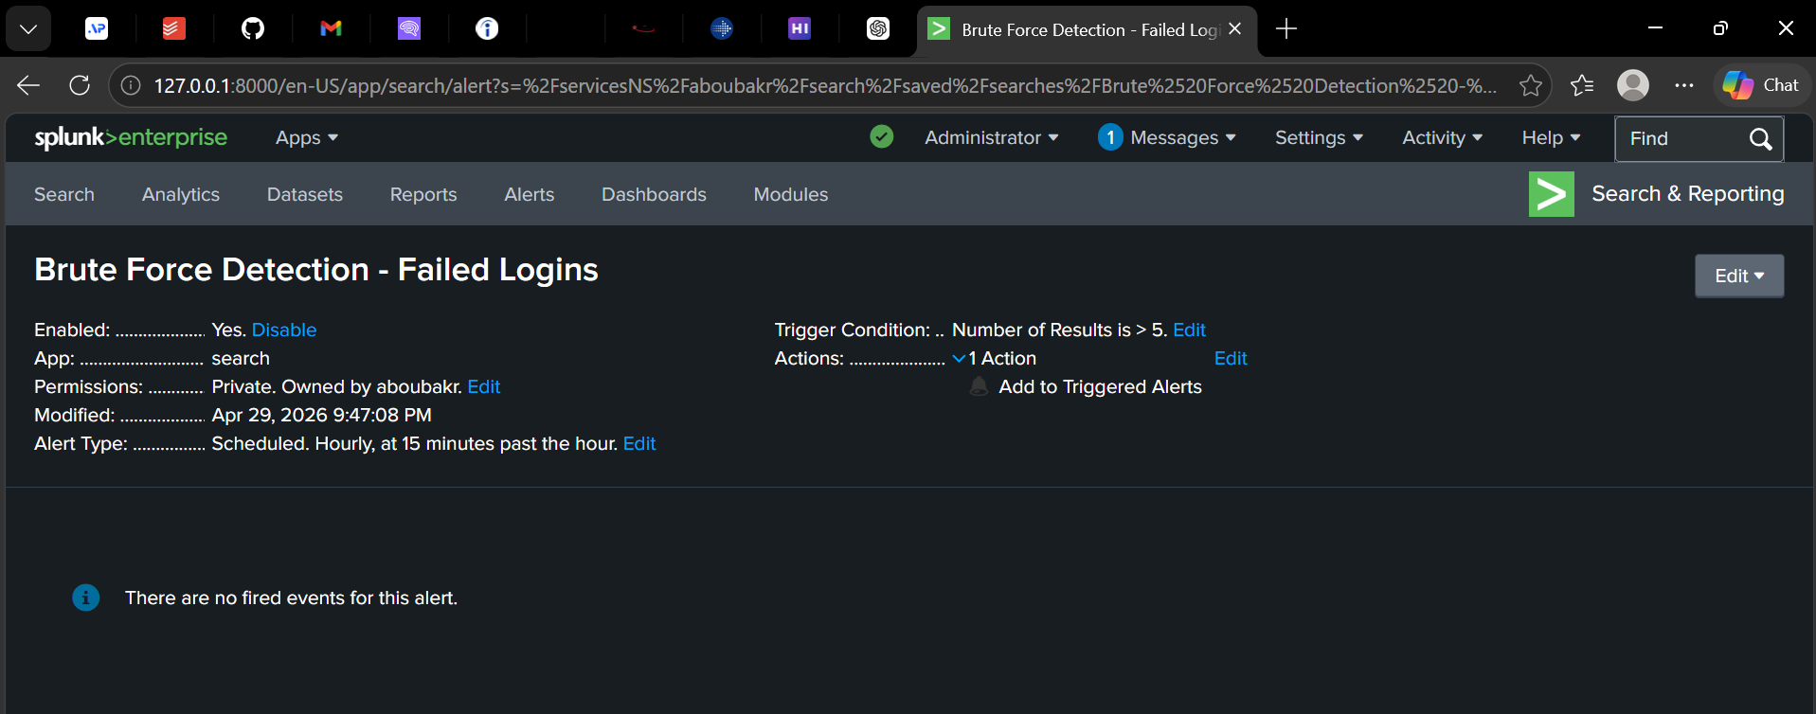
This figure shows the configuration of a scheduled alert in Splunk designed to detect brute-force login attempts. The alert is triggered when the number of failed login events exceeds a defined threshold (greater than 5). It is scheduled to run every hour at 15 minutes past the hour, ensuring continuous monitoring of suspicious authentication activity.
The alert has not been triggered yet because it runs on a scheduled interval and requires the defined threshold to be met within the evaluation period.
Threshold-based alerting helps reduce false positives by distinguishing normal user behavior from potential brute-force attacks, allowing SOC analysts to focus on high-risk events.

