Executive Summary

1--Windows Event Logs provide critical visibility into system activity and are widely used by Security Operations Center (SOC) analysts to investigate potential security incidents. During routine log review, PowerShell activity was identified within the Microsoft-Windows-PowerShell/Operational event log channel. PowerShell logging can reveal detailed information about commands executed on a system and is therefore a valuable source of forensic evidence.

Initial analysis identified Event ID 4103 as the earliest recorded PowerShell operational event. Further investigation focused on Event ID 4104, which captures PowerShell script block execution and can expose the commands executed during a PowerShell session.

Filtering the operational log revealed that the second command executed during the session was whoami, a command commonly used to identify the currently logged-in user and associated privileges. The event metadata categorized the action under “Execute a Remote Command.”

While the command itself is not inherently malicious, enumeration commands such as whoami frequently appear during the early reconnaissance phase of cyber attacks. The presence of this command within a remotely executed PowerShell context increases the relevance of the activity from a security perspective.

This investigation demonstrates how Windows event log analysis can help analysts reconstruct system activity, identify potentially suspicious commands, and determine whether activity should be escalated for further validation.

Alert Details

Alert Name: Suspicious PowerShell Activity Detected
Severity: Medium
Log Source: Microsoft-Windows-PowerShell/Operational
Analysis Tool: Windows Event Viewer

Relevant Event IDs
Event ID Description
4103 PowerShell pipeline execution
4104 PowerShell script block logging
800 Windows PowerShell operational event

The investigation focused primarily on Event ID 4103 and Event ID 4104, which provide visibility into PowerShell execution activity.

Script block logging (Event ID 4104) is particularly valuable because it can expose the exact commands executed within a PowerShell session. Such telemetry is often used by SOC analysts to identify malicious command execution or suspicious administrative behavior.

The investigation was triggered after reviewing PowerShell operational logs and identifying command execution activity associated with remote PowerShell operations.

Investigation Process

The investigation followed a structured log analysis methodology using Windows Event Viewer to examine PowerShell operational logs.

Identifying Relevant Log Sources

The Microsoft-Windows-PowerShell/Operational log channel was selected as the primary investigation source because it records detailed information about PowerShell activity, including executed commands, script block events, and pipeline execution.

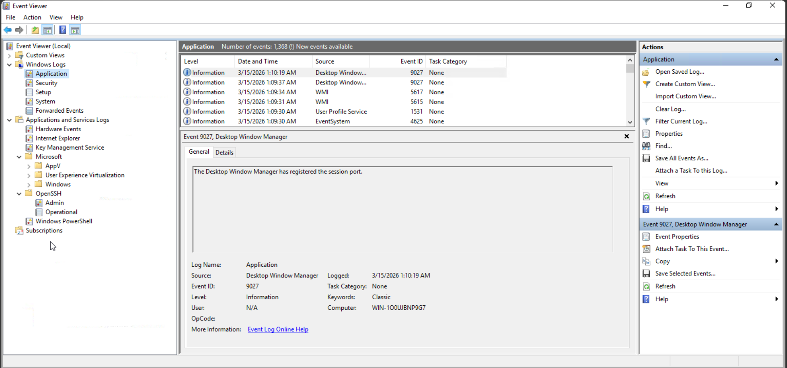
Figure 1 — Navigating to the Microsoft-Windows-PowerShell/Operational log channel in Windows Event Viewer to analyze PowerShell activity.

PowerShell operational logs are particularly valuable for incident investigations because they allow analysts to reconstruct command execution behavior.

Reviewing Initial Events

The event log dataset was reviewed to identify the earliest relevant PowerShell activity. The earliest non-warning event recorded in the dataset was Event ID 4103, indicating PowerShell pipeline execution activity.

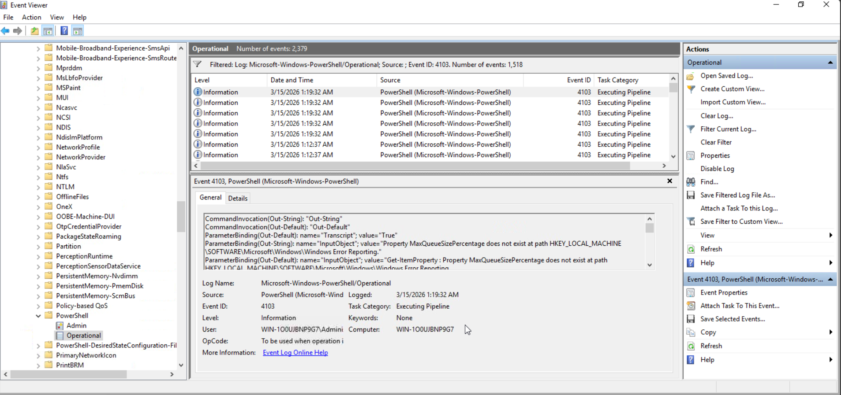
Figure 2 — PowerShell Operational log entry (Event ID 4103) indicating pipeline execution activity during a PowerShell session.
This confirmed that a PowerShell session had been initiated and was actively executing commands.

Filtering Script Block Events

To identify the commands executed during the session, the event log was filtered using Event ID 4104.

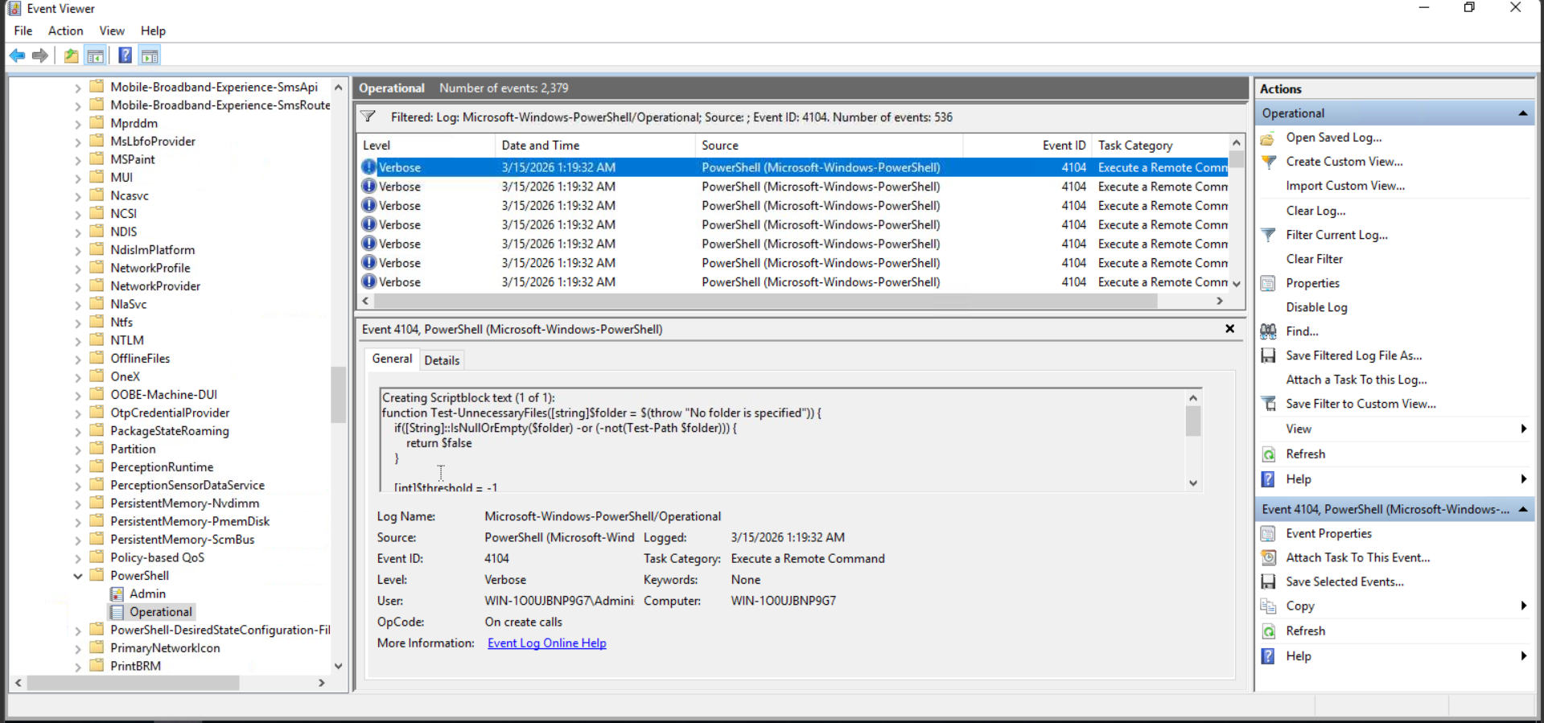
Figure 3 — Event Viewer filtered to display PowerShell Script Block logging events (Event ID 4104), which reveal commands executed during a PowerShell session.

Event ID 4104 records script block activity and can reveal commands executed during PowerShell sessions. Filtering these events revealed that the second command executed during the session was whoami.
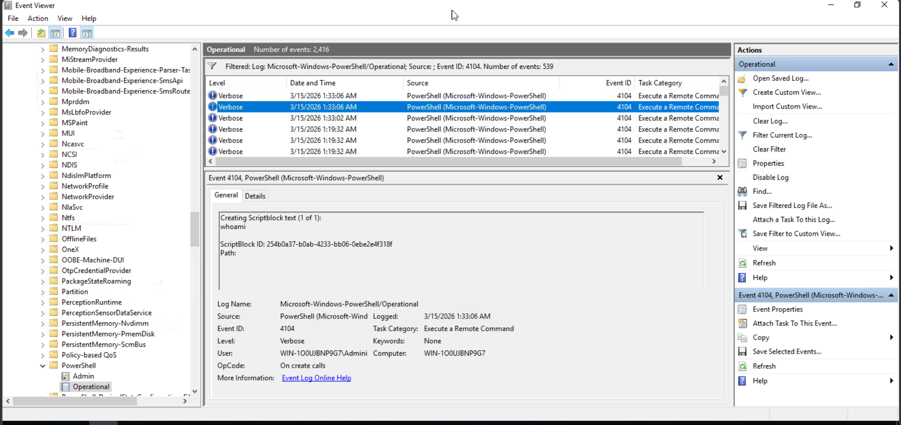
Figure 4 — PowerShell Script Block logging event (Event ID 4104) revealing execution of the whoami command during the PowerShell session.

As shown in Figure 4, the event metadata lists the task category as “Execute a Remote Command,” indicating that the command execution occurred within a remote PowerShell context.
Evaluating Command Context

The whoami command is commonly used to determine:

The identity of the current user

The privileges associated with the user account

The security context under which commands are executed

In security investigations, enumeration commands such as whoami frequently appear when attackers attempt to verify their access level after gaining initial system access.

Reviewing Task Category

The event metadata identified the Task Category as:

Execute a Remote Command

This classification indicates that the command may have been executed through a remote PowerShell session or remote administrative interface.

Because remote PowerShell functionality is frequently used by both system administrators and attackers, the context surrounding this activity must be carefully analyzed.

Evidence Collected

The following artifacts were identified during the investigation.

Evidence 1 — PowerShell Pipeline Execution

Event ID: 4103
Log Source: Microsoft-Windows-PowerShell/Operational

This event represents the earliest non-warning PowerShell operational event recorded in the log dataset.

Event ID 4103 indicates that PowerShell pipeline execution activity occurred, confirming that a PowerShell session was active on the system.

Evidence 2 — Script Block Execution

Event ID: 4104
Task Category: Execute a Remote Command

Script block logging events revealed commands executed during the PowerShell session.

Evidence 3 — Sample Log Entry

Example log artifact observed during analysis:

Event ID: 4104
Log Source: Microsoft-Windows-PowerShell/Operational
ScriptBlockText: whoami
Task Category: Execute a Remote Command
Computer: WIN-SOC01
User: Administrator

This log entry indicates that the whoami command was executed during a PowerShell session categorized as a remote command execution event.

Evidence 4 — Additional PowerShell Log Reference

Event ID: 800
Log Source: Windows PowerShell Log

This event suggests that additional PowerShell activity may be recorded in other PowerShell log channels. In real SOC investigations, analysts typically correlate multiple log sources to gain a complete view of system activity.

Timeline Analysis

The following timeline reconstructs the sequence of activity based on the available event log data.

Time Event
10:15 PowerShell session initiated
10:16 Script block execution detected
10:16 whoami command executed
10:17 Remote command execution recorded
Timeline Interpretation

The reconstructed timeline indicates that a PowerShell session was initiated and commands were executed shortly afterward. The execution of whoami suggests that the user or operator attempted to verify the active user context and privilege level.

This behavior can be consistent with legitimate administrative activity, but it also aligns with common reconnaissance techniques used by attackers following initial system access.

Conclusion

Analysis of Windows PowerShell operational logs revealed command execution activity associated with Event ID 4103 and Event ID 4104. Script block logging provided visibility into commands executed during the PowerShell session, allowing investigators to identify the whoami command as part of the activity.

The event metadata indicated that the command execution occurred under the “Execute a Remote Command” task category, suggesting that the activity may have originated from a remote PowerShell session.

While the command itself is not malicious, the presence of enumeration activity within a remotely executed PowerShell context raises potential security concerns.

Final Assessment

Based on the available evidence, the activity is classified as:

Suspicious Activity – Requires Further Validation

Enumeration commands such as whoami may be executed during legitimate administrative operations. However, similar commands are also frequently used by attackers during reconnaissance phases following system compromise.

Further investigation would normally involve correlating this activity with additional log sources such as authentication logs, process creation logs, and network telemetry to determine whether the activity was authorized.

Recommendations
Enable Advanced PowerShell Logging

Organizations should enable advanced PowerShell logging features including:

Script Block Logging

Module Logging

PowerShell Transcription

These logging capabilities provide valuable visibility into PowerShell command execution.

Monitor Enumeration Commands

Security monitoring systems should detect and review command sequences involving common enumeration commands such as:

whoami

hostname

ipconfig

net user

Get-LocalUser

Such commands often appear during attacker reconnaissance activity.

Monitor Remote PowerShell Activity

Remote PowerShell execution should be carefully monitored, especially when associated with privileged accounts or unusual hosts.

Unexpected remote command execution events may indicate unauthorized access or lateral movement attempts.

Correlate Multiple Log Sources

SOC analysts should correlate PowerShell activity with additional telemetry sources including:

Windows Security logs

Process creation events (Event ID 4688)

Network connection logs

SIEM alerts

Correlation of multiple data sources improves detection accuracy and investigation capability.

