Active Directory Compromise Investigation

(Initial Access & Domain Enumeration)

Executive Summary
This project presents a SOC-style investigation into a potential compromise of an Active Directory (AD) environment. The focus was on identifying how an attacker could obtain initial access using credential-based attacks and how that access could be leveraged to enumerate the domain.
The investigation demonstrates that even low-privileged credentials can expose critical information about users, groups, and systems, enabling further attack progression.

Scenario
Suspicious authentication activity was observed within a Windows domain environment. The objective of this investigation was to:
- Identify possible initial access vectors
- Analyze authentication mechanisms that could be abused
- Determine what information an attacker could gather after access

Investigation

1️- Initial Access: Credential Acquisition
The investigation identified several realistic methods for obtaining valid AD credentials:
- OSINT Exposure
Credentials may be leaked through public platforms such as GitHub, forums, or previous data breaches
- Phishing Attacks
Users may unknowingly submit credentials or execute malicious payloads, allowing attackers to gain access
- Exposed Services
Services such as RDP, VPN, and web applications may allow attackers to attempt authentication
📌 Even low-privileged accounts were sufficient to authenticate to the domain.
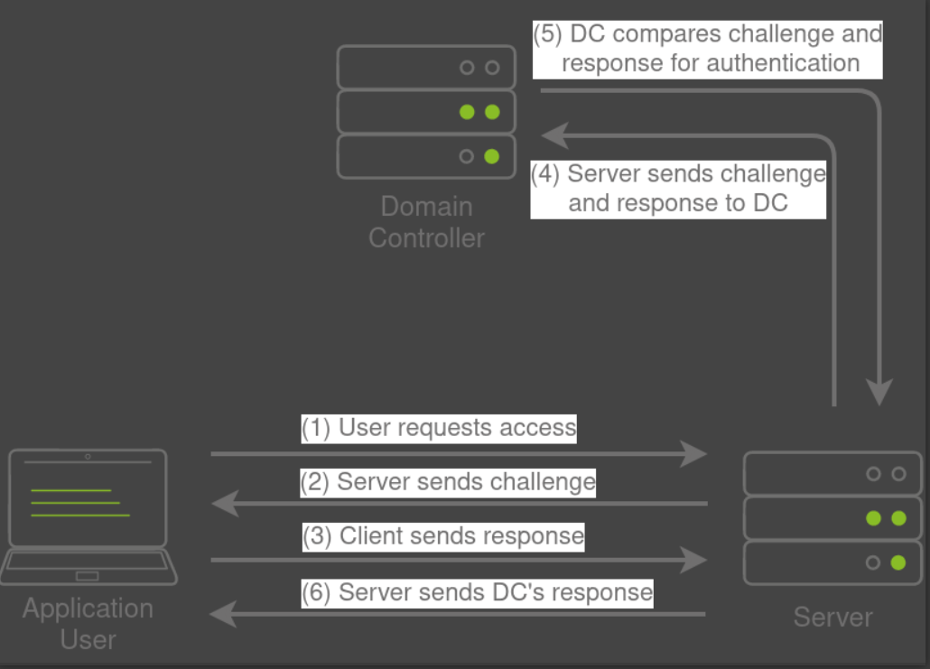

2️-Authentication Analysis

🔹 NTLM / NetNTLM Authentication
- Uses a challenge-response mechanism
- Authentication is handled via the Domain Controller
- Common in enterprise services
Risk:
Authentication traffic can be intercepted and abused.

🔹 LDAP Authentication
- Used by third-party applications
- Directly validates user credentials against AD
Risk:
Service accounts may expose credentials if compromised.
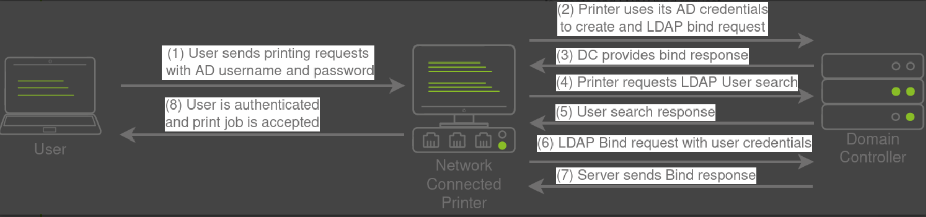

3️-Network-Based Attacks
The investigation explored how attackers can exploit network protocols:
- SMB Authentication Weaknesses
Widely used protocol with legacy vulnerabilities
- LLMNR / NBT-NS / WPAD Poisoning
Attackers can intercept broadcast requests and impersonate services
- Credential Capture & Relay
Authentication can be captured or relayed to gain unauthorized access
Result:
Attackers can obtain authentication hashes or active sessions.
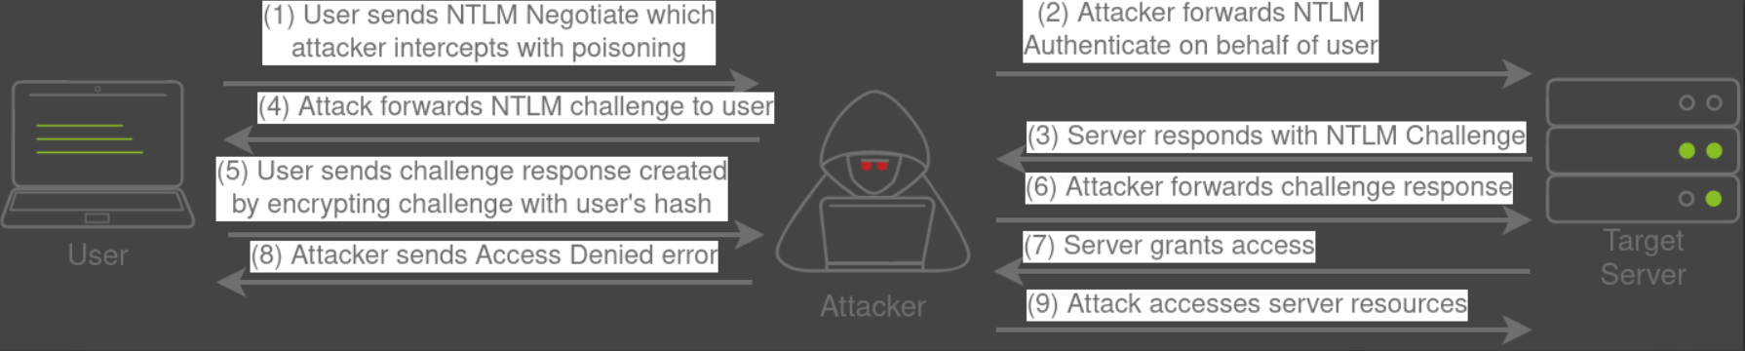

4️- Active Directory Enumeration
After gaining access, the attacker performed enumeration using built-in tools.

🔹 Domain Structure
- Identified domain and Organizational Units (OUs)
- Mapped departments and structure

🔹 User Enumeration
- Identified domain users
- Analyzed group memberships

🔹 Group Analysis
- Determined access levels through group assignments

🔹 Host Discovery
- Identified domain-joined systems (servers and workstations)
Impact:
This information allows attackers to plan privilege escalation and lateral movement.
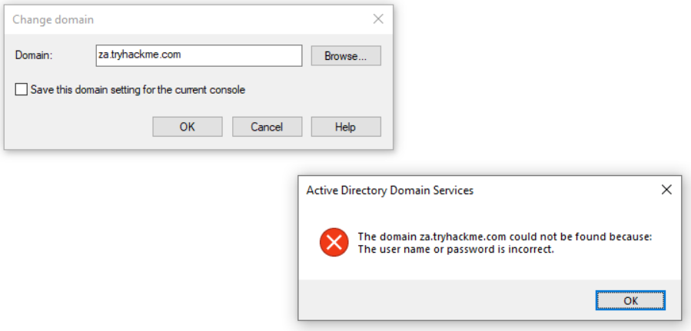
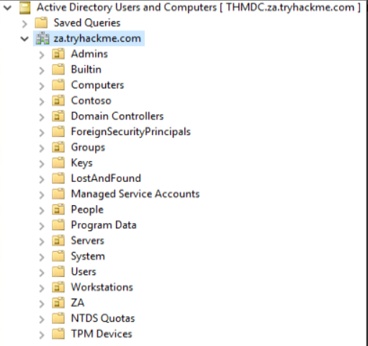

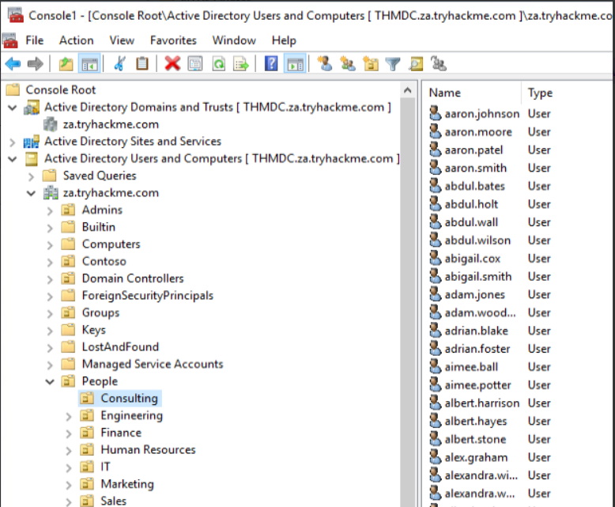

Findings
- Multiple attack vectors for credential compromise
- Weak authentication mechanisms increase exposure
- Network protocols allow credential interception
- AD structure is easily discoverable with low privileges

Assessment
The environment is vulnerable to credential-based attacks and unauthorized enumeration.
Initial access combined with visibility into AD significantly increases the risk of further compromise.

Severity: HIGH
- AD controls identity and access across the environment
- Credential compromise can lead to domain-wide impact
- Enumeration enables attackers to identify critical targets

SOC Analyst Actions

Immediate
- Reset potentially compromised credentials
- Enforce Multi-Factor Authentication (MFA)

Hardening
- Disable LLMNR and NBT-NS
- Enforce SMB signing
- Secure LDAP communications

Monitoring
- Detect abnormal authentication patterns
- Monitor enumeration behavior
- Alert on suspicious network activity

Key Takeaways
- Initial access often begins with credential compromise
- Even low-privileged accounts pose a significant risk
- Enumeration is a critical phase in attacker progression
- Strong authentication and monitoring are essential

