

*Report about ICT and Technologies*

Content Table :

❖ Understanding Information and Communications Technology (ICT) 2

➢ Definition and Scope: 2

➢ Evolution of ICT: 3

➢ Skills Framework for ICT Professionals: 3

❖ Technological Advancements in ICT 3

➢ Storage and Retrieval Capabilities: 3

➢ Communication Tools and Resources: 5

➢ Integration of ICT in Education: 5

❖ ICT Statistic Data and Surveys: 6

➢ Usage in Entreprises and Households: 6

➢ Digital Economy and Society Statistics: 7

➢ EU Survey on ICT Usage : 7

▪ Enterprises conducting remote meeting via the internet 2022: 7

❖ Examples of ICT tools: 7

➢ Google Services: 8

➢ Microsoft office: 8

➢ Git/GitHub: 8

➢ Other Tools: 9

➢ Stats about the market share in productive ICT tools: 9

❖ Conclusion: 9

# *Understanding Information and Communications Technology (ICT)*

Information and Communications Technology (ICT) is a fascinating field that encompasses various technological tools and resources used for handling information and aiding communication.

With its wide-ranging applications, ICT has become an integral part of our daily lives. In this report, we will explore the definition and scope of ICT, its evolution over the years, and the skills framework for ICT professionals.

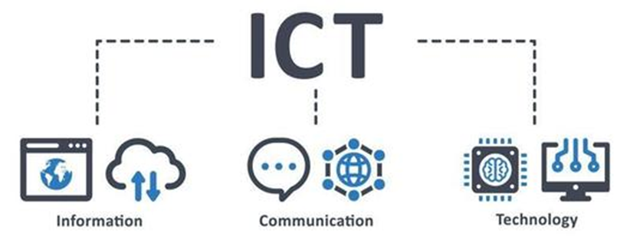

## Definition and Scope:

ICT is an umbrella term that includes information technology (IT) and emphasizes the integration of unified communications and the combination of telecommunications and computers. It also encompasses enterprise software, middleware, storage, and audiovisual systems that enable users to store, access, transmit, understand, and manipulate information.

Additionally, ICT involves the convergence of audiovisuals, telephone networks, and computer networks through a single cabling or link system.

This includes various communication devices such as radios, televisions, cell phones, computers, and network hardware. ICT even covers services and appliances like video conferencing and distance learning.

It is important to note that ICT encompasses both digital and analog technologies and any mode of communication transmission.

## Evolution of ICT:

ICT is a broad and ever-evolving field. It includes any product or technology that allows for the storage, manipulation, retrieval, transmission, or reception of information electronically in a digital format.

This ranges from personal computers and smartphones to digital television and email. The Skills Framework for the Information Age is one of many models used to describe and manage competencies for ICT professionals in the 21st century.

As technology continues to advance, ICT concepts and applications will continue to evolve, shaping the way we communicate and interact with information.

## Skills Framework for ICT Professionals:

The Skills Framework for the Information Age is a comprehensive model used to describe and manage competencies for ICT professionals in the modern era. This framework helps professionals develop and evaluate their skills and knowledge in various areas of ICT.

It covers a wide range of competencies, including technical skills in areas such as programming, database management, and networking, as well as non-technical skills like project management, communication, and problem-solving.

The Skills Framework serves as a valuable resource for individuals looking to enter the ICT field or enhance their existing skills.

# *Technological Advancements in ICT:*

Over the years, ICT has witnessed remarkable technological advancements, revolutionizing the way we store, retrieve, and communicate information. In this section, we will explore some of these advancements and their impact on our lives.

## Storage and Retrieval Capabilities:

One of the significant advancements in ICT is the improvement in storage and retrieval capabilities.

From early magnetic tapes and floppy disks to modern solid-state drives and cloud storage, ICT has made it easier than ever to store and access vast amounts of information.

With the exponential growth of data, these advancements have been crucial in enabling businesses, organizations, and individuals to manage and process data efficiently.

Today, we can store and retrieve data quickly, securely, and in real-time, leading to enhanced productivity and seamless information management.

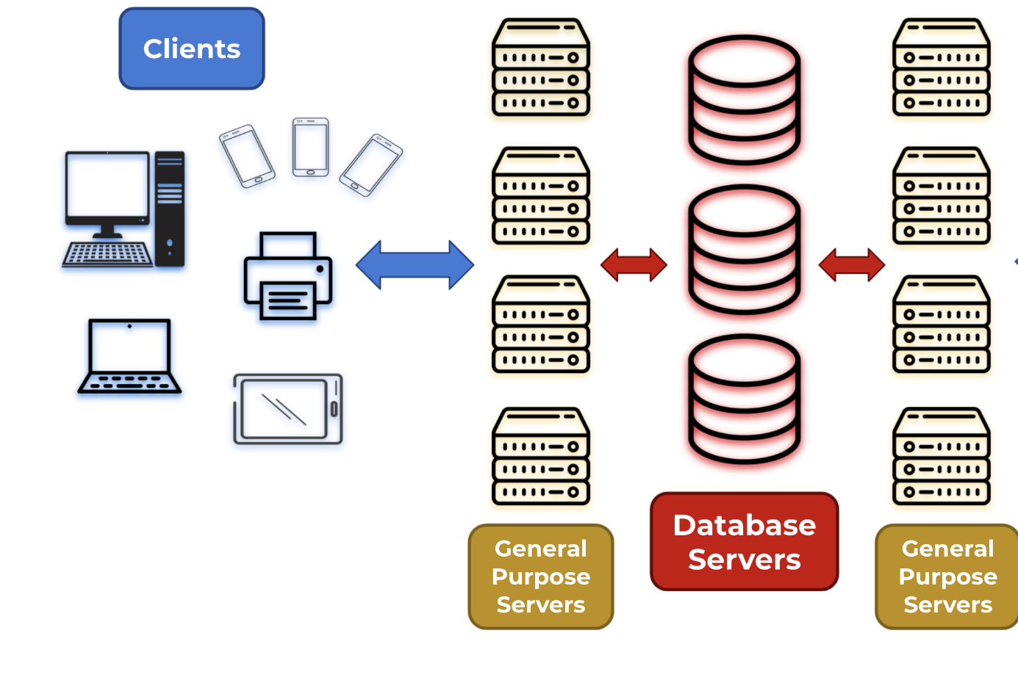

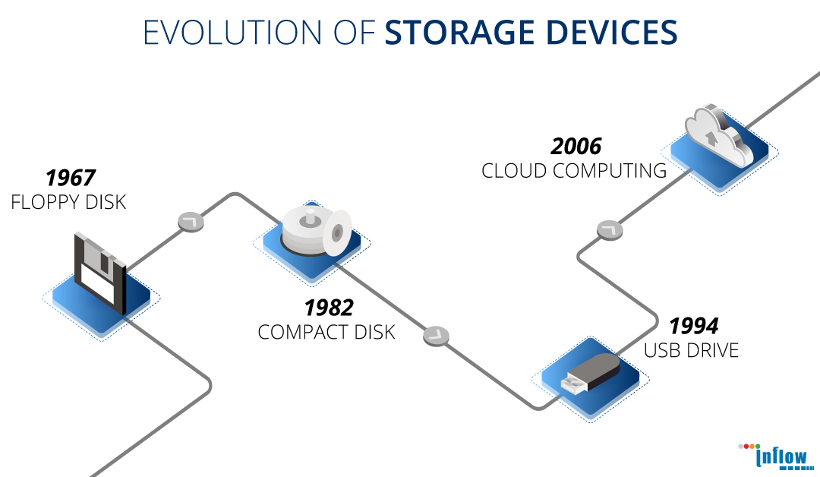

## Communication Tools and Resources:

ICT has transformed the way we communicate and interact with others. With the advent of the internet, email, and instant messaging applications, communication has become instantaneous and convenient.

Social media platforms enable us to connect with friends and family across the globe, while video conferencing tools allow for face-to-face communication even when we are physically apart.

Furthermore, telephony technologies have evolved, with mobile phones becoming an indispensable part of our lives.

The ability to communicate effortlessly and efficiently has brought people closer, breaking down barriers of distance and time.

## Integration of ICT in Education:

The integration of ICT in education has revolutionized the learning landscape.

With the use of computers, the internet, and various educational software, students can access a wealth of information, collaborate with peers, and engage in interactive learning experiences.

The use of ICT in classrooms has transformed traditional teaching methods, making learning more engaging and interactive.

Students now have access to a vast array of resources and tools, enabling them to develop digital literacy skills essential for life in a technology-driven world. Moreover, ICT allows for distance learning, making education accessible to individuals who may not have access to traditional educational institutions.

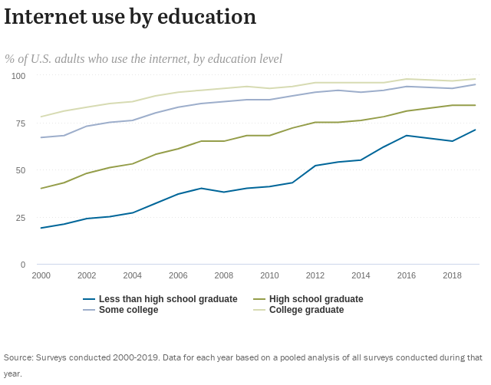

# *ICT Statistic Data and Surveys:*

To understand the impact of ICT, it is essential to explore relevant statistical data and surveys. In this section, we will delve into some key findings and insights from surveys conducted on ICT usage.

## Usage in Enterprises and Households:

Surveys on ICT usage in enterprises and households provide valuable insights into the adoption and utilization of ICT tools and services. These surveys help identify trends, challenges, and opportunities in the ICT landscape.

They shed light on the integration of ICT in various industries and the impact it has on productivity, efficiency, and innovation.

Moreover, surveys on ICT usage in households reveal the penetration of technology in everyday life, highlighting the extent to which individuals rely on ICT for communication, entertainment, and information retrieval.

## Digital Economy and Society Statistics:

Digital economy and society statistics encompass a wide range of data related to ICT. These statistics provide an understanding of the impact of ICT on economic growth, employment, and social development.

They analyze various indicators, such as the contribution of the digital sector to the gross domestic product (GDP), e-commerce trends, and the digital divide among different segments of society.

By examining these statistics, policymakers and stakeholders gain insights into the current state of the digital economy and society, enabling them to make informed decisions and promote inclusive growth.

## EU Survey on ICT Usage :

The European Union (EU) conducts surveys on ICT usage to gather comprehensive data on the adoption and usage of ICT tools and services.

These surveys provide valuable information on the digital transformation of businesses, the integration of ICT in education, and the digital skills of individuals. By examining the results of these surveys, policymakers and organizations can identify areas that require further investment and support to strengthen the digital infrastructure, promote digital literacy, and harness the potential of ICT for economic and social progress.

### Enterprises conducting remote meeting via the internet 2022:

|  |  |
| --- | --- |
| Countries | Percentage (%) |
| Sweden | 89.4 |
| Norway | 77.0 |
| France | 43.9 |
| Bulgaria | 28.2 |
| Denmark | 78.5 |
| Italy | 44.3 |
| Germany | 60.5 |

# *Examples of ICT tools:*

ICT has become an essential aspect of contemporary society, incorporating various technological advancements that impact our professional lives, communication methods, and ability to retrieve information. Notable instances of ICT tools, like Google services and Microsoft Office, have revolutionized efficiency, cooperation, and resource accessibility in the era of digital innovation.

## Google Services:

Google Services have transformed the approach of individuals and organizations in managing their digital lives. These services, such as Gmail, Google Drive, Google Docs, and Google Calendar, provide convenient and efficient solutions. Gmail offers a robust and feature-rich email platform with ample storage and organizational tools. Google Drive offers cloud-based storage and enables easy sharing of files. Additionally, Google Docs, an integral part of Google Drive, facilitates collaborative document creation and editing, enhancing teamwork and document management. Furthermore, Google Calendar simplifies scheduling and time management by streamlining personal and professional agendas.



## Microsoft office:

fundamental aspect of digital efficiency for many years. Word is a flexible tool for processing words, allowing the creation of documents with extensive formatting options and the ability for multiple users to Microsoft Office, which includes software like Word, Excel, PowerPoint, and Outlook, has been a collaborate. Excel is a strong spreadsheet program used for analyzing and visualizing data, while PowerPoint aids in the development of influential presentations. Outlook, as a component of the Office suite, provides reliable email management and communication capabilities that seamlessly integrate with other Office applications.





[This Photo](https://jurnal.fkip.unmul.ac.id/index.php/ucej/about/contact) by Unknown Author is licensed under [CC BY-SA](https://creativecommons.org/licenses/by-sa/3.0/)

## Git/GitHub:

Git is a distributed version control system that enables developers to track changes in their code and collaborate effectively with others. It allows for efficient management of code repositories and seamless coordination among team members. GitHub, on the other hand, is a web-based platform built around Git, providing a collaborative environment for hosting, reviewing, and sharing code. As an Information and Communications Technology (ICT) tool, Git and GitHub facilitate the sharing of information by offering version control, issue tracking, and collaborative features, making it easier for individuals and teams to work together on software development projects and share valuable insights and resources. These tools play a crucial role in modern ICT practices by enhancing collaboration, code management, and knowledge sharing within the technology community.



## Other Tools:

In addition to Google, Microsoft, Git and GitHub, there are numerous other ICT tech tools and services that are shaping the digital terrain. Team communication and project management have been transformed by platforms like Slack, Trello, and Asana, simplifying collaboration and task coordination. Individuals and businesses can now benefit from cloud-based storage solutions like Dropbox, which provide secure and convenient storage options across various devices and locations, guaranteeing data accessibility.



## Statistics about the market share in productive ICT tools:

|  |  |
| --- | --- |
| **Productivity Software** | **Market Share (%)** |
| Google Apps | 50.34% |
| Microsoft Office 365 | 45.46% |
| Microsoft PowerPoint | 2.44% |
| Adobe Acrobat Pro | 0.47 |

# *Conclusion:*

In conclusion, Information and Communications Technology (ICT) plays a crucial role in our modern society.

It encompasses various tools, resources, and technologies that facilitate the handling of information and communication.

With advancements in storage, retrieval, and communication capabilities, ICT has transformed the way we access, process, and share information.

The integration of ICT in education has revolutionized the learning process, making it more interactive and engaging. Statistical data and surveys on ICT usage provide valuable insights into its impact on various sectors, allowing policymakers and stakeholders to make informed decisions.

As ICT continues to evolve, it will shape the future and drive innovation across industries, making it an essential aspect of our lives.

Reference:

1. Information and communications technology – Wikipedia.
2. Glossary: Information and communication technology (ICT) - Statistics.
3. Information and communication technologies (ICT) - IIEP Learning

Portal – UNESCO.

1. Internet use by education | Pew Research Center
2. Google Workspace User Stats 2023.