# OGC

The OGC Definitions Server is a Web-accessible source of information about things ("Concepts") the OGC defines or that communities ask the OGC to host on their behalf. It applies FAIR principles to the key concepts that underpin interoperability in systems using OGC specifications.

## Introduction to OGC

On our OGC scope in applications supported in Esri :-

- WMS

- WMTS

- WFS (3.x only)

- WCS (3.x only)

## OGC Layer Types

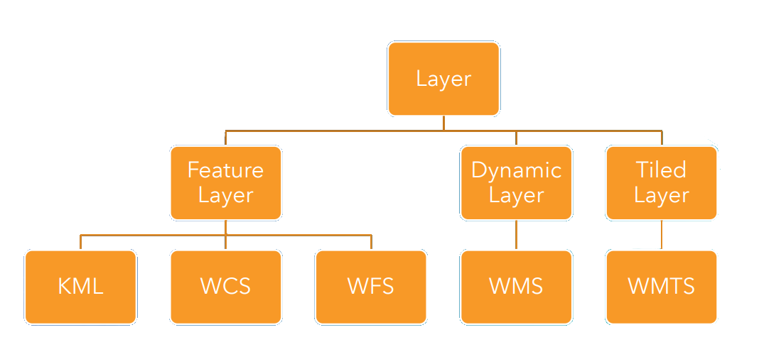

## WMS

The OGC WMS (Web Map Server) standard specifies the interface and parameters to dynamically request maps from a server. Every OGC WMS is individually configured and can serve a multitude of different maps, combination of layers and can optionally even be styled with different cartography. The "Capabilities" document contains all information needed to intelligently request maps from the server

### What Can You Do With It?

In simple words: Get maps! Depending on the configuration of the server maps can come in a variety of formats, sizes, coordinate and projection systems. The following examples show the same map data at different scales and in different coordinate systems.

Maps can be structured into "layers" and the server can offer to apply filters to select or highlight specific features. The OGC WMS standard offers a great many options limited only by your data and

Your creativity.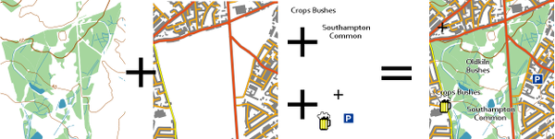

### Primary API Calls

There are two primary API calls:

* GetCapabilities
* GetMap

#### GetCapabilities

The GetCapabilities request returns a document in XML format which contains all information a client needs to make a GetMap request.

We can add this query parameter in WMS link to can consume in web browser

* SERVICE=WMS&
* VERSION=1.3.0&
* REQUEST=GetCapabilities

#### GetMap

The GetMap request returns an image files of the requested map.

## WMTS

### Why use a WMTS service?

WMTS services are useful if you want to make your cached map or image services available in an open, recognized way across different platforms and clients. Additionally, WMTS services are an effective way to make your ArcGIS Server cached map or image services run faster on OGC clients.

### Primary API Calls

There are two primary API calls:

* GetCapabilities
* GetTile

# WFS

The Web Feature Service (WFS) represents a change in the way geographic information is created, modified and exchanged on the Internet. Rather than sharing geographic information at the file level using File Transfer Protocol (FTP), for example, the WFS offers direct fine-grained access to geographic information at the feature and feature property level.

## This International Standard defines eleven operations:

* GetCapabilities (discovery operation)
* DescribeFeatureType (discovery operation)
* GetPropertyValue (query operation)
* GetFeature (query operation)
* GetFeatureWithLock (query & locking operation)
* LockFeature (locking operation)
* Transaction (transaction operation)
* CreateStoredQuery (stored query operation)
* DropStoredQuery (stored query operation)
* ListStoredQueries (stored query operation)
* DescribeStoredQueries (stored query operation)

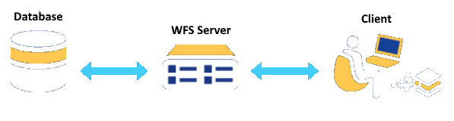

## Primary API Calls

* Get Capabilites
* Get Feature

## Versions Supported

* 1.0.0
* 1.1.0
* 2.0.0

## WFS-T

### Editing:

* Insert – Delete - Update

# Limitations

The following are the current limitations of using OGC layers in Map Viewer:

* You cannot edit features, add token-based secure OGC layers, or add internal OGC layers.
* Your OGC layer and basemap need to use the same coordinate system, for example, Web Mercator (the coordinate system of the default basemaps in the Map Viewer basemap gallery). Your administrator may have changed the default basemaps. Check with your administrator if you have issues using Map Viewer basemaps with your OGC layer.
* OGC WMS group layers are not supported.
* Refresh on OGC WMS layers only works if the WMS service honors standard HTTP caching rules.

If the option to enable pop-ups is not available for the WMS layer, you may need to add the layer to Map Viewer again or re-create the WMS item. Some WMS layers do not support pop-ups.

* When printing OGC WMS or WMTS layers, custom parameters are not supported.
* To print secure OGC layers from ArcGIS Online, you must use your own print service that supports the secure layer.

# Advising

OGC is good outside ESRI I mean that from development view JavaScript API for esri not ready to implement all OGC functionality and we can go to look in Open Layer.

# Sources

* <https://www.ogc.org/standards>