Source officiel : <https://redux.js.org/introduction/examples>

https://reactjs.org/docs/forms.html

Source Meraim :

<https://hackernoon.com/redux-step-by-step-a-simple-and-robust-workflow-for-real-life-apps-1fdf7df46092>

<https://hackernoon.com/a-basic-react-redux-introductory-tutorial-adcc681eeb5e>

Basic Redux (thunks)

https://redux.js.org/basics/dataflow

<https://github.com/wix-incubator/react-dataflow-example>

Détails:

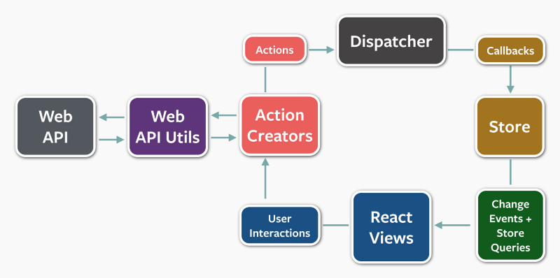

D:\dev\reduxexamples