Réalisation:

Maquettes:

**Ecran Réalisations:**

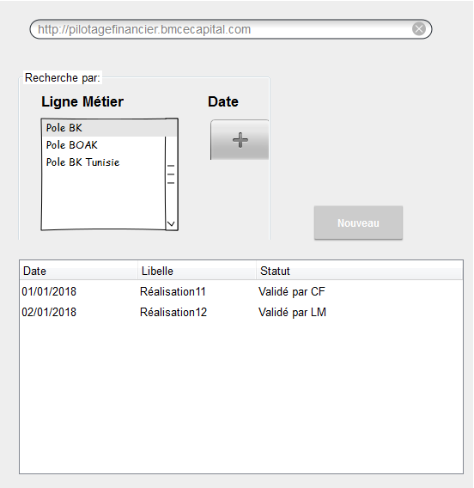

**Ecran Ajout nouvelle réalisation:**

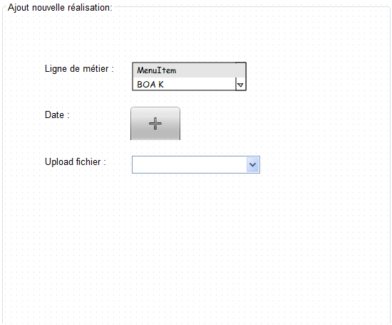

**Ecran des objectifs:**

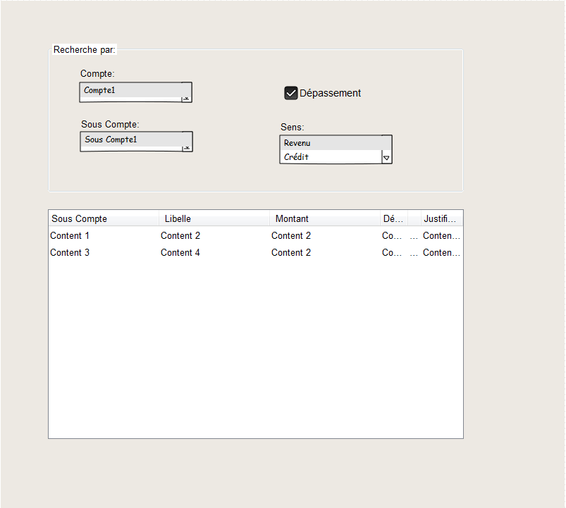

**Ecran Ajout nouveau objectif:**

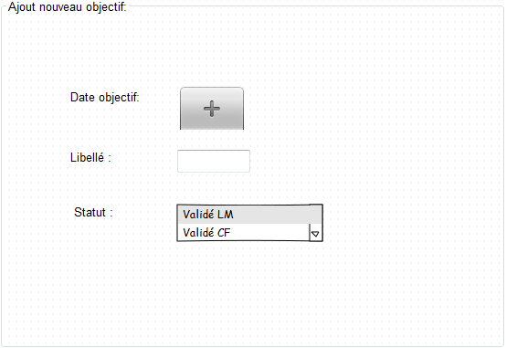

**Pré-requis:**

Spring Boot 1.5.16

https://github.com/souvikduttachoudhury/CrystalReportsSpringBoot

Java 8

IHM: React 16.2, Redux, Highcharts

<https://github.com/highcharts>

Webpack: https://www.alsacreations.com/tuto/lire/1754-debuter-avec-webpack.html

BD: H2(DDL scripts ?), cible = MySql

20181019:

<https://medium.com/coding-crackerjack/spring-boot-and-reactjs-a50367d56521>

https://github.com/umairraslam/expense-manager-spring-react

<https://github.com/hendisantika/SpringBootReact>

https://github.com/spring-guides/tut-react-and-spring-data-rest

Source example: https://grokonez.com/spring-framework/spring-data-rest/spring-boot-react-redux-mysql-crud-example

Source 1: <https://www.logicbig.com/tutorials/spring-framework/spring-boot/jdbc-and-in-memory-h2.html>

<https://www.logicbig.com/tutorials/spring-framework/spring-boot/method-validation.html>

<https://www.logicbig.com/tutorials/spring-framework/spring-hateoas/multiple-link-relations.html>

https://www.logicbig.com/tutorials/spring-framework/spring-hateoas/resource-assembler.html

<https://docs.oracle.com/javase/8/docs/>

Source 2: https://github.com/oktadeveloper/okta-spring-boot-react-crud-example

https://spring.io/guides/tutorials/react-and-spring-data-rest/

Spring Cloud :

https://www.logicbig.com/tutorials/spring-framework/spring-cloud/cloud-config-with-file-system-backend.html

GIT

React 16.3?

Crystal report

Activiti

Autres: MDN

TODO:

Service Rest appellant Crystal report

Source : http://forum.spring.io/forum/spring-projects/web/94387-how-setup-spring-mvc-with-crystal-report

**Old workspaces :**

C:\Users\s.naimi.BMCEK\Documents\BMCE Capital\Projets\CFPBKM\Backend

C:\Users\s.naimi.BMCEK\Documents\BMCE Capital\Projets\BKG\Backend

C:\Users\s.naimi.BMCEK\Documents\BMCE Capital\Projets\BKG\Backend\bkgmodels

C:\Users\s.naimi.BMCEK\Documents\BMCE Capital\Projets\CFPBKM\